Cells and
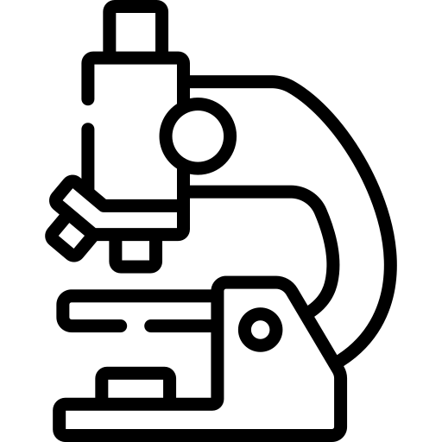
organisation
Name ______________________________
Class ______________________________
Teacher ______________________________
All animals and plants are made of tiny cells that can only be seen with a microscope. These cells are the basic building blocks of life and are responsible for carrying out the essential functions that sustain an organism.
Cells
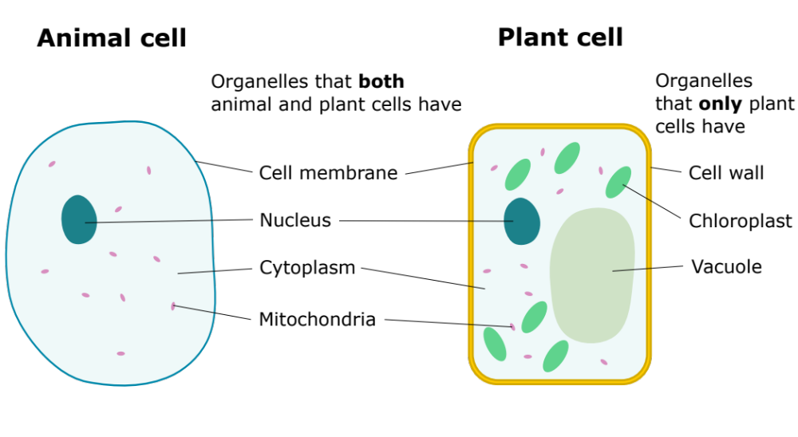
Each cell contains organelles, which serve different purposes. Most cells have a nucleus, cytoplasm, mitochondria and a cell membrane. Plant cells also have a vacuole, chloroplasts, and a cell wall.
Adapted from domdomegg, CC BY 4.0, via Wikimedia Commons

The functions of each organelle can be seen below:
Cell membrane | Controls what goes in and out of the cell.
Nucleus | Controls the activities of the cell by housing the genetic material and coordinating cell functions like growth and reproduction.
Cytoplasm | Chemical reactions happen in the cytoplasm.
Mitochondria | Aerobic respiration happens in the mitochondria. Respiration is a chemical reaction that releases energy stored in glucose so that it can be used to fuel cell activities.
Cell wall | Covers the cell membrane and gives strength to a plant cell.
Chloroplast | Where photosynthesis takes place. Photosynthesis is a chemical reaction that produces glucose. Chloroplasts contain the green pigment chlorophyll.
Vacuole | Contains cell sap (a solution of sugars and salts).

Q1. State the four organelles that plant and animal cells both have:
………………………………………………………………………………………………………………………………………………………………………………………………………..
………………………………………………………………………………………………………………………………………………………………………………………………………..
………………………………………………………………………………………………………………………………………………………………………………………………………..
………………………………………………………………………………………………………………………………………………………………………………………………………..
Q2. State the three organelles that only plant cells have:
………………………………………………………………………………………………………………………………………………………………………………………………………..
………………………………………………………………………………………………………………………………………………………………………………………………………..
………………………………………………………………………………………………………………………………………………………………………………………………………..
Q3. Label the diagrams below, using the words in the box.
Vacuole, cell wall, nucleus, cytoplasm, chloroplast, cell membrane, animal, mitochondria, plant
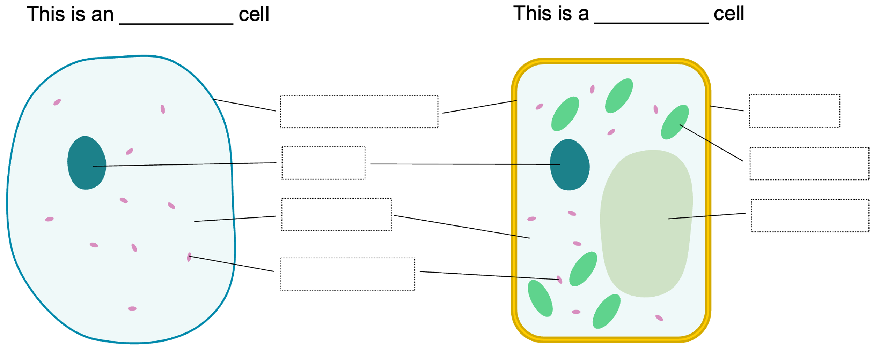
Adapted from domdomegg, CC BY 4.0, via Wikimedia Commons
Q4. The following statements are either true or false. State which are true and which are false.
- Both plant and animal cells have cell walls.
………………………………………………………………………………………………………………………………………………………………………………………………………..
- Both plant and animal cells have cell membranes.
………………………………………………………………………………………………………………………………………………………………………………………………………..
- Only animal cells contain a nucleus.
………………………………………………………………………………………………………………………………………………………………………………………………………..
- Plant cells contain a vacuole.
………………………………………………………………………………………………………………………………………………………………………………………………………..
- The mitochondria control the activities of a cell.
………………………………………………………………………………………………………………………………………………………………………………………………………..
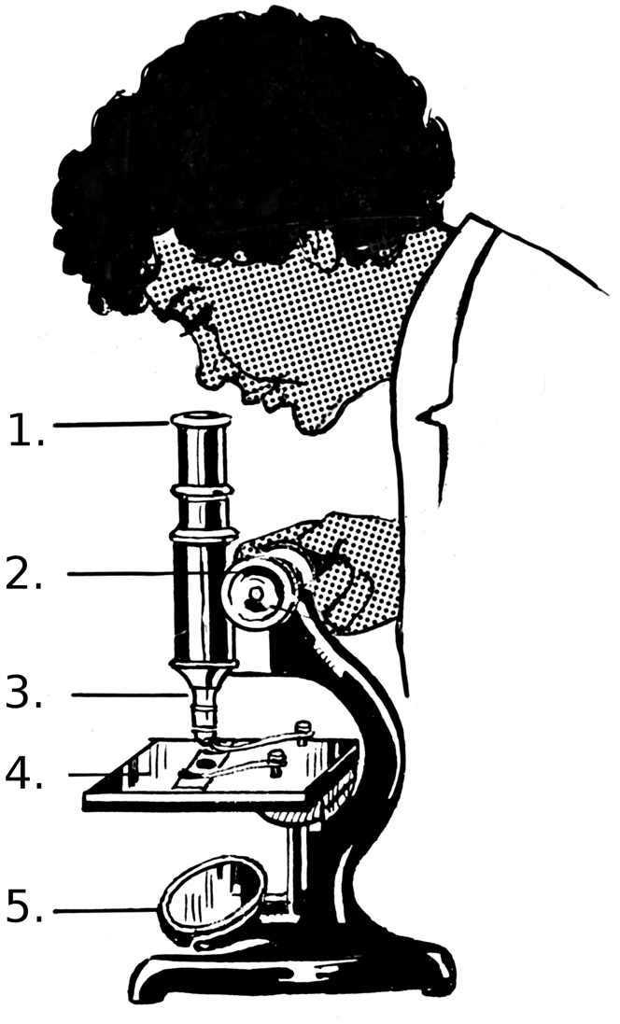
A light microscope is a tool that scientists use to see tiny things that are too small to be seen with the naked eye. Light microscopes use visible light and lenses to magnify objects, allowing us to see details of cells and other small structures.
Light microscopes
The diagram to the right shows a light microscope. Typical parts include:
- Eyepiece lens. This is the lens that you look through at the top of the microscope.
- Focus adjuster. Used to move the stage up and down to bring the object into focus. Microscopes usually have two adjustment controls – coarse and fine. Generally, the fine adjustment is used to sharpen the focus after using the coarse adjustment. This provides a clear and detailed view.
- Objective lens. These lenses magnify the object. Commonly, microscopes have a rotating nosepiece which allows different lenses to be selected for varying levels of magnification.
- Stage. The flat platform where you place the slides. Clips hold the slides in place.
- Mirror or light source. A lamp or mirror that shines light through the object being viewed, making it easier to see details.
Pearson Scott Foresman, Public domain, via Wikimedia Commons
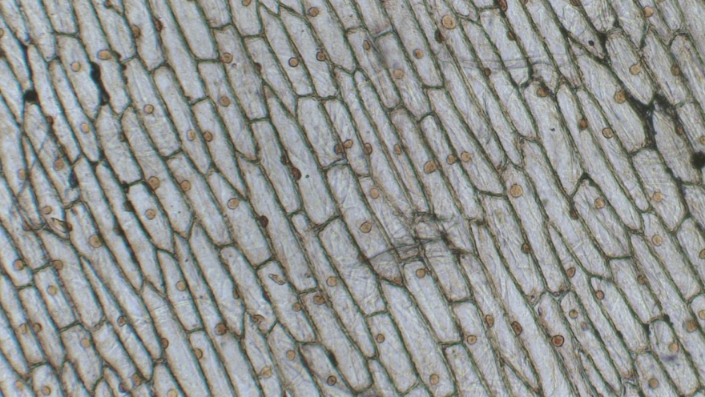
A common practical that you can do in the classroom is to view onion cells (shown left). To prepare a microscope slide, you would cut an onion and peel off a thin layer (called the epidermis). This thin layer should then be carefully placed onto the slide. To view the cells better, add a drop of iodine to the onion and then gently place a coverslip over the onion. The slide is then placed onto the stage and secured with the stage clips.
Berkshire Community College Bioscience Image Library, CC0, via Wikimedia Commons
Q1. The following statements are either true or false. State which are true and which are false.
- Light microscopes are used to magnify objects.
……………………………………………………………………………………………………..
- The objective lens is the lens that we look through.
……………………………………………………………………………………………………..
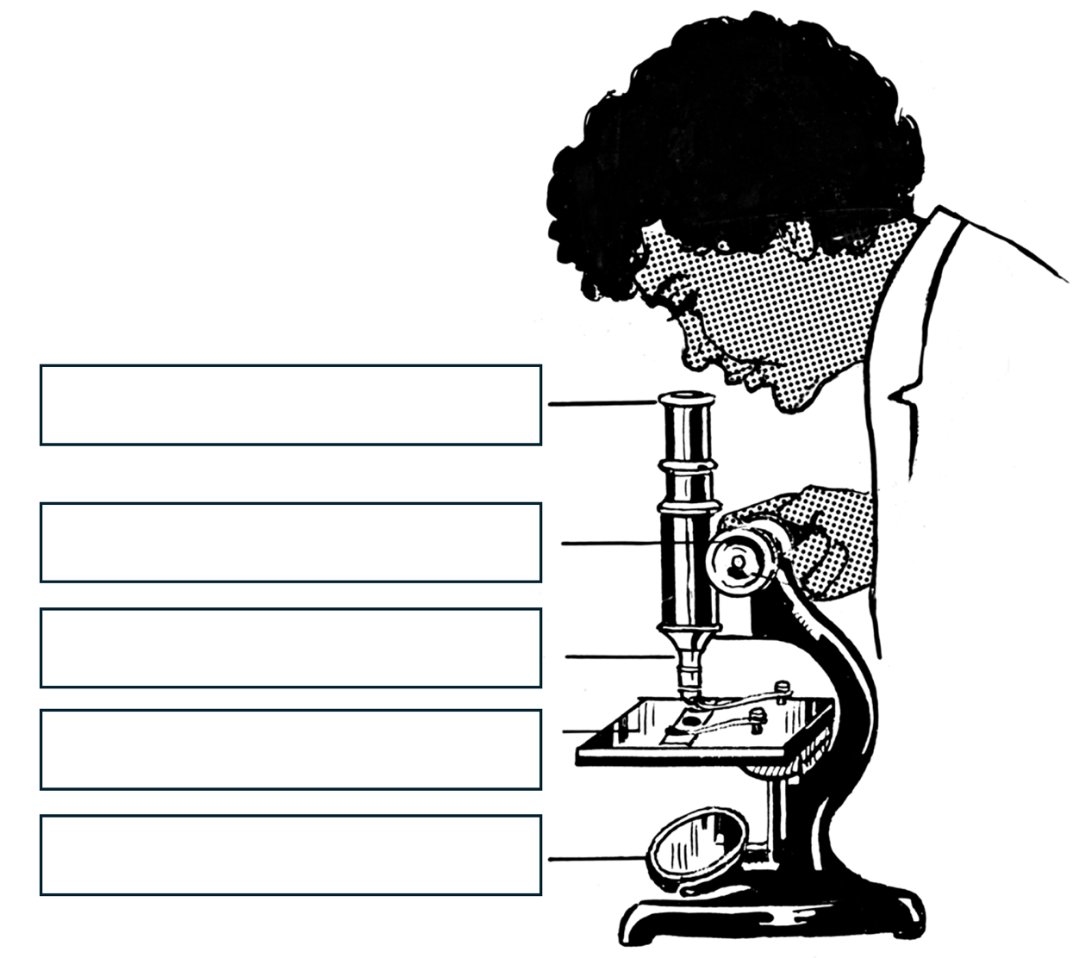
- Clips are used to hold microscope slides onto the stage.
……………………………………………………………………………………………………..
- The focus adjuster usually has coarse and a fine adjustment.
……………………………………………………………………………………………………..
Q2. Label the diagram of the light microscope.

Pearson Scott Foresman, Public domain, via Wikimedia Commons
Q3. Describe the purpose of the mirror on a light microscope.
………………………………………………………………………………………………………………………………………………………………………………………………………..
………………………………………………………………………………………………………………………………………………………………………………………………………..
Q4. Describe how you would use the focus adjuster to bring an object into focus.
………………………………………………………………………………………………………………………………………………………………………………………………………..
………………………………………………………………………………………………………………………………………………………………………………………………………..
Q5. Describe how you would prepare a slide to view onion cells.
………………………………………………………………………………………………………………………………………………………………………………………………………..
………………………………………………………………………………………………………………………………………………………………………………………………………..
………………………………………………………………………………………………………………………………………………………………………………………………………..
………………………………………………………………………………………………………………………………………………………………………………………………………..
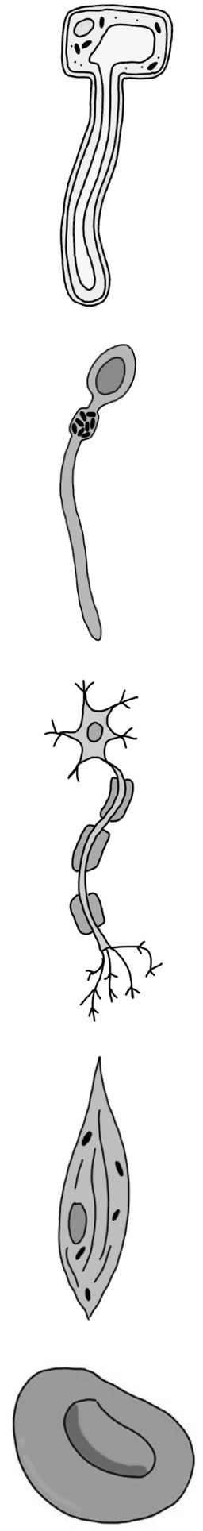
While many cells look similar, they can have special features that help them perform unique jobs. These are called specialised cells. Some examples are below.
Specialised cells
Root hair cells.
These cells absorb water and nutrients from the soil to help a plant grow. Root hair cells have long, hair-like projections that increase their surface area to absorb more water and nutrients efficiently.
Sperm cells.
These cells fertilise an egg cell (ovum) for reproduction. They have a long tail, called a flagellum, which helps them swim toward the egg. They are streamlined and have a head that contains enzymes to help penetrate the egg cell. The head also contains the cell's genetic material.

Nerve Cells (Neurons).
Electrical signals are transmitted through the nerve cells throughout the body to help control body functions, send messages from the brain to other parts of the body, and respond to stimuli.
Nerve cells have long extensions called axons and dendrites that connect with other nerve cells to transmit signals quickly over long distances.

Muscle Cells.
Movement is produced in muscle cells by contracting and relaxing in response to signals from the nervous system. Muscle cells are long and can change shape by contracting. They contain many mitochondria, which provide the energy needed for contraction.

Red Blood Cells.
These cells carry oxygen in the blood to the rest of the body. They have a biconcave shape which increases their surface area for absorbing oxygen. They are small and flexible, allowing them to fit through tiny blood vessels.
Q1. The following statements are either true or false. State which are true and which are false.
- Specialised cells have the same shape and size as all other cells.
………………………………………………………………………………………………………………………………………………………………………………………………………..
- Red blood cells have a long tail to help them swim through blood.
………………………………………………………………………………………………………………………………………………………………………………………………………..
- Sperm cells fertilise an egg cell for reproduction.
………………………………………………………………………………………………………………………………………………………………………………………………………..
- Electrical signals are transmitted through nerve cells.
………………………………………………………………………………………………………………………………………………………………………………………………………..
- Red blood cells have a large surface area for carrying oxygen.
………………………………………………………………………………………………………………………………………………………………………………………………………..
- Root hair cells are responsible for hair growing on humans.
………………………………………………………………………………………………………………………………………………………………………………………………………..
- Muscle cells contract and relax in response to signals from the nervous system.
………………………………………………………………………………………………………………………………………………………………………………………………………..
- Root hair cells help plants absorb sunlight.
………………………………………………………………………………………………………………………………………………………………………………………………………..
Q2. Describe the role of root hair cells in plants. Include how they are adapted for this purpose.
………………………………………………………………………………………………………………………………………………………………………………………………………..
………………………………………………………………………………………………………………………………………………………………………………………………………..
Q3. Describe why muscle cells contain many mitochondria.
………………………………………………………………………………………………………………………………………………………………………………………………………..
………………………………………………………………………………………………………………………………………………………………………………………………………..
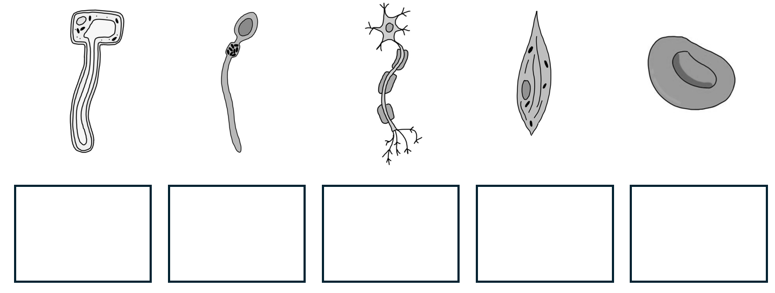
Q4. State the name of each cell in the boxes below.
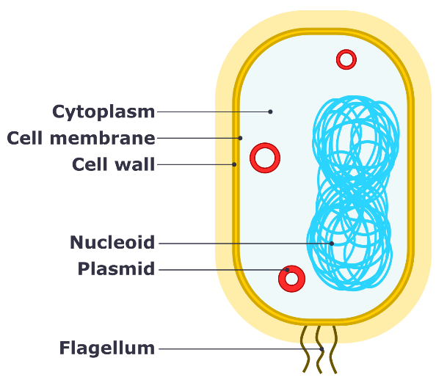
Unicellular organisms are living organisms made of just one cell. Despite their small size and simplicity, these single-celled organisms perform all seven life processes. We can use the acronym Mrs. Gren to help remember all of the life processes:
Life processes and unicellular organisms
Movement | All living organisms move in some way. Plants move slowly as they grow towards light, and animals move to find food or escape danger.
Respiration | Respiration is a chemical reaction that releases energy stored in glucose.
Sensitivity | Living things can sense changes in their environment and respond to them. For example, humans can feel heat and move away from it, while plants can grow toward the light.
Growth | All living organisms grow. Unicellular organisms grow by increasing in size, and multicellular organisms grow by producing more cells.
Reproduction | Reproduction is the process of producing offspring.
Excretion | This is the process of removing waste products from the body.
Nutrition | Plants photosynthesise, while animals need to eat plants or other animals.
Bacteria are some of the most common and diverse unicellular organisms.
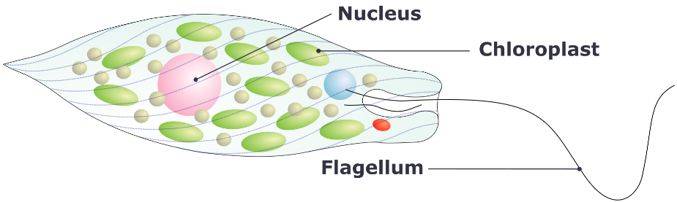
A diagram of bacteria can be seen to the right. Unlike many cells, bacteria do not have a nucleus. Instead, genetic material is located in the nucleoid and plasmids. Some (but not all) bacteria have a long tail, called a flagellum, for movement.
Adapted from domdomegg, CC BY 4.0, via Wikimedia Commons
Euglena is a unicellular organism that is found in water. They also have a flagellum that helps them swim and chloroplasts for photosynthesis. Other examples of unicellular organisms include some fungi such as yeast and amoebas.
Adapted from Alexei Kouprianov, CC BY 2.5, via Wikimedia Commons
Q1. The following statements are either true or false. State which are true and which are false.
- There are seven life processes that all living organisms perform.
………………………………………………………………………………………………………………………………………………………………………………………………………..
- Unicellular organisms are living organisms made of more than one cell.
………………………………………………………………………………………………………………………………………………………………………………………………………..
- All living organisms carry out respiration.
………………………………………………………………………………………………………………………………………………………………………………………………………..
- All living organisms carry out photosynthesis.
………………………………………………………………………………………………………………………………………………………………………………………………………..
- Bacteria are an example of a unicellular organism.
………………………………………………………………………………………………………………………………………………………………………………………………………..
- Bacteria contain a nucleus.
………………………………………………………………………………………………………………………………………………………………………………………………………..
Q2. State the acronym that we use to remember the life processes that living organisms perform.
………………………………………………………………………………………………………………………………………………………………………………………………………..
Q3. State all of the life processes that living organisms perform.
………………………………………………………………………………………………………………………………………………………………………………………………………..
………………………………………………………………………………………………………………………………………………………………………………………………………..
………………………………………………………………………………………………………………………………………………………………………………………………………..
Q4. State three examples of unicellular organisms.
………………………………………………………………………………………………………………………………………………………………………………………………………..
………………………………………………………………………………………………………………………………………………………………………………………………………..
Q5. State three organelles that euglena are made of and describe the purpose of each organelle.
………………………………………………………………………………………………………………………………………………………………………………………………………..
………………………………………………………………………………………………………………………………………………………………………………………………………..
………………………………………………………………………………………………………………………………………………………………………………………………………..
………………………………………………………………………………………………………………………………………………………………………………………………………..
Q6. State two organelles that bacteria are made of and describe the purpose of each organelle.
………………………………………………………………………………………………………………………………………………………………………………………………………..
………………………………………………………………………………………………………………………………………………………………………………………………………..

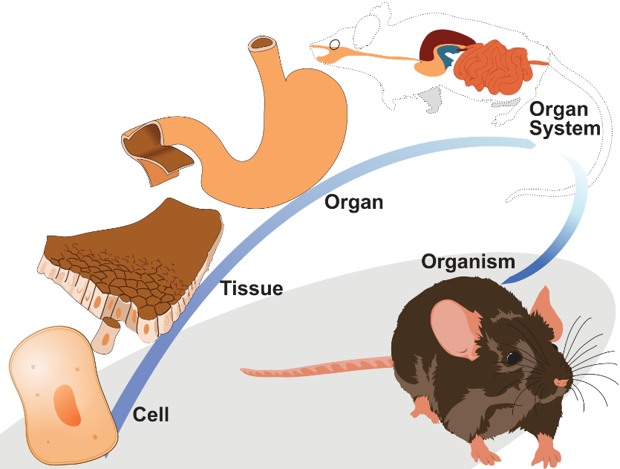
Multicellular organisms are made of many individual cells and need a way of organising cells so that they can work together. These levels are arranged in a hierarchy from simple to complex: cells, tissues, organs, organ systems, and finally, organisms.
Cell organisation
The diagram to the right shows cell organisation to form the digestive system of a mouse. Firstly, epithelial cells are shown. These cells line the stomach, providing a protective barrier and aiding in nutrient absorption.
Adapted from LadyofHats, CC0, via Wikimedia Commons
These cells are arranged into epithelial tissue which, in turn, is joined with other tissues to form the stomach. The stomach is an organ which is then combined with other organs, such as the intestines, to form the digestive system. Different organs join together to form organ systems. Collectively, organ systems form the whole organism.
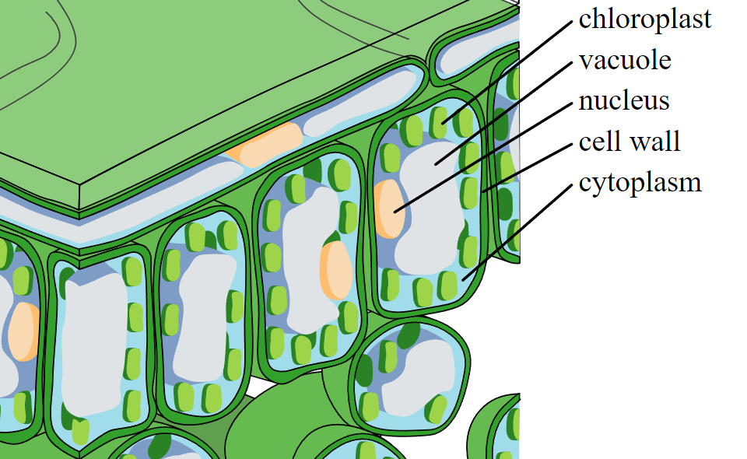
Another example of cell organisation is the organisation of cells in a leaf. One of the cells in a leaf is called a palisade cells. Palisade cells are near the surface of a leaf and have many chloroplasts for photosynthesis.
Palisade cells join together to form palisade tissue (shown in the image to the left). In turn, different tissues join to form a leaf which is an organ. Leaves combine with other organs to form the shoot system.
Cropped image from Zephyris, CC BY-SA 3.0, via Wikimedia Commons
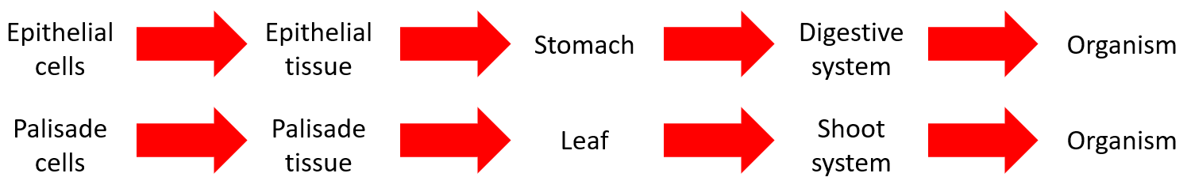
A summary of the cell organisation for both examples is below:
Q1. The following statements are either true or false. State which are true and which are false.
- Multicellular organisms are made of many individual cells.
………………………………………………………………………………………………………………………………………………………………………………………………………..
- The stomach is a tissue.
………………………………………………………………………………………………………………………………………………………………………………………………………..
- A tissue is made from a group of similar cells working together.
………………………………………………………………………………………………………………………………………………………………………………………………………..
- Plant leaves are organs.
………………………………………………………………………………………………………………………………………………………………………………………………………..
- Epithelial cells are needed for photosynthesis.
………………………………………………………………………………………………………………………………………………………………………………………………………..
Q2. Describe the difference between tissues and organs.
………………………………………………………………………………………………………………………………………………………………………………………………………..
………………………………………………………………………………………………………………………………………………………………………………………………………..
Q3. Describe an example of cell organisation in a plant. Include a description of how cells are organised into tissues, organs and organ systems.
………………………………………………………………………………………………………………………………………………………………………………………………………..
………………………………………………………………………………………………………………………………………………………………………………………………………..
………………………………………………………………………………………………………………………………………………………………………………………………………..
………………………………………………………………………………………………………………………………………………………………………………………………………..
Q4. Describe an example of cell organisation in an animal. Include a description of how cells are organised into tissues, organs and organ systems.
………………………………………………………………………………………………………………………………………………………………………………………………………..
………………………………………………………………………………………………………………………………………………………………………………………………………..
………………………………………………………………………………………………………………………………………………………………………………………………………..
………………………………………………………………………………………………………………………………………………………………………………………………………..
Q5. State three organelles that a palisade cell is made of and describe the purpose of each organelle.
………………………………………………………………………………………………………………………………………………………………………………………………………..
………………………………………………………………………………………………………………………………………………………………………………………………………..
………………………………………………………………………………………………………………………………………………………………………………………………………..
………………………………………………………………………………………………………………………………………………………………………………………………………..

