When we look at living things, from the smallest bacteria to the largest animals, we can see that they all have characteristics that make them unique. These characteristics (like eye colour or height) are passed down from one generation to the next. This passing on of traits is known as inheritance. To understand inheritance, we need to learn about chromosomes, DNA and genes:
DNA and inheritance
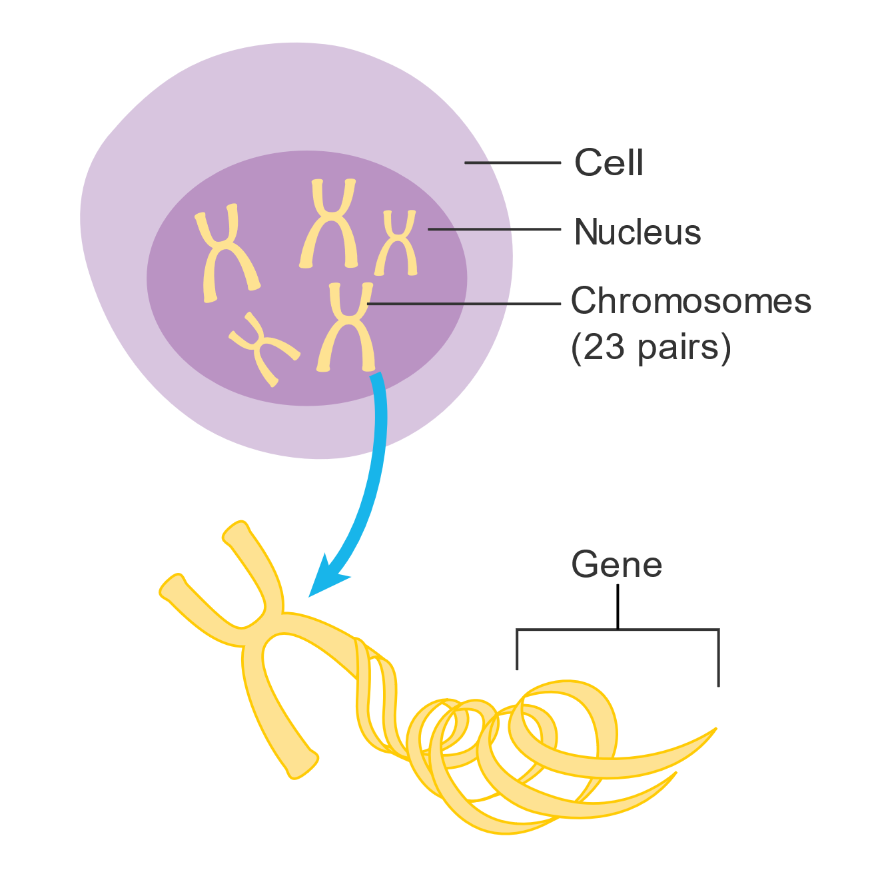
- Chromosomes are thread-like structures found in the nucleus of every cell. Humans have 46 chromosomes, arranged in 23 pairs. You inherit one chromosome from each pair from your mother and the other from your father. This is why you have some characteristics from your mother and some from your father.
- DNA (deoxyribonucleic acid) is the molecule that makes up chromosomes. DNA carries the genetic instructions that tell your cells how to function and determine your traits.
- Genes are specific segments of DNA that carry the instructions for a specific characteristic. For example, one gene might carry the instructions for your eye colour while another might determine your blood type.
Cancer Research UK, CC BY-SA 4.0, via Wikimedia Commons

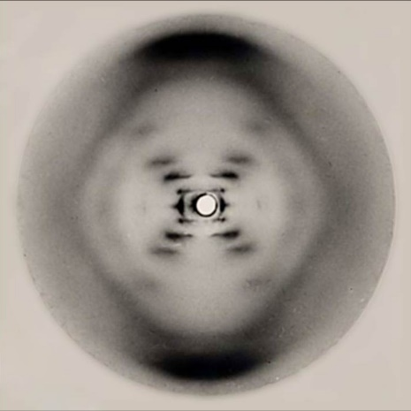
Humans have thousands of genes, and they all work together to determine your physical traits and even some aspects of your personality. Some genes are dominant, meaning that if you inherit the dominant version of a gene from one parent, that trait is more likely to show up in you. Other genes are recessive, meaning that the trait will only appear if you inherit the recessive version from both parents.
In the 1950s, James Watson and Francis Crick were working to uncover the structure of DNA. They were able to build on the work of Rosalind Franklin and Maurice Wilkins, who used X-ray crystallography to take images of DNA. Raymond Gosling, a student working under Franklin and Wilkins, produced the famous “Photo 51” which provided crucial clues that helped Watson and Crick determine that DNA has a double-helix structure, which looks like a twisted ladder. Photo 51 is shown in the image to the left.
By Raymond Gosling/King's College London - http://www-project.slac.stanford.edu/wis/images/photo_51.jpg, Public Domain

Q1. The following statements are either true or false. State which are true and which are false.
- DNA is short for deoxyribonucleic acid.
………………………………………………………………………………………………………………………………………………………………………………………………………..
- Humans have 46 chromosomes, arranged in 23 pairs.
………………………………………………………………………………………………………………………………………………………………………………………………………..
- DNA has a double helix structure.
………………………………………………………………………………………………………………………………………………………………………………………………………..
- DNA is made of chromosomes.
………………………………………………………………………………………………………………………………………………………………………………………………………..
- If you inherit a recessive version of a gene from one parent, that trait is more likely to show up in you.
………………………………………………………………………………………………………………………………………………………………………………………………………..
Q2. Describe what is meant by inheritance.
………………………………………………………………………………………………………………………………………………………………………………………………………..
………………………………………………………………………………………………………………………………………………………………………………………………………..
Q3. Describe what chromosomes are and where there are usually found.
………………………………………………………………………………………………………………………………………………………………………………………………………..
………………………………………………………………………………………………………………………………………………………………………………………………………..
………………………………………………………………………………………………………………………………………………………………………………………………………..
Q4. Describe what DNA is.
………………………………………………………………………………………………………………………………………………………………………………………………………..
………………………………………………………………………………………………………………………………………………………………………………………………………..
………………………………………………………………………………………………………………………………………………………………………………………………………..
Q5. Describe what genes are.
………………………………………………………………………………………………………………………………………………………………………………………………………..
………………………………………………………………………………………………………………………………………………………………………………………………………..
………………………………………………………………………………………………………………………………………………………………………………………………………..
Q6. Describe the history of how the structure of DNA was discovered.
………………………………………………………………………………………………………………………………………………………………………………………………………..
………………………………………………………………………………………………………………………………………………………………………………………………………..
………………………………………………………………………………………………………………………………………………………………………………………………………..
………………………………………………………………………………………………………………………………………………………………………………………………………..

