Ecosystems
Name ______________________________
Class ______________________________
Teacher ______________________________



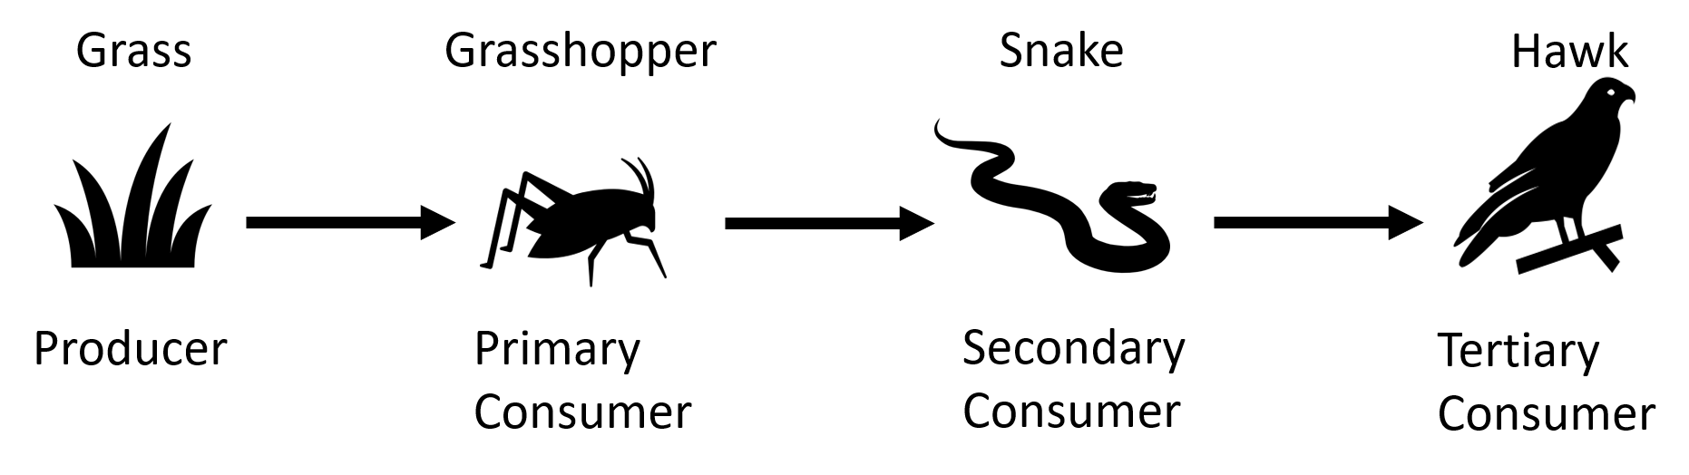
A food chain is a way of showing what eats what. For example, the diagram below shows that grasshoppers eat grass.
Food chains and webs

Below are some important definitions:
Producers | Organisms that make their own food through photosynthesis.
Primary consumer | Animal that eats the producer.
Secondary consumer | Animal that eats the primary consumer.
Tertiary consumer | Animal that eats the secondary consumer.
Herbivore | Animal that eats only plants.
Carnivore | Animal that eats other animals.
Omnivore | Animal that eats both plants and animals.
Predator | An organism that eats another organism.
Prey | The organism that a predator eats.

Usually, patterns of eating are more complicated than a simple food chain. A food web contains lots of food chains linked together.
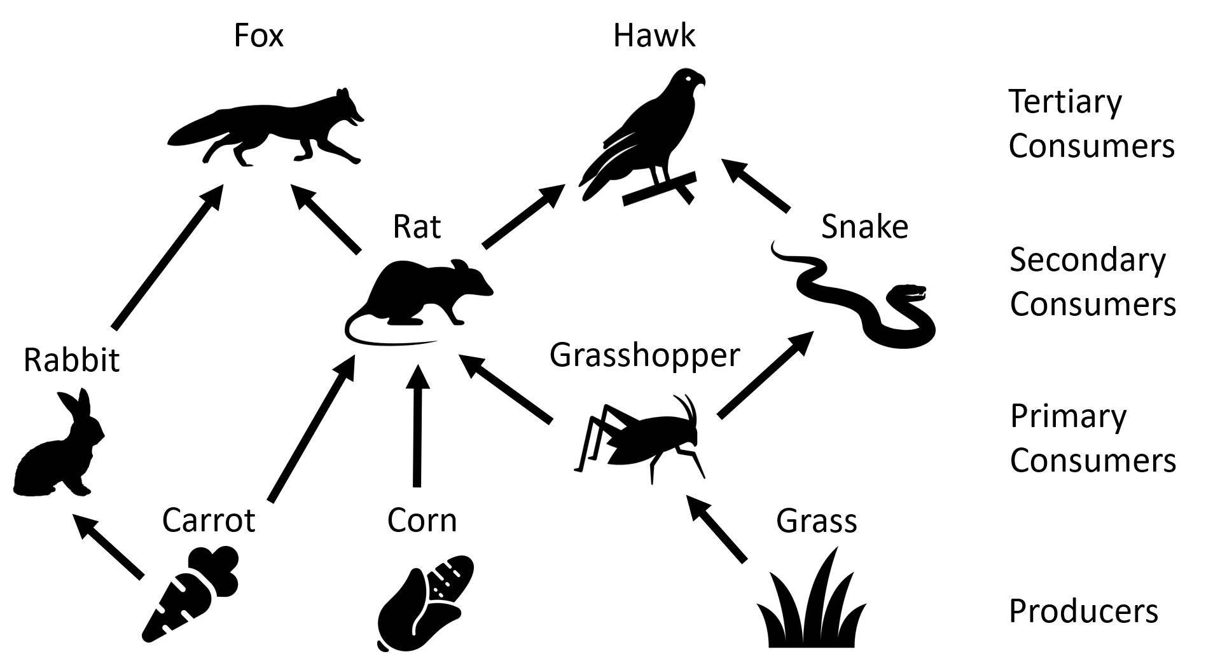

Each part of a food chain/web is linked to others. For example, if all the carrots in the food web above died then there would be fewer rabbits (as they’d have less food to eat).
Q1. Describe what a producer is.
………………………………………………………………………………………………………………………………………………………………………………………………………..
Q2. Describe what a herbivore is.
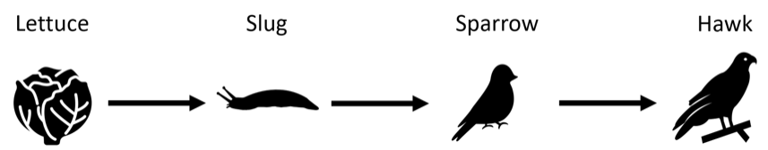
………………………………………………………………………………………………………………………………………………………………………………………………………..

Use the food chain above to answer the following questions.
Q3. The producer is ………………………………
Q4. The secondary consumer is ………………………………
Q5. The prey of the hawk is ………………………………
Q6. The predator of the slug is ………………………………
Q7. State what would happen to the sparrow population if most of the slugs died.
………………………………………………………………………………………………………………………………………………………………………………………………………..
Q8. State what would happen to the lettuce population if most of the slugs died.
………………………………………………………………………………………………………………………………………………………………………………………………………..
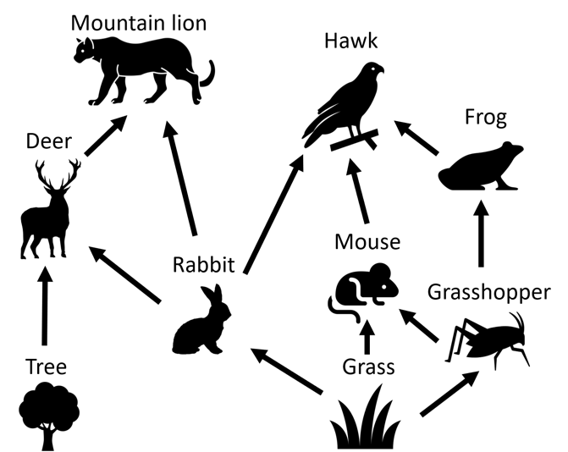

Use the food web above to answer the following questions.
Q9. Name a primary consumer.
………………………………………………………………………………………………………………………………………………………………………………………………………..
Q10. Name the predators of a rabbit.
………………………………………………………………………………………………………………………………………………………………………………………………………..
Q11. Name an omnivore.
………………………………………………………………………………………………………………………………………………………………………………………………………..
Q12. Name a carnivore.
………………………………………………………………………………………………………………………………………………………………………………………………………..
An ecosystem is a community of living and non-living things interacting with each other. Plants, animals and microorganisms depend on water, soil, climate and each other for survival. These interactions create a web of relationships that keep the ecosystem balanced and functioning.
Relationships in an ecosystem
In an ecosystem, all organisms are interdependent. This means they rely on each other to survive. For instance, plants need sunlight to make glucose through photosynthesis. Some animals depend on these plants for food, and predators rely on other animals as their food source. If one part of this chain is disturbed, it can impact the entire ecosystem.
One key example of interdependence is pollination. Many plants, including those that humans rely on for food, need insects like bees to pollinate them. Pollination is the process of transferring pollen from one flower to another, allowing the plant to produce seeds and fruit. Without pollinators, many plants would struggle to reproduce. This would affect the animals that rely on them for food.
Humans heavily depend on insect pollination for a lot of the food we eat, such as fruits, vegetables and nuts. Without pollinators, these crops would produce less food. This would lead to food shortages and higher prices. The health of ecosystems, therefore, has a direct impact on human food security.
However, the use of insecticides (chemicals designed to kill insects) can also harm beneficial insects like bees. When these chemicals reduce pollinator populations, it can lead to lower crop yields and disrupt the entire food chain. This reduction in pollinators can also decrease biodiversity, making ecosystems less resilient to other threats.
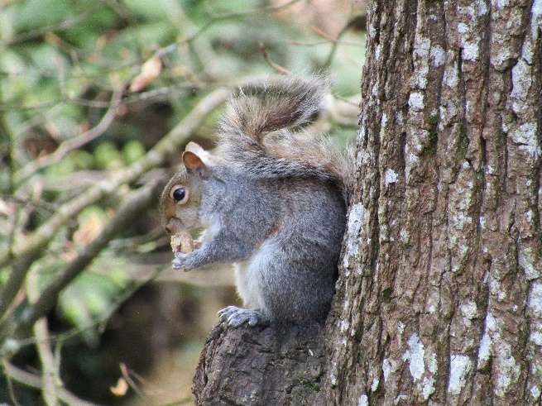
In addition to issues like insecticide use, ecosystems can also be disrupted by invasive species. An invasive species is a non-native organism introduced to an ecosystem, often causing harm. These species can outcompete native organisms for resources like food and habitat, disrupt food chains and reduce biodiversity.
For example, the introduction of grey squirrels to the UK from North America has led to a decline in the native red squirrel population. Grey squirrels compete with red squirrels for food and carry a disease that is deadly to red squirrels but not to themselves. This has significantly reduced red squirrel numbers and upset the balance of the local ecosystem.
Partonez, CC BY-SA 4.0, via Wikimedia Commons

Q1. The following statements are either true or false. State which are true and which are false.
- Bees are an example of a pollinator.
………………………………………………………………………………………………………………………………………………………………………………………………………..
- Invasive species are needed to keep ecosystems balanced.
………………………………………………………………………………………………………………………………………………………………………………………………………..
Q2. Describe why pollination is important for both plants and animals.
………………………………………………………………………………………………………………………………………………………………………………………………………..
………………………………………………………………………………………………………………………………………………………………………………………………………..
………………………………………………………………………………………………………………………………………………………………………………………………………..
………………………………………………………………………………………………………………………………………………………………………………………………………..
Q3. Describe how the use of insecticides can affect an ecosystem.
………………………………………………………………………………………………………………………………………………………………………………………………………..
………………………………………………………………………………………………………………………………………………………………………………………………………..
………………………………………………………………………………………………………………………………………………………………………………………………………..
Q4. Describe what is meant by an ecosystem.
………………………………………………………………………………………………………………………………………………………………………………………………………..
………………………………………………………………………………………………………………………………………………………………………………………………………..
………………………………………………………………………………………………………………………………………………………………………………………………………..
Q5. Describe what is meant by an invasive species.
………………………………………………………………………………………………………………………………………………………………………………………………………..
………………………………………………………………………………………………………………………………………………………………………………………………………..
………………………………………………………………………………………………………………………………………………………………………………………………………..
Q6. State an example of an invasive species.
………………………………………………………………………………………………………………………………………………………………………………………………………..
Q7. Describe what is meant by interdependence in an ecosystem.
………………………………………………………………………………………………………………………………………………………………………………………………………..
………………………………………………………………………………………………………………………………………………………………………………………………………..
………………………………………………………………………………………………………………………………………………………………………………………………………..
Q8. Describe what might happen to the human food supply if pollinator populations decrease.
………………………………………………………………………………………………………………………………………………………………………………………………………..
………………………………………………………………………………………………………………………………………………………………………………………………………..
………………………………………………………………………………………………………………………………………………………………………………………………………..
………………………………………………………………………………………………………………………………………………………………………………………………………..
When we study ecosystems, we often need to assess the number of different species in a specific area. It isn’t possible to count every single one of an organism within a large area, so we instead carry out an estimate using quadrats.
Assessing ecosystems
A quadrat is a square frame, usually made of wood or metal, that is used to give a sample area within an ecosystem. The size of a quadrat can vary, but it’s often 1m x 1m. The quadrats are placed randomly in an area they want to study and count the organisms within the frame. By doing this in multiple places within the area, we can estimate the population size.
To do this correctly, we should use the following method.
- Random Placement. To avoid bias, the quadrat should be placed randomly in the area to be studied. This can be done by using a random number generator to determine coordinates within the area.
- Counting Organisms. Once the quadrat is placed, all organisms within the frame are identified and counted.
- Repeating the Process. The process is repeated multiple times in different parts of the area. A mean number of organisms can then be calculated per quadrat.
- Multiply mean by area. The mean number of organisms per quadrat gives the number in each m². Multiplying this by the total area gives an estimate of the population size.
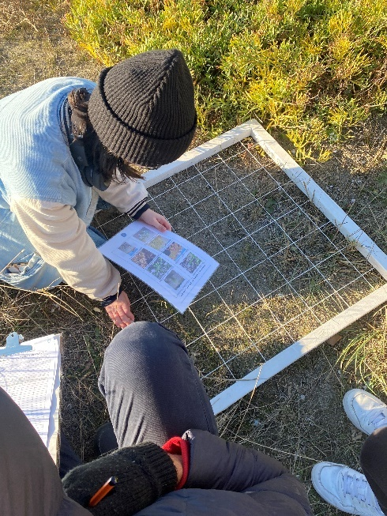
Example question
A field has an area of 10 000 m². Some students use quadrats of area 1 m² to estimate the number of daisies in the field. They find an average of 12 daisies per quadrat. Calculate an estimate for the total number of daisies in the field.
Step 1. Write down equation:
Total population = average number per quadrat × total area
Step 2. Insert variables into equation:
Total population = 12 × 10 000
Step 3. Calculate answer.
Giulia Castiglioni, CC0, via Wikimedia Commons

Total population = 120 000 daisies
By studying ecosystems, we can detect changes over time, such as a decline in a particular species or the impact of human activities like pollution or deforestation. This information can help us make decisions about how to protect and manage ecosystems.
Q1. The following statements are either true or false. State which are true and which are false.
- To calculate the population of an organism within a large area, it’s easiest to count them all.
………………………………………………………………………………………………………………………………………………………………………………………………………..
- Quadrats usually have an area of 1 m².
………………………………………………………………………………………………………………………………………………………………………………………………………..
- To calculate an estimate for the total population in an area, we can divide the average number per quadrat by the total area.
………………………………………………………………………………………………………………………………………………………………………………………………………..
Q2. A meadow has an area of 5000 m². Students use quadrats of 1 m² to estimate the number of clover plants in the meadow. They find an average of 20 clover plants per quadrat. Calculate an estimate for the total number of clover plants in the meadow.
………………………………………………………………………………………………………………………………………………………………………………………………………..
………………………………………………………………………………………………………………………………………………………………………………………………………..
………………………………………………………………………………………………………………………………………………………………………………………………………..
Q3. A field has an area of 2,500 m² and the average number of dandelions per m² quadrat is found to be 8. Calculate the estimated total number of dandelions in the field.
………………………………………………………………………………………………………………………………………………………………………………………………………..
………………………………………………………………………………………………………………………………………………………………………………………………………..
………………………………………………………………………………………………………………………………………………………………………………………………………..
Q4. After placing 15 quadrats in a 4,000 m² area, the average number of organisms counted per m² quadrat is 10. Calculate an estimate for the total population of the organisms in the area.
………………………………………………………………………………………………………………………………………………………………………………………………………..
………………………………………………………………………………………………………………………………………………………………………………………………………..
………………………………………………………………………………………………………………………………………………………………………………………………………..
Q5. Describe what a quadrat is and how it is used in studying ecosystems.
………………………………………………………………………………………………………………………………………………………………………………………………………..
………………………………………………………………………………………………………………………………………………………………………………………………………..
………………………………………………………………………………………………………………………………………………………………………………………………………..
………………………………………………………………………………………………………………………………………………………………………………………………………..
Q6. Describe a reason why it’s useful to assess ecosystem populations.
………………………………………………………………………………………………………………………………………………………………………………………………………..
………………………………………………………………………………………………………………………………………………………………………………………………………..
………………………………………………………………………………………………………………………………………………………………………………………………………..
………………………………………………………………………………………………………………………………………………………………………………………………………..

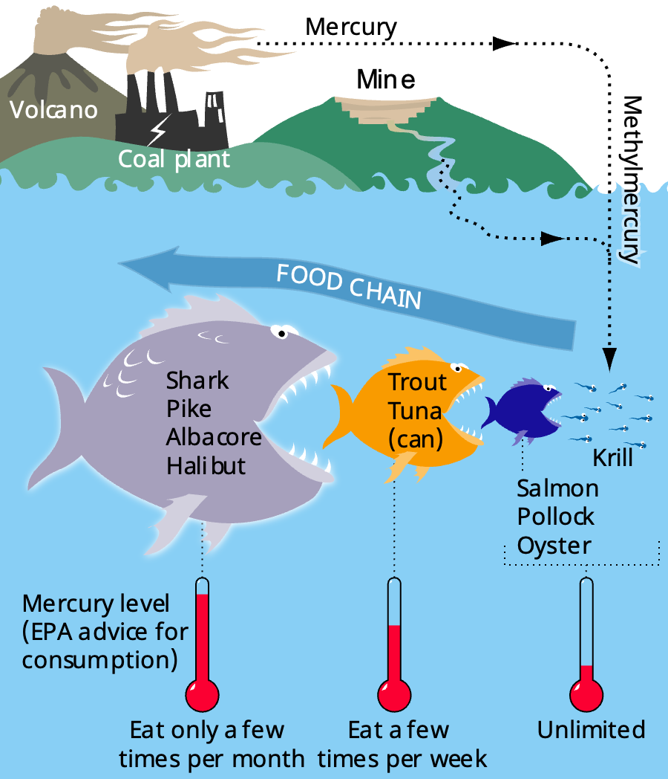
Bioaccumulation is the process by which toxic substances build up in the tissues of organisms over time. These toxic substances can include chemicals like pesticides, heavy metals (such as mercury or lead) and other pollutants that enter the environment through air, water or soil. Once these toxins are in an ecosystem, they can move through the food chain and become more concentrated in the bodies of animals higher up the food chain.
Bioaccumulation
One common example of bioaccumulation involves mercury, a heavy metal that can be released into the environment from industrial processes like coal burning. In aquatic ecosystems, mercury is absorbed by small organisms like plankton. Small fish eat the plankton and the mercury accumulates in their bodies. When larger fish (like tuna or trout) eat these smaller fish, they take in the mercury as well. By the time these large fish are eaten by humans or other top predators, the mercury concentration can be dangerously high, leading to health risks such as neurological disorders.
Bretwood Higman, Ground Truth Trekking., CC BY 3.0, via Wikimedia Commons

Another example of bioaccumulation is the pesticide DDT. DDT was used extensively in agriculture to control insects. However, it also accumulated in the environment and particularly in aquatic ecosystems. Small organisms in the water absorbed the DDT and, as it moved up the food chain, it became highly concentrated in birds of prey like eagles and ospreys. The high levels of DDT caused these birds to lay eggs with very thin shells, which often broke before the chicks could hatch. This led to a significant decline in bird populations before DDT was banned in many countries.
Preventing bioaccumulation involves reducing the release of harmful chemicals and pollutants into the environment. This can be achieved by using less toxic alternatives to pesticides, enforcing stricter regulations on industrial waste and ensuring that toxic materials are properly disposed of.

Q1. Define bioaccumulation and describe how it occurs in an ecosystem.
………………………………………………………………………………………………………………………………………………………………………………………………………..
………………………………………………………………………………………………………………………………………………………………………………………………………..
………………………………………………………………………………………………………………………………………………………………………………………………………..
………………………………………………………………………………………………………………………………………………………………………………………………………..
Q2. State two examples of toxic substances that can lead to bioaccumulation.
………………………………………………………………………………………………………………………………………………………………………………………………………..
Q3. A small fish in a polluted river absorbs 2 units of a toxin. If a larger fish eats 10 of these small fish, state how many units of toxin the larger fish has.
………………………………………………………………………………………………………………………………………………………………………………………………………..
Q4. A top predator in a food chain eats 15 animals, each with 10 units of toxin. State how many units of the toxin the predator accumulates from eating these animals.
………………………………………………………………………………………………………………………………………………………………………………………………………..
Q5. Describe how human activities contribute to bioaccumulation and suggest ways to reduce its impact on ecosystems.
………………………………………………………………………………………………………………………………………………………………………………………………………..
………………………………………………………………………………………………………………………………………………………………………………………………………..
………………………………………………………………………………………………………………………………………………………………………………………………………..
………………………………………………………………………………………………………………………………………………………………………………………………………..
Q6. NHS advice is for an adult to eat no more than 2 tuna steaks a week. Describe why this advice is in place.
………………………………………………………………………………………………………………………………………………………………………………………………………..
………………………………………………………………………………………………………………………………………………………………………………………………………..
………………………………………………………………………………………………………………………………………………………………………………………………………..
………………………………………………………………………………………………………………………………………………………………………………………………………..
Q7. Describe why the pesticide DDT has been banned in many countries.
………………………………………………………………………………………………………………………………………………………………………………………………………..
………………………………………………………………………………………………………………………………………………………………………………………………………..
………………………………………………………………………………………………………………………………………………………………………………………………………..
………………………………………………………………………………………………………………………………………………………………………………………………………..

