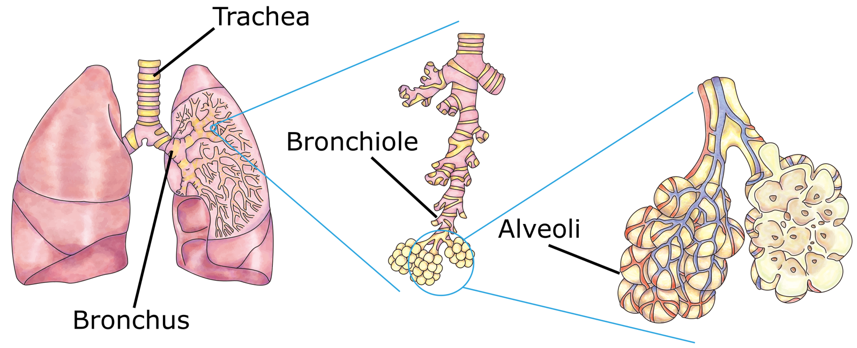
Gas exchange is a vital process in humans that involves taking in oxygen from the air and removing carbon dioxide from the bloodstream. This exchange takes place in tiny air sacs called alveoli. A single one of these air sacs is called an alveolus.
DataBase Center for Life Science (DBCLS), CC BY 4.0, via Wikimedia Commons
Gas exchange in humans
When you inhale, air first travels through the trachea and then through the bronchi and bronchioles before entering the alveoli. Oxygen from the inhaled air diffuses through the thin walls of the alveoli and into the surrounding capillaries. These are small blood vessels that wrap around each alveolus. Diffusion is the movement of particles from a high concentration (of those particles) to a lower concentration.
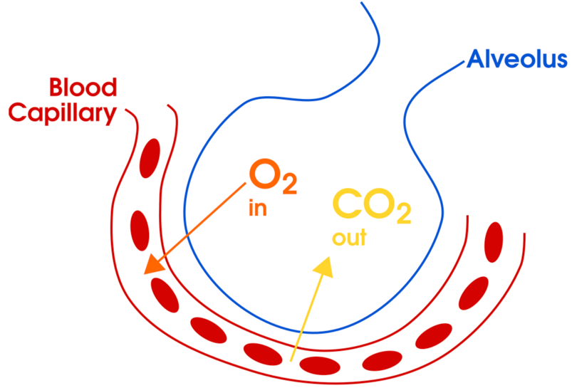
Carbon dioxide, a waste product of cellular respiration, is carried by the blood back to the lungs. In the alveoli, carbon dioxide diffuses from the blood into the alveoli. When you exhale, carbon dioxide is expelled from the body through the bronchioles, bronchi, trachea, and out through the nose or mouth.
Alveoli maximise diffusion in the lungs by:
- Giving the lungs a large surface area.
- Having a good blood supply, with surrounding capillaries that have thin walls.
- Being moist, so that gases dissolve quickly.
Collectively, this allows for efficient oxygen (O₂) intake and carbon dioxide (CO₂) removal.
domdomegg, CC BY 4.0, via Wikimedia Commons

Q1. The following statements are either true or false. State which are true and which are false.
- Carbon dioxide is a waste product of respiration.
………………………………………………………………………………………………………………………………………………………………………………………………………..
- Diffusion is the movement of particles from a low concentration to a higher concentration.
………………………………………………………………………………………………………………………………………………………………………………………………………..
- Alveoli give the lungs a small surface area.
………………………………………………………………………………………………………………………………………………………………………………………………………..
- There are small blood vessels called capillaries wrapped around each alveolus.
………………………………………………………………………………………………………………………………………………………………………………………………………..
- Blood capillaries have thick walls to protect them.
………………………………………………………………………………………………………………………………………………………………………………………………………..
- Gas exchange is necessary for providing oxygen to the body’s cells.
………………………………………………………………………………………………………………………………………………………………………………………………………..
Q2. Describe three ways the alveoli maximise diffusion in the lungs.
………………………………………………………………………………………………………………………………………………………………………………………………………..
………………………………………………………………………………………………………………………………………………………………………………………………………..
………………………………………………………………………………………………………………………………………………………………………………………………………..
………………………………………………………………………………………………………………………………………………………………………………………………………..
Q3. When you exhale, describe the route that carbon dioxide takes to be expelled from the body.
………………………………………………………………………………………………………………………………………………………………………………………………………..
………………………………………………………………………………………………………………………………………………………………………………………………………..
………………………………………………………………………………………………………………………………………………………………………………………………………..
………………………………………………………………………………………………………………………………………………………………………………………………………..
Q4. Compare the concentration of oxygen and carbon dioxide in the blood before and after it passes through the alveoli.
………………………………………………………………………………………………………………………………………………………………………………………………………..
………………………………………………………………………………………………………………………………………………………………………………………………………..
………………………………………………………………………………………………………………………………………………………………………………………………………..
………………………………………………………………………………………………………………………………………………………………………………………………………..

