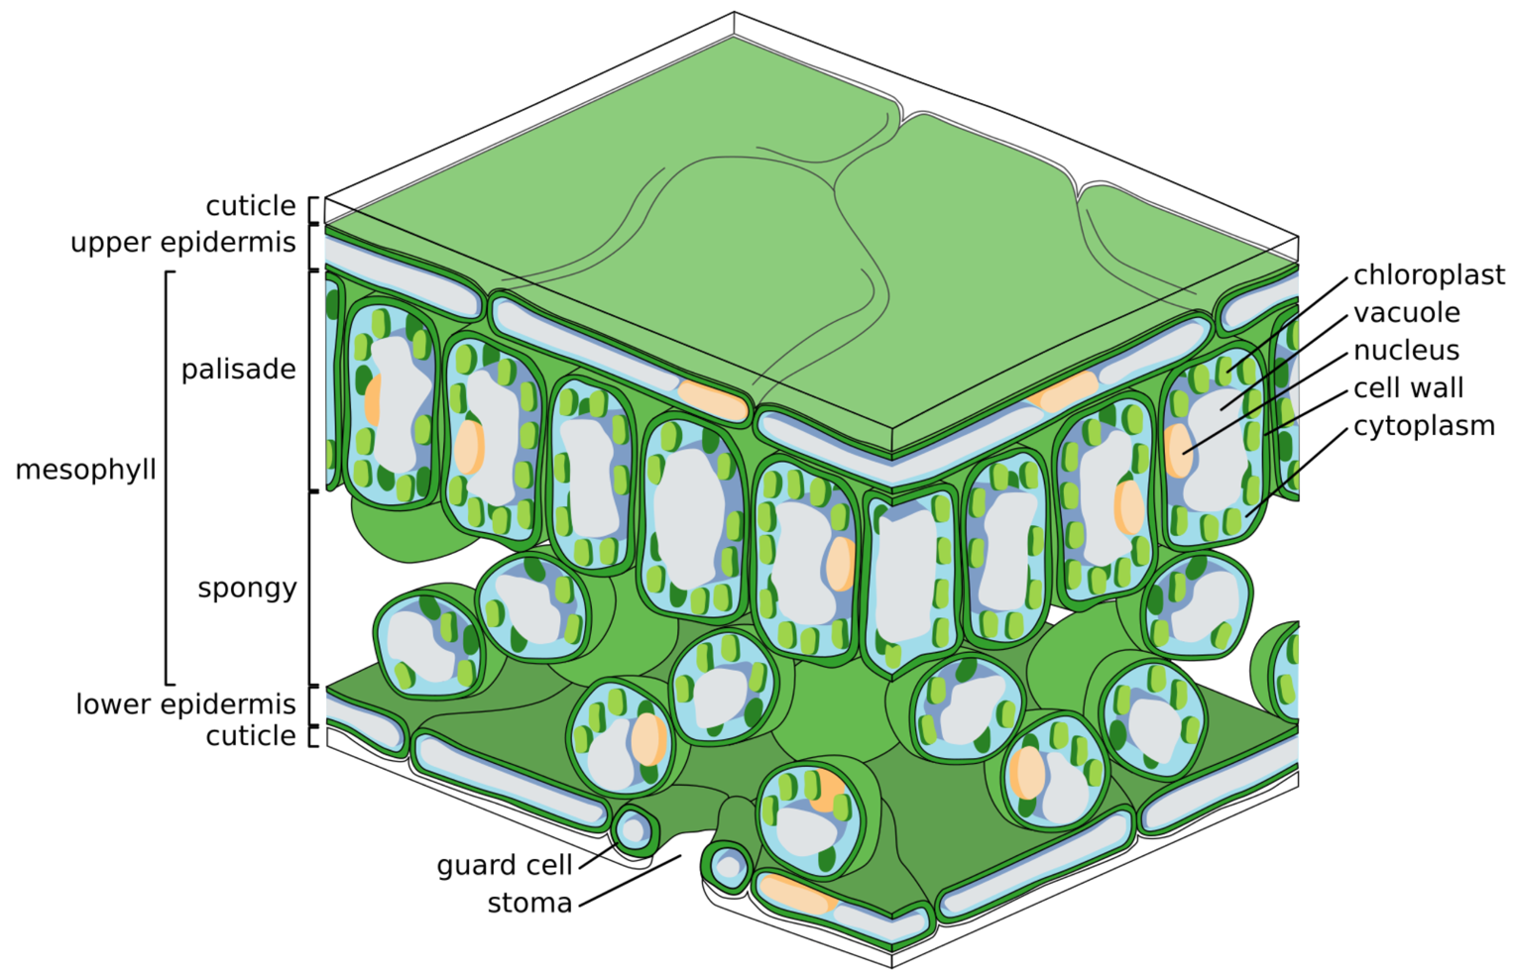
Plants, like animals, need to exchange gases with their environment to survive. Gas exchange in plants mainly involves taking in carbon dioxide and releasing oxygen during photosynthesis. It also involves taking in oxygen and releasing carbon dioxide during respiration.
Gas exchange in plants

Zephyris, CC BY-SA 3.0, via Wikimedia Commons
The leaf (cross-section shown above) is designed for gas exchange, with several key structures playing important roles:
- Stomata are small openings mainly located on the underside of leaves. Each stoma is surrounded by two guard cells that control its opening and closing. When stomata are open, carbon dioxide enters the leaf and oxygen and water vapour exit.
- Guard cells are responsible for opening and closing the stomata. When the plant has plenty of water, the guard cells swell and open the stomata to allow gas exchange. When water is scarce, they shrink and close the stomata to prevent water loss.
- The spongy mesophyll layer contains loosely arranged cells with air spaces that facilitate the movement of gases. The air spaces allow carbon dioxide to diffuse through the leaf to the palisade cells for photosynthesis.
- The palisade mesophyll layer consists of tightly packed cells that are rich in chloroplasts, the site of photosynthesis.
- The waxy cuticle is a thin, protective layer that covers the leaf surface. It prevents excessive water loss by reducing evaporation while allowing light to penetrate.
Q1. The following statements are either true or false. State which are true and which are false.
- Stomata are small openings mainly located on the upper side of leaves.
………………………………………………………………………………………………………………………………………………………………………………………………………..
- The spongy mesophyll layer is tightly packed with cells rich in chloroplasts.
………………………………………………………………………………………………………………………………………………………………………………………………………..
- Guard cells open the stomata when the plant has plenty of water.
………………………………………………………………………………………………………………………………………………………………………………………………………..
- Photosynthesis occurs in the palisade cells.
………………………………………………………………………………………………………………………………………………………………………………………………………..
- During photosynthesis, oxygen is taken in and carbon dioxide is released.
………………………………………………………………………………………………………………………………………………………………………………………………………..
- Only animals undergo respiration, plants do not respire.
………………………………………………………………………………………………………………………………………………………………………………………………………..
Q2. Describe the role that guard cells have in gas exchange in plants.
………………………………………………………………………………………………………………………………………………………………………………………………………..
………………………………………………………………………………………………………………………………………………………………………………………………………..
………………………………………………………………………………………………………………………………………………………………………………………………………..
………………………………………………………………………………………………………………………………………………………………………………………………………..
Q3. Describe the function of the spongy mesophyll layer in a leaf.
………………………………………………………………………………………………………………………………………………………………………………………………………..
………………………………………………………………………………………………………………………………………………………………………………………………………..
………………………………………………………………………………………………………………………………………………………………………………………………………..
………………………………………………………………………………………………………………………………………………………………………………………………………..
Q4. Describe how the structure of the palisade mesophyll layer is suited for photosynthesis.
………………………………………………………………………………………………………………………………………………………………………………………………………..
………………………………………………………………………………………………………………………………………………………………………………………………………..
Q5. Describe the role of the waxy cuticle.
………………………………………………………………………………………………………………………………………………………………………………………………………..
………………………………………………………………………………………………………………………………………………………………………………………………………..

