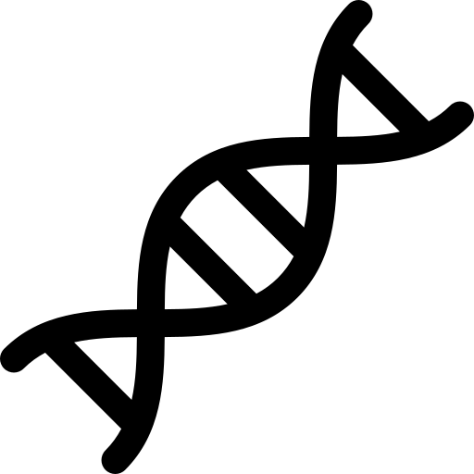
Genetics and
Name ______________________________
Class ______________________________
Teacher ______________________________

evolution

When we look at living things, from the smallest bacteria to the largest animals, we can see that they all have characteristics that make them unique. These characteristics (like eye colour or height) are passed down from one generation to the next. This passing on of traits is known as inheritance. To understand inheritance, we need to learn about chromosomes, DNA and genes:
DNA and inheritance
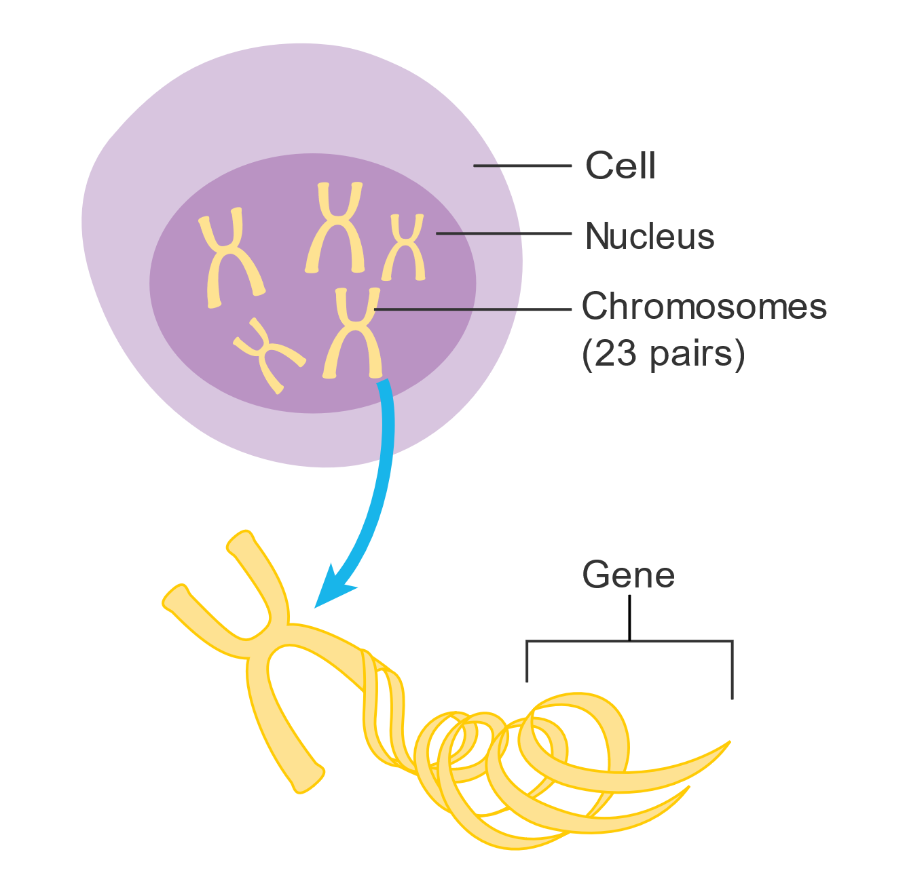
- Chromosomes are thread-like structures found in the nucleus of every cell. Humans have 46 chromosomes, arranged in 23 pairs. You inherit one chromosome from each pair from your mother and the other from your father. This is why you have some characteristics from your mother and some from your father.
- DNA (deoxyribonucleic acid) is the molecule that makes up chromosomes. DNA carries the genetic instructions that tell your cells how to function and determine your traits.
- Genes are specific segments of DNA that carry the instructions for a specific characteristic. For example, one gene might carry the instructions for your eye colour while another might determine your blood type.
Cancer Research UK, CC BY-SA 4.0, via Wikimedia Commons

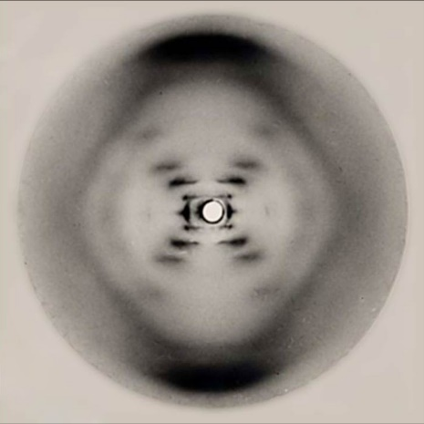
Humans have thousands of genes, and they all work together to determine your physical traits and even some aspects of your personality. Some genes are dominant, meaning that if you inherit the dominant version of a gene from one parent, that trait is more likely to show up in you. Other genes are recessive, meaning that the trait will only appear if you inherit the recessive version from both parents.
In the 1950s, James Watson and Francis Crick were working to uncover the structure of DNA. They were able to build on the work of Rosalind Franklin and Maurice Wilkins, who used X-ray crystallography to take images of DNA. Raymond Gosling, a student working under Franklin and Wilkins, produced the famous “Photo 51” which provided crucial clues that helped Watson and Crick determine that DNA has a double-helix structure, which looks like a twisted ladder. Photo 51 is shown in the image to the left.
By Raymond Gosling/King's College London - http://www-project.slac.stanford.edu/wis/images/photo_51.jpg, Public Domain

Q1. The following statements are either true or false. State which are true and which are false.
- DNA is short for deoxyribonucleic acid.
………………………………………………………………………………………………………………………………………………………………………………………………………..
- Humans have 46 chromosomes, arranged in 23 pairs.
………………………………………………………………………………………………………………………………………………………………………………………………………..
- DNA has a double helix structure.
………………………………………………………………………………………………………………………………………………………………………………………………………..
- DNA is made of chromosomes.
………………………………………………………………………………………………………………………………………………………………………………………………………..
- If you inherit a recessive version of a gene from one parent, that trait is more likely to show up in you.
………………………………………………………………………………………………………………………………………………………………………………………………………..
Q2. Describe what is meant by inheritance.
………………………………………………………………………………………………………………………………………………………………………………………………………..
………………………………………………………………………………………………………………………………………………………………………………………………………..
Q3. Describe what chromosomes are and where there are usually found.
………………………………………………………………………………………………………………………………………………………………………………………………………..
………………………………………………………………………………………………………………………………………………………………………………………………………..
………………………………………………………………………………………………………………………………………………………………………………………………………..
Q4. Describe what DNA is.
………………………………………………………………………………………………………………………………………………………………………………………………………..
………………………………………………………………………………………………………………………………………………………………………………………………………..
………………………………………………………………………………………………………………………………………………………………………………………………………..
Q5. Describe what genes are.
………………………………………………………………………………………………………………………………………………………………………………………………………..
………………………………………………………………………………………………………………………………………………………………………………………………………..
………………………………………………………………………………………………………………………………………………………………………………………………………..
Q6. Describe the history of how the structure of DNA was discovered.
………………………………………………………………………………………………………………………………………………………………………………………………………..
………………………………………………………………………………………………………………………………………………………………………………………………………..
………………………………………………………………………………………………………………………………………………………………………………………………………..
………………………………………………………………………………………………………………………………………………………………………………………………………..

When we observe the natural world, we notice that living things are diverse and have a wide range of shapes, sizes and colours. This diversity is referred to as variation. Variation can be seen between different species as well as within the same species.
Variation
Different species have different sets of genes, which lead to the different characteristics we see between them. For example, the genes in a bird are different from those in a fish. This leads to traits like feathers and the ability to fly in birds, and scales and the ability to swim in fish.
Variation also exists within a species. This means that even though individuals of the same species share many of the same genes, there are still differences between them. For example, all humans share the same basic set of genes that make us human but each person has a unique combination of these genes that results in differences like eye colour, height and hair type. This variation within a species is what makes each individual unique.
Variation within a species can be classified as continuous or discontinuous:
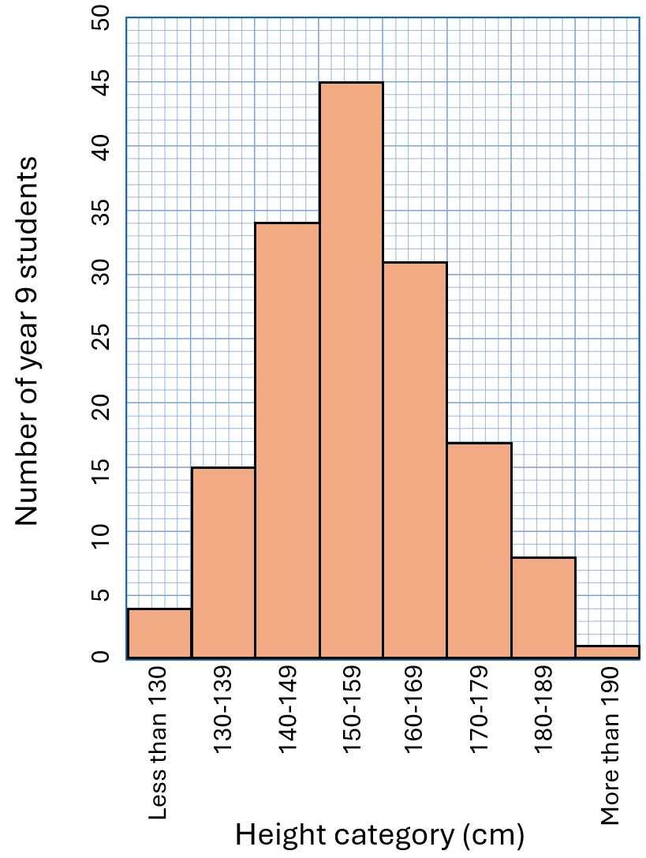
- Continuous variation shows a range of differences that gradually change, with no clear divisions between them. For example, human height is a continuous variation. People can be any height within a range, and there are no fixed categories. Continuous variation is often represented using a histogram. For example, the histogram to the right shows the distribution of the heights of 155 year 9 students.
- Discontinuous variation is characterised by distinct categories with no intermediate forms. For example, blood type in humans is a discontinuous variation. You can have type A, B, AB, or O, but there are no in-between types. Discontinuous variation is usually controlled by a small number of genes and is represented using a bar chart.

Q1. The following statements are either true or false. State which are true and which are false.
- Variation refers only to differences between different species.
………………………………………………………………………………………………………………………………………………………………………………………………………..
- Continuous variation shows a range of differences that gradually change.
………………………………………………………………………………………………………………………………………………………………………………………………………..
- Blood type is an example of continuous variation.
………………………………………………………………………………………………………………………………………………………………………………………………………..
Q2. The table below shows the distribution of heights of 150 year 8 students.
- State whether height is a continuous or discontinuous variable.
………………………………………………………………………………………………………………………………………………………………………………………………………..
- Plot a histogram using the data in the table.
Height category (cm) | Number of year 8 students
Less than 130 | 12
130-139 | 21
140-149 | 46
150-159 | 35
160-169 | 17
170-179 | 13
180-189 | 5
More than 180 | 0
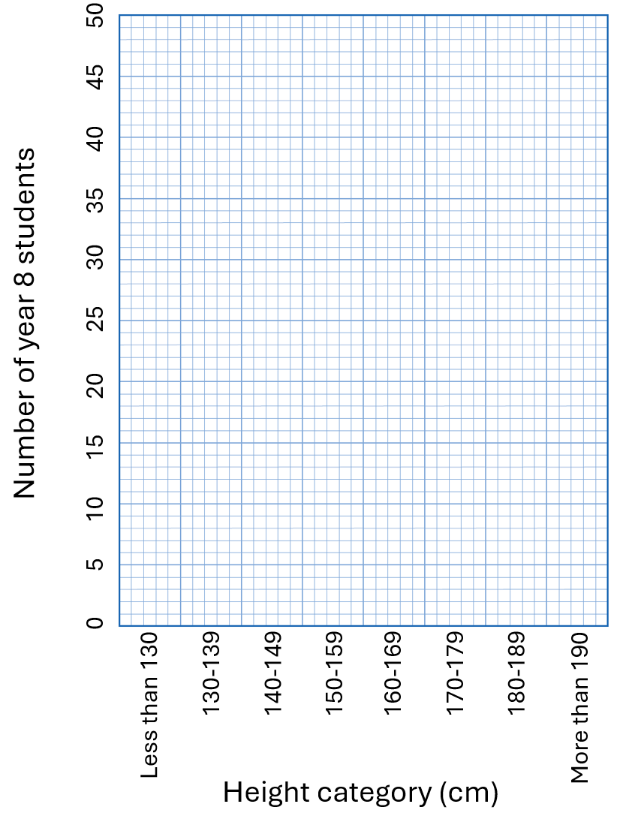

Natural selection is a process that explains how species change over time. In any group of organisms, there is always variation. Variation means that not all individuals are exactly the same. Some are taller, faster or stronger, while others might be smaller, slower or weaker. This variation is due to differences in their genes, which they inherit from their parents.
Natural selection
Because resources like food, water, and shelter are limited, not all individuals in a species can survive. This leads to competition. Organisms that have traits that give them an advantage in their environment are more likely to survive. The longer they survive, the more likely it is that they reproduce and pass on their genes. For example, in a population of rabbits, some might have thicker fur, which helps them survive in cold climates. Those with thicker fur are more likely to live longer, find mates and have offspring.
This idea, often summarised as "survival of the fittest", means that the individuals best suited to their environment are the ones most likely to survive. However, "fittest" doesn’t necessarily mean the strongest or the fastest. It means the individuals whose traits are best matched to their environment.
For example, in a forest where the ground is covered with brown leaves, brown beetles might be less likely to be seen and eaten by predators than green beetles. As a result, the brown beetles are more likely to survive and reproduce, passing on their brown colour to their offspring. Over many generations, the population of beetles might become mostly brown.
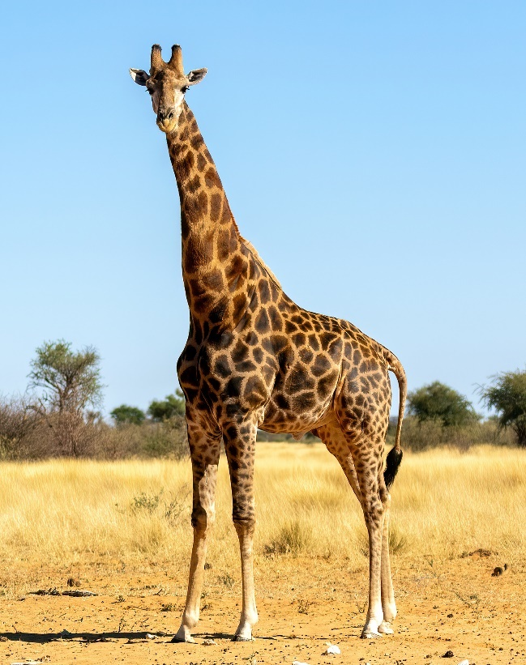
Natural selection can lead to significant changes in a species over time. If a certain trait helps an organism survive, that trait becomes more common in the population. Over many generations, these changes can add up, leading to the development of new species.
Another example of natural selection is the giraffe. Giraffes are known for their long necks, which allow them to reach leaves high up in trees. Originally, giraffes had shorter necks, but in times of food scarcity, those with slightly longer necks were able to reach leaves that others couldn’t. This gave them an advantage, as they were more likely to survive and reproduce. Over many generations, this led to the population of giraffes having longer and longer necks, which we see in giraffes today.
AfricanConservation, CC BY-SA 4.0, via Wikimedia Commons

Q1. The following statements are either true or false. State which are true and which are false.
- All individuals within the same species are exactly the same.
………………………………………………………………………………………………………………………………………………………………………………………………………..
- Individuals that survive for longer are more likely to reproduce.
………………………………………………………………………………………………………………………………………………………………………………………………………..
Q2. Describe what is meant by “survival of the fittest”.
………………………………………………………………………………………………………………………………………………………………………………………………………..
………………………………………………………………………………………………………………………………………………………………………………………………………..
Q3. Describe how variation within a species can lead to competition.
………………………………………………………………………………………………………………………………………………………………………………………………………..
………………………………………………………………………………………………………………………………………………………………………………………………………..
………………………………………………………………………………………………………………………………………………………………………………………………………..
………………………………………………………………………………………………………………………………………………………………………………………………………..
Q4. Describe how giraffes evolved to have such long necks.
………………………………………………………………………………………………………………………………………………………………………………………………………..
………………………………………………………………………………………………………………………………………………………………………………………………………..
………………………………………………………………………………………………………………………………………………………………………………………………………..
………………………………………………………………………………………………………………………………………………………………………………………………………..
Q5. Describe why brown beetles might survive longer in a forest compared to green beetles.
………………………………………………………………………………………………………………………………………………………………………………………………………..
………………………………………………………………………………………………………………………………………………………………………………………………………..
………………………………………………………………………………………………………………………………………………………………………………………………………..
………………………………………………………………………………………………………………………………………………………………………………………………………..
Q6. In a population of birds, some have longer beaks and some have shorter beaks. The environment changes so that food is only available in deep crevices. State which birds are more likely to survive and explain why.
………………………………………………………………………………………………………………………………………………………………………………………………………..
………………………………………………………………………………………………………………………………………………………………………………………………………..
………………………………………………………………………………………………………………………………………………………………………………………………………..
………………………………………………………………………………………………………………………………………………………………………………………………………..

Extinction is the process where a species completely disappears from the Earth. This can happen when the environment changes in ways that make it difficult for certain species to survive. If a species can't adapt quickly enough to these changes, they may struggle to compete for resources like food and water. When this happens, fewer individuals survive to reproduce, and over time, the entire species can become extinct.
Extinction
There are many ways the environment can change, leading to extinction. For example:
- Climate change. If the climate becomes too hot, too cold, too dry or too wet, some species might not be able to survive in the new conditions.
- Habitat loss. When forests are cut down or wetlands are drained, the animals and plants that lived there may have nowhere to go.
- Pollution. Chemicals released into the air, water and soil can harm or kill species that are sensitive to these pollutants.
- Introduction of new species. Sometimes, new species are introduced to an environment where they have no natural predators. These new species can outcompete native species for resources, leading to the extinction of the native species.
Biodiversity refers to the variety of all living things on Earth, including plants, animals and microorganisms. High biodiversity means that there are many different species living in an ecosystem. Maintaining biodiversity is important for several reasons:
- Ecosystem stability. Different species often depend on each other. If one species goes extinct, it can affect many other species in the ecosystem.
- Resources. Many of the resources we rely on, such as food, medicine and clean water, come from biodiversity. Losing species can reduce the availability of these resources.
- Resilience to change. Ecosystems with high biodiversity are often more resilient to changes, such as climate change, because they have more species that can fill different roles if some species are lost.
One way to help prevent the loss of species and maintain biodiversity is by using gene banks. Gene banks are places where genetic material (like seeds, sperm, eggs or embryos) is stored. This genetic material can be used to help protect endangered species or bring back species that have become extinct. Gene banks are important for several reasons:
- Preservation and research. By storing genetic material, scientists can preserve and study the genetic material in gene banks to learn more about how to protect endangered species.
- Restoration. In some cases, gene banks can be used to reintroduce species into the wild by breeding new individuals from the stored genetic material.
Q1. The following statements are either true or false. State which are true and which are false.
- Ecosystems with a high biodiversity are often less resistant to change.
………………………………………………………………………………………………………………………………………………………………………………………………………..
- If one species in an ecosystem goes extinct, it won’t affect any other species.
………………………………………………………………………………………………………………………………………………………………………………………………………..
- One way to help prevent extinction is to use gene banks.
………………………………………………………………………………………………………………………………………………………………………………………………………..
Q2. State four ways the environment can change, leading to extinction.
………………………………………………………………………………………………………………………………………………………………………………………………………..
………………………………………………………………………………………………………………………………………………………………………………………………………..
Q3. Describe what is meant by biodiversity.
………………………………………………………………………………………………………………………………………………………………………………………………………..
………………………………………………………………………………………………………………………………………………………………………………………………………..
Q4. Describe why maintaining biodiversity is important.
………………………………………………………………………………………………………………………………………………………………………………………………………..
………………………………………………………………………………………………………………………………………………………………………………………………………..
………………………………………………………………………………………………………………………………………………………………………………………………………..
………………………………………………………………………………………………………………………………………………………………………………………………………..
Q5. Describe what a gene bank is.
………………………………………………………………………………………………………………………………………………………………………………………………………..
………………………………………………………………………………………………………………………………………………………………………………………………………..
Q6. Explain how gene banks help in preserving species.
………………………………………………………………………………………………………………………………………………………………………………………………………..
………………………………………………………………………………………………………………………………………………………………………………………………………..
………………………………………………………………………………………………………………………………………………………………………………………………………..
………………………………………………………………………………………………………………………………………………………………………………………………………..
Q7. Explain how habitat loss can lead to extinction.
………………………………………………………………………………………………………………………………………………………………………………………………………..
………………………………………………………………………………………………………………………………………………………………………………………………………..

