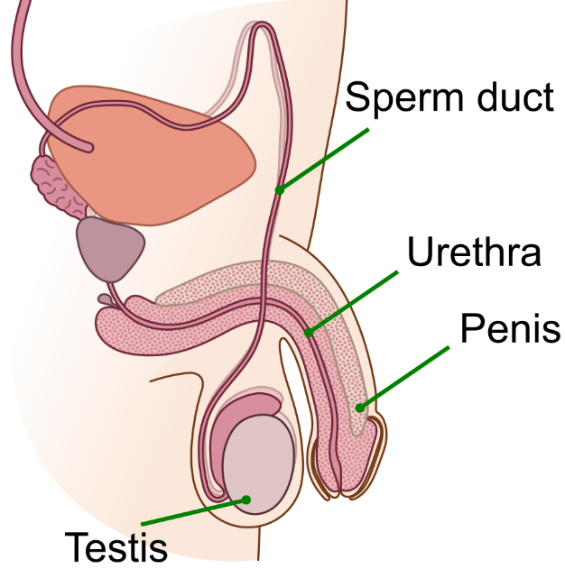
To reproduce, both males and females have specialised organs that work together. The main organs of the male reproductive system are the testes, penis and sperm ducts.
Human reproductive system
The testes (singular testis) are two oval-shaped organs that produce sperm, the male reproductive cells. The testes also produce the hormone testosterone.
Sperm is carried from the testes to the urethra (the tube that runs through the penis) through sperm ducts. Along the way, sperm mixes with fluids from glands to form semen.
The penis is the organ that delivers sperm into the female reproductive system. During sexual intercourse, the penis becomes erect, allowing for the transfer of semen.
Adapted from T. Kebert, CC BY-SA 4.0, via Wikimedia Commons

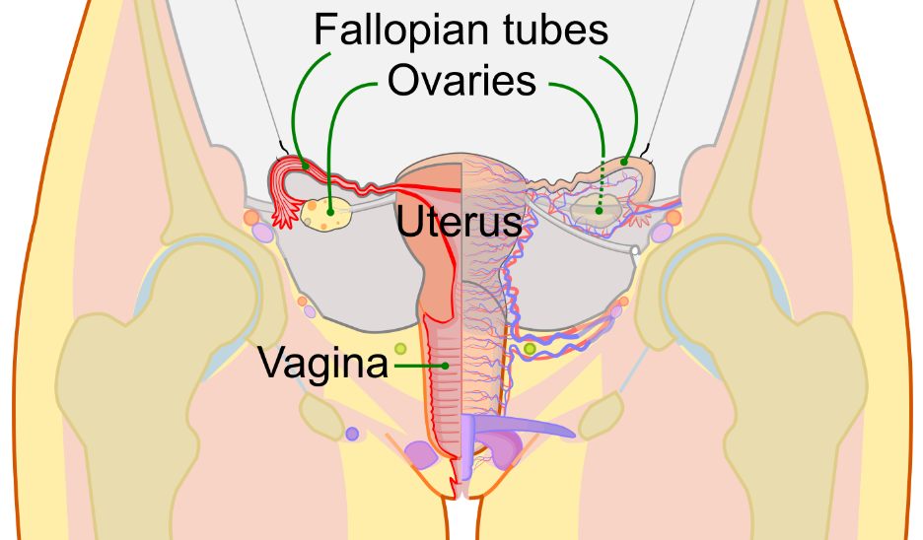
The main organs of the female reproductive system are the ovaries, fallopian tubes, uterus, and vagina.
The ovaries are located on either side of the uterus. They produce egg cells (ova) and release them during the menstrual cycle. The ovaries also produce the hormones oestrogen and progesterone, which regulate the menstrual cycle.
Adapted from CDC, Mysid, Public domain, via Wikimedia Commons
When an egg is released from the ovary, it travels through the fallopian tube toward the uterus. Fertilisation, which takes place when a sperm cell joins with an egg cell, usually occurs in the fallopian tube. The fertilised egg then implants and develops into a baby in the uterus (also known as the womb). The lining of the uterus thickens each month in preparation for a possible pregnancy.
The vagina connects the uterus to the outside of the body. It is the passage through which sperm enters the female reproductive system and also serves as the birth canal during childbirth.
Q1. The following statements are either true or false. State which are true and which are false.
- The testes produce sperm and testosterone.
………………………………………………………………………………………………………………………………………………………………………………………………………..
- The fallopian tubes connect the ovaries to the uterus.
………………………………………………………………………………………………………………………………………………………………………………………………………..
- Fertilisation usually occurs in the vagina.
………………………………………………………………………………………………………………………………………………………………………………………………………..
- Sperm is carried from the testes to the urethra through the fallopian tubes.
………………………………………………………………………………………………………………………………………………………………………………………………………..
- Ovaries produce egg cells.
………………………………………………………………………………………………………………………………………………………………………………………………………..
Q2. State the name of three organs that the male reproductive system consists of.
………………………………………………………………………………………………………………………………………………………………………………………………………..
Q3. State the name of four organs that the female reproductive system consists of.
………………………………………………………………………………………………………………………………………………………………………………………………………..
Q4. Describe the function of the uterus in the female reproductive system.
………………………………………………………………………………………………………………………………………………………………………………………………………..
………………………………………………………………………………………………………………………………………………………………………………………………………..
………………………………………………………………………………………………………………………………………………………………………………………………………..
Q5. Describe the function of the penis in the male reproductive system.
………………………………………………………………………………………………………………………………………………………………………………………………………..
………………………………………………………………………………………………………………………………………………………………………………………………………..
………………………………………………………………………………………………………………………………………………………………………………………………………..
Q6. Describe the function of the ovaries in the female reproductive system.
………………………………………………………………………………………………………………………………………………………………………………………………………..
………………………………………………………………………………………………………………………………………………………………………………………………………..
………………………………………………………………………………………………………………………………………………………………………………………………………..
Q7. Describe the function of the vagina in the female reproductive system.
………………………………………………………………………………………………………………………………………………………………………………………………………..
………………………………………………………………………………………………………………………………………………………………………………………………………..
………………………………………………………………………………………………………………………………………………………………………………………………………..

