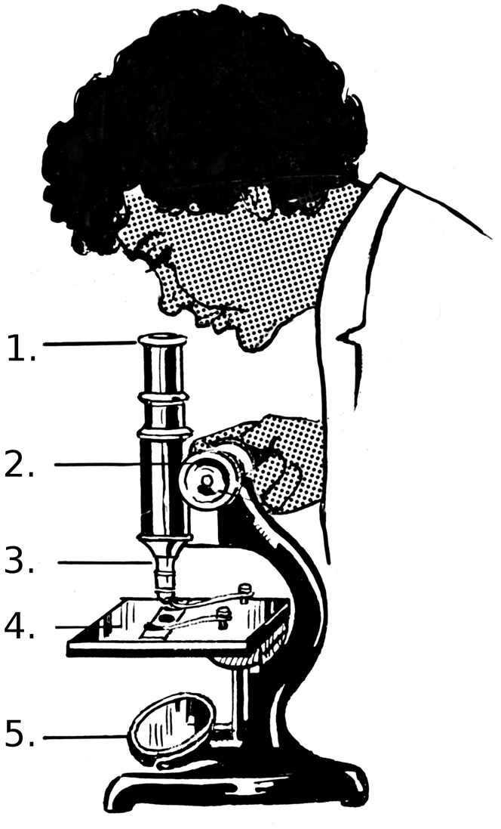
A light microscope is a tool that scientists use to see tiny things that are too small to be seen with the naked eye. Light microscopes use visible light and lenses to magnify objects, allowing us to see details of cells and other small structures.
Light microscopes
The diagram to the right shows a light microscope. Typical parts include:
- Eyepiece lens. This is the lens that you look through at the top of the microscope.
- Focus adjuster. Used to move the stage up and down to bring the object into focus. Microscopes usually have two adjustment controls – coarse and fine. Generally, the fine adjustment is used to sharpen the focus after using the coarse adjustment. This provides a clear and detailed view.
- Objective lens. These lenses magnify the object. Commonly, microscopes have a rotating nosepiece which allows different lenses to be selected for varying levels of magnification.
- Stage. The flat platform where you place the slides. Clips hold the slides in place.
- Mirror or light source. A lamp or mirror that shines light through the object being viewed, making it easier to see details.
Pearson Scott Foresman, Public domain, via Wikimedia Commons
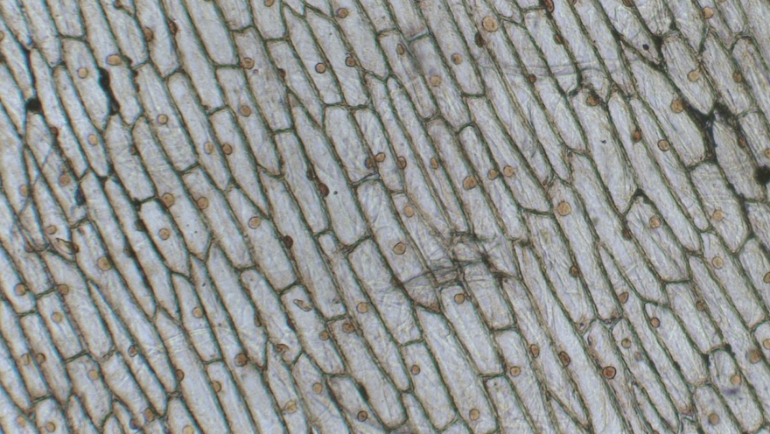
A common practical that you can do in the classroom is to view onion cells (shown left). To prepare a microscope slide, you would cut an onion and peel off a thin layer (called the epidermis). This thin layer should then be carefully placed onto the slide. To view the cells better, add a drop of iodine to the onion and then gently place a coverslip over the onion. The slide is then placed onto the stage and secured with the stage clips.
Berkshire Community College Bioscience Image Library, CC0, via Wikimedia Commons
Q1. The following statements are either true or false. State which are true and which are false.
- Light microscopes are used to magnify objects.
……………………………………………………………………………………………………..
- The objective lens is the lens that we look through.
……………………………………………………………………………………………………..
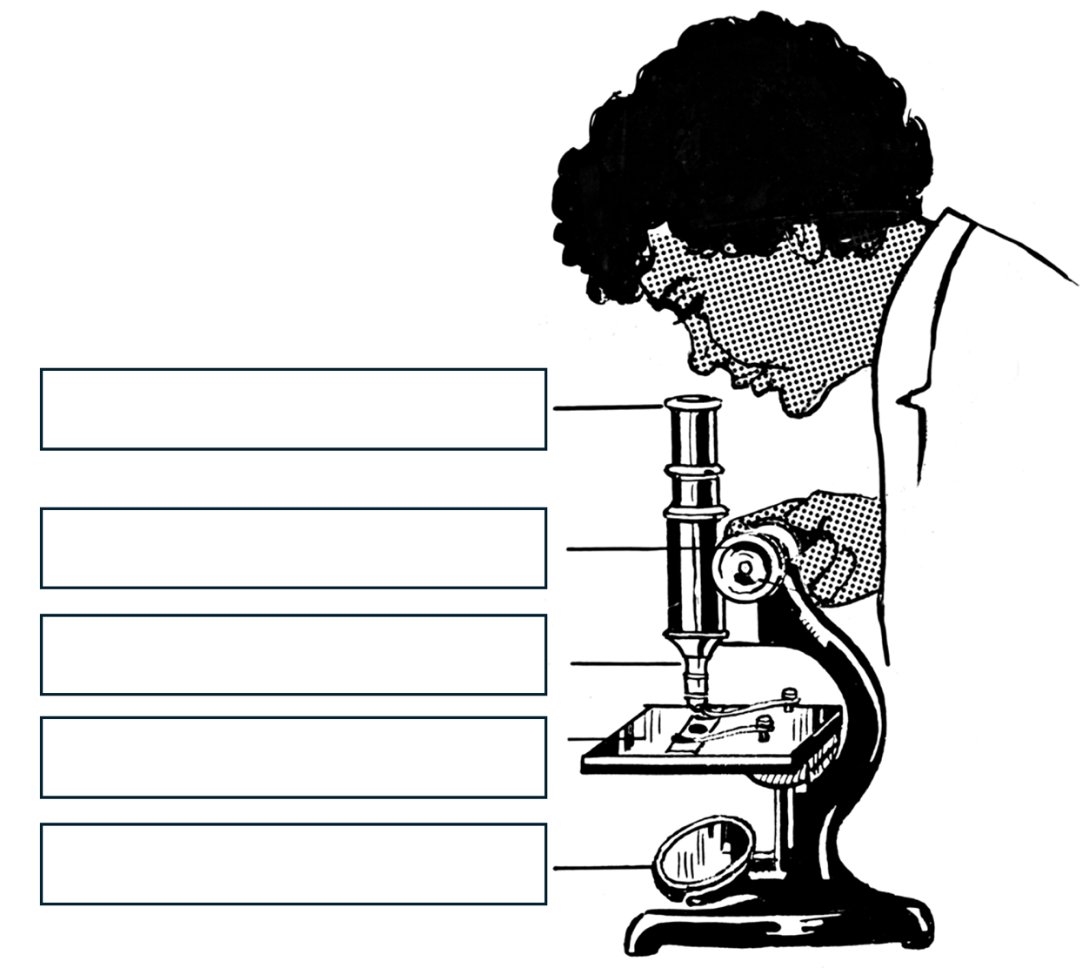
- Clips are used to hold microscope slides onto the stage.
……………………………………………………………………………………………………..
- The focus adjuster usually has coarse and a fine adjustment.
……………………………………………………………………………………………………..
Q2. Label the diagram of the light microscope.

Pearson Scott Foresman, Public domain, via Wikimedia Commons
Q3. Describe the purpose of the mirror on a light microscope.
………………………………………………………………………………………………………………………………………………………………………………………………………..
………………………………………………………………………………………………………………………………………………………………………………………………………..
Q4. Describe how you would use the focus adjuster to bring an object into focus.
………………………………………………………………………………………………………………………………………………………………………………………………………..
………………………………………………………………………………………………………………………………………………………………………………………………………..
Q5. Describe how you would prepare a slide to view onion cells.
………………………………………………………………………………………………………………………………………………………………………………………………………..
………………………………………………………………………………………………………………………………………………………………………………………………………..
………………………………………………………………………………………………………………………………………………………………………………………………………..
………………………………………………………………………………………………………………………………………………………………………………………………………..

