A moment is the turning effect of a force around a point. When a muscle pulls on a bone, it creates a moment around the joint (which is the point where two bones meet). The size of this moment depends on two things: the amount of force the muscle generates and the distance from the joint to where the force is applied.
Measuring forces exerted by muscles
We can calculate a moment using the following equation:
Moment = force × distance
where the distance (measured in metres) is the perpendicular distance to the pivot. Forces are measured in Newtons (N) and moments are therefore measured in Newton metres (Nm).
To calculate the force applied by a muscle, we need to rearrange to make force the subject of the equation. This rearranged equation is:
Force = moment ÷ distance
To directly measure the size of a force applied by a muscle, we could use a Newton meter.
Example question 1:
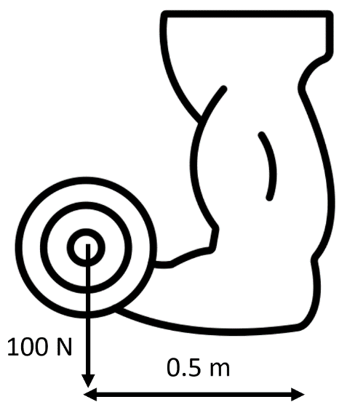
A person is doing a biceps curl and is holding a 100 N weight stationary. The distance from the centre of the weight to the person’s elbow is 0.5 m.
Calculate the moment of the weight from the person’s elbow.
Step 1. Write down equation:
Moment = force × distance
Step 2. Insert variables into equation:
Moment = 100 × 0.5
Step 3. Calculate answer. Remember units:
Moment = 50 Nm
Note that in the question above, the force applied by the person’s biceps is the same size as the 100 N weight. This is because if the weight is stationary, then the forces on the weight must be balanced. The person must therefore be applying a 100 N force upwards to hold the weight still.

Q1. The following statements are either true or false. State which are true and which are false.
- A moment is measured by a Newton meter.
………………………………………………………………………………………………………………………………………………………………………………………………………..
- A moment depends on both force and perpendicular distance to a pivot.
………………………………………………………………………………………………………………………………………………………………………………………………………..
- Muscles create a moment around a joint.
………………………………………………………………………………………………………………………………………………………………………………………………………..
Q2. Using the diagrams below, calculate the moments of the weight from the person’s elbow.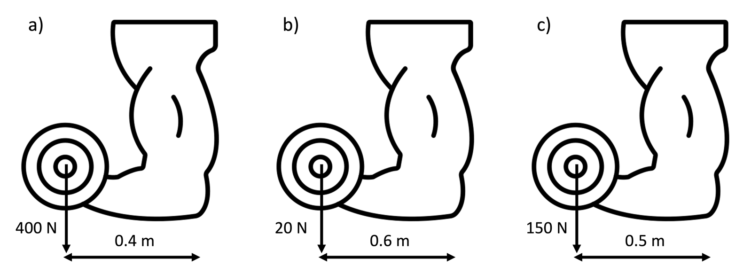
- …………………………………………………………………………………………………………………………………………………………………………………………

- …………………………………………………………………………………………………………………………………………………………………………………………

- …………………………………………………………………………………………………………………………………………………………………………………………
Q3. A person’s hamstring applies a moment of 1200 Nm at a distance of 0.6m from their knee. Calculate the force applied by the hamstring.
………………………………………………………………………………………………………………………………………………………………………………………………………..
………………………………………………………………………………………………………………………………………………………………………………………………………..
Q4. A person’s biceps applies a moment of 120 Nm at a distance of 0.5m from their elbow. Calculate the force applied by the biceps.
………………………………………………………………………………………………………………………………………………………………………………………………………..
………………………………………………………………………………………………………………………………………………………………………………………………………..
Q5. A person’s triceps applies a moment of 60 Nm at a distance of 0.4m from their elbow. Calculate the force applied by the triceps.
………………………………………………………………………………………………………………………………………………………………………………………………………..
………………………………………………………………………………………………………………………………………………………………………………………………………..

