Natural selection is a process that explains how species change over time. In any group of organisms, there is always variation. Variation means that not all individuals are exactly the same. Some are taller, faster or stronger, while others might be smaller, slower or weaker. This variation is due to differences in their genes, which they inherit from their parents.
Natural selection
Because resources like food, water, and shelter are limited, not all individuals in a species can survive. This leads to competition. Organisms that have traits that give them an advantage in their environment are more likely to survive. The longer they survive, the more likely it is that they reproduce and pass on their genes. For example, in a population of rabbits, some might have thicker fur, which helps them survive in cold climates. Those with thicker fur are more likely to live longer, find mates and have offspring.
This idea, often summarised as "survival of the fittest", means that the individuals best suited to their environment are the ones most likely to survive. However, "fittest" doesn’t necessarily mean the strongest or the fastest. It means the individuals whose traits are best matched to their environment.
For example, in a forest where the ground is covered with brown leaves, brown beetles might be less likely to be seen and eaten by predators than green beetles. As a result, the brown beetles are more likely to survive and reproduce, passing on their brown colour to their offspring. Over many generations, the population of beetles might become mostly brown.
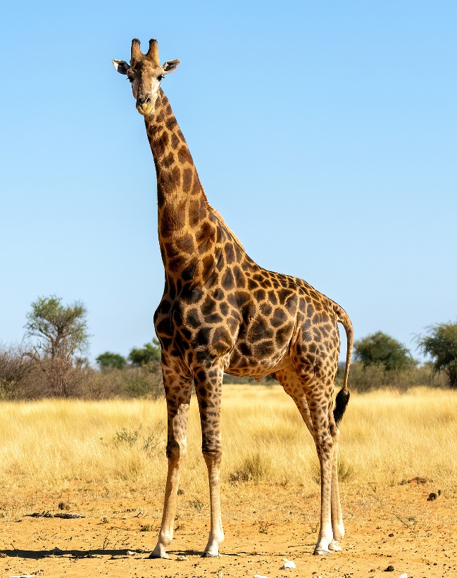
Natural selection can lead to significant changes in a species over time. If a certain trait helps an organism survive, that trait becomes more common in the population. Over many generations, these changes can add up, leading to the development of new species.
Another example of natural selection is the giraffe. Giraffes are known for their long necks, which allow them to reach leaves high up in trees. Originally, giraffes had shorter necks, but in times of food scarcity, those with slightly longer necks were able to reach leaves that others couldn’t. This gave them an advantage, as they were more likely to survive and reproduce. Over many generations, this led to the population of giraffes having longer and longer necks, which we see in giraffes today.
AfricanConservation, CC BY-SA 4.0, via Wikimedia Commons

Q1. The following statements are either true or false. State which are true and which are false.
- All individuals within the same species are exactly the same.
………………………………………………………………………………………………………………………………………………………………………………………………………..
- Individuals that survive for longer are more likely to reproduce.
………………………………………………………………………………………………………………………………………………………………………………………………………..
Q2. Describe what is meant by “survival of the fittest”.
………………………………………………………………………………………………………………………………………………………………………………………………………..
………………………………………………………………………………………………………………………………………………………………………………………………………..
Q3. Describe how variation within a species can lead to competition.
………………………………………………………………………………………………………………………………………………………………………………………………………..
………………………………………………………………………………………………………………………………………………………………………………………………………..
………………………………………………………………………………………………………………………………………………………………………………………………………..
………………………………………………………………………………………………………………………………………………………………………………………………………..
Q4. Describe how giraffes evolved to have such long necks.
………………………………………………………………………………………………………………………………………………………………………………………………………..
………………………………………………………………………………………………………………………………………………………………………………………………………..
………………………………………………………………………………………………………………………………………………………………………………………………………..
………………………………………………………………………………………………………………………………………………………………………………………………………..
Q5. Describe why brown beetles might survive longer in a forest compared to green beetles.
………………………………………………………………………………………………………………………………………………………………………………………………………..
………………………………………………………………………………………………………………………………………………………………………………………………………..
………………………………………………………………………………………………………………………………………………………………………………………………………..
………………………………………………………………………………………………………………………………………………………………………………………………………..
Q6. In a population of birds, some have longer beaks and some have shorter beaks. The environment changes so that food is only available in deep crevices. State which birds are more likely to survive and explain why.
………………………………………………………………………………………………………………………………………………………………………………………………………..
………………………………………………………………………………………………………………………………………………………………………………………………………..
………………………………………………………………………………………………………………………………………………………………………………………………………..
………………………………………………………………………………………………………………………………………………………………………………………………………..

