Photosynthesis is a chemical reaction that produces glucose (a type of sugar). This glucose can then be used for respiration, the process where cells release energy from glucose. During photosynthesis, plants use sunlight to turn carbon dioxide and water into glucose and oxygen. The chemical equation for photosynthesis is:
Photosynthesis
carbon dioxide + water → glucose + oxygen
Photosynthesis occurs in chloroplasts, which contain the green pigment chlorophyll. Chloroplasts are an organelle that are particularly found in a leaf’s palisade cells. These cells are found near the top of a leaf, where they get the most light. Leaves are also well adapted for photosynthesis as they have a large surface area.
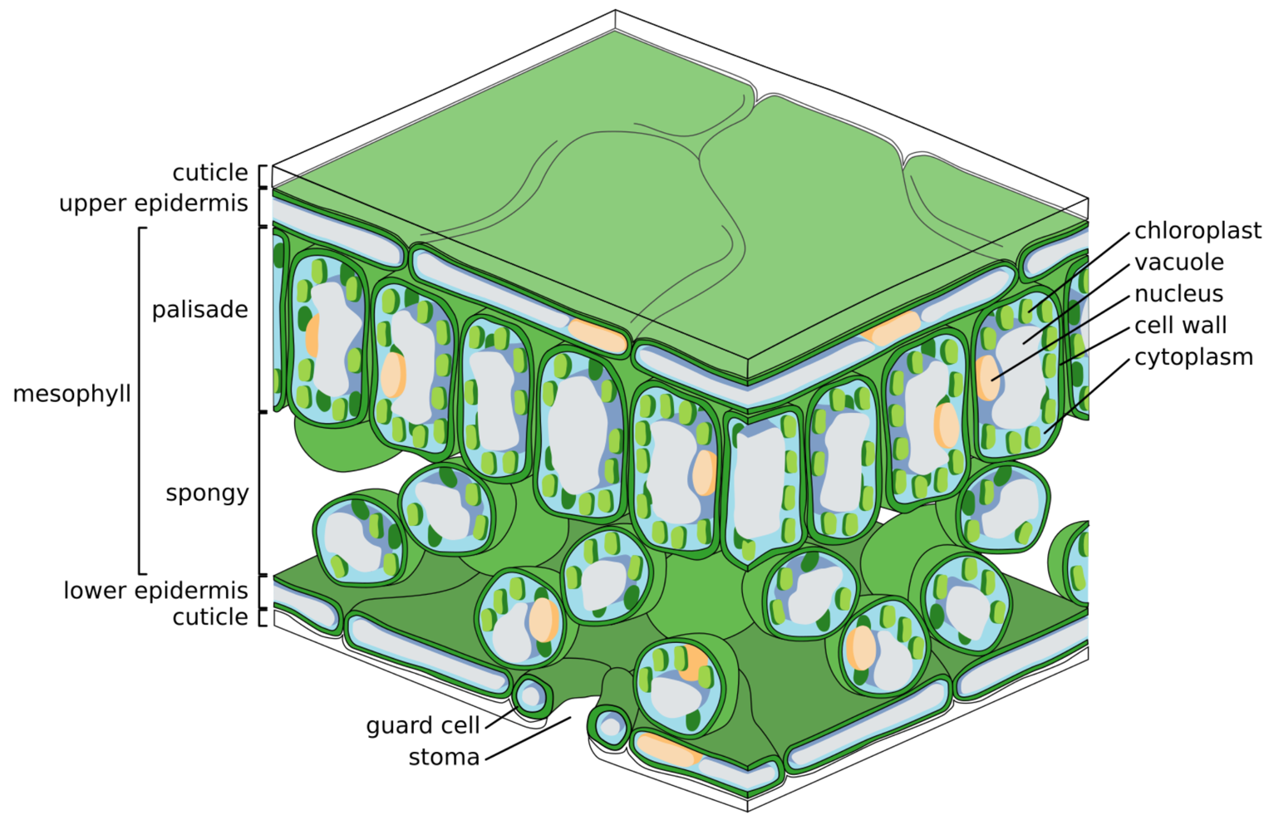
Carbon dioxide enters the underside of a leaf through stomata. The spongy mesophyll layer contains loosely arranged cells with air spaces that allow for the movement of gases. The air spaces allow carbon dioxide to diffuse through the leaf to the palisade cells for photosynthesis.

Zephyris, CC BY-SA 3.0, via Wikimedia Commons
The rate of photosynthesis is affected by light intensity, carbon dioxide concentration, temperature, and water availability. To measure this rate, you can conduct an experiment using pondweed in water. Cover the pondweed with an inverted funnel and place a water-filled test tube over it to capture the oxygen produced. A lamp can be used to provide a steady light source. By counting the oxygen bubbles released in one minute, you can estimate the rate of photosynthesis. By adjusting variables like light intensity or temperature, you can observe how these factors affect photosynthesis.
Q1. The following statements are either true or false. State which are true and which are false.
- Photosynthesis is a chemical reaction.
………………………………………………………………………………………………………………………………………………………………………………………………………..
- Plants do not carry out respiration.
………………………………………………………………………………………………………………………………………………………………………………………………………..
- Photosynthesis occurs in chloroplasts.
………………………………………………………………………………………………………………………………………………………………………………………………………..
- Palisade cells contain many chloroplasts.
………………………………………………………………………………………………………………………………………………………………………………………………………..
Q2. State the products of photosynthesis.
………………………………………………………………………………………………………………………………………………………………………………………………………..
Q3. Write a word equation for photosynthesis.
………………………………………………………………………………………………………………………………………………………………………………………………………..
Q4. Describe an experiment that could investigate the effect of light intensity on the rate of photosynthesis. Include a description of how you would change the light intensity.
………………………………………………………………………………………………………………………………………………………………………………………………………..
………………………………………………………………………………………………………………………………………………………………………………………………………..
………………………………………………………………………………………………………………………………………………………………………………………………………..
………………………………………………………………………………………………………………………………………………………………………………………………………..
Q5. Other than light intensity, state three other factors that the rate of photosynthesis depends on.
………………………………………………………………………………………………………………………………………………………………………………………………………..
………………………………………………………………………………………………………………………………………………………………………………………………………..
Q6. Euglena is a unicellular organism that is found in water and carries out photosynthesis. State what organelle it must contain for photosynthesis to occur.
………………………………………………………………………………………………………………………………………………………………………………………………………..
Q7. State why it is an advantage that palisade cells are generally found near the top of a leaf.
………………………………………………………………………………………………………………………………………………………………………………………………………..
………………………………………………………………………………………………………………………………………………………………………………………………………..
Q8. Describe the movement of carbon dioxide from the air into the palisade cells.
………………………………………………………………………………………………………………………………………………………………………………………………………..
………………………………………………………………………………………………………………………………………………………………………………………………………..
………………………………………………………………………………………………………………………………………………………………………………………………………..
………………………………………………………………………………………………………………………………………………………………………………………………………..

