All animals and plants are made of tiny cells that can only be seen with a microscope. These cells are the basic building blocks of life and are responsible for carrying out the essential functions that sustain an organism.
Cells
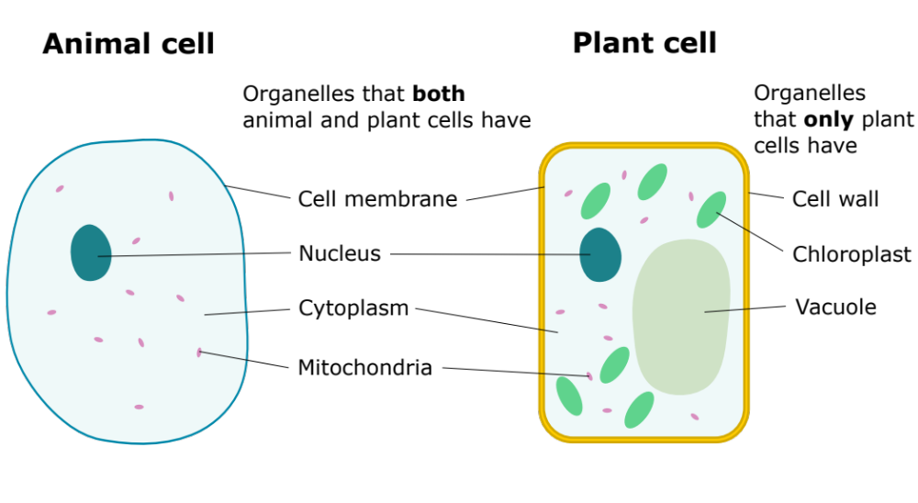
Each cell contains organelles, which serve different purposes. Most cells have a nucleus, cytoplasm, mitochondria and a cell membrane. Plant cells also have a vacuole, chloroplasts, and a cell wall.
Adapted from domdomegg, CC BY 4.0, via Wikimedia Commons

The functions of each organelle can be seen below:
Cell membrane | Controls what goes in and out of the cell.
Nucleus | Controls the activities of the cell by housing the genetic material and coordinating cell functions like growth and reproduction.
Cytoplasm | Chemical reactions happen in the cytoplasm.
Mitochondria | Aerobic respiration happens in the mitochondria. Respiration is a chemical reaction that releases energy stored in glucose so that it can be used to fuel cell activities.
Cell wall | Covers the cell membrane and gives strength to a plant cell.
Chloroplast | Where photosynthesis takes place. Photosynthesis is a chemical reaction that produces glucose. Chloroplasts contain the green pigment chlorophyll.
Vacuole | Contains cell sap (a solution of sugars and salts).

Q1. State the four organelles that plant and animal cells both have:
………………………………………………………………………………………………………………………………………………………………………………………………………..
………………………………………………………………………………………………………………………………………………………………………………………………………..
………………………………………………………………………………………………………………………………………………………………………………………………………..
………………………………………………………………………………………………………………………………………………………………………………………………………..
Q2. State the three organelles that only plant cells have:
………………………………………………………………………………………………………………………………………………………………………………………………………..
………………………………………………………………………………………………………………………………………………………………………………………………………..
………………………………………………………………………………………………………………………………………………………………………………………………………..
Q3. Label the diagrams below, using the words in the box.
Vacuole, cell wall, nucleus, cytoplasm, chloroplast, cell membrane, animal, mitochondria, plant
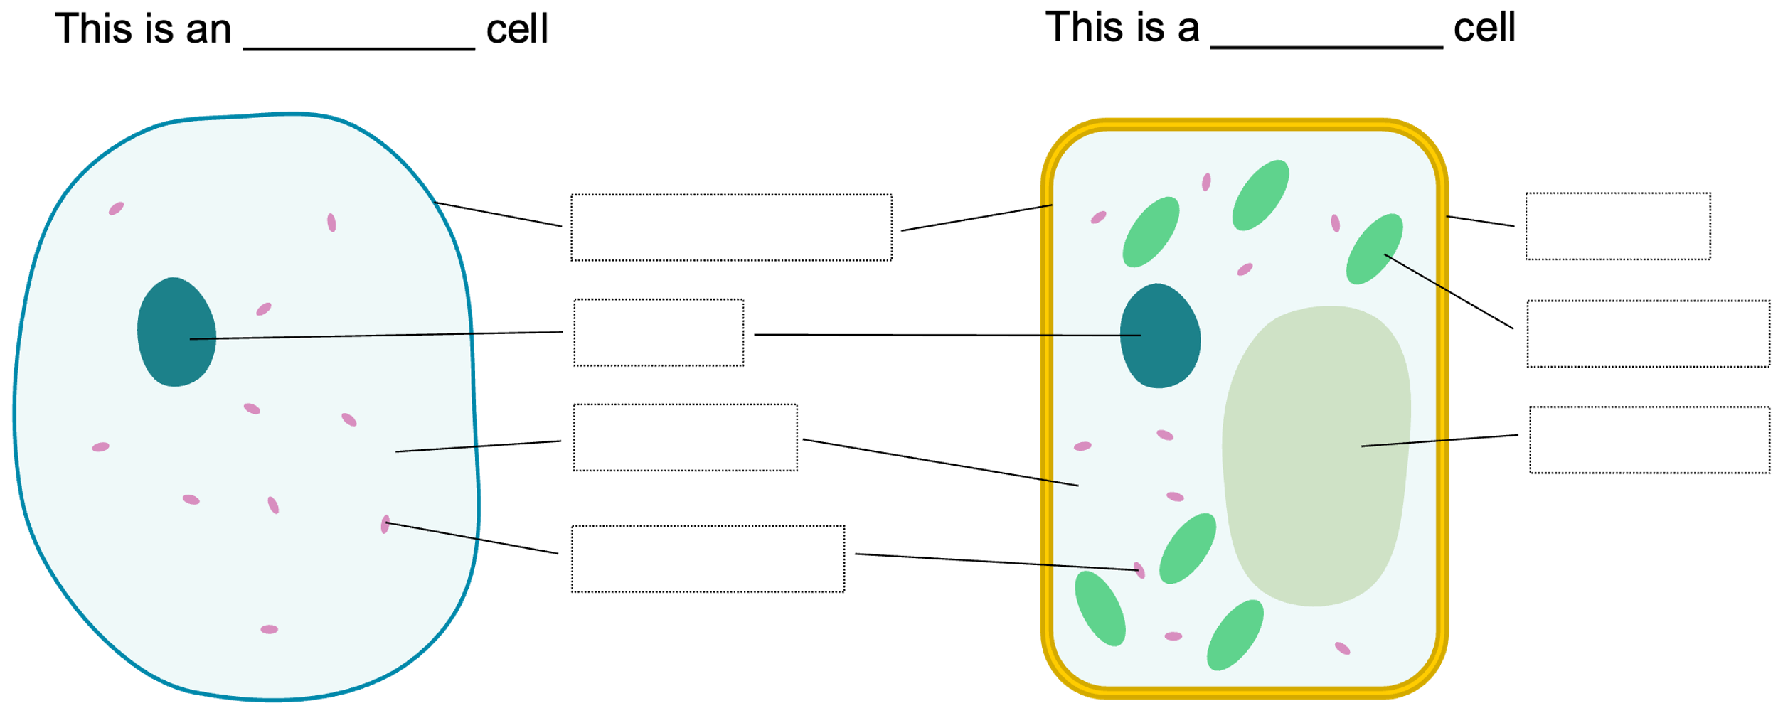
Adapted from domdomegg, CC BY 4.0, via Wikimedia Commons

Q4. The following statements are either true or false. State which are true and which are false.
- Both plant and animal cells have cell walls.
………………………………………………………………………………………………………………………………………………………………………………………………………..
- Both plant and animal cells have cell membranes.
………………………………………………………………………………………………………………………………………………………………………………………………………..
- Only animal cells contain a nucleus.
………………………………………………………………………………………………………………………………………………………………………………………………………..
- Plant cells contain a vacuole.
………………………………………………………………………………………………………………………………………………………………………………………………………..
- The mitochondria control the activities of a cell.
………………………………………………………………………………………………………………………………………………………………………………………………………..

