Plants and
Name ______________________________
Class ______________________________
Teacher ______________________________

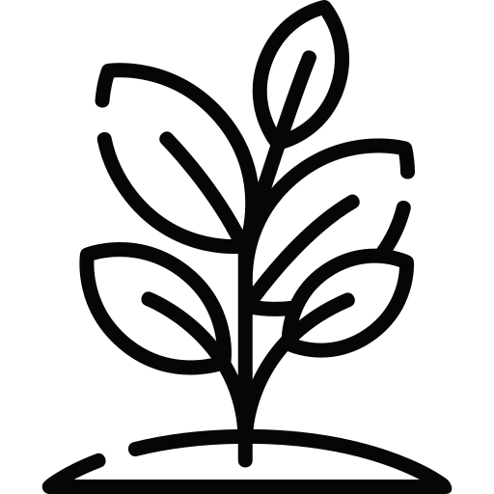

photosynthesis
Photosynthesis is a chemical reaction that produces glucose (a type of sugar). This glucose can then be used for respiration, the process where cells release energy from glucose. During photosynthesis, plants use sunlight to turn carbon dioxide and water into glucose and oxygen. The chemical equation for photosynthesis is:
Photosynthesis
carbon dioxide + water → glucose + oxygen
Photosynthesis occurs in chloroplasts, which contain the green pigment chlorophyll. Chloroplasts are an organelle that are particularly found in a leaf’s palisade cells. These cells are found near the top of a leaf, where they get the most light. Leaves are also well adapted for photosynthesis as they have a large surface area.
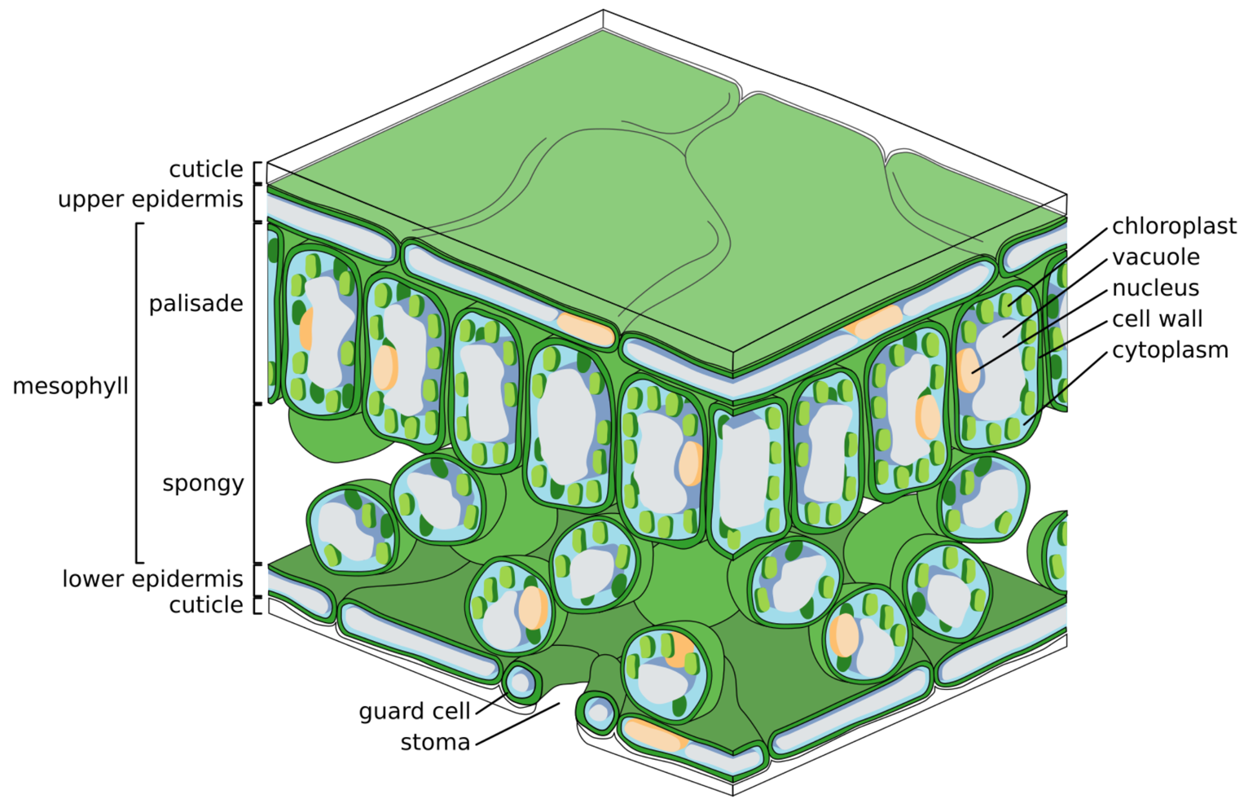
Carbon dioxide enters the underside of a leaf through stomata. The spongy mesophyll layer contains loosely arranged cells with air spaces that allow for the movement of gases. The air spaces allow carbon dioxide to diffuse through the leaf to the palisade cells for photosynthesis.

Zephyris, CC BY-SA 3.0, via Wikimedia Commons
The rate of photosynthesis is affected by light intensity, carbon dioxide concentration, temperature, and water availability. To measure this rate, you can conduct an experiment using pondweed in water. Cover the pondweed with an inverted funnel and place a water-filled test tube over it to capture the oxygen produced. A lamp can be used to provide a steady light source. By counting the oxygen bubbles released in one minute, you can estimate the rate of photosynthesis. By adjusting variables like light intensity or temperature, you can observe how these factors affect photosynthesis.
Q1. The following statements are either true or false. State which are true and which are false.
- Photosynthesis is a chemical reaction.
………………………………………………………………………………………………………………………………………………………………………………………………………..
- Plants do not carry out respiration.
………………………………………………………………………………………………………………………………………………………………………………………………………..
- Photosynthesis occurs in chloroplasts.
………………………………………………………………………………………………………………………………………………………………………………………………………..
- Palisade cells contain many chloroplasts.
………………………………………………………………………………………………………………………………………………………………………………………………………..
Q2. State the products of photosynthesis.
………………………………………………………………………………………………………………………………………………………………………………………………………..
Q3. Write a word equation for photosynthesis.
………………………………………………………………………………………………………………………………………………………………………………………………………..
Q4. Describe an experiment that could investigate the effect of light intensity on the rate of photosynthesis. Include a description of how you would change the light intensity.
………………………………………………………………………………………………………………………………………………………………………………………………………..
………………………………………………………………………………………………………………………………………………………………………………………………………..
………………………………………………………………………………………………………………………………………………………………………………………………………..
………………………………………………………………………………………………………………………………………………………………………………………………………..
Q5. Other than light intensity, state three other factors that the rate of photosynthesis depends on.
………………………………………………………………………………………………………………………………………………………………………………………………………..
………………………………………………………………………………………………………………………………………………………………………………………………………..
Q6. Euglena is a unicellular organism that is found in water and carries out photosynthesis. State what organelle it must contain for photosynthesis to occur.
………………………………………………………………………………………………………………………………………………………………………………………………………..
Q7. State why it is an advantage that palisade cells are generally found near the top of a leaf.
………………………………………………………………………………………………………………………………………………………………………………………………………..
………………………………………………………………………………………………………………………………………………………………………………………………………..
Q8. Describe the movement of carbon dioxide from the air into the palisade cells.
………………………………………………………………………………………………………………………………………………………………………………………………………..
………………………………………………………………………………………………………………………………………………………………………………………………………..
………………………………………………………………………………………………………………………………………………………………………………………………………..
………………………………………………………………………………………………………………………………………………………………………………………………………..
Pollination involves the transfer of pollen from the male part of the flower (the stamen) to the female part (the carpel). This process allows plants to reproduce and create seeds for the next generation of plants. Before understanding pollination, we first need to know the different parts of a flower:
Pollination
- The stamen is the male reproductive part of the flower. It consists of:
- The anther, which produces pollen grains that contain the male sex cells.
- The filament, a stalk which supports the anther.
- The carpel is the female reproductive part of the flower. It includes:
- The stigma, the sticky surface at the top that captures pollen.
- The style, a tube that connects the stigma to the ovary.
- The ovary, which contains female sex cells inside ovules.
- Petals are often brightly coloured to attract pollinators such as bees and butterflies.
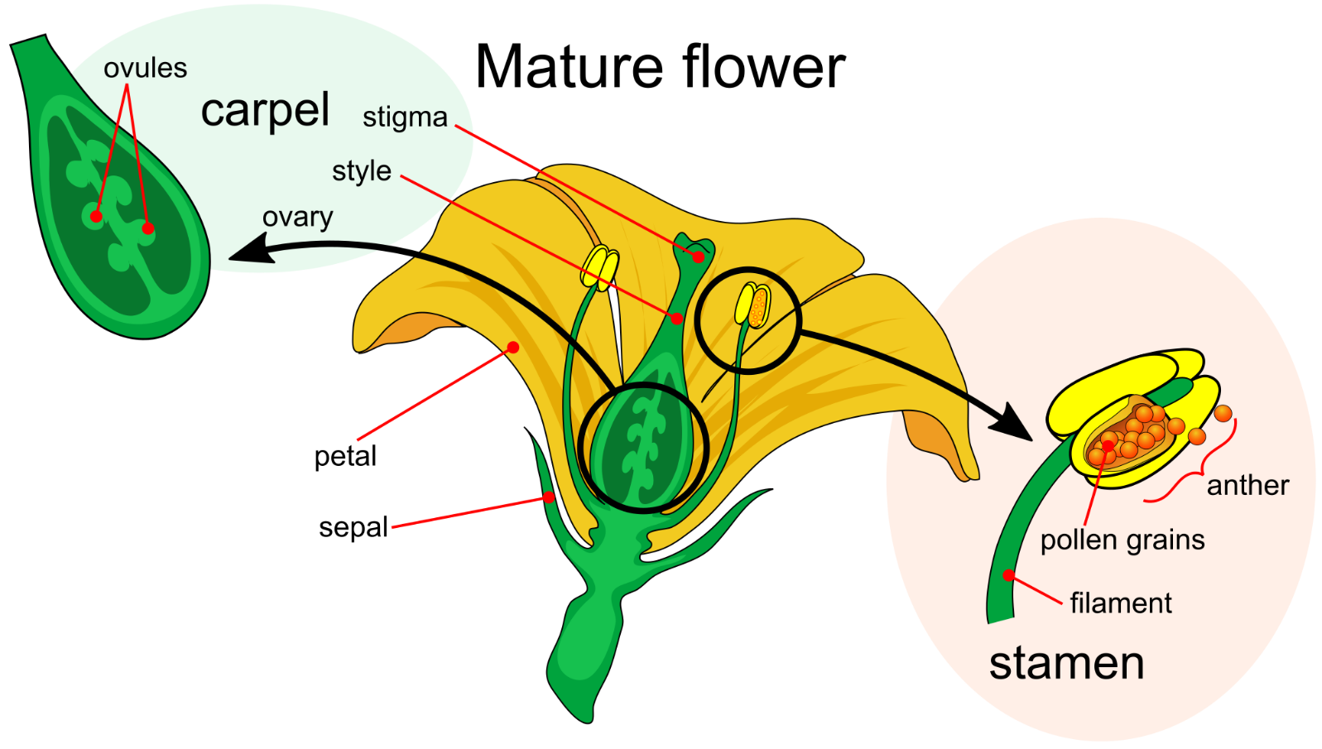
- Sepals are green and leaf-life and protect the flower bud before it opens.
Adapted from LadyofHats, Public domain, via Wikimedia Commons
There are two main types of pollination:
- Self-pollination occurs when pollen from the anther of a flower lands on the stigma of the same flower or another flower on the same plant. This can happen without the need for external pollinators.
- Cross-pollination involves the transfer of pollen from the anther of one flower to the stigma of a flower on a different plant of the same species. Cross-pollination often requires the help of pollinators like insects such as bees or butterflies or the wind.
Once pollen reaches a stigma, a seed can be made.
Q1. The following statements are either true or false. State which are true and which are false.
- The male reproductive part of the flower is called the carpel.
………………………………………………………………………………………………………………………………………………………………………………………………………..
- The stigma produces pollen grains.
………………………………………………………………………………………………………………………………………………………………………………………………………..
- Petals are often brightly coloured.
………………………………………………………………………………………………………………………………………………………………………………………………………..
- The anther is supported by the filament.
………………………………………………………………………………………………………………………………………………………………………………………………………..
- Pollination allows plants to reproduce and create seeds.
………………………………………………………………………………………………………………………………………………………………………………………………………..
- Pollination occurs when pollen reaches a stigma.
………………………………………………………………………………………………………………………………………………………………………………………………………..
- Wind can lead to pollination.
………………………………………………………………………………………………………………………………………………………………………………………………………..
Q2. Describe what the stamen is and what it consists of.
………………………………………………………………………………………………………………………………………………………………………………………………………..
………………………………………………………………………………………………………………………………………………………………………………………………………..
………………………………………………………………………………………………………………………………………………………………………………………………………..
Q3. Describe what the carpel is and what it consists of.
………………………………………………………………………………………………………………………………………………………………………………………………………..
………………………………………………………………………………………………………………………………………………………………………………………………………..
………………………………………………………………………………………………………………………………………………………………………………………………………..
Q4. Describe the difference between self-pollination and cross-pollination.
………………………………………………………………………………………………………………………………………………………………………………………………………..
………………………………………………………………………………………………………………………………………………………………………………………………………..
………………………………………………………………………………………………………………………………………………………………………………………………………..
………………………………………………………………………………………………………………………………………………………………………………………………………..
Q5. State two pollinators.
………………………………………………………………………………………………………………………………………………………………………………………………………..

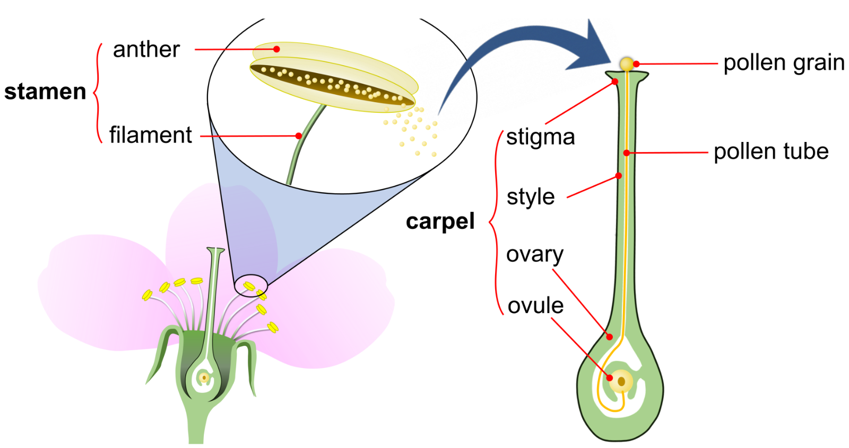
Fertilisation occurs after successful pollination, when pollen from the stamen (the male part of the flower) reaches the carpel (the female part of the flower).
Adapted from Teohalfen, CC BY-SA 4.0, via Wikimedia Commons

Fertilisation and seed formation
Once the pollen grain lands on a stigma, it germinates and grows a pollen tube down through the style towards the ovary. The nucleus of a male sex cell then moves through this tube and joins with the nucleus of the ovule. The process of the two nuclei joining is called fertilisation.
The fertilised ovule becomes a seed. Each seed contains an embryo plant and is equipped with a food store to nourish the embryo as it grows. The seed is protected by a seed coat. As seeds develop, the ovary transforms into a fruit, which helps protect the seeds and can aid in their dispersal. Fruits come in many forms, such as berries, nuts and pods.
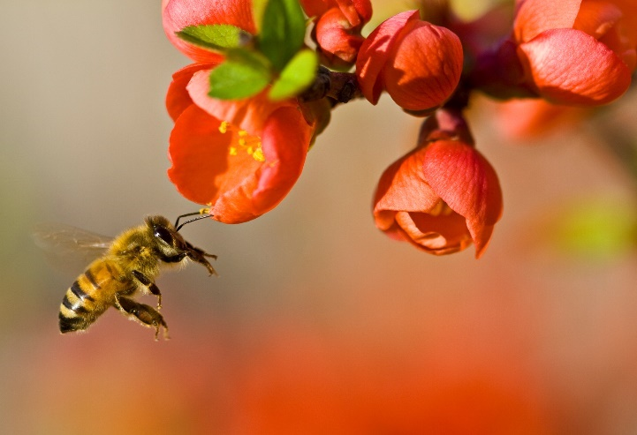
Many of the crops that form the basis of the human diet, such as fruits, vegetables, and nuts, depend on pollination by insects like bees, butterflies, and beetles. These pollinators transfer pollen from flower to flower, enabling plants to produce seeds and fruit. Without insect pollination, crop yields would decrease significantly, leading to reduced food availability and increased prices. This would have a direct impact on global food security, affecting both the quantity and diversity of foods available.
Louise Docker, CC BY 2.0, via Wikimedia Commons

Q1. The following statements are either true or false. State which are true and which are false.
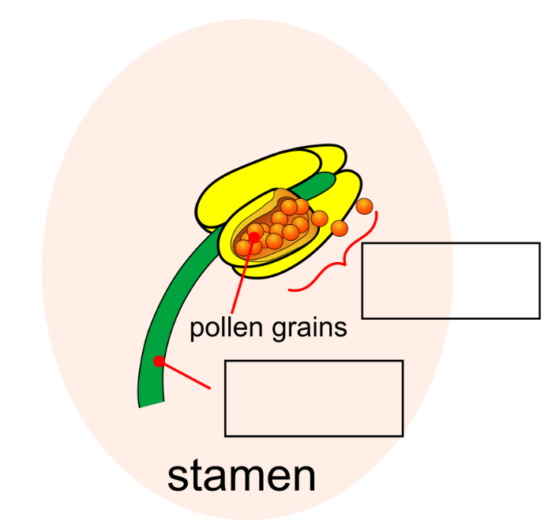
- Fertilisation happens before pollination.
………………………………………………………………………………………………
- After pollination, a pollen tube grows from the stigma to the ovary.
………………………………………………………………………………………………
- The stamen is the male part of the flower.
………………………………………………………………………………………………
- The anther and filament make up the carpel.
………………………………………………………………………………………………
Q2. A diagram of the stamen is shown to the right. Fill in the missing labels in the boxes.
Adapted from LadyofHats, Public domain, via Wikimedia Commons
Q3. Describe how plant fertilisation occurs.
………………………………………………………………………………………………………………………………………………………………………………………………………..
………………………………………………………………………………………………………………………………………………………………………………………………………..
………………………………………………………………………………………………………………………………………………………………………………………………………..
………………………………………………………………………………………………………………………………………………………………………………………………………..
Q4. Describe how a fruit is formed.
………………………………………………………………………………………………………………………………………………………………………………………………………..
………………………………………………………………………………………………………………………………………………………………………………………………………..
………………………………………………………………………………………………………………………………………………………………………………………………………..
………………………………………………………………………………………………………………………………………………………………………………………………………..
Q5. State three parts of a seed.
………………………………………………………………………………………………………………………………………………………………………………………………………..
………………………………………………………………………………………………………………………………………………………………………………………………………..
Q6. Bee populations are declining in the UK. Explain the effect that this might have on food availability and prices.
………………………………………………………………………………………………………………………………………………………………………………………………………..
………………………………………………………………………………………………………………………………………………………………………………………………………..
………………………………………………………………………………………………………………………………………………………………………………………………………..
………………………………………………………………………………………………………………………………………………………………………………………………………..

For new plants to grow, seeds need to be dispersed away from the parent plant. This helps plants to spread to new areas, promotes genetic diversity and reduces competition for resources such as water and light. Different plants have evolved various seed dispersal mechanisms to ensure their seeds are carried away from the parent plant. These mechanisms include:
Seed dispersal
- Wind dispersal. Some seeds are light and have special structures that help them catch the wind. For example, dandelion seeds have feathery bristles, and maple seeds have wings that allow them to be carried by the wind.
- Water dispersal. Seeds that are dispersed by water often have waterproof coverings that enable them to float. Coconuts, for instance, can travel long distances across oceans and still germinate.
- Animal dispersal. Animals can disperse seeds in several ways. Seeds with hooks or spines, like burrs, attach to the fur or feathers of animals and are carried to new locations. Some seeds are eaten by animals and later excreted in different areas.
- Explosive dispersal. Some plants have seed pods that dry out and burst open, flinging seeds in all directions. An example of this are pea pods.
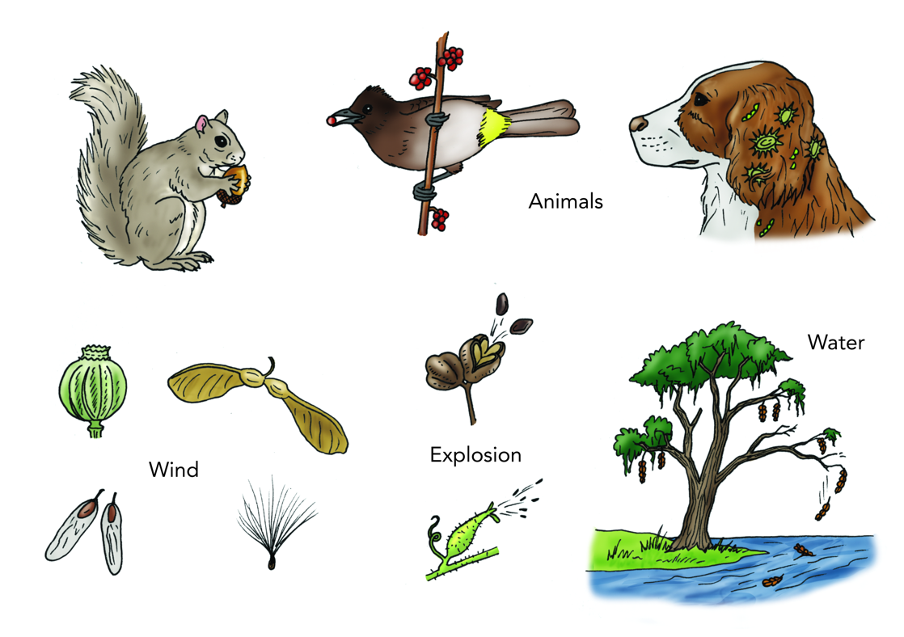
- Gravity dispersal. Fruit simply falls from the plant and relies on gravity to roll away, especially if the plant is on a slope.

Siyavula Education, CC BY 2.0
You can investigate how effectively different types of seeds are dispersed by the wind with a simple experiment. In a clear, open area, use a fan or hairdryer to create a steady breeze. Drop a seed from a marked starting point and let the wind carry it. Measure the distance the seed travels and record the result. Repeat this with different types of seeds and compare which ones travel the furthest. This experiment shows how different seed structures help or hinder wind dispersal.
Q1. The following statements are either true or false. State which are true and which are false.
- Coconuts are an example of seeds dispersed by wind.
………………………………………………………………………………………………………………………………………………………………………………………………………..
- Animal fur can carry seeds to new locations.
………………………………………………………………………………………………………………………………………………………………………………………………………..
- If many plants grow in the same location, they compete for resources.
………………………………………………………………………………………………………………………………………………………………………………………………………..
Q2. State four seed dispersal mechanisms.
………………………………………………………………………………………………………………………………………………………………………………………………………..
………………………………………………………………………………………………………………………………………………………………………………………………………..
Q3. Explain why it is necessary for seeds to be dispersed away from the parent plant.
………………………………………………………………………………………………………………………………………………………………………………………………………..
………………………………………………………………………………………………………………………………………………………………………………………………………..
………………………………………………………………………………………………………………………………………………………………………………………………………..
Q4. Describe an experiment to investigate how effectively different types of seeds are dispersed by the wind.
………………………………………………………………………………………………………………………………………………………………………………………………………..
………………………………………………………………………………………………………………………………………………………………………………………………………..
………………………………………………………………………………………………………………………………………………………………………………………………………..
………………………………………………………………………………………………………………………………………………………………………………………………………..
Q5. Describe how maple seeds are adapted for dispersal.
………………………………………………………………………………………………………………………………………………………………………………………………………..
………………………………………………………………………………………………………………………………………………………………………………………………………..
Q6. Describe how animals can disperse seeds.
………………………………………………………………………………………………………………………………………………………………………………………………………..
………………………………………………………………………………………………………………………………………………………………………………………………………..
………………………………………………………………………………………………………………………………………………………………………………………………………..
………………………………………………………………………………………………………………………………………………………………………………………………………..
Q7. Describe how seeds can be dispersed by water.
………………………………………………………………………………………………………………………………………………………………………………………………………..
………………………………………………………………………………………………………………………………………………………………………………………………………..

