Pollination involves the transfer of pollen from the male part of the flower (the stamen) to the female part (the carpel). This process allows plants to reproduce and create seeds for the next generation of plants. Before understanding pollination, we first need to know the different parts of a flower:
Pollination
- The stamen is the male reproductive part of the flower. It consists of:
- The anther, which produces pollen grains that contain the male sex cells.
- The filament, a stalk which supports the anther.
- The carpel is the female reproductive part of the flower. It includes:
- The stigma, the sticky surface at the top that captures pollen.
- The style, a tube that connects the stigma to the ovary.
- The ovary, which contains female sex cells inside ovules.
- Petals are often brightly coloured to attract pollinators such as bees and butterflies.
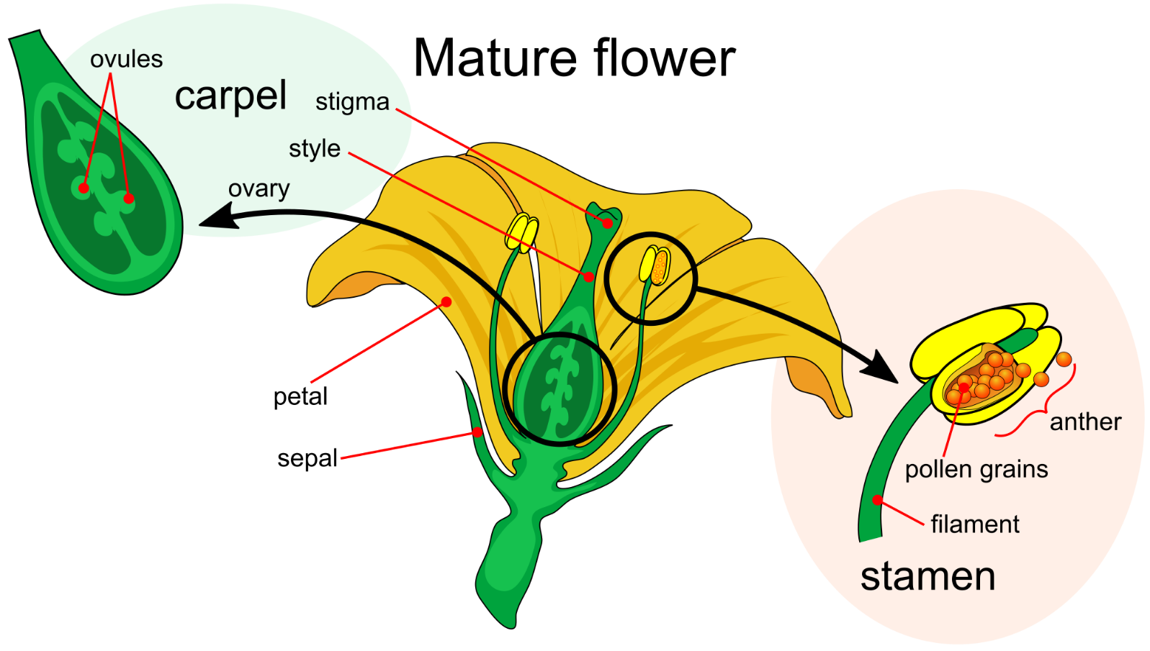
- Sepals are green and leaf-life and protect the flower bud before it opens.
Adapted from LadyofHats, Public domain, via Wikimedia Commons
There are two main types of pollination:
- Self-pollination occurs when pollen from the anther of a flower lands on the stigma of the same flower or another flower on the same plant. This can happen without the need for external pollinators.
- Cross-pollination involves the transfer of pollen from the anther of one flower to the stigma of a flower on a different plant of the same species. Cross-pollination often requires the help of pollinators like insects such as bees or butterflies or the wind.
Once pollen reaches a stigma, a seed can be made.
Q1. The following statements are either true or false. State which are true and which are false.
- The male reproductive part of the flower is called the carpel.
………………………………………………………………………………………………………………………………………………………………………………………………………..
- The stigma produces pollen grains.
………………………………………………………………………………………………………………………………………………………………………………………………………..
- Petals are often brightly coloured.
………………………………………………………………………………………………………………………………………………………………………………………………………..
- The anther is supported by the filament.
………………………………………………………………………………………………………………………………………………………………………………………………………..
- Pollination allows plants to reproduce and create seeds.
………………………………………………………………………………………………………………………………………………………………………………………………………..
- Pollination occurs when pollen reaches a stigma.
………………………………………………………………………………………………………………………………………………………………………………………………………..
- Wind can lead to pollination.
………………………………………………………………………………………………………………………………………………………………………………………………………..
Q2. Describe what the stamen is and what it consists of.
………………………………………………………………………………………………………………………………………………………………………………………………………..
………………………………………………………………………………………………………………………………………………………………………………………………………..
………………………………………………………………………………………………………………………………………………………………………………………………………..
Q3. Describe what the carpel is and what it consists of.
………………………………………………………………………………………………………………………………………………………………………………………………………..
………………………………………………………………………………………………………………………………………………………………………………………………………..
………………………………………………………………………………………………………………………………………………………………………………………………………..
Q4. Describe the difference between self-pollination and cross-pollination.
………………………………………………………………………………………………………………………………………………………………………………………………………..
………………………………………………………………………………………………………………………………………………………………………………………………………..
………………………………………………………………………………………………………………………………………………………………………………………………………..
………………………………………………………………………………………………………………………………………………………………………………………………………..
Q5. State two pollinators.
………………………………………………………………………………………………………………………………………………………………………………………………………..

