Pregnancy begins when a sperm cell from the father fertilises an egg cell from the mother. This usually happens in the fallopian tube. The fertilised egg, now called a zygote, travels down the fallopian tube and into the uterus. Once in the uterus, the zygote implants itself into the thickened lining of the uterus.
Pregnancy
Pregnancy can be split into three trimesters:
First trimester (weeks 1-12). In the early weeks of pregnancy, the baby is called an embryo. The heart, brain, and other organs begin to form. By the end of this period, the baby is about the size of a lemon and is now called a foetus.
Second trimester (weeks 13-26). The baby continues to grow, developing muscles, bones, and more detailed features like fingers, toes, and facial expressions. The baby can move, and the mother may start to feel these movements. The baby also begins to hear sounds.
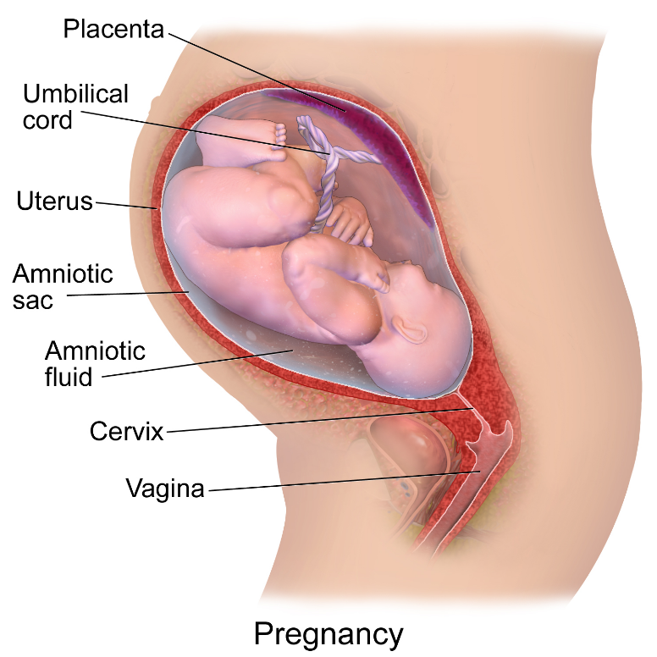
Third trimester (weeks 27-40). During the final weeks, the baby grows rapidly and gains weight. The lungs mature, and the baby moves into a head-down position, ready for birth. By the end of this period, the baby is fully developed and ready to be born.
Several structures help support and protect the baby as it grows:
- The placenta is an organ that develops in the uterus during pregnancy. It connects to the baby through the umbilical cord and provides nutrients and oxygen from the mother’s blood. It also removes waste products from the baby’s blood.
- The uterus is the organ where the baby develops. It stretches and grows as the baby gets bigger.
- The amniotic sac is a thin but strong bag that surrounds the baby in the uterus. Inside the sac, the baby is cushioned by amniotic fluid, which protects the baby and allows it to move around easily.
Blausen.com staff (2014). "Medical gallery of Blausen Medical 2014". WikiJournal of Medicine 1 (2). DOI:10.15347/wjm/2014.010. ISSN 2002-4436., CC BY 3.0, via Wikimedia Commons

- The cervix is the lower part of the uterus that connects to the vagina. During pregnancy, the cervix remains closed to keep the baby inside the uterus. As the time for birth approaches, the cervix gradually opens to allow the baby to be born.
- The vagina is the passage that connects the uterus to the outside of the body. During birth, the baby passes through the vagina.
Q1. The following statements are either true or false. State which are true and which are false.
- A fertilised egg is called a zygote.
………………………………………………………………………………………………………………………………………………………………………………………………………..
- The zygote implants itself into the thickened lining of the uterus.
………………………………………………………………………………………………………………………………………………………………………………………………………..
- An embryo turns into a zygote.
………………………………………………………………………………………………………………………………………………………………………………………………………..
- Pregnancy usually lasts around 40 weeks.
………………………………………………………………………………………………………………………………………………………………………………………………………..
- Fertilisation usually happens in the fallopian tube.
………………………………………………………………………………………………………………………………………………………………………………………………………..
Q2. Describe the role of the placenta and umbilical cord during pregnancy.
………………………………………………………………………………………………………………………………………………………………………………………………………..
………………………………………………………………………………………………………………………………………………………………………………………………………..
………………………………………………………………………………………………………………………………………………………………………………………………………..
………………………………………………………………………………………………………………………………………………………………………………………………………..
Q3. Describe the role of the amniotic fluid during pregnancy.
………………………………………………………………………………………………………………………………………………………………………………………………………..
………………………………………………………………………………………………………………………………………………………………………………………………………..
………………………………………………………………………………………………………………………………………………………………………………………………………..
………………………………………………………………………………………………………………………………………………………………………………………………………..
Q4. Describe what happens during the third trimester to prepare the baby for birth.
………………………………………………………………………………………………………………………………………………………………………………………………………..
………………………………………………………………………………………………………………………………………………………………………………………………………..
………………………………………………………………………………………………………………………………………………………………………………………………………..
………………………………………………………………………………………………………………………………………………………………………………………………………..
Q5. Describe what happens to the cervix as the time for birth gets close.
………………………………………………………………………………………………………………………………………………………………………………………………………..
………………………………………………………………………………………………………………………………………………………………………………………………………..
………………………………………………………………………………………………………………………………………………………………………………………………………..
………………………………………………………………………………………………………………………………………………………………………………………………………..

