An ecosystem is a community of living and non-living things interacting with each other. Plants, animals and microorganisms depend on water, soil, climate and each other for survival. These interactions create a web of relationships that keep the ecosystem balanced and functioning.
Relationships in an ecosystem
In an ecosystem, all organisms are interdependent. This means they rely on each other to survive. For instance, plants need sunlight to make glucose through photosynthesis. Some animals depend on these plants for food, and predators rely on other animals as their food source. If one part of this chain is disturbed, it can impact the entire ecosystem.
One key example of interdependence is pollination. Many plants, including those that humans rely on for food, need insects like bees to pollinate them. Pollination is the process of transferring pollen from one flower to another, allowing the plant to produce seeds and fruit. Without pollinators, many plants would struggle to reproduce. This would affect the animals that rely on them for food.
Humans heavily depend on insect pollination for a lot of the food we eat, such as fruits, vegetables and nuts. Without pollinators, these crops would produce less food. This would lead to food shortages and higher prices. The health of ecosystems, therefore, has a direct impact on human food security.
However, the use of insecticides (chemicals designed to kill insects) can also harm beneficial insects like bees. When these chemicals reduce pollinator populations, it can lead to lower crop yields and disrupt the entire food chain. This reduction in pollinators can also decrease biodiversity, making ecosystems less resilient to other threats.
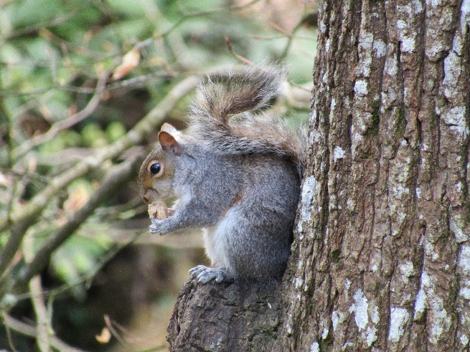
In addition to issues like insecticide use, ecosystems can also be disrupted by invasive species. An invasive species is a non-native organism introduced to an ecosystem, often causing harm. These species can outcompete native organisms for resources like food and habitat, disrupt food chains and reduce biodiversity.
For example, the introduction of grey squirrels to the UK from North America has led to a decline in the native red squirrel population. Grey squirrels compete with red squirrels for food and carry a disease that is deadly to red squirrels but not to themselves. This has significantly reduced red squirrel numbers and upset the balance of the local ecosystem.
Partonez, CC BY-SA 4.0, via Wikimedia Commons

Q1. The following statements are either true or false. State which are true and which are false.
- Bees are an example of a pollinator.
………………………………………………………………………………………………………………………………………………………………………………………………………..
- Invasive species are needed to keep ecosystems balanced.
………………………………………………………………………………………………………………………………………………………………………………………………………..
Q2. Describe why pollination is important for both plants and animals.
………………………………………………………………………………………………………………………………………………………………………………………………………..
………………………………………………………………………………………………………………………………………………………………………………………………………..
………………………………………………………………………………………………………………………………………………………………………………………………………..
………………………………………………………………………………………………………………………………………………………………………………………………………..
Q3. Describe how the use of insecticides can affect an ecosystem.
………………………………………………………………………………………………………………………………………………………………………………………………………..
………………………………………………………………………………………………………………………………………………………………………………………………………..
………………………………………………………………………………………………………………………………………………………………………………………………………..
Q4. Describe what is meant by an ecosystem.
………………………………………………………………………………………………………………………………………………………………………………………………………..
………………………………………………………………………………………………………………………………………………………………………………………………………..
………………………………………………………………………………………………………………………………………………………………………………………………………..
Q5. Describe what is meant by an invasive species.
………………………………………………………………………………………………………………………………………………………………………………………………………..
………………………………………………………………………………………………………………………………………………………………………………………………………..
………………………………………………………………………………………………………………………………………………………………………………………………………..
Q6. State an example of an invasive species.
………………………………………………………………………………………………………………………………………………………………………………………………………..
Q7. Describe what is meant by interdependence in an ecosystem.
………………………………………………………………………………………………………………………………………………………………………………………………………..
………………………………………………………………………………………………………………………………………………………………………………………………………..
………………………………………………………………………………………………………………………………………………………………………………………………………..
Q8. Describe what might happen to the human food supply if pollinator populations decrease.
………………………………………………………………………………………………………………………………………………………………………………………………………..
………………………………………………………………………………………………………………………………………………………………………………………………………..
………………………………………………………………………………………………………………………………………………………………………………………………………..
………………………………………………………………………………………………………………………………………………………………………………………………………..

