For new plants to grow, seeds need to be dispersed away from the parent plant. This helps plants to spread to new areas, promotes genetic diversity and reduces competition for resources such as water and light. Different plants have evolved various seed dispersal mechanisms to ensure their seeds are carried away from the parent plant. These mechanisms include:
Seed dispersal
- Wind dispersal. Some seeds are light and have special structures that help them catch the wind. For example, dandelion seeds have feathery bristles, and maple seeds have wings that allow them to be carried by the wind.
- Water dispersal. Seeds that are dispersed by water often have waterproof coverings that enable them to float. Coconuts, for instance, can travel long distances across oceans and still germinate.
- Animal dispersal. Animals can disperse seeds in several ways. Seeds with hooks or spines, like burrs, attach to the fur or feathers of animals and are carried to new locations. Some seeds are eaten by animals and later excreted in different areas.
- Explosive dispersal. Some plants have seed pods that dry out and burst open, flinging seeds in all directions. An example of this are pea pods.
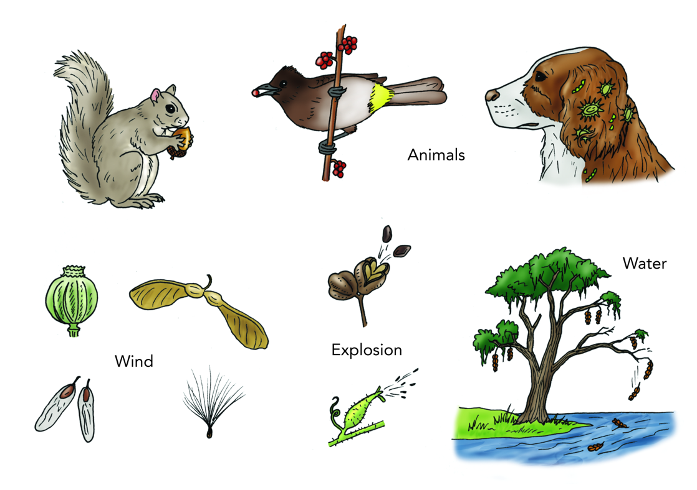
- Gravity dispersal. Fruit simply falls from the plant and relies on gravity to roll away, especially if the plant is on a slope.

Siyavula Education, CC BY 2.0
You can investigate how effectively different types of seeds are dispersed by the wind with a simple experiment. In a clear, open area, use a fan or hairdryer to create a steady breeze. Drop a seed from a marked starting point and let the wind carry it. Measure the distance the seed travels and record the result. Repeat this with different types of seeds and compare which ones travel the furthest. This experiment shows how different seed structures help or hinder wind dispersal.
Q1. The following statements are either true or false. State which are true and which are false.
- Coconuts are an example of seeds dispersed by wind.
………………………………………………………………………………………………………………………………………………………………………………………………………..
- Animal fur can carry seeds to new locations.
………………………………………………………………………………………………………………………………………………………………………………………………………..
- If many plants grow in the same location, they compete for resources.
………………………………………………………………………………………………………………………………………………………………………………………………………..
Q2. State four seed dispersal mechanisms.
………………………………………………………………………………………………………………………………………………………………………………………………………..
………………………………………………………………………………………………………………………………………………………………………………………………………..
Q3. Explain why it is necessary for seeds to be dispersed away from the parent plant.
………………………………………………………………………………………………………………………………………………………………………………………………………..
………………………………………………………………………………………………………………………………………………………………………………………………………..
………………………………………………………………………………………………………………………………………………………………………………………………………..
Q4. Describe an experiment to investigate how effectively different types of seeds are dispersed by the wind.
………………………………………………………………………………………………………………………………………………………………………………………………………..
………………………………………………………………………………………………………………………………………………………………………………………………………..
………………………………………………………………………………………………………………………………………………………………………………………………………..
………………………………………………………………………………………………………………………………………………………………………………………………………..
Q5. Describe how maple seeds are adapted for dispersal.
………………………………………………………………………………………………………………………………………………………………………………………………………..
………………………………………………………………………………………………………………………………………………………………………………………………………..
Q6. Describe how animals can disperse seeds.
………………………………………………………………………………………………………………………………………………………………………………………………………..
………………………………………………………………………………………………………………………………………………………………………………………………………..
………………………………………………………………………………………………………………………………………………………………………………………………………..
………………………………………………………………………………………………………………………………………………………………………………………………………..
Q7. Describe how seeds can be dispersed by water.
………………………………………………………………………………………………………………………………………………………………………………………………………..
………………………………………………………………………………………………………………………………………………………………………………………………………..

