The menstrual cycle is a monthly process that prepares the female body for pregnancy. It typically lasts around 28 days, but it can vary from person to person. The cycle involves the release of an egg from the ovaries, the preparation of the uterus for a possible pregnancy, and the shedding of the uterus lining if pregnancy does not occur.
Adapted from Speck-Made - Own work, CC BY-SA 3.0, via Wikimedia Commons

The menstrual cycle
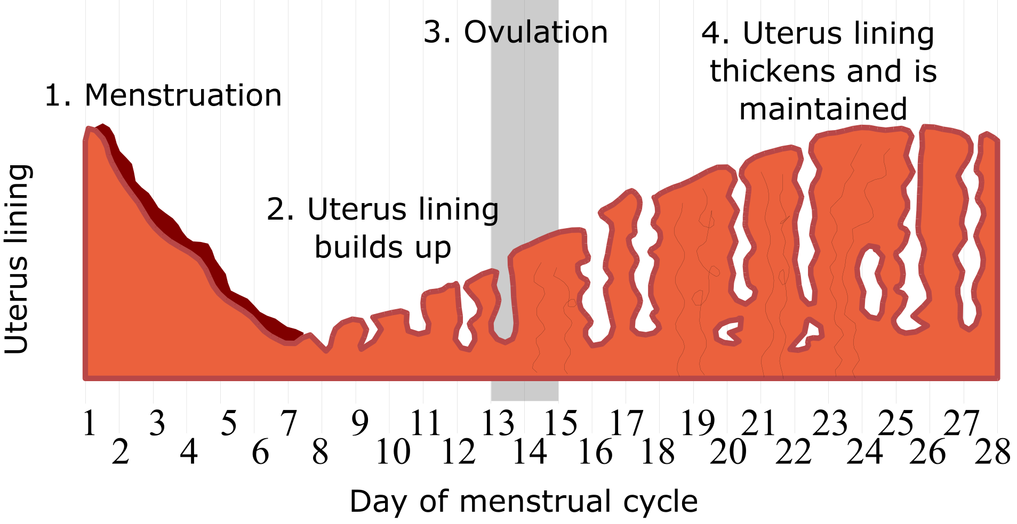

The four stages of the menstrual cycle are:
- Menstruation (days 1-5). The first stage of the menstrual cycle is menstruation, also known as a period. During this time, the lining of the uterus breaks down and is shed from the body through the vagina. Menstruation usually lasts between 3 to 7 days.
- Uterus lining builds up. The body gets ready to release an egg from the ovary. The hormone oestrogen helps to thicken the uterus lining to get ready for a possible pregnancy.
- Ovulation (day 14). Ovulation usually happens around the middle of the cycle. This is when the ovary releases an egg. The egg travels down the fallopian tube, and this is the time when a woman is most fertile.
- Uterus lining thickens and is maintained. After the egg is released, the body produces another hormone called progesterone. This hormone makes the lining of the uterus even thicker. If the egg isn’t fertilised, the uterus lining breaks down and the cycle starts all over again with menstruation.

Q1. The following statements are either true or false. State which are true and which are false.
- Ovulation is when an ovary releases an egg.
………………………………………………………………………………………………………………………………………………………………………………………………………..
- The menstrual cycle usually lasts around 28 days.
………………………………………………………………………………………………………………………………………………………………………………………………………..
- A woman is most fertile before they ovulate.
………………………………………………………………………………………………………………………………………………………………………………………………………..
Q2. Describe what happens in the first five days of the menstrual cycle.
………………………………………………………………………………………………………………………………………………………………………………………………………..
………………………………………………………………………………………………………………………………………………………………………………………………………..
………………………………………………………………………………………………………………………………………………………………………………………………………..
Q3. State which day of the menstrual cycle ovulation usually happens on.
………………………………………………………………………………………………………………………………………………………………………………………………………..
Q4. Describe what ovulation is.
………………………………………………………………………………………………………………………………………………………………………………………………………..
………………………………………………………………………………………………………………………………………………………………………………………………………..
………………………………………………………………………………………………………………………………………………………………………………………………………..
Q5. Describe what happens to the uterus lining if an egg isn’t fertilised.
………………………………………………………………………………………………………………………………………………………………………………………………………..
………………………………………………………………………………………………………………………………………………………………………………………………………..
………………………………………………………………………………………………………………………………………………………………………………………………………..
Q6. Describe the role of oestrogen in the menstrual cycle.
………………………………………………………………………………………………………………………………………………………………………………………………………..
………………………………………………………………………………………………………………………………………………………………………………………………………..
………………………………………………………………………………………………………………………………………………………………………………………………………..
Q7. Describe the role of progesterone in the menstrual cycle.
………………………………………………………………………………………………………………………………………………………………………………………………………..
………………………………………………………………………………………………………………………………………………………………………………………………………..
………………………………………………………………………………………………………………………………………………………………………………………………………..

