When we observe the natural world, we notice that living things are diverse and have a wide range of shapes, sizes and colours. This diversity is referred to as variation. Variation can be seen between different species as well as within the same species.
Variation
Different species have different sets of genes, which lead to the different characteristics we see between them. For example, the genes in a bird are different from those in a fish. This leads to traits like feathers and the ability to fly in birds, and scales and the ability to swim in fish.
Variation also exists within a species. This means that even though individuals of the same species share many of the same genes, there are still differences between them. For example, all humans share the same basic set of genes that make us human but each person has a unique combination of these genes that results in differences like eye colour, height and hair type. This variation within a species is what makes each individual unique.
Variation within a species can be classified as continuous or discontinuous:
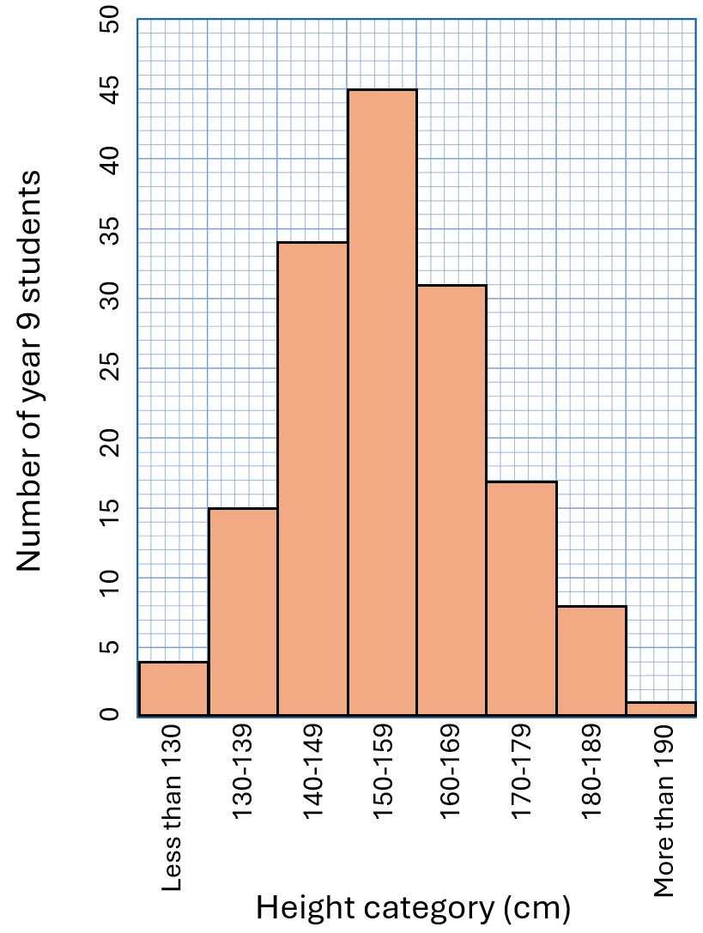
- Continuous variation shows a range of differences that gradually change, with no clear divisions between them. For example, human height is a continuous variation. People can be any height within a range, and there are no fixed categories. Continuous variation is often represented using a histogram. For example, the histogram to the right shows the distribution of the heights of 155 year 9 students.
- Discontinuous variation is characterised by distinct categories with no intermediate forms. For example, blood type in humans is a discontinuous variation. You can have type A, B, AB, or O, but there are no in-between types. Discontinuous variation is usually controlled by a small number of genes and is represented using a bar chart.

Q1. The following statements are either true or false. State which are true and which are false.
- Variation refers only to differences between different species.
………………………………………………………………………………………………………………………………………………………………………………………………………..
- Continuous variation shows a range of differences that gradually change.
………………………………………………………………………………………………………………………………………………………………………………………………………..
- Blood type is an example of continuous variation.
………………………………………………………………………………………………………………………………………………………………………………………………………..
Q2. The table below shows the distribution of heights of 150 year 8 students.
- State whether height is a continuous or discontinuous variable.
………………………………………………………………………………………………………………………………………………………………………………………………………..
- Plot a histogram using the data in the table.
Height category (cm) | Number of year 8 students
Less than 130 | 12
130-139 | 21
140-149 | 46
150-159 | 35
160-169 | 17
170-179 | 13
180-189 | 5
More than 180 | 0
