
Astrophysics
Name ______________________________
Teacher ______________________________
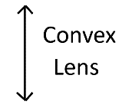
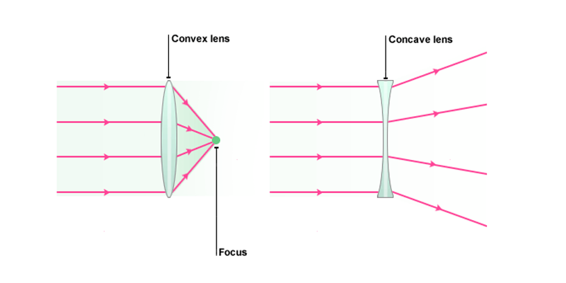
A converging lens is convex (it bulges outwards). It causes parallel rays to converge to a focus through refraction. The symbol for a convex lens is
Lenses
Lenses

The image produced by a convex lens can be either real or virtual. The image is real if it can be projected onto a screen, but virtual if it cannot.
The region where the rays converge is called the focus and the distance between this region and the lens is called the focal length.
Three rules for drawing convex lens ray diagrams:
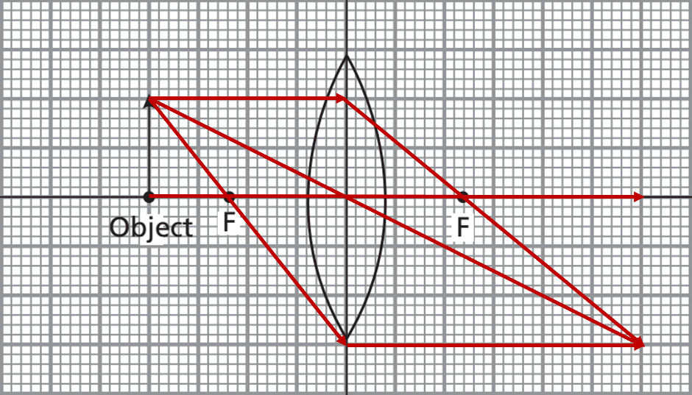
- Parallel Ray: A ray parallel to the optical axis passes through the focal point on the other side of the lens
- Centre Ray: A ray that passes through the centre of the lens continues with no change in direction
- Focal Ray: A ray that passes through the focal point emerges parallel to the optical axis on the other side of the lens

A diverging lens is concave (it caves inwards). It causes parallel rays to diverge (spread out) through refraction.
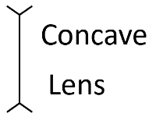
The symbol for a concave lens is
The image produced by a concave lens is always virtual.

Three rules for drawing concave lens ray diagrams:
1. Parallel Ray: A ray parallel to the optical axis passes emerges as though it was coming from the focal point
2. Focal Ray: A ray that is heading towards the focal point on the other side of the lens emerges parallel to the optical axis
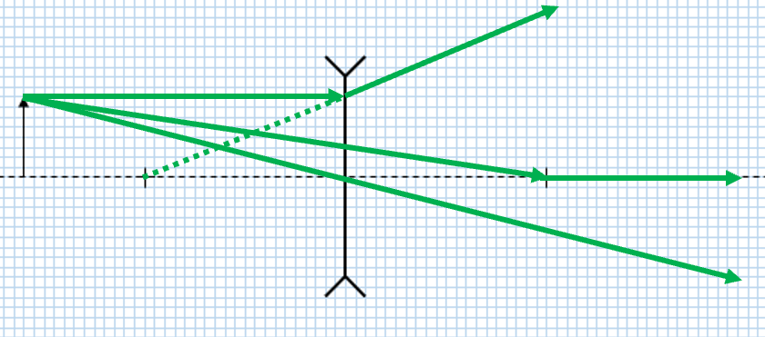
3. Centre Ray: A ray that passes through the centre of the lens continues with no change in direction

Task: Complete in your exercise book.
Basic
- What does a convex lens look like? What does it cause parallel rays of light to do?
- Draw the symbol for a convex lens.
- Why does a lens change the direction of light?
- What type of images can be produced by a convex lens?
Rules for ray diagram construction:
- Parallel Ray: A ray parallel to the optical axis passes through the focal point on the other side of the lens
- Focal Ray: A ray that passes through the focal point emerges parallel to the optical axis on the other side of the lens
- Centre Ray: A ray that passes through the centre of the lens continues with no change in direction

Medium
- Construct a ray diagram to show where the image is formed
- Describe the image formed (e.g. is it real or virtual and how does its size compare to the object).
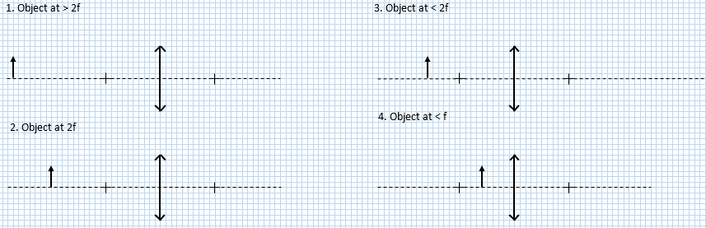
Hard
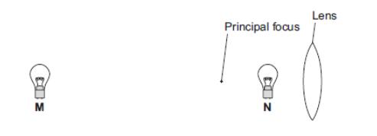
- A light bulb is placed between a convex lens and the principle focus of this lens, at position N shown in the diagram. The light bulb is then moved to position M, a large distance from the lens.

Describe how the nature of the image formed changes as the light bulb is moved from position N to position M.
- A lens is used to produce an image. The image produced is real, inverted and magnified.
- What kind of lens has been used?
- Where is the image in relation to the lens?
- Explain the difference between a real image and a virtual image.
- Name some uses of convex lenses. Explain what makes a convex lens suitable for each purpose.

Q1.
(a) A camera was used to take a photograph. The camera contains a convex (converging) lens.
Complete the ray diagram to show how the lens produces an image of the object.
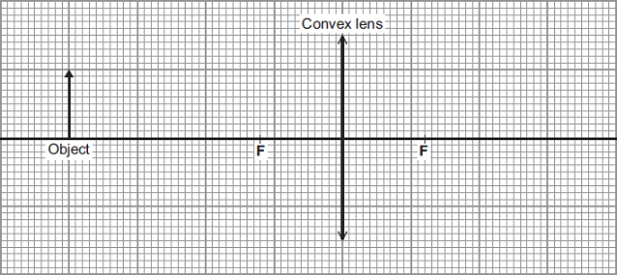
F = Principal focus
(4)
(b) State two words to describe the nature of the image produced by the lens in the camera.
1. _________________________________________________________________
2. _________________________________________________________________
(2)
(Total 6 marks)

Q2.
The graph shows how a concave lens forms an image of an object.
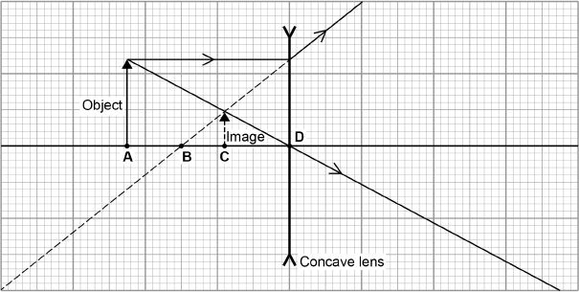
(a) Which point on the graph above marks the position of the principal focus of the lens? (1)
A |  | B |  | C |  | D
(b) Which two words describe the image? Tick two boxes. (2)

Enlarged
Inverted
Real
Upright
Virtual
(c) Calculate the magnification produced by the lens. (2)
___________________________________________________________________
___________________________________________________________________
Magnification = ____________________
(d) Complete the sentence. (1)

decrease | increase | not change
As the object is moved further away from the lens, the size of
the image will __________________________ .

Converging and Diverging Lenses
Refracting telescopes
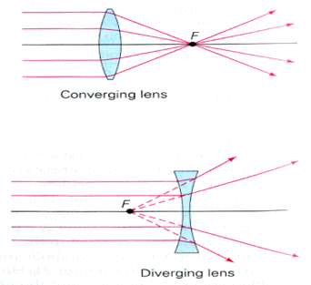
There are two basic types of optical lens. A concave lens also called a diverging lens, and a convex lens, also called a converging lens.
A converging lens can produce both a real image and a virtual image, a real image is one that can be formed on a screen; a virtual image cannot be formed on a screen.

Astronomical Refracting Telescopes
Incident light is focused by refraction through a converging objective lens followed by a converging eyepiece lens. The light rays leaving the eyepiece are parallel, and so the final image appears at infinity, to reduce eye strain. This setting is called normal adjustment for an astronomical telescope.
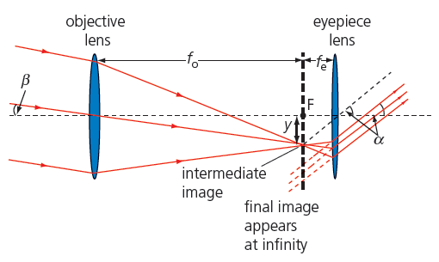

Angular Magnification
Light from the edge of the object enters the objective lens at an angle β to the optical axis and forms an intermediate real image between the lenses. The angle β is the angle subtended by the object to the unaided eye and is a very small angle. An object's angular size is the angle between the lines of sight to its two opposite ends and is a measure of how big the object appears to the unaided eye. In normal adjustment, parallel light emerges from the eyepiece lens. This occurs when the focus of the eyepiece lens (focal length f_{e}) is coincident with that of the objective lens (focal length f₀). When looking through the eyepiece, the angle subtended by the image to the eye, α, has now increased.
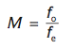

The angular magnification, M, or magnifying power of a refracting telescope is given by:
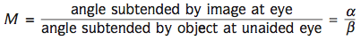

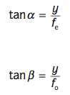
In normal adjustment, the magnification can be expressed in terms of the focal lengths of the lenses, we have, by simple geometry (properties of vertical angles):
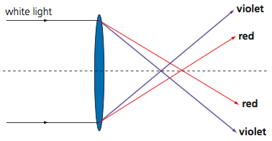
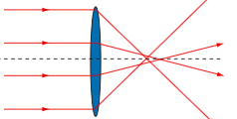
And that

Spherical aberration
Chromatic aberration
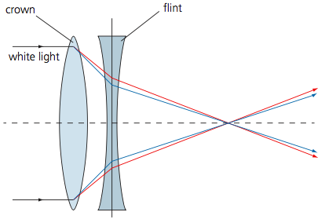
Refracting telescopes suffer from fundamental aberrations (faults), of which there are two main types. Chromatic aberration – where the objective lens focuses the different colours over a range of focal lengths. Spherical aberration - results in light rays in a parallel beam being focused at slightly different positions resulting in a blurring of the image.
To compensate for aberrations the objective lens in a refractor is often an achromatic doublet (below). This is made up of two individual lenses are cemented together and corrected to bring light of two wavelengths (two of red, green and blue) into focus in the same plane. Each lens is made from glass with different dispersion.
Achromatic doublet
Refracting telescopes
- Describe the difference between a convex and concave lens in terms of the images they produce.
- Describe the images formed for an object placed at the following distances from a convex lens:
  - At 2F
  - Beyond 2F
  - Inside 2F
  - Inside F
  - Explain why no image would be formed if the object was at F
- Calculate the focal length of a lens, when the object is placed at 20 cm and the image forms at 30 cm. State whether this is a real or virtual image.
- Calculate the distance an image is formed if a lens with a focal length of 15 cm has an object placed at 40 cm from it. State whether this is a real or virtual image.
- Calculate the distance from the lens an image forms if the focal length of the lens is 10 cm and the object was 5 cm from the lens. State whether this is a real or virtual image.
- A simple, 35 mm film camera is used in landscape mode to take a picture of a 1.7 m tall person from a distance u =5m. Assuming the camera's only thin lens is v = 8cm from the film
  - find the focal distance of the lens required for this image.
  - find the image size and orientation.
  - Will it fit on the 35 mm film?
- A simple telescope of length L=40 cm has two options for the eyepiece lens:
    - f_{eyepiece}=4 cm
    - f_{eyepiece}=1 cm
  - Calculate the focal distance of the objective lens necessary for each option, as well as the (magnitude of the total angular) magnification in each case.
- Calculate the angular magnification of a telescope with an objective lens focal length of 1200 mm, using an eyepiece lens of
  - 25 mm
  - 10 mm
- The moon has an angular size of 0.5º in the night sky. If viewed through a telescope with objective lens focal length of 100 cm and eyepiece lens focal length of 30 mm, what is the angular size of the Moon seen through this telescope?
- What is the angular size of the sun, when viewed through the same telescope?
- Calculate the angular magnification and image size:
  - An astronomical telescope has an objective of focal length 40 cm and an eyepiece focal length of 5 cm. The telescope is in normal adjustment and a distant object subtends an angle of 2.5 x 10⁻³ radians at the objective.
  - A feature on the moon subtends and angle of $5.0×{10}^{-4}$radians at the objective lens of a telescope. The total length of the telescope is 2.1 m and the eyepiece lens has a focal length of 5 cm.
    - What is the magnification and image size on the eyepiece lens?
    - What is the height of the image?
- Explain why refracting telescopes suffer from chromatic aberration.
- The 1 m diameter objective lens of the Yerkes refractor has a mass of 225 kg. Suggest two limiting factors for the size of refracting telescopes in astronomy.
- Challenge Binoculars using a simple telescope design have an objective lens focal length of 20 cm and eyepiece focal length of 0.5 cm. The distance between the lenses can be adjusted so that an image is in focus.
  - What is the distance between the needed if the object is at infinity?
- What is the distance needed between if the object is placed 10 m away from the objective lens?

Q1.
(a) Draw a ray diagram for an astronomical refracting telescope in normal adjustment. Your diagram should show the paths of three non-axial rays through both lenses.
Label the principal foci of the two lenses.

(3)
(b) Figure 1 shows an astronomical telescope made from two cardboard tubes of slightly different diameter, two convex lenses of focal lengths 0.10 m and 0.50 m respectively and some modelling clay.
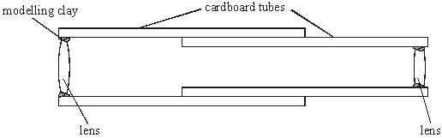
Figure 1
(i) Calculate the distance between the two lenses when the telescope is in normal adjustment.
______________________________________________________________
(ii) The Moon is 380 000 km from the Earth and has a diameter of 3 500 km. Calculate the angle subtended by the image of the full Moon when viewed through the telescope.
______________________________________________________________
______________________________________________________________
______________________________________________________________
______________________________________________________________
(iii) The telescope suffers from chromatic aberration. Describe how this affects the appearance of the image.
______________________________________________________________
______________________________________________________________
(4)
Q2.
(a) Draw a ray diagram for an astronomical refracting telescope in normal adjustment.
Your diagram should show the paths of three non-axial rays through both lenses. Label the principal foci of the two lenses.

(3)
(b) An early form of this telescope was built by Johannes Hevelius. It was 3.7 m long and had an angular magnification of 50. Hevelius used it to help produce one of the earliest maps of the Moon’s surface.
(i) Calculate the focal lengths of the objective lens and eyepiece lens in an astronomical telescope of length 3.7 m and angular magnification 50.

focal length of objective lens = ______________________ m
focal length of eyepiece lens = ______________________ m
(2)
(ii) The Triesnecker Crater on the Moon has a diameter of 23 km. Calculate the angle subtended by the image of this crater when viewed through a telescope of angular magnification 50 on the Earth.
distance from Earth to Moon = 3.8 × 10⁵ km

angle = ______________________ rad
(2)
(c) Early refracting telescopes suffered significantly from chromatic aberration. Draw a diagram to show how a single converging lens produces chromatic aberration.

(2)
Reflecting telescopes

Reflecting Telescope
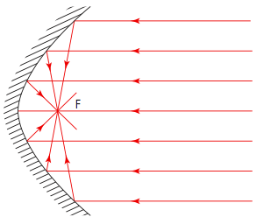
Reflecting telescopes use a curved objective mirror, or ‘primary mirror’, to collect light from a distant object and direct it onto a secondary mirror. The diameter of the primary mirror determines the ability of the telescope to collect light. The light-gathering power is proportional to the mirror area, and so to the square of the diameter of the mirror.
Spherical aberration occurs for mirrors as well as for lenses, a parabolic shape will remove this aberration because this focuses parallel light rays from a distant object to a single focal point, so eliminating spherical aberration.
The mirror itself consists of a very thin coating of silver or aluminium atoms that have been deposited onto a backing material. The thickness of this coating is often less than 25nm (2.5 × 10⁻⁸ m). This provides as smooth a surface as possible and so minimises distortions.

Magnification of Reflecting Telescopes
The magnification of a reflecting telescope is found by using the same formula as for a refracting telescope – it is the ratio of the focal length of the objective (mirror) to the focal length of the eyepiece.

Cassegrain Arrangement
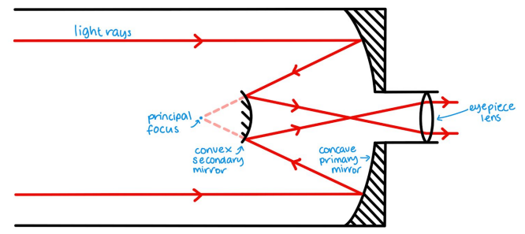
One advantage of reflecting telescopes over refracting telescopes is that they allow the large focal length of the objective mirror to be ‘folded up’ to produce an instrument with large magnification in a compact space. A common design for reflecting telescopes is the Cassegrain arrangement (below). The large primary mirror has a parabolic shape. A convex secondary mirror with a hyperbolic shape is used, which sends the rays down an opening in the primary mirror (usually in the centre), where the image is brought to a focus using an eyepiece or an imaging camera. The Hubble space telescope uses a variation of the Cassegrain design.

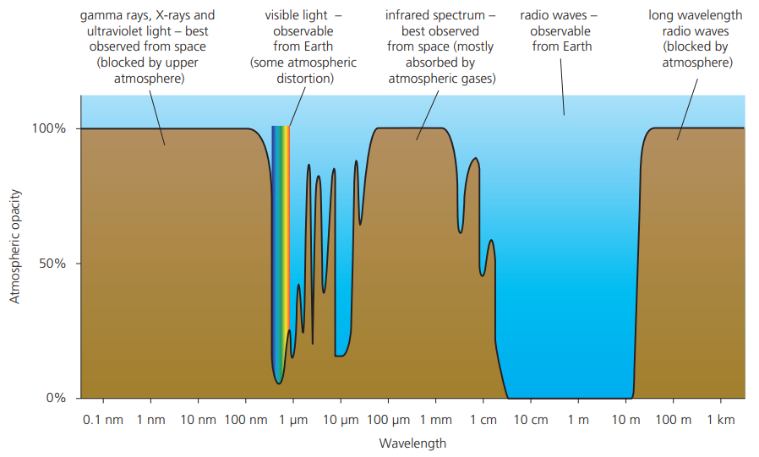
Limitations of Ground Based Telescopes
Ozone, oxygen, water vapour and carbon dioxide, in the atmosphere absorbs some ultraviolet, visible, and infrared light. Dust also absorbs and scatters light on its way to a telescope, and atmospheric turbulence (due to convection currents) reduces image quality.
We need special non-optical telescopes, for example, radio or X-ray telescopes to observe many astronomical formations and events that are not in the visible light spectrum.
Atmospheric opacity is a measure of the absorption of electromagnetic radiation by the atmosphere, as a function of wavelength.

Task: In the table below write some advantages and disadvantages of refracting telescopes compared to reflecting telescopes.
Disadvantages of refracting telescopes | Advantages of refracting telescopes

Reflecting telescopes
- Describe the difference between a reflecting telescope and a refracting telescope.
- Explain how spherical aberration arises and complete a ray diagram to show how using a parabolic mirror can overcome this.
- Calculate the magnification of a reflecting telescope that has a diameter of 0.8 m, a focal length for its primary mirror of 1800 mm and an eyepiece focal length of 35 mm.
- Draw a ray diagram to show the setup of a Cassegrain telescope.
- Calculate the magnification of a Cassegrain telescope which has a primary focal length of 2800 mm when used with eyepieces of focal length:
  - 5 mm
  - 15 mm
  - 25 mm
- Compare the advantages and disadvantages of refracting and reflecting telescope designs.
- Explain why the objective of a refracting telescope produces spherical aberration but a Cassegrain does not.
- An astronomical telescope has an objective of focal length 80.0cm and an eyepiece of focal length 5.0cm. The telescope is in normal adjustment and a distant object subtends an angle of 5.0 x10⁻³ radians at the objective. Find:
  - the length of the instrument
  - the angular magnification it produces
  - the size of the intermediate image (that is, the size of the image produced by the objective lens).

Q1.
(a) The diagram shows the concave mirror of a Cassegrain reflecting telescope, together with the eyepiece lens. Complete the diagram of the telescope and mark on it the focal point of the concave mirror. Draw a ray diagram for two rays from a star, parallel to the principal axis, passing through the telescope and emerging from the eyepiece lens
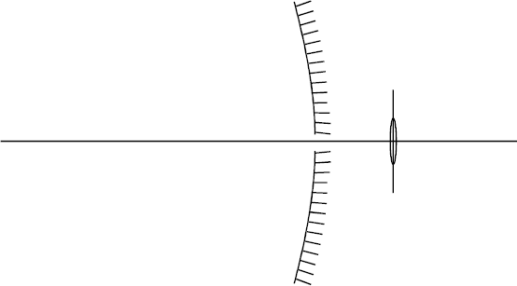
(4)

(b) State, with reasons, two optical advantages which the reflecting telescope normally has over a refracting telescope.
___________________________________________________________________
___________________________________________________________________
___________________________________________________________________
___________________________________________________________________
(2)
(Total 6 marks)
Q2.
(a) Draw a ray diagram for a Cassegrain reflecting telescope. Your diagram should show the paths of two rays from a distant object, which pass through the telescope and emerge from the eyepiece lens.

(3)
(b) (i) With the aid of a ray diagram, explain what is meant by spherical aberration of a curved mirror. State how a reflecting telescope can be designed to overcome spherical aberration.

(3)
(ii) State what is meant by chromatic aberration. Explain why a reflecting telescope does not suffer from chromatic aberration.
______________________________________________________________
______________________________________________________________
______________________________________________________________
(3)
(Total 9 marks)

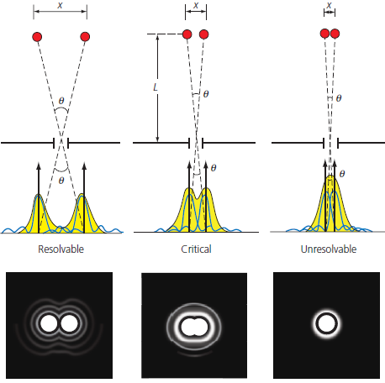
Resolving Power
Resolving power
Resolving power is a telescope’s ability to produce separate images of closely spaced objects. When light waves pass through an opening or aperture of a telescope, they will diffract (single slit diffraction) and interfere constructively or destructively, this creates a disc image instead, called an Airy disc.
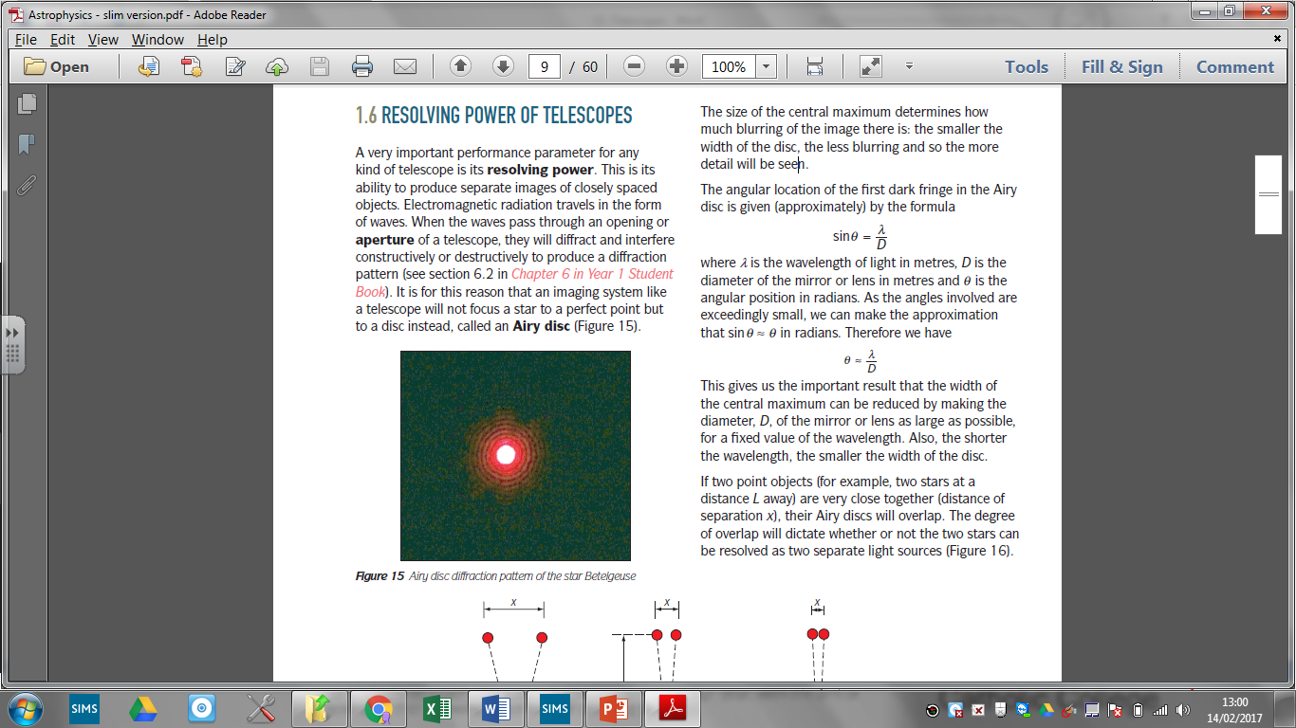
The angular location of the first dark fringe in the Airy disc is given (approximately) by the formula:
Where λ is the wavelength of light in metres, D is the diameter of the mirror or lens in metres and θ is the angular position in radians. As the angles involved are exceedingly small, sin θ ≈ θ in radians.
If two point objects (two stars at a distance L away) are very close together (distance of separation x), their Airy discs will overlap. The degree of overlap will dictate whether or not the two stars can be resolved as two separate light sources.
The Rayleigh criterion states that two point objects can be resolved if their angular separation is at least:
The angle θ is known as the minimum angular resolution of the instrument at a particular wavelength λ.

Angular Measure and the Size of Astronomical Objects
Angular measurements are used describe the apparent size of an object in space. The angular size of an object is expressed in degrees, arcminutes and/or arcseconds.
1 degree = 1°= 1/360 of a circle
1 arcminute = 1' = 1/60 of a degree
1 arcsecond = 1" = 1/60 of an arcminute = 1/3600 of a degree
Collecting Power of Telescopes
Collecting power is a measure of a telescopes ability to collect incident EM radiation. It is directly proportional to the square of the diameter of its objective. So: collecting power ∝ (objective diameter)²
An optical telescope, for example, has a collecting power specifically called its light-gathering power (LGP), measured in m².

CCDs and Quantum Efficiency
A charge-coupled device (CCD) is a semiconductor device in which light is converted directly into digital information. CCDs are divided into small regions called pixels. When light strikes the CCD, electric charge is accumulated in the pixels. Charge is proportional to the brightness at a particular pixel location. The human eye has a low QE of about 4–5%, whereas CCDs can have QEs in > 80%.

The quantum efficiency tells us how well a detector can capture photons and make them available for further amplification and imaging: $Quantum Efficiency \left(QE\right)= \frac{number of photons detected}{number of photons incident} x 100\%$
Compared to a CCD, the human eye has a higher pixel resolution (500 megapixels for the human eye, but approximately 50 megapixels for a CCD). The human eye is only sensitive to visible light though, whereas CCDs can be designed to be sensitive to not only visible light but also infrared and ultraviolet light.

Resolving power of telescopes
- What is the name for the physical phenomenon that causes the image formed by a lens or mirror of a point object to be spread out?
- Define the term Rayleigh criterion.
- Define the term resolving power.
- Two stars have an angular separation of 8.0 × 10⁻⁶ rad.
  - Assuming light from them has an average wavelength of 500 nm, calculate an approximate value for the diameter of the objective of a telescope that can just resolve the two stars.
  - Discuss how the image of the two stars would differ if they were viewed with a telescope with an objective of twice the diameter and the same angular magnification.
- The Hubble Space Telescope has an objective of diameter 2.4 m.
  - Show that the theoretical resolution of the HST is 1.2 × 10⁻⁵ degrees.
  - Hence estimate the diameter of the smallest crater on the Moon that can be seen using the telescope. Assume the wavelength of light is 500 nm. Earth–Moon distance = 3.8 × 10⁸ m
- Compare the resolving power of the human eye with a pupil diameter of 8 mm and a reflecting telescope with primary mirror diameter 20 cm.
- Calculate the minimum angular separation θ of visible light (550nm) for
  - A telescope with a primary mirror of 1m
  - A telescope with an objective lens of 5cm
  - Red (700nm) and Blue (475nm) for the above telescopes
- The table summarises some properties of Vesta, the largest object in the asteroid belt between Mars and Jupiter.
Diameter / m | Distance from the Sun / AU
Diameter / m | smallest | largest
5.4×10⁵ | 2.15 | 2.57
Calculate:
  - The largest separation between Earth and Vesta (1 AU = 1.5 x 10¹¹ m)
  - The angle subtended by Vesta at that distance.
  - The diameter of the telescope IRTF that is capable of detecting Vesta using IR wavelengths in the range 1.0 µm to 5.0 µm that has a minimum angular resolution of 3.3 x 10⁻⁷ rad.
  - The smallest object detectable on the surface of vesta using this telescope when Vesta is 1.73 x 10¹¹ m from Earth.
- Define the term collecting power.
- Compare the collecting power and resolving power of the following telescopes:
  - Hubble telescope, mirror diameter 2.4 m, wavelength 3.0 µm
  - Meade X80 with a 25.4 cm diameter mirror, wavelength 500 nm.
  - Lovell telescope at Jodrell bank with diameter 76.2 m, detecting radio waves at wavelength 6.0 cm.
- The light from a distant star is incident on a 1 m diameter objective lens. The average wavelength of the light is 550nm. Only 172 photons are detected per second on the CCD
  - Using a quantum efficiency of 70% how many photons arrive at the objective lens?
  - How much average energy does each photon carry?
  - Given the surface area of the objective lens what is the intensity in W/m²?

Q1.
(a) Draw a ray diagram for a Cassegrain telescope.
Your diagram should show the paths of two rays up to the eyepiece lens.
The rays should initially be parallel to the principal axis.
_______________________________________________________ principal axis
(2)
(b) A spacecraft passes Pluto at a distance of 12 500 km. The telescope on board has an aperture of diameter 0.21 m and operates at a wavelength of 450 nm.
Discuss whether this telescope is suitable for studying a crater with a diameter of approximately 1 km on Pluto.

___________________________________________________________________
___________________________________________________________________
___________________________________________________________________
___________________________________________________________________
___________________________________________________________________
___________________________________________________________________
(3)
(c) The Hubble telescope has an aperture of diameter 2.4 m.
Compare the collecting power of the Hubble telescope with the telescope on the spacecraft in part (b).

___________________________________________________________________
___________________________________________________________________
___________________________________________________________________
___________________________________________________________________
___________________________________________________________________
___________________________________________________________________
(2)
(d) An astrophysicist had to decide whether to use a reflecting telescope or a refracting telescope on the spacecraft in part (b).
Discuss which type of telescope to use.
___________________________________________________________________
___________________________________________________________________
___________________________________________________________________
___________________________________________________________________
___________________________________________________________________
___________________________________________________________________
___________________________________________________________________
___________________________________________________________________
(3)
(Total 10 marks)
Q2.
The Kielder Observatory in Northumberland includes two optical telescopes attached to the same mount, so that they can be used to view the same object.
Some of the properties of these telescopes are summarised in the table.

Telescope | Type | Objective diameter/mm
A | refractor | 70
B | refractor | 400
(a) The telescopes are used to view the same object.
Suggest which telescope in the table produces the brighter image.
Support your answer with a suitable calculation.
___________________________________________________________________
___________________________________________________________________
___________________________________________________________________
___________________________________________________________________
(3)
(b) The minimum angular resolution of a telescope can be determined using the Rayleigh criterion.
Explain what is meant by the Rayleigh criterion.
___________________________________________________________________
___________________________________________________________________
___________________________________________________________________
___________________________________________________________________
___________________________________________________________________
___________________________________________________________________
___________________________________________________________________
(2)
(c) Discuss which of the two telescopes in the table would be better at resolving the images of two objects that are close together.
___________________________________________________________________
___________________________________________________________________
___________________________________________________________________
___________________________________________________________________
___________________________________________________________________
___________________________________________________________________
___________________________________________________________________
(2)
(Total 7 marks)
Q3.
The Griffith Observatory in Los Angeles includes an astronomical refracting telescope (Griffith telescope) with an objective lens of diameter 305 mm and focal length 5.03 m
(a) Calculate the wavelength of light for which the Griffith telescope has a minimum angular resolution of 1.8 × 10^{–6} rad
wavelength = ____________________ m
(2)

(b) The Griffith telescope is used to observe two point objects which subtend an angle of 1.8 × 10^{–6} rad at the unaided eye.
The typical human eye has a minimum angular resolution of approximately 3.2 × 10^{–4} rad
Calculate the focal length of the eyepiece lens so that an observer can just resolve the two objects when observing them through the Griffith telescope.
focal length = ____________________ m
(3)
(c) The asteroid Apophis has a diameter of 325 m
It has been calculated that, in 2029, its distance of closest approach to the Earth’s surface will be 3.0 × 10⁴ km
The Griffith telescope may be used to view Apophis using the eyepiece calculated in question (b)
Deduce whether this telescope is suitable to obtain a detailed view of Apophis.
Support your answer with a calculation.
___________________________________________________________________
___________________________________________________________________
___________________________________________________________________
___________________________________________________________________
___________________________________________________________________
___________________________________________________________________
___________________________________________________________________
___________________________________________________________________
___________________________________________________________________
___________________________________________________________________
(3)

Telescopes can be set up to detect varying wavelengths in the electromagnetic spectrum. This can reveal images of objects that we are unable to see using only visible light and optical telescopes. The diagram to the right shows what wavelengths are transmitted through Earth’s atmosphere.
Non-optical telescopes
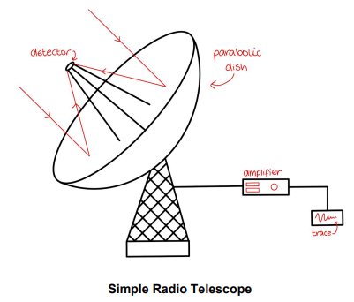
Radio telescopes use radio waves to create images of astronomical objects. Fortunately, the atmosphere is transparent to a large range of radio wavelengths (it does not absorb them) so it is possible to build radio telescopes that are ground-based. However, they should be in isolated locations so as to avoid interference from nearby radio sources. The simplest radio telescope uses a parabolic dish to focus radio waves onto a receiver.
Infrared telescopes use infrared radiation to create images of astronomical objects. These telescopes consist of large concave mirrors which focus radiation onto a detector. However, since all objects emit infrared radiation as heat, infrared telescopes must be cooled using cryogenic fluids (such as liquid nitrogen or hydrogen) to almost absolute zero. They also must be well shielded to avoid thermal contamination from nearby objects as well as its own infrared emissions.
Infrared telescopes are used to observe cooler regions in space. However, the atmosphere absorbs most infrared radiation so these telescopes must be launched into space and accessed remotely from the ground.
Ultraviolet telescopes use ultraviolet radiation to create images of astronomical objects. The ozone layer blocks all ultraviolet rays that have a wavelength of less than 300nm, meaning UV telescopes also need to be positioned in space. These telescopes utilise the Cassegrain configuration to bring ultraviolet rays to a focus. The rays are detected by solid state devices which use the photoelectric effect to convert UV photons into electrons, which then pass around a circuit. UV telescopes can be used to observe the interstellar medium and star formation regions.
X-ray telescopes use X-rays to create images of astronomical objects. Since all X-rays are absorbed by the atmosphere, these telescopes need to be in space to collect data. These rays have such high energy that using mirrors like an ordinary optical telescope would not work as they would just pass straight through. This means that X-ray telescopes must be made from a combination of parabolic and hyperbolic mirrors, all of which must be extremely smooth.
The rays enter the telescope, skim off the mirrors, and are brought into focus on CCDs which convert light into electrical pulses. Since X-rays are high-energy, they can be used to observe high-energy events and areas of space such as active galaxies, black holes and neutron stars.
Gamma telescopes use gamma radiation to create images of astronomical objects. These telescopes do not use mirrors at all as gamma rays have so much energy they would just pass straight through. Instead, they use a detector made of layers of pixels. As the gamma photons pass through, they cause a signal in each pixel they come into contact with. These telescopes are used to observe things such as gamma ray bursts (GRBs), quasars, black holes and solar flares.
Non-optical telescopes
- Explain why an X-ray telescope must be placed in orbit.
- Explain why it is advantageous to place an optical telescope on the top of a mountain.
- The Arecibo telescope has a diameter of 305 m and is used for observations of radio wavelengths at 4 cm. What is the theoretical angular resolution at this wavelength? How does this compare with an optical telescope of diameter 5.1 m observing wavelengths of 550 nm?
- SOFIA is a flying IR observatory housed in an aircraft, with a telescope objective dish of diameter 2.4 m. If it is observing an object at a wavelength of 24 μm, what is its minimum angular resolution? How would this compare with that of an optical telescope of the same diameter observing at 510 nm?
- The Arecibo telescope has a diameter of 305 m, while the Lovell telescope has a diameter of 76.2 m. By how many times greater is the collecting power of the Arecibo telescope?
- The IUE had a parabolic mirror of diameter 45 cm and focused UV radiation. For a wavelength of 120 nm, compare its minimum angular resolution and its collecting power with that of an optical telescope of the same diameter operating at 550 nm.
- The detector on a UV telescope uses the photoelectric effect to convert UV photons to electrons. Calculate the energy of a UV photon with a wavelength of 100 nm.
- Why do radio telescopes need to be placed away from cities and towns?
- Linking radio telescopes into an array has both advantages and disadvantages. Discuss these and explain why these arrays are used.
- If the twin Keck telescopes on Mauna Kea, Hawaii, are operating as an optical interferometer with a baseline of 85 m, what is the theoretical angular resolution at a wavelength of 2.2 μm?
- The Multi-Element Radio Linked Interferometer Network (MERLIN) is a radio interferometer made up of seven radio telescopes spread across England (Figure A1). MERLIN has a minimum angular resolution of 40 milliarcseconds, which is similar to that of the Hubble space telescope at optical wavelengths, and is equivalent to measuring the diameter of a one-pound coin from a distance of 100 km.
  - One of MERLIN’s antennas, at Jodrell Bank, has dish diameter of 28 m. What is its theoretical angular resolution in arcseconds when used alone to observe 1.5 cm radio waves?
  - The longest baseline currently possible with MERLIN’s antennas is 217 km. If they are observing a radio source at a wavelength of 6 cm, what is the theoretical resolution in arcseconds?
  - Compare the resolution of MERLIN in your answer to b with the minimum optical angular resolution of the Hubble space telescope, which is 0.05 arcsecond.
  - Suppose that two of MERLIN’s antennas were placed on the equator at opposite ends of the Earth’s diameter. What would the theoretical angular resolution at this wavelength then be? [Radius of Earth = 6400 km]
  - Explain the advantage of having seven dishes across England linked up as a network.
- ALMA (Atacama Large Millimeter/ submillimeter Array) is a large radio interferometer sited at an altitude of 5000 m in northern Chile, at the European Southern Observatory
  - Why is ALMA situated at high altitudes?
  - What is the theoretical resolution at a radio frequency of 1 THz of
    - a single dish
    - the whole array?
    - By what order of magnitude is the resolution improved?
  - What kind of objects is ALMA designed to investigate?

Q1.
(a) The lenses used in refracting telescopes can cause chromatic aberration.
Complete the diagram to show how a lens produces chromatic aberration.
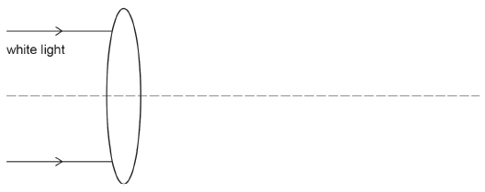
(1)
(b) A Cassegrain telescope uses mirrors.
What are the shapes of the primary and secondary mirrors in a Cassegrain telescope?
Tick (✔) one box.

Primary mirror | Secondary mirror
concave | concave
concave | convex
convex | concave
convex | convex
(1)
(c) The table contains information about two telescopes, A and B. Each telescope is planned to be the biggest of its type in the world.

Telescope | A | B
Type | Optical reflecting telescope | Radio telescope
Diameter / m | 39.3 | 110
Range of wavelengths detected | 350 nm to 1800 nm | 2.5 mm to 1000 mm
Discuss the similarities and differences between optical reflecting telescopes and radio telescopes. Your answer should include references to:
• structure
• positioning
• collecting power.
Go on to discuss which telescope, A or B, will give a more detailed image of an astronomical object that emits both radio waves and visible light.

___________________________________________________________________
___________________________________________________________________
___________________________________________________________________
___________________________________________________________________
___________________________________________________________________
___________________________________________________________________
___________________________________________________________________
___________________________________________________________________
___________________________________________________________________
___________________________________________________________________
___________________________________________________________________
(6)
(Total 8 marks)
Q2.
(a) State two similarities between a radio telescope and an optical reflecting telescope.
___________________________________________________________________
___________________________________________________________________
___________________________________________________________________
___________________________________________________________________
(2)
(b) The dish of a radio telescope has holes of diameter 20 mm spaced close together in its reflecting surface in order to reduce the weight of the dish. Explain why the performance of this telescope will be far more satisfactory when receiving signals of frequency 7.5 × 10⁸ Hz than when receiving signals of frequency 1.5 × 10¹⁰ Hz.
___________________________________________________________________
___________________________________________________________________
___________________________________________________________________
___________________________________________________________________
(3)
(c) Explain why the resolving power of a single dish radio telescope is normally much less than that of a normal optical telescope.
___________________________________________________________________
___________________________________________________________________
___________________________________________________________________
(2)
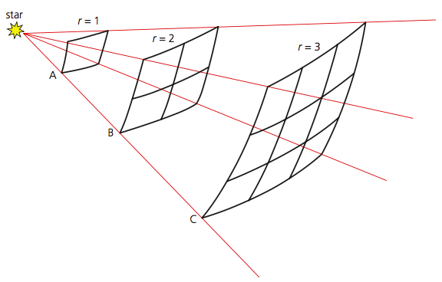
Luminosity, brightness & magnitude
Stellar Luminosity
As it spreads out from distant objects, light obeys an inverse square law. The luminosity L of a star is the amount of energy in Joules it actually radiates per second (that is, its power) and is measured in watts, W.
The intensity of the radiation is defined as the brightness, b, of a star: $b=\frac{L}{4πr^{2}}$
The unit of brightness is Wm⁻².
Stellar Magnitude
Relative brightness, from Earth, is expressed on the Hipparchus scale. On this scale, stars are classified by their apparent magnitude, m, with the brightest stars that can be seen with the naked eye as magnitude 1.0 and the faintest as magnitude 6.0. The more negative the value of apparent magnitude, the brighter the star appears.
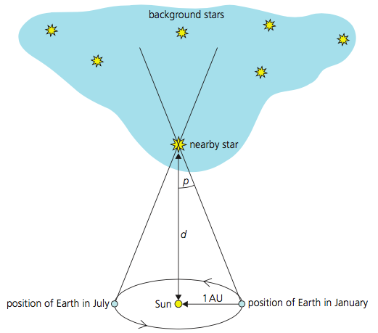
The magnitude scale is therefore a logarithmic scale. called Pogson’s law, expressed as:
$$m_{1}-m_{2}= -2.5\log_{10}\left(\frac{b_{2}}{b_{1}}\right)$$Where m₁ = apparent magnitude of star 1, b₁ = received brightness of star 1, m₂ = apparent magnitude of star 2, b₂ = received brightness of star 2, and log means log to the base 10, that is, log₁₀.
Astronomical Distances
The mean distance from the Earth to the Sun is called the astronomical unit (AU) and 1 AU is equal to 1.50 × 10¹¹ m.
For interstellar distances, astronomers use a unit called the parsec.
The effect of parallax can be used to measure how far stars are from Earth. The parallax angle of a star is half the angle that a star moves in six months, against a background of very distant stars. Parallax angle p (measured in radians) is related to the distance d of the star by: $d=\frac{1AU}{\tan{p}}= \frac{1AU}{P}$ using the fact that, for small angles, tan p = p. One radian = 57° 17′ 45″ radians to arcsecond (″): 1 rad = (57 × 3600)″ + (17 × 60)″ + 45 = 206 265″
So: $d=\frac{206265}{p(arcsecond)}$ (1 parsec (1 pc) = 206 265 AU) so: $d=\frac{1}{p}$
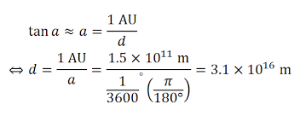
1 parsec is the distance at which the observed parallax angle of the star is equal to 1 arcsecond (1 second of arc).
1 kiloparsec (1 kpc) = 103 pc 1 megaparsec (1 Mpc) = 106 pc
One light year (ly) is the distance that a photon of light travels through space in one year (3 × 108 m s⁻¹).
1 light minute = 3.00 × 108 m s−1 × 60 s =1.80 × 1010 m
1 light second = 3.00 × 108 m s−1 × 1 s = 3.00 × 108 m
Also: 1 pc = 3.26 ly
Absolute Magnitude
Absolute magnitude is the measure of brightness of a celestial object. It is the hypothetical apparent magnitude of an object at a standard distance of exactly 10 parsecs (32.6 light years) from the observer: 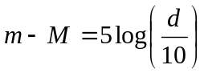
The quantity (m − M) is called the distance modulus.

Luminosity, Brightness and magnitude
- How many times brighter is a star with apparent magnitude of 2.5 compared to a star with apparent magnitude 3.8?
- How many times brighter is a star with apparent magnitude of -0.5 compared to a star with apparent magnitude 2.1?
- How many times brighter is a star with apparent magnitude of 2.3 compared to a star with apparent magnitude 2.9?
- How many times brighter is a star with apparent magnitude of -4.2 compared to a star with apparent magnitude 2.8?
- What is the difference in brightness as seen from the Earth for two stars with the same Luminosity, but one star is 4 times closer to the Earth?
- What is the difference in brightness as seen from the Earth for two stars with the same Luminosity, but one star is 6.5 times closer to the Earth?
- If star B has a luminosity of 3x the luminosity of star A, but is 6 times further away, what is the difference in brightness as seen at Earth?
- Two stars have the same Luminosity of 4 x 10²⁶ W. What is
  - The brightness of 1 star at 150 million km?
  - The brightness of the other star at 3.97 x 10¹³ km?
  - What is the ratio of their brightness?
- What is the definition of the parsec?
- Will a nearby star have a large, or small parallax angle?
- What is the parallax angle of a star that is at a distance of 20 pc?
- What is the parallax angle of a star at 650 ly?
- What is the distance to a star if the parallax angle is 0.2 milliarcseonds
- A star has a parallax angle of 0.3’’. What is the distance from Earth in:
  - Astronomical units
  - Light years
  - Parsecs
- What is the difference between apparent and absolute magnitude?
- At what distance is absolute magnitude calculated?
- Why does the Sun have a negative apparent magnitude?
- A star has an apparent magnitude of 3.8 and is 1000 pc away. What is the star’s absolute magnitude?
- A star has an absolute magnitude of -2.4 and is 100 pc away. What is the star’s apparent magnitude?
- A star has an apparent magnitude of 7.3 and is 10 000 pc away. What is the star’s absolute magnitude?
- A galaxy has an absolute magnitude of -18.4 and is 1000 kpc away. What is the star’s apparent magnitude?
- A star has an apparent magnitude of -0.3 and is 100 pc away. What is the star’s absolute magnitude?
- A star has an absolute magnitude of -4.8 and is 100 pc away. What is the star’s apparent magnitude?
- A star has an apparent magnitude of 9.6 and is 10 kpc away. What is the star’s absolute magnitude?
- The apparent magnitude of a distant galaxy is 10.9. If the galaxy is 10 Mpc away, determine its absolute magnitude.
- M62, a globular cluster in the constellation Ophiuchus, appears as a faint 6.5 magnitude patch of light through binoculars. If M62 was 1.0 kpc away from us, what would its absolute magnitude be?
- M65 is a galaxy in the constellation Leo, 10 Mpc away. Through a small telescope, M65 has an apparent magnitude of 9.3. Calculate the absolute magnitude of M65.

Q1.
The table has information on two stars.

Star | Apparent magnitude | Absolute magnitude | Spectral class
Sirius | –1.4 | –1.4 | A
Rigel | 0.12 | –7.1 | B
(a) State the difference between apparent magnitude and absolute magnitude.
___________________________________________________________________
___________________________________________________________________
___________________________________________________________________
(2)
(b) Sirius has an intensity of 1.18 × 10^{–7} Wm^{–2} at the Earth. The distance between Sirius and the Earth is 8.13 × 10¹³ km.
Calculate the luminosity of Sirius.
Give an appropriate unit for your answer.
luminosity ____________________ unit __________
(3)
(c) State which star in the table is closer to the Earth.
Explain your reasoning.
___________________________________________________________________
___________________________________________________________________
___________________________________________________________________
(2)
(Total 7 marks)
Q2.
(a) Explain what is meant by
apparent magnitude
___________________________________________________________________
___________________________________________________________________
absolute magnitude
___________________________________________________________________
___________________________________________________________________
(2)
(b) (i) The star Betelgeuse has a mean apparent magnitude of +0.5 and an absolute magnitude of –5.7. Use the definitions you have given above to deduce (without calculation) that the distance between Betelgeuse and Earth is greater than 10 pc.
______________________________________________________________
______________________________________________________________
______________________________________________________________
______________________________________________________________
(ii) The star Proxima is much closer to Earth than 10 pc and its mean apparent magnitude is +11.0. Giving a reason, suggest a value for its absolute magnitude.
______________________________________________________________
______________________________________________________________
______________________________________________________________
(iii) Using the values of apparent magnitude and absolute magnitude from part (b) (ii), determine the distance, in pc, between Proxima and Earth.
______________________________________________________________
______________________________________________________________
______________________________________________________________
(6)
(Total 8 marks)

Stefan and Boltzmann’s Law
Star classification by temperature
The luminosity of a star depends on the temperature of the star and its size. When heated, stars will emit EM radiation over a range of wavelengths, with a total intensity that is proportional to the fourth power of its absolute temperature. This can be written as: I ∝ T⁴. Where I is the intensity, or radiated power per unit area, and T is the absolute temperature in kelvin. We then obtain the Stefan–Boltzmann law, or Stefan’s law as it is more commonly known:
P = σ AT⁴ (remember for a spherical star of radius R, the surface area is 4πR²). So: P = σ 4πR²T⁴
Where P is the total power in Watts radiated by an object of surface area A, and σ is a constant of proportionality called the Stefan–Boltzmann constant, which is equal to 5.67 × 10⁻⁸ W m⁻² K⁻⁴.
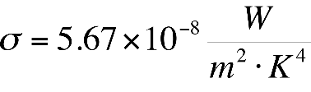
If an object is an efficient absorber of radiation at a given wavelength, then it will also be an efficient radiator at that wavelength. It was shown by Boltzmann that Stefan’s law is valid only for a body that is a perfect absorber of energy. Such an object is known as a black body, because it does not reflect any light.
Its radiated energy flux depends only on its temperature and not on its surface composition, in accordance with Stefan’s law.
Wien’s displacement law
A black body emits electromagnetic radiation over a wide range of wavelengths, but there will be one wavelength, called the peak wavelength, for which the emission of radiation has its maximum intensity. The wavelength of the peak emission intensity is inversely proportional to the absolute temperature of the object.
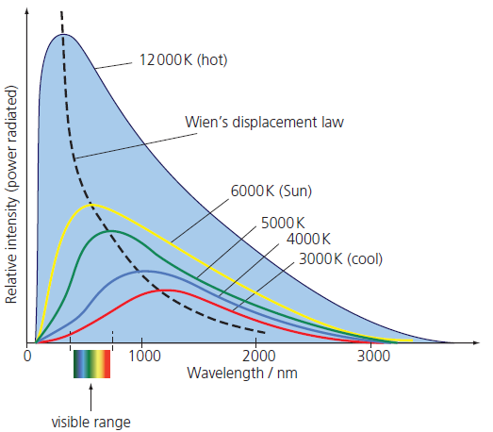
λ_{max}T = constant = 2.90 ×10⁻³ m K (This relationship is known as Wien’s displacement law or sometimes simply Wien’s law. Note that ‘m K’ is metre kelvin, not millikelvin).

It shows that the dominant wavelength of a black-body radiator decreases as its gets hotter.
Notice that the higher the temperature, the shorter the wavelength of maximum intensity, just as we would expect from Wien’s law.
These curves are called black-body curves. It is important to realise that when you see a black-body curve you know that the processes that give rise to the emission of radiation depend only on temperature and not on any other property, such as the chemical composition of the object.

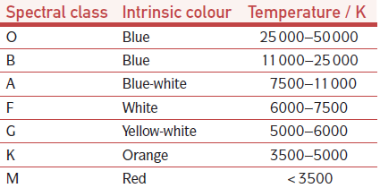
Stellar Spectral Classes

Stars are classified by their temperature using letters of the alphabet. There are seven main types of stars denoted, in order of decreasing temperature, O, B, A, F, G, K and M (Only Bright Astrophysicists Fight Green Killer Martians).

Classification by temperature
- What are the units for the Stefan-Boltzmann constant?
- What effect does doubling the temperature have on the power output of a star?
- How does doubling the radius effect the power output of a star?
- What is the power output of a star with radius 8 x 10⁸ m and surface temperature of 5000 K?
- A star has a power output of 5.9 x 10²⁸ W, and surface temperature of 10 000 K. Calculate
  - Its radius
  - The ratio of its radius to that of the Sun (radius of Sun = 7.0 x 10⁸ m)
- The radius of the Sun is 7.0 x 10⁸ m and has a power output of 3.846 × 10²⁶ W. Calculate its surface temperature.
- Given a Dyson sphere the size of the Earth’s orbit around the Sun, calculate its surface temperature.
- If Jupiter were caused to ignite stellar fusion and become a star with the same surface temperature as the Sun what would its equivalent power output be? R_{J} = 6.9 x 10⁴ km?
- Sketch the blackbody radiation for a typical star
- A star has λ_{max} 500 nm. Calculate its surface temperature.
- What is the peak wavelength for a star with a surface temperature of 18000 K
- Calculate the surface temperature of a star whose intensity peaks at a wavelength of 0.4 µm
- A star has a λ_{max} of 650nm and a radius of 700 000 km..
  - Calculate its surface temperature
  - Calculate its surface area
  - Calculate its power output
- A star has a luminosity of 4.0 x 10²⁶ W. If it has a peak intensity at a wavelength of 550 nm, calculate:
  - The temperature at the surface
  - The radius of the star
  - The flux from the star at a distance of 1 AU
- A star has a power output of 5 x 10³⁰ W and a peak emission of 100 nm. Determine
  - Temperature at the surface
  - Radius of the star
  - Spectral class
- What radius of star in spectral class F is needed for a power output at the surface of 2.5 x 10²⁷ W?
- A star has a surface radius of 2 R⊙ and a luminosity of 3 L⊙. Calculate:
  - Surface temperature
  - Spectral class

Q1.
The table summarises some information about four stars in the constellation Cassiopeia.

Name | Colour | Apparent magnitude | Distance / ly
Caph | white | 2.3 | 55
Ruchbah | blue/white | 2.7 | 99
Schedar | orange | 2.2 | 228
Tsih | blue | 2.2 | 610
(a) Which star has the highest surface temperature?
Tick (✓) one box.

Caph | 
Ruchbah
Schedar
Tsih
(1)
(b) The graph below shows the intensity received at Earth from two of the stars, plotted against wavelength.
The effect of absorption by the Earth’s atmosphere is not shown.
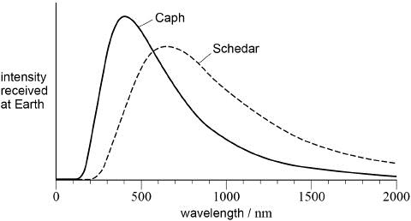
Discuss what information can be found from the graph about the temperature and colour of these stars.
Support your answer with suitable calculations.

___________________________________________________________________
___________________________________________________________________
___________________________________________________________________
___________________________________________________________________
___________________________________________________________________
___________________________________________________________________
___________________________________________________________________
___________________________________________________________________
(4)
(c) State which star in the table above is dimmest on the absolute magnitude scale.
___________________________________________________________________
(1)
(d) Calculate the absolute magnitude of Schedar.

absolute magnitude = _______________
(3)

Q2.
The table summarises some of the properties of four stars in the constellation Hercules.

Star | Distance/pc | Spectral class | Apparent magnitude
Kornephoros | 43 | G | 2.8
Rasalgethi | 110 | M | 3.0
Rutilicus | 11 | G | 2.8
Sarin | 23 | A | 3.1
(a) Define the parsec. You may use a diagram as part of your answer.
___________________________________________________________________
___________________________________________________________________
___________________________________________________________________
___________________________________________________________________
(2)
(b) Deduce which star is larger, Kornephoros or Rutilicus.
___________________________________________________________________
___________________________________________________________________
___________________________________________________________________
___________________________________________________________________
___________________________________________________________________
___________________________________________________________________
___________________________________________________________________
___________________________________________________________________
___________________________________________________________________
(3)

(c) One of the four stars has the peak in its black-body radiation curve at a wavelength of 1.0 μm.
Calculate the corresponding temperature for this curve.
temperature = ____________________ K
(2)
(d) Explain which star produced the black-body radiation curve described in question (c).
___________________________________________________________________
___________________________________________________________________
___________________________________________________________________
___________________________________________________________________
(2)
(e) Which star has the brightest absolute magnitude?
Tick (✔) the correct box.

Kornephoros | 
Rasalgethi
Rutilicus
Sarin
(1)
(f) Determine the absolute magnitude of Sarin.
absolute magnitude = ____________________
(3)
(Total 13 marks)

Spectroscopy
Stellar spectroscopy
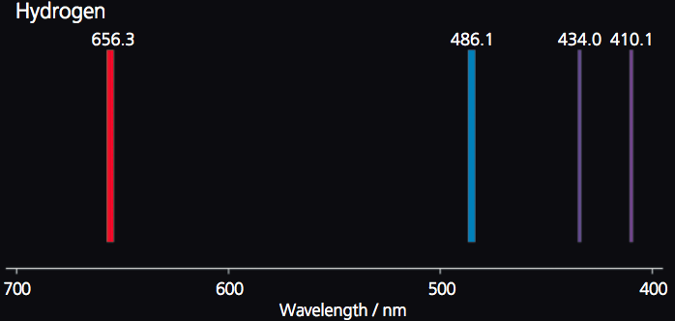
Stellar spectroscopy is a method of analysing the spectrum of stars. Spectroscopy gives rise to three types of spectra:
› an emission line spectrum
› an emission continuous spectrum
› an absorption spectrum.
After heating, electrons are raised to new energy levels, and eventually return to lower energy levels. The atoms then emit photons at precise characteristic energies corresponding exactly to the spacing of the energy levels within the atoms of the gas. The spectrum recorded is of bright lines on a dark background, an emission line spectrum with the intensity and position of these lines corresponding to particular electronic transitions in the atoms of the gas.
In the time it takes atoms to drop down to a lower energy level, further atomic collisions have occurred. This results in a blurring of the emission spectrum and the loss of any detail about the atoms in the gas, giving rise to a continuous spectrum. This is typical of the emission spectrum obtained from the region of a star, the photosphere.

The photosphere acts as a source of visible light. This light then passes through the outer layers of the Sun, which are much cooler and composed mainly of hydrogen gas. Photons of the characteristic energies of the transitions in the gas will be absorbed and atomic electrons raised to an excited state (perhaps to the second level or shell, n = 2, or even higher shells, n = 3, 4, 5, 6 and so on). As electrons fall back to the rest level, n = 1 (the ground state), or intermediate levels, photons are emitted, but in random directions. The resulting spectrum comprises dark lines (undetected photons) characteristic of an
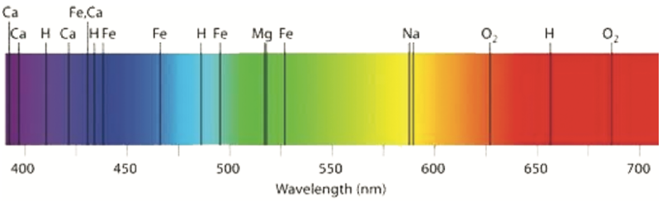
The absorption lines for hydrogen in the visible part of the spectrum result from electrons moving from the rest excitation level (n = 2) to higher energy levels. This leads to a series of dark lines called the Balmer series. The intensity of the absorption lines depends on the particular temperature of the star’s photosphere.
Other dark lines in a star’s absorption spectrum are characteristic of other particular elements within the gas in the outer layers. A full analysis of the absorption lines also reveals the state of the atoms, that is, whether they are neutral or ionised, which also depends on the temperature. The absorption spectrum therefore not only enables identification of the elements present in the star
but also allows the temperature of the star to be determined accurately.
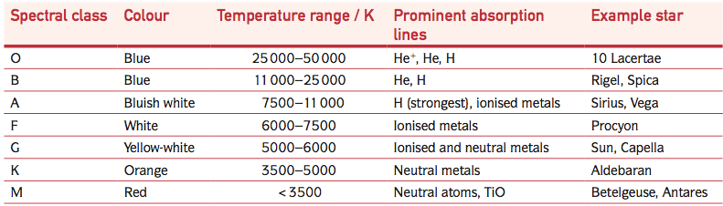
The relative strength of particular absorption lines, and hence temperature, gives the spectral class of a star. We can further define the classification by temperature with a description of the prominent spectral absorption lines, as shown in the table shown.

Q1.
(a) The table summarises the properties of five of the stars in the constellation of Cassiopeia.

name | absolute  magnitude | apparent  magnitude | spectral class
Achird | 4.6 | 3.5 | G
Chaph | 1.9 | 2.3 | F
Ruchbah | 0.24 | 2.7 | A
Segin | –2.4 | 3.4 | B
Shedir | –0.9 | 2.2 | K
Explaining your answer in each case, state which star
(i) is the hottest,
______________________________________________________________
______________________________________________________________
______________________________________________________________
(ii) is likely to appear orange in colour,
______________________________________________________________
______________________________________________________________
______________________________________________________________
(iii) appears the brightest from Earth,
______________________________________________________________
______________________________________________________________
______________________________________________________________
(iv) is less than 10 pc away from the Earth.
______________________________________________________________
______________________________________________________________
______________________________________________________________
(4)
(b) The constellation Cassiopeia contains another star with an apparent magnitude of 2.2, absolute magnitude of –4.6 and a surface temperature of 12 000 K. Calculate, for this star,
(i) its distance from the Earth,
______________________________________________________________
______________________________________________________________
______________________________________________________________
(ii) the peak wavelength in its black body radiation curve.
______________________________________________________________
______________________________________________________________
______________________________________________________________
(3)
(Total 7 marks)
Q2.
(a) The graph shows part of the visible region of the spectrum of the star Vega.
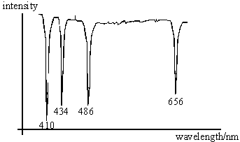
The absorption lines are due to excited hydrogen atoms. The wavelength of each absorption is given in nm.
You may be awarded marks for the quality of the written communication provided in your answer.
(i) Explain how hydrogen atoms produce these absorption lines.
______________________________________________________________
______________________________________________________________
______________________________________________________________
______________________________________________________________
(ii) The diagram below shows the first six energy levels of a hydrogen atom. Draw an arrow to show the largest energy transition which produces an absorption line in the visible spectrum of Vega.

(iii) State the value of the wavelength corresponding to this transition.
______________________________________________________________
(iv) What is the name given to the series which gives rise to the visible region of the hydrogen spectrum?
______________________________________________________________
(v) For which spectral classes are these lines the dominant feature?
______________________________________________________________
(4)
(b) (i) The wavelength at maximum intensity in the spectrum of Vega has a value of 300 nm. Show that this corresponds to a value of about 10 000 K for the surface temperature of Vega.
______________________________________________________________
______________________________________________________________
______________________________________________________________
(ii) State the assumption made in your answer to (b)(i).
______________________________________________________________
(2)
(c) State the spectral class to which Vega belongs, giving a reason for your answer.
___________________________________________________________________
___________________________________________________________________
(1)
(Total 7 marks)
Q3.
The table summarises some of the properties of four stars in the constellation Hercules.

Star | Distance/pc | Spectral class | Apparent magnitude
Kornephoros | 43 | G | 2.8
Rasalgethi | 110 | M | 3.0
Rutilicus | 11 | G | 2.8
Sarin | 23 | A | 3.1
(a) Define the parsec. You may use a diagram as part of your answer.
___________________________________________________________________
___________________________________________________________________
___________________________________________________________________
___________________________________________________________________
(2)
(b) Deduce which star is larger, Kornephoros or Rutilicus.
___________________________________________________________________
___________________________________________________________________
___________________________________________________________________
___________________________________________________________________
___________________________________________________________________
___________________________________________________________________
___________________________________________________________________
___________________________________________________________________
___________________________________________________________________
(3)
(c) One of the four stars has the peak in its black-body radiation curve at a wavelength of 1.0 μm.
Calculate the corresponding temperature for this curve.
temperature = ____________________ K
(2)
(d) Explain which star produced the black-body radiation curve described in question (c).
___________________________________________________________________
___________________________________________________________________
___________________________________________________________________
___________________________________________________________________
(2)
(e) Which star has the brightest absolute magnitude?
Tick (✔) the correct box.

Kornephoros
Rasalgethi
Rutilicus
Sarin
(1)
(f) Determine the absolute magnitude of Sarin.
absolute magnitude = ____________________
(3)
(Total 13 marks)

Birth of Stars

Star Birth
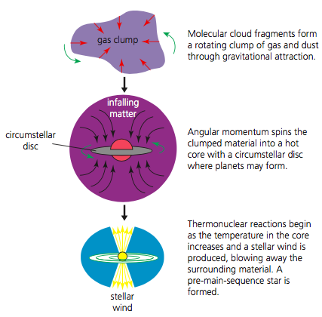
Stars are born in the ‘space’ between stars called the interstellar medium, which contains molecular clouds (see right) that are mostly made up of cold hydrogen gas in the form of atoms. About 1% of this material is ‘dust’ in the form of silicates and graphite material.

Protostars are formed when the irregular clumps rotate, and the action of gravity and the conservation of angular momentum spins them inwards to form a denser spherical centre. As such, the density and temperature increase. This is surrounded by a rotating at disc of material called the circumstellar disc, where planets may form. and

After a time the temperature of the star so that the mutual electrostatic repulsion between hydrogen nuclei can be overcome and nuclear fusion reactions begin in its core. A strong outward stellar wind is produced, which opposes the infall of material. It starts to shine in the visible part of the electromagnetic spectrum, and is now known as a pre-main-sequence star.

Main Sequence Stars and Nuclear Fusion
An equilibrium state is reached because of a balance between the star’s own gravitational force due to mass of its outer layers pushing inwards and the internal gas pressure caused by hydrogen burning pushing outwards.
The star now has a fixed mass, and its energy comes only from nuclear fusion, not from gravitational contraction. It is now a main-sequence star. Its mass will determine its future evolution.
The fusion of hydrogen nuclei with a release of nuclear binding energy, known as hydrogen burning, is the primary source of energy generation in main-sequence stars.
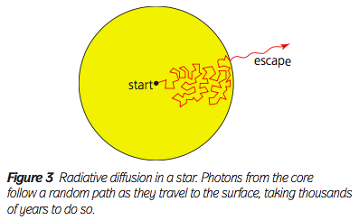
There are two principal nuclear reaction pathways in which hydrogen burning occurs in a star, determined by the core temperature of the star. These are the proton–proton chain (or p–p chain) and the carbon–nitrogen–oxygen cycle (or CNO cycle). In each of these reactions, four protons combine by nuclear fusion to form a single helium nucleus with a small loss of mass, which, by the mass–energy relation ∆E = ∆mc² is released as energy.
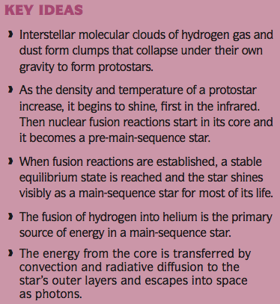
Energy from the fusion reactions is transported from the core to the outermost layers by convection and radiative (photon) diffusion.

Nuclear Reaction Pathways
The CNO cycle has 6 steps:
$${}_{6}^{12}C+{}_{1}^{1}H→{}_{7}^{13}N+γ$$

$${}_{7}^{13}N→{}_{6}^{13}C+{}_{1}^{0}e+ν_{e}$$
$${}_{6}^{13}C+{}_{1}^{1}H→{}_{7}^{14}N+γ$$
$${}_{7}^{14}N+{}_{1}^{1}H→{}_{8}^{15}O+γ$$

$${}_{8}^{15}O→{}_{7}^{15}N+{}_{1}^{0}e+ν_{e}$$

${}_{7}^{15}N+{}_{1}^{1}H→{}_{6}^{12}C$+${}_{2}^{4}{He}$
proton–proton chain converts hydrogen into helium in three steps:

$${}_{1}^{1}H+{}_{1}^{1}H→{}_{1}^{2}H+{}_{1}^{0}e+ν_{e}$$
$${}_{1}^{1}H+{}_{1}^{2}H→{}_{2}^{3}{He}+γ \\ {}_{2}^{3}{He}+{}_{2}^{3}{He}→{}_{2}^{4}{He}+{}_{1}^{1}H+{}_{1}^{1}H$$
Life of Stars
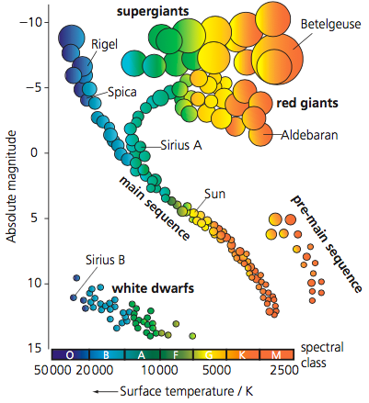

Hertzsprung-Russel Diagram
A graph of absolute magnitude versus spectral class of a star is known as a Hertzsprung–Russell diagram (or HR diagram).
An HR diagram is essentially a plot of the luminosity of stars against their surface temperature. The stars on the HR diagram are divided into four principal groupings:
- Main sequence (the long diagonal band). At the top of the main sequence are the hot and luminous blue stars, and at the bottom are the cool and dim reddish stars.
- Red giants are similar in mass to our Sun but have an expanded outer shell and hence large size and surface area. They are cooler and hence redder but highly luminous. Nuclear fusion of helium occurs in their cores.
- Supergiants have masses typically 10–100 times that of the Sun and are therefore substantially larger and more luminous even than the red giants. In their cores the temperatures are hot enough for nuclear fusion reactions to produce carbon and heavier elements.
- White dwarfs are old stars that have a high surface temperature but are not very luminous, because they no longer generate energy by nuclear fusion, and because they are small (planet sized). They are extremely dense. Eventually, they cool to the point of emitting no heat or light and become black dwarfs, which appears to be the end state of all low-mass stars.
From the HR diagram, we can see different stages of stellar evolution – how stars are born, grow old and die.
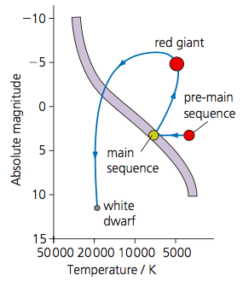
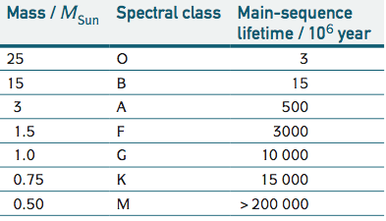
Evolution of a Sun-like star on the Hertzsprung–Russell diagram
A star will move through different stages in the HR diagram as it moves though different stages in its own life cycle. Eventually, when the red giant star has exhausted (following the path of protostar → pre-main sequence star → main sequence star → red giant) all of its nuclear fuel, its outer layers are ejected (thrown off), forming a planetary nebula (Figure 6), and its core collapses into a dense white dwarf. Since nuclear burning has ceased, there is no more outward pressure to halt the crushing force of gravity, and the core of a white dwarf is compressed to a size roughly the same as that of the Earth.
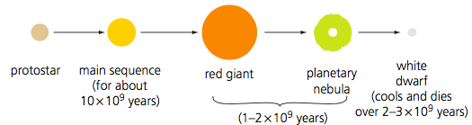
The lifetimes of stars
The lifetime of a star is determined by its mass. Stars spend roughly 90% of their lives converting hydrogen into helium on the main sequence, and the mass of a star determines the rate of hydrogen burning. In more massive stars fusion reactions proceed at a faster rate than in lower mass stars due to the higher temperature and pressures in their cores. The Sun, a G type star, has a main-sequence lifetime of about 10¹⁰ years. It is currently about 5 × 10⁹ years old. Stars higher along the main sequence than the Sun (spectral classes O to F) must be younger than the Sun or they would have used up all the hydrogen in their cores and would have moved off the main sequence.

Q1.
The absolute magnitude and spectral class of four stars W, X, Y and Z are plotted using the axes below.
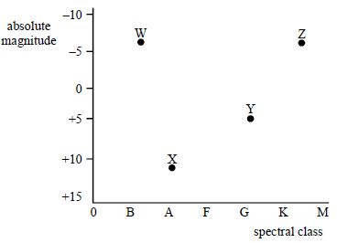
(a) Draw and label, on the diagram above, the regions occupied by the main sequence, white dwarf stars and red giant stars.
(2)
(b) The following observations were made for the star Alnilam in the constellation of Orion.
apparent magnitude: 1.7
distance from Earth: 1350 light years
spectrum: strong hydrogen Balmer absorption lines
(i) Explain what is meant by apparent magnitude.
______________________________________________________________
______________________________________________________________
(ii) Calculate the distance in parsecs of Alnilam from the Earth.
______________________________________________________________
______________________________________________________________
(iii) Hence calculate the absolute magnitude of Alnilam.
______________________________________________________________
______________________________________________________________
______________________________________________________________
______________________________________________________________
(iv) Which of the stars, W, X, Y or Z is Alnilam? Explain your answer.
______________________________________________________________
______________________________________________________________
(7)

(c) The stars shown on the graph could represent the position of a star at different times during its evolution. Write down the correct sequence, using some or all of the letters, that would best represent the evolution of the Sun starting from its present position.
___________________________________________________________________
(1)
(Total 10 marks)
Q2.
(a) Sketch a Hertzsprung−Russell diagram on the axes on the graph below. Label the position of the main sequence, white dwarf and giant stars.
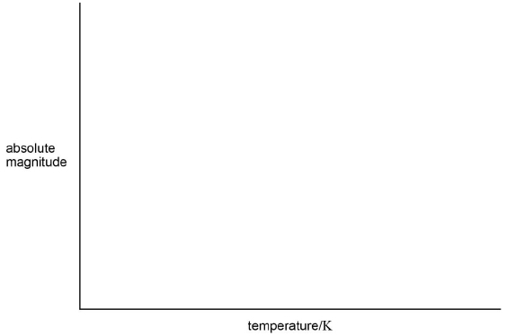
(3)
(b) Label the minimum and maximum values on the scale of each axis.
(2)
(c) Some of the properties of three stars are shown in the table below.

 | Rigel | Omicron 2 Eridani | Regulus A
distance/light year | 860 | 16.5 | 79
apparent magnitude | 0.13 | 9.5 | 1.3
temperature/K | 12 000 | 16 500 | 12 500
Identify the spectral class to which all three stars belong.

Tick (✔) the correct answer in the right hand column.

✔ if correct
A
B
F
G
K
M
O
(1)
(d) Explain your answer to part (c).
___________________________________________________________________
___________________________________________________________________
___________________________________________________________________
___________________________________________________________________
(2)
(e) The three stars belong to different parts of the Hertzsprung−Russell diagram.
Deduce which star is a white dwarf.
___________________________________________________________________
___________________________________________________________________
___________________________________________________________________
___________________________________________________________________
___________________________________________________________________
___________________________________________________________________
___________________________________________________________________
___________________________________________________________________
___________________________________________________________________
(3)
(Total 11 marks)

Evolution of massive stars
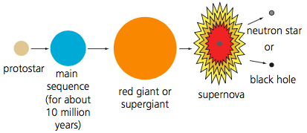
Giant and Supergiant Stars
The evolution of stars with a mass higher than about 1.4M_{Sun} is different from that described previously. This is because these stars fuse hydrogen to helium but do so primarily via the CNO cycle. Stars between 1.4M_{Sun} and 3M_{Sun} also evolve into red giants, but they end their life as supernovae, leaving behind a neutron star. Stars with a main-sequence mass in excess of 3M_{Sun} evolve into red supergiants, and when these explode as supernovae they leave behind a black hole.

A red supergiant is formed when the high-mass star runs out of hydrogen in its core. The core contracts and the star expands in size, burning hydrogen in its outer layers, increasing its luminosity and becoming much redder. The interior temperature gets much higher than in red giants, so elements heavier than hydrogen and helium can be fused, producing elements as heavy as iron, in a series of layers around their core.

Blue supergiants also exist, which are much hotter than red supergiants but smaller. They form when a star of more than 10 solar masses exhausts the nuclear fuel in its core and starts burning its outer layers. Like red supergiants, they have very short lifetimes of only a few million years.

Supernovae
A supernova is a star that suddenly and very rapidly increases in absolute magnitude because of an explosion that ejects most of its mass. Supernovae are classified into two types:
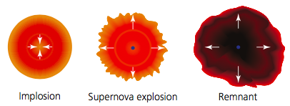
› Type I supernova. This is a star that accretes (draws in) matter from another star in a binary system until it becomes compressed and runaway nuclear reactions are set off, blasting its matter into space.
› Type II supernova. This is a single star – a red giant or supergiant – that runs out of nuclear fuel and collapses rapidly under its own gravity, ejecting its outer layers with enormous energy.
In a Red Giant, or Red Super-Giant, when the nuclear fuel is exhausted, the gravitational compression is so strong that the star collapses on itself extremely rapidly creating a gigantic explosion, and rapidly increasing the absolute magnitude. The outer parts of the star are blown into space. What is left is called a supernova remnant, at the centre of which is an exotic object called a neutron star.

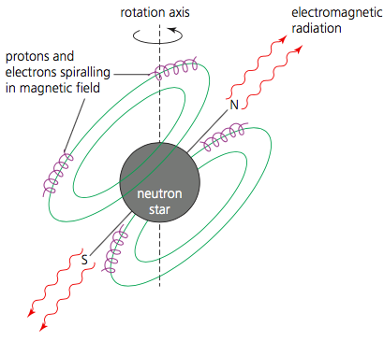
Neutron Stars and Pulsars
What is left after a supernova is an extremely dense object called a neutron star. The gravitational contraction has become so great that the electrons in the atoms are forced into protons, forming neutrons. A neutron star is thus composed almost entirely of neutrons, surrounded by an iron outer crust. The escape velocity from the surface of an object of mass M and radius R is given by:
$V_{esc}=\sqrt{\frac{2GM}{R}}$ where G is the gravitational constant G = 6.67 × 10⁻¹¹ N m² kg⁻² .
Neutron stars may behave as a pulsar. A pulsar is a rotating neutron star with a very strong magnetic field. The surface of a neutron star has numerous protons and electrons where the gravitational field is not strong enough for them to be pushed into each other to form neutrons. They are accelerated towards the magnetic poles of the neutron star, and in doing so emit electromagnetic radiation over a wide range of wavelengths in a narrow beam in opposite directions. The neutron star can rotate up to 600 times per second, giving a pulsed beam rather like a lighthouse.

Black Holes
For extremely massive stars, whose core after a supernova is more than three solar masses, gravitational compression in the neutron star continues, producing a black hole. A black hole is a region of space-time with an escape velocity greater than the speed of light, c, which from Einstein’s theory of special relativity is impossible to achieve. This is due to such a strong gravitational field that no particles or electromagnetic radiation can escape from it.
Then we can obtain the maximum value of R as: $R=R_{s}= \frac{2GM}{c^{2}}$
This radius R_{S} is called the Schwarzschild radius. The Schwarzschild radius tells us, for a given mass, how small an object must be for it to trap light around it and therefore appear black. This radius effectively forms a boundary that we call the event horizon of the black hole. Within this, the escape velocity is greater than or equal to the speed of light. Hence, all information from inside the event horizon is lost. Since black holes cannot be directly seen, information about them can only be inferred from the effects they have on nearby objects.

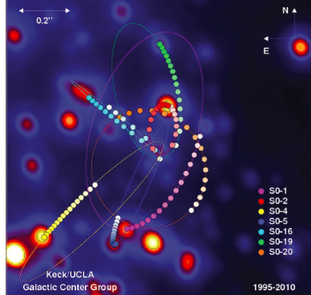
Gamma Ray Bursts
About once a day, intense ashes of gamma rays coming from distant galaxies in random directions, lasting from a few milliseconds to tens of seconds, are observed by gamma ray telescopes. These gamma ray bursts (GRBs) are thought to originate in supernovae, when supergiant stars collapse to form neutron stars or black holes.

Supermassive Black Holes
Observations have shown that stars and gas orbiting near the centres of galaxies are being accelerated to very high orbital velocities. This can be explained if a large supermassive object with a strong gravitational field in a small region of space is attracting them. The most likely candidate is a supermassive black hole.

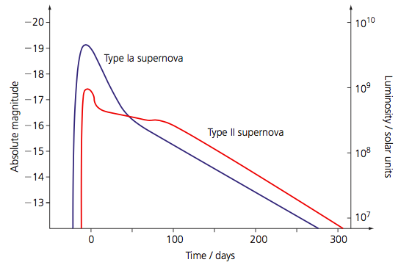
Type Ia (1a) Supernovae as Standard Candles
Type I supernovae, when matter accretes onto one star in a binary system, has a sub-type called Type Ia (or 1a). Supernovae undergo a rapid increase in brightness. Their absolute magnitude increases rapidly, reaching a peak absolute magnitude and then dimming over a period of several months. A graph of absolute magnitude versus time is called a light curve. The light curves for Type Ia and Type II supernovae are different. All Type Ia supernovae explosions occur at the same critical mass, and thus produce very consistent light curves, with the same peak value of absolute magnitude, –19.3, about 20 days from the beginning of the collapse.
Because of their known luminosity and absolute magnitude, type Ia supernovae can be used as standard candles. We can measure the distance d in parsecs of an object by measuring its apparent magnitude m using the relation for the distance modulus: m − M = 5 log₁₀($\frac{d}{10}$). Since we know the absolute magnitude M of a Type Ia supernova, we can calculate how far away it is.
These emit so much energy and are so bright that they can be seen at distances out to 1000Mpc (3.26 billion light years), which is a significant fraction of the radius of the known Universe. Such distances are known as cosmological distances. One of the most surprising findings from using Type Ia supernovae to measure cosmological distances was that the data suggested, controversially, that the expanding Universe is accelerating and not slowing down. For this to happen implies that there is some as-yet undetected energy permeating the Universe that acts in opposition to gravity. This has been given the name dark energy and its origin is currently a mystery to astrophysicists.

Evolution of massive stars
- Stars with a mass greater than 10 solar masses evolve into a super red giant. Explain the effects on brightness and temperature as a star evolves into a super red giant.
- What is the main difference between a type I and type II supernova?
- Explain what is meant by the term standard candle
- Explain how a type Ia supernova can be used as a standard candle.
- Sketch the light curve for a typical type Ia supernova.
- A type Ia supernova is observed in a galaxy with an apparent magnitude of 2. How far away is the galaxy containing the supernova?
- What is the apparent magnitude of a type Ia supernova that takes place in a galaxy 900 Mpc away?
- Describe and explain the different evolution routes of a star with core remanent greater than
  - < 1.4 solar masses
  - 1.4 – 2.8 solar masses
  - > 2.8 solar masses
- What is meant by the term escape velocity?
- Why is a black hole called a black hole?
- What does the term Schwarzschild radius mean?
- What is the Schwarzschild radius for Sagittarius prime, the black hole at the centre of the milky way, that has a mass of 4.1 million solar masses?
- Estimate the Schwarzschild radius of a black hole with mass 10²⁰ kg.
- What is the Schwarzschild radius of the Earth?
- If the Sun was instantly replaced with a black hole, what would the Schwarzschild radius of this black hole be such that all planets would remain in their orbits?
Q1.
(a) Betelgeuse is a red supergiant star with a mass approximately ten times greater than that of the Sun. Eventually it is quite likely that Betelgeuse will become a supernova, leaving a neutron star or perhaps a black hole.
State a significant property of a
(i) supernova,
______________________________________________________________
______________________________________________________________
(ii) neutron star,
______________________________________________________________
______________________________________________________________
(iii) black hole.
______________________________________________________________
______________________________________________________________
(3)
(b) Calculate the Schwarzchild radius for a black hole whose mass is ten times greater than that of the Sun.
___________________________________________________________________
___________________________________________________________________
(2)
(Total 5 marks)
Q2.
Centaurus A is the nearest example of an active galactic nucleus. Many astronomers believe a supermassive black hole at the centre of such a galaxy produces a quasar as it consumes the material of its nearby stars.
(a) Explain what is meant by the event horizon of a black hole.
___________________________________________________________________
___________________________________________________________________
___________________________________________________________________
(1)
(b) (i) The mass of the black hole is 60 million times the mass of the Sun. Calculate the radius of its event horizon.

answer = ______________________m
(2)
(ii) Calculate the average density of the matter within its event horizon.

answer = ______________________kg m^{–3}
(2)
(Total 5 marks)

Q3.
Antares is a red supergiant star in the constellation of Scorpio. It has a mass about 18 times that of the Sun.
Eventually the star will become a supernova, leaving behind a core that could form a neutron star or a black hole.
(a) State what is meant by a supernova.
___________________________________________________________________
___________________________________________________________________
(1)
(b) State the defining properties of a neutron star.
___________________________________________________________________
___________________________________________________________________
___________________________________________________________________
(2)
(c) To become a black hole it is likely that the core would have to have a mass at least twice that of the Sun.
Calculate the Schwarzschild radius of a black hole with a mass twice that of the Sun.

radius = ___________________ m
(2)
(d) Some scientists are concerned about the consequences for the Earth of a supernova occurring in a nearby part of the galaxy.
Explain the cause of this concern.
___________________________________________________________________
___________________________________________________________________
___________________________________________________________________
___________________________________________________________________
(2)
(Total 7 marks)

The Doppler Effect

The Doppler Effect and Cosmology
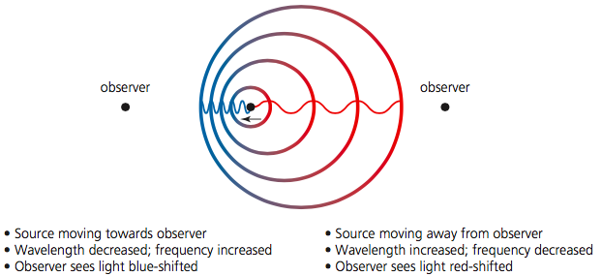
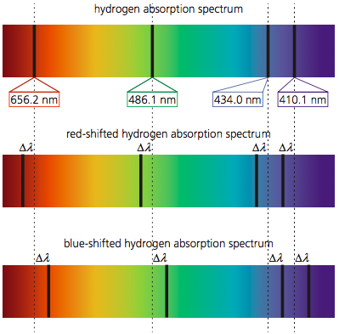
The study of the structure and development of the Universe as a whole is called Cosmology.
The Doppler effect is a change in frequency, or wavelength of a wave for an observer moving relative to its source. The same phenomenon occurs with all other types of waves, including electromagnetic radiation.
Depending on the motion of the object with respect to the observer, the frequency – and hence colour in the case of light – is affected.
The colour of an approaching light source is a shifted to the blue (shorter wavelength) than it would otherwise be, and the colour of one that is moving away is shifted to the red (longer wavelength), as shown left.
The lines in a star’s absorption spectrum are shifted when compared to the same lines as measured in a laboratory. This is due to the motion of the star relative to the Earth. The size of the wavelength shift, ∆$λ$, depends on the relative velocity of the star and the observer. The relationship is given by the Doppler equation:
$$z=\frac{∆λ}{λ}=\frac{λ_{app}-λ}{λ}=-\frac{V}{c}$$
The quantity $\frac{∆λ}{λ}$ is termed the Doppler shift and is given the symbol z.
Here $λ$ is the true wavelength of the absorption line, $λ$_{app} is the apparent wavelength of the observed absorption line on Earth, v is the relative velocity of the star and the Earth, and c is the velocity of light. The relative velocity v is taken to be the relative velocity of approach, so that v is positive when the two objects are approaching (blue shift) one another and negative if they are receding (red shift).
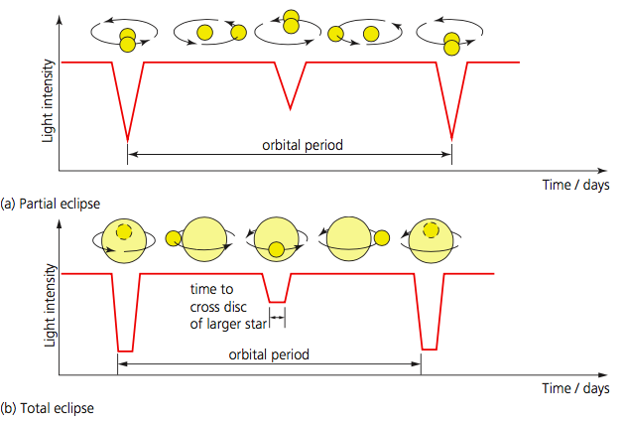
The Doppler equation can also be expressed in terms of the change in frequency: $\frac{∆f}{f}=\frac{V}{c}$
Doppler Shift and the Motion of Binary Stars
The Doppler effect can be used to determine the rotational velocity and the distance between two stars in a binary star system.
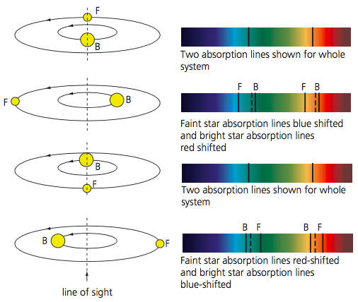
Here, eclipsing binaries, are revealed by the Doppler shift of lines in their spectrum. The absorption lines seen from Earth will be Doppler-shifted as the stars rotate about their centre of mass, moving between longer and shorter wavelengths in a periodic motion.

There will be a blue-shift in the star’s spectral lines when the star is moving towards the Earth, a red-shift in the spectral lines when the star is moving away from the Earth, and no spectral shift in the lines when the star is moving perpendicularly to the line of sight.
Analysis of the spectral motion reveals a cyclic movement of a particular absorption line, shifted one way and then the next with a constant period
It is possible to calculate the linear velocity along the line of sight and the period, hence the distance between the two stars using the mechanics of circular motion.

Doppler effect questions

- What is the effect on the observed spectrum of a star due to the recession of that star relative to our location?
- What element’s spectrum is usually used when determining this observed change? Why?
- The wavelength from a galaxy is measured at 300nm. If the rest wavelength is 240 nm, at what fraction of c (the speed of light) is the galaxy receding?
- A galaxy is moving away at 20% the speed of light. What would the measured wavelength be for light with a rest wavelength of 200 nm?
- A galaxy is receding at 50% the speed of light. What would the rest wavelength be for light with a measured wavelength of 240 nm?
- Neutral, atomic hydrogen gas in the spiral arms of the Milky Way emits a spectral line of wavelength 21cm, which is in the microwave part of the electromagnetic spectrum. The spectral line when detected by a radio telescope in a certain orientation is observed to be shifted by 0.1mm less than 21cm. How fast is this part of the Galaxy moving relative to us along the line of sight? Is it moving towards us or away from us?
- Describe the effect on the spectrum of two stars in a binary system.
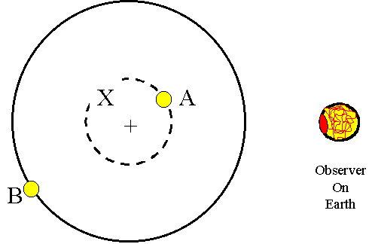
- Consider the binary system depicted, consisting of stars A and B orbiting (on circles) about a centre of mass (+). We on Earth are observing the system from the right in the diagram.
  - Which star has the greater orbit period?
  - Suppose this system is viewed from Earth as a binary system so that the Doppler shifts of both stars are observed. The lines of which star show the larger Doppler shifts? Why?
  - As seen from Earth, where is star A located when its spectrum lines show maximum redshift? Maximum blueshift?
  - As seen from Earth, where is A located when its spectrum lines show zero Doppler shift?
- The H-alpha spectral line in the hydrogen spectrum is at 656.00 nm when measured in the laboratory. Star A is observed to have that line at 656.60 nm, star B at 655.90 nm and star C at 656.40 nm.
  - Which star is moving the fastest relative to Earth (along the line of sight)?
  - What is the direction of motion of each of the stars?
- Measurements of the red-shift of the 21cm H1 line in the spectrum of galaxy M84 suggest that the galaxy is receding from us at a velocity of 900 km s−1.Calculate the value of the red-shift z for galaxy M84.
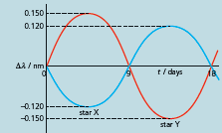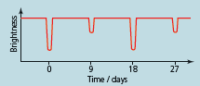
- An eclipsing binary system consists of star X and star Y, orbiting one another.
  - The above figure is a graph showing how the spectral line at wavelength l = 477 nm from the system changes due to the Doppler effect during one full period of revolution of the stars.
    - Why are the curves not identical?
    - Calculate the maximum linear speed of star X.
  - The second figure shows a plot of how the brightness of the binary pair, seen as an unresolved single star, varies with time. Use this graph to explain why the shape of the curve of star X in the first figure is not the same as that of star Y.

Q1.
Photographs of lines in the spectrum of the Sun show changes in wavelength due to the Doppler effect. Due to the rotation of the Sun about its axis, one edge of the Sun is approaching the Earth, and the other edge is receding.
(a) Give expressions for the observed change in the wavelength of a line of original wavelength, λ,
(i) for light coming from the edge which is moving away from the observer at speed υ,
______________________________________________________________
______________________________________________________________
(ii) for light coming from the edge which is moving towards the observer at speed υ.
______________________________________________________________
______________________________________________________________
(2)
(b) The apparent wavelength of a line of original wavelength 589 nm is measured from photographs showing opposite ends of the diameter of the Sun. The difference between the readings is 78 × 10^{–3} nm.
Calculate
(i) the speed, υ, of a point on the edge of the Sun,
______________________________________________________________
______________________________________________________________
______________________________________________________________
______________________________________________________________
(ii) the angular speed of rotation of the Sun.
radius of Sun = 7.0 × 10⁸ m
______________________________________________________________
______________________________________________________________
______________________________________________________________
(4)
(Total 6 marks)

Q2.
(a) Figure 1 shows two stars, A and B, which form a binary star system. The two stars orbit their common centre of mass with the same period of rotation. The Earth is in the same plane as the orbits of the two stars.
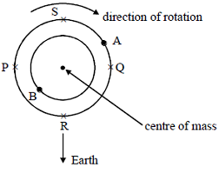
Figure 1
Figure 2 shows part of the spectrum of star A when it is in position R.
The spectrum of star A is observed when it is in position P and again when it is in position Q.
Explaining your reasoning, draw in the two boxes (i) and (ii) the same part of the spectrum of star A when it is at P and Q, respectively.
(for reference, the dotted lines in boxes (i) and (ii) show the same spectrum as in Figure 2)
Figure 2 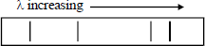 star A in position R
(i)  star A in position P
(ii)  star A in position Q
___________________________________________________________________
___________________________________________________________________
___________________________________________________________________
(5)
(b) (i) The calcium K line from a laboratory source has a wavelength of 3.9342 × 10^{–7} m. The same line, when measured in the spectrum of star A, when A is in position S in figure 1, has a wavelength of 4.7804 × 10^{–7} m. Calculate the velocity of the binary system.
______________________________________________________________
______________________________________________________________
______________________________________________________________

(ii) The wavelength of the same calcium K line, when measured in the spectrum of star A as it orbits, varies from a maximum of 4.7936 × 10^{–7} m to a minimum of 4.7672 × 10^{–7} m over an interval of 120 days. Calculate the radius of the orbit.
______________________________________________________________
______________________________________________________________
______________________________________________________________
______________________________________________________________
______________________________________________________________
(7)
(Total 12 marks)

Recession and Expansion

The Recession of Galaxies and Quasars
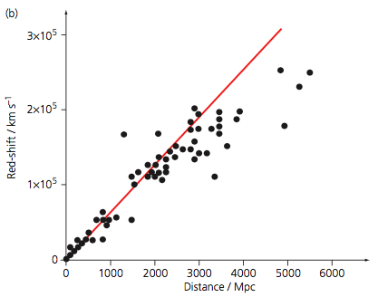
When light from whole galaxies is analysed, in the vast majority of cases, the absorption (or emission) spectra from distant galaxies is found to be red-shifted. This indicates that all of these galaxies are moving away from us and so is evidence of an expanding Universe. The red-shift is given by: $z=-\frac{V}{c}$
Where v is the galaxy’s recession velocity relative to our own Galaxy, the Milky Way. Note that z is positive for a red-shift, since recession velocity is taken to be negative.
Hubble’s Law
The spectra of all galaxies, apart from a few very near to our own Milky Way, show red-shift. A plot of the recession velocity against distance for galaxies is close to a straight line and is called a Hubble diagram.
The data shows that the rate at which a galaxy recedes is directly proportional to its distance from us, that is, $v=Hd$.
v is the recession velocity in kms⁻¹ and d is the distance of the galaxy in Mpc. This is called Hubble’s law and the constant of proportionality H is the Hubble constant, which is the gradient of a Hubble diagram. Current best estimates give H = 67.3 kms⁻¹Mpc⁻¹. Note that the SI unit for H is s⁻¹. To get H in SI units, v has to be in ms⁻¹ and d in m (1 Mpc = 3.09 × 10²² m).
Hubble’s Law and the Big Bang
Hubble’s law states that the Universe is expanding. An expanding Universe means that it is cooling down – so the further back in time, the smaller and hotter the Universe was. This implied to theoretical physicists that at a time t=0 the Universe came into being from an infinitely hot, infinitely dense point (called a singularity) and has been expanding ever since. This is the Big Bang theory, sometimes now called the Hot Big Bang (HBB) model.
An accurate value of the Hubble constant, allows an estimate of the age of the Universe. If in time t a galaxy has moved outwards a distance d at velocity v, then:
$t=\frac{v}{d}$ but from Hubble’s law we have $v=Hd$ so, if we assume H has been constant, then
$time (age of universe= \frac{v}{d}=\frac{1}{H}$
Here H needs to have unit s⁻¹. Taking H = 67.3kms⁻¹Mpc⁻¹, using 1 Mpc = 3.09 × 10²²m, we obtain H = 2.18 ×10⁻¹⁸s⁻¹
H = 4.59 × 10¹⁷ s = 14.5 billion years
Rate of expansion of the Universe
Observations of distant galaxies has shown that they are less bright than predicted (calculated using Hubble’s law). This shows that they are further from us than predicted by Hubble’s law – the light from them has taken longer to reach us than predicted by a constant rate of expansion (H). This indicates that the rate of expansion is not steady, but is accelerating.
Cosmologists were puzzled as to what could be driving this acceleration. The cause did not appear to be either matter or radiation, and is still at present unknown. Several possibilities have been put forward, including the notion of dark energy. This is a postulated energy that exerts an overall repulsive effect throughout the Universe, causing ‘empty’ space to expand, and its effect increases as the Universe expands.
While dark energy opposes the force of gravity, it adds to the total mass–energy density within the Universe. Dark matter emits no radiation, so is difficult to measure – its presence is inferred by the movement of galaxies. Current experimental data estimates that the Universe is composed of 27% matter and 73% dark matter, resulting in an ever-expanding Universe.
Hubble’s law questions
- Light arriving at the Earth from a distant galaxy is observed to be red shifted. Explain, in terms of spectral lines, what the term red shift means.
- What is the evidence that the Universe is expanding?
- Measurements of the red-shift of the 21cm H₁ line in the spectrum of galaxy M84 suggest that the galaxy is receding from us at a velocity of 900 km s⁻¹.Calculate the value of the red-shift z for galaxy M84.
- An absorption line of calcium usually has a wavelength of 393.4 nm, but it is observed in a distant galaxy to have a wavelength of 820.9 nm. What is the red-shift? Comment on your answer.
- A galaxy has an observed recession velocity of 500 kms⁻¹. Calculate
  - The distance to the galaxy
  - The observed value of a spectral line that has a lab value of 420 nm.
- Hubble collected data for the red-shift of whole galaxies that were distant rather than nearby. Why were distant galaxies needed rather than using nearby galaxies?
- Show that Hubble’s constant can be written with the units s⁻¹.
- Work out the distance to the following galaxies:
  - M64 (Black eye galaxy), with recession velocity 408 kms⁻¹.
  - NGC1275. Recession velocity 5264 kms⁻¹.
  - 3c48 (a quasar), recession velocity 110 000 kms⁻¹.
- The wavelength of a given line in the spectrum is 5.40×10^{–7}m when measured using a light source in a laboratory on Earth. When the light from the distant galaxy is used for the measurement, the wavelength is found to be 5.61×10^{–7} m.
  - Show that this wavelength change corresponds to a frequency shift of about 2.1×10¹³ Hz.
    - speed of light in a vacuum, c=3.0×10⁸ ms^{–1}
  - Calculate the speed of the galaxy relative to Earth.
  - Estimate the distance, in m, between the galaxy and the Earth.
    - Hubble constant = 65 kms⁻¹Mpc⁻¹
    - 1pc (parsec) = 3×10¹⁶ m
- There is some uncertainty in the value of H: (71 +/- 10%) km s⁻¹ Mpc⁻¹.
  - If a galaxy is moving away from us with a recession velocity of 5500 km s⁻¹, calculate its maximum and minimum distance from us.
  - How is the estimated age of the Universe affected by this range of values for H?
- Suppose the universe stopped expanding and began contracting. What feature would be observed in galaxy spectra that would indicate this?
- Use the current value for the Hubble constant to determine the age of the Universe. H = 67.4 km s⁻¹ Mpc⁻¹.
- Observations of distant galaxies indicate they are dimmer than would be predicted. What phenomenon does this infer?

Q1.
(a) State what is meant by the Hubble constant.
___________________________________________________________________
___________________________________________________________________
(1)
(b) The recessional velocity of a galaxy 8.0 × 10⁸ ly from Earth is measured to be 1.8 × 10⁴ km s⁻¹.
Show that this suggests a value for the Hubble constant of 73 km s⁻¹ Mpc⁻¹.

(2)
(c) (i) Using the value for the Hubble constant given in part (b), estimate the age of the Universe.
Give your answer in years.

age of the Universe ____________________ years
(3)
(ii) State one assumption that must be made to justify the estimate made in part (i).
______________________________________________________________
______________________________________________________________
(1)
(Total 7 marks)
Q2.
The red shift of a galaxy’s spectrum can be used to determine its velocity, relative to the Earth.
(a) The wavelength of the hydrogen alpha line in the spectrum of the galaxy NGC 1357 is 660.86 nm. The wavelength of the same line from a laboratory based source is 656.28 nm. Calculate the velocity of galaxy NGC 1357.
___________________________________________________________________
___________________________________________________________________
___________________________________________________________________
___________________________________________________________________
(2)
(b) Use the value obtained in part (a) to complete the table. Plot a graph of the data in the table below and use the graph to determine a value for the Hubble constant.

galaxy | velocity/km s^{–1} | distance/Mpc
NGC 1357 |  | 28
NGC 1832 | 2000 | 31
NGC 5548 | 5270 | 67
NGC 7469 | 4470 | 65
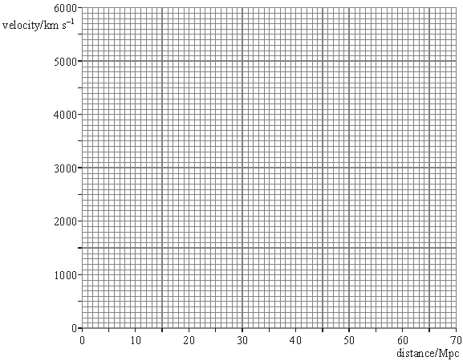
___________________________________________________________________
___________________________________________________________________
___________________________________________________________________
___________________________________________________________________
(3)
(Total 5 marks)

Evidence for the Big Bang

Cosmological Microwave Background (CMB)
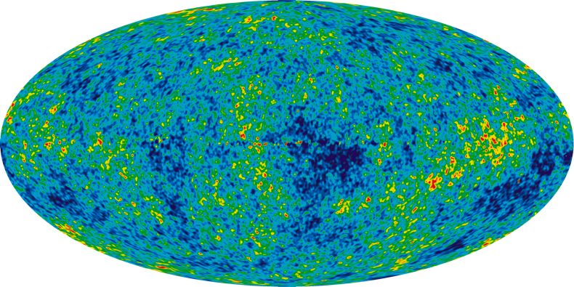
Crucial evidence for the Hot Big Bang (HBB) model includes precise measurements of the remnants of the very early Universe through the so-called cosmological microwave background (or cosmic microwave background). The HBB model predicts that high-energy (gamma) electromagnetic radiation produced around t ≈ 300 000 years should still be observed today, but owing to the expansion of the Universe should be red-shifted down to the millimetre wavelength (microwave) region. The thermal intensity of the spectrum fitted perfectly to a black-body curve corresponding to a temperature of 2.73 K.
Although the temperature of the CMB is almost completely uniform at 2.7 K, there are very tiny variations in the temperature of the order of 10⁻⁵ K, which appear on the maps in Figure 15 as cooler blue and warmer red patches. The key findings of WMAP were that a more accurate age of the Universe could be established as 13.7 billion years ± 0.2 billion years.
Hydrogen and Helium Abundances
Hydrogen and helium account for nearly all the matter in the Universe that we observe today. The relative abundance, by mass, of these elements in the Universe is 25% helium and 73% hydrogen, with all the other elements amounting to 2%.
The HBB model predicts that primordial nucleosynthesis, the process by which the lightest elements such as H and He formed, began approximately 100 s after the Big Bang. Owing to the immense temperatures and pressures, nuclear fusion reactions converted hydrogen into helium. Then, owing to the rapid expansion of the Universe, temperatures dropped below those required to sustain fusion. As a result, nucleosynthesis lasted only for about three minutes. All the heavier elements, including those of which the planets and you and I are made, were created later by long-lived fusion processes inside stars and were dispersed across the interstellar medium by supernovae.
Quasars
Quasars are distinguished by extremely large red-shifts and are therefore believed to be some of the most distant objects in the known Universe. Optically, quasars are very faint and star-like, but application of the inverse square law reveals them to be amongst the brightest objects in the Universe. One quasar may emit hundreds or even thousands of times the entire power output of our Galaxy.

Evidence for the big bang questions
- What is the peak emission wavelength for the CMBR that corresponds to a temperature of 2.7 K?
- Describe and explain the key features of the CMBR that provide evidence for the HBB model.
- Explain how we can use the relative abundance of hydrogen and helium as evidence for the big bang.
- Show that the prediction of an initial p:n ratio of 7:1 leads to the observed mass ratio of H:He in the Universe of 3:1.
- Explain why, although the early Universe formed to be mostly hydrogen and helium, we observe many different elements in the Universe now.
- Define the term Quasar
- Describe the key features of a Quasar.
- Explain why there are no nearby Quasars observed.
- A quasar has an apparent magnitude of + 10 and a red shift value z = 0.10.
  - Calculate the distance to the quasar.
  - Calculate its absolute magnitude.
  - Calculate how many times brighter than the sun (abs. mag +4.8) the Quasar is.
A quasar has a red shift value of z = 0.15 and is at a distance of 690 Mpc. Use these data to determine the age of the Universe in seconds.

Q1.
Evidence to support the Big Bang theory comes from cosmological microwave background radiation and the relative abundance of hydrogen and helium in the Universe.
(a) Explain what is meant by cosmological microwave background radiation and how its existence supports the Big Bang theory.
___________________________________________________________________
___________________________________________________________________
___________________________________________________________________
___________________________________________________________________
___________________________________________________________________
___________________________________________________________________
___________________________________________________________________
___________________________________________________________________
___________________________________________________________________
___________________________________________________________________
___________________________________________________________________
___________________________________________________________________
___________________________________________________________________
___________________________________________________________________
(3)
(b) Explain how the relative abundance of hydrogen and helium supports the Big Bang theory.
___________________________________________________________________
___________________________________________________________________
___________________________________________________________________
___________________________________________________________________
___________________________________________________________________
___________________________________________________________________
___________________________________________________________________
___________________________________________________________________
___________________________________________________________________
___________________________________________________________________
___________________________________________________________________
(3)
Q2.
(a) Describe the links between galaxies, black holes and quasars.
___________________________________________________________________
___________________________________________________________________
___________________________________________________________________
___________________________________________________________________
___________________________________________________________________
___________________________________________________________________
(2)
(b) At a distance of 5.81 × 10⁸ light year, Markarian-231 is the closest known quasar to the Earth. The red shift z of Markarian-231 is 0.0415
Use these data to estimate an age, in seconds, of the Universe.

age = __________________ s
(4)
(c) A typical quasar is believed to be approximately the size of the solar system, with a power output similar to that of a thousand galaxies.
Estimate, with reference to the inverse-square law, how much further the most distant visible quasar is likely to be compared to the most distant visible galaxy.
___________________________________________________________________
___________________________________________________________________
___________________________________________________________________
___________________________________________________________________
___________________________________________________________________
___________________________________________________________________
___________________________________________________________________
___________________________________________________________________
___________________________________________________________________
(3)
(Total 9 marks)

Exoplanet detection

Exoplanets
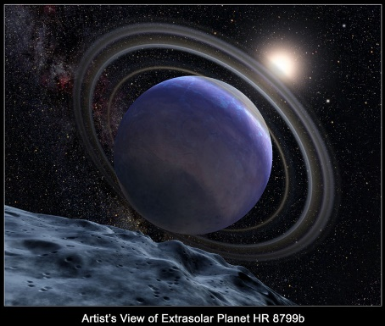
An exoplanet (or extrasolar planet) is a planet that orbits a star other than the Sun. They are much fainter than the star they orbit and so are lost in its glare and very difficult to detect directly. Most have been found using indirect methods that involve tiny but measurable effects of the exoplanet on its parent star.
Detection of Exoplanets
Until 1995 the existence of exoplanets was pure speculation, but today many measurements indicate that almost every star is orbited by several planets. There are hundreds of billions, probably even many trillions of planets in our Milky Way galaxy alone. The science of exoplanet detection is still in its infancy, but in the next years and decades we will make great progress in this area. Amongst other things the James Webb Space Telescope and the European Extremely Large Telescope are expected to boost our knowledge in many areas of astronomy, including exoplanets.
Types of Exoplanets
As with the planets in our own solar system, exoplanets come in various sizes and compositions from small rocky planets to huge gas giants. But, in addition, other stars are orbited by types of exoplanets that do not exist in our solar system: hot Jupiters, super-Earths or ocean planets enlarge the spectrum of exoplanets beyond the rocky planets and gas giants that we know so well from our solar system.
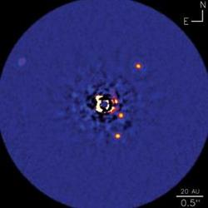
How to detect exoplanets
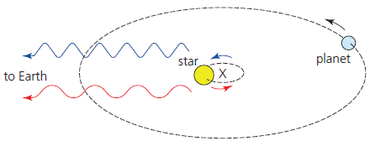
Exoplanets orbiting other stars are too far away to be directly imaged from Earth with currently available telescopes. There are a few exceptions of huge planets orbiting far away from their host star and some of the future telescopes currently under construction will be much more able to image exoplanets than can be done today. But direct images of exoplanets are currently exceptions and, in any case, we will not be able to see much more than a dot of light; nothing that could reveal any surface details of the planet.

The Radial Velocity Method: The radial velocity method in the search for planets looks for periodic variation in Doppler shift in the star’s spectral lines as the star ‘wobbles’ as a planet moves around this point (affected by the gravitational attraction between the planet and the star. This can only be done if the planet orbit is not perpendicular to our view.
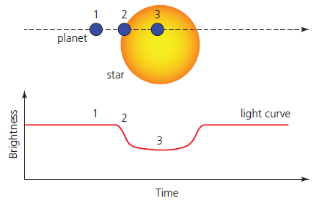
The Transit Method: This works by detecting a dimming in the star’s brightness as an exoplanet moves across its disc, perpendicular to our line of sight – called a transit. The decrease in observed brightness allows the radius of the exoplanet to be calculated if the radius of the parent star is known. If the star has a radius r_{star} and the planet has radius r_{planet}, the fractional drop in brightness will be:
$\frac{πr_{planet }^{2}}{πr_{star}^{2}}$=$\frac{r_{planet}^{2}}{r_{star}^{2}}$ = ${\left(\frac{r_{planet}}{r_{star}}\right)}^{2}$

Q1.
Two methods involved in the detection of exoplanets are the radial velocity method and the transit method.
(a) Explain what is meant by the transit method of detection.
___________________________________________________________________
___________________________________________________________________
___________________________________________________________________
___________________________________________________________________
___________________________________________________________________
___________________________________________________________________
(3)
(b) Explain why it is important that there is more than one method of detection.
___________________________________________________________________
___________________________________________________________________
___________________________________________________________________
___________________________________________________________________
(2)
(Total 5 marks)
Q2.
According to NASA nearly 2000 exoplanets had been discovered by 2016, and the search continues. One aim of this search is to find an Earth-like planet orbiting a Sun-like star.
Discuss the difficulties associated with the detection of an Earth-like planet orbiting a Sun-like star.
In your answer you should compare the methods that are used in the search and suggest which may be the most successful.
_______________________________________________________________________
_______________________________________________________________________
_______________________________________________________________________
_______________________________________________________________________
_______________________________________________________________________
_______________________________________________________________________
_______________________________________________________________________
_______________________________________________________________________
_______________________________________________________________________
_______________________________________________________________________
_______________________________________________________________________
_______________________________________________________________________
(Total 6 marks)
Q3.
The table shows some properties of the four brightest stars in the constellation Canis Minor.

Name | Apparent magnitude | Absolute magnitude | Spectral class
Gamma A | 4.46 | –0.50 | K
Gomeisa | 2.89 | –0.70 | B
HD 66141 | 4.39 | –0.13 | K
Procyon | 0.34 | 2.65 | F
(a) Discuss, with reference to the Hipparcos scale, why many star maps show only two stars in the constellation Canis Minor.
___________________________________________________________________
___________________________________________________________________
___________________________________________________________________
___________________________________________________________________
___________________________________________________________________
___________________________________________________________________
(3)
(b) State and explain which star in the table above has the most prominent Hydrogen Balmer absorption lines.
___________________________________________________________________
___________________________________________________________________
___________________________________________________________________
___________________________________________________________________
(2)
(c) Deduce which star, Gamma A or HD 66141, has the larger diameter.
___________________________________________________________________
___________________________________________________________________
___________________________________________________________________
___________________________________________________________________
___________________________________________________________________
___________________________________________________________________
___________________________________________________________________
___________________________________________________________________
(3)
(d) Astronomers recently used the radial velocity method to discover an exoplanet orbiting HD 66141.
Describe the main features of the radial velocity method in the detection of planets.
___________________________________________________________________
___________________________________________________________________
___________________________________________________________________
___________________________________________________________________
___________________________________________________________________
___________________________________________________________________
___________________________________________________________________
(2)
(e) Calculate the distance from the Earth to Procyon.
Give an appropriate unit for your answer.
distance = ____________________ unit ___________
(3)
(Total 13 marks)

