Basic
Scalars and vectors
Q1. Describe the difference between a scalar and a vector.
………………………………………………………………………………………………………………………………………………………………………………………………………..
………………………………………………………………………………………………………………………………………………………………………………………………………..
Q2. The following quantities are either scalars or vectors. State which are scalars and which are vectors.
- Displacement  ……………………………………………………………………………… | - Velocity  ………………………………………………………………………………
- Mass  ……………………………………………………………………………… | - Energy  ………………………………………………………………………………
- Force  ……………………………………………………………………………… | - Distance  ………………………………………………………………………………
- Acceleration  ……………………………………………………………………………… | - Time  ………………………………………………………………………………
- Speed  ……………………………………………………………………………… | - Power  ………………………………………………………………………………
Q3. State the difference between speed and velocity.
………………………………………………………………………………………………………………………………………………………………………………………………………..
Q4. State the equations for speed and velocity.
………………………………………………………………………………………………………………………………………………………………………………………………………..
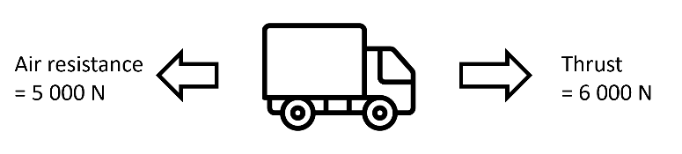
………………………………………………………………………………………………………………………………………………………………………………………………………..
Q5. A lorry is travelling on the motorway. Use the force diagram to the right to answer the questions:
- Calculate the resultant force.
………………………………………………………………………………………………………………………………………………………………………………………………………..
- What will happen to the lorry?
………………………………………………………………………………………………………………………………………………………………………………………………………..
Medium
Q6. Student X says that their displacement is zero after they run a complete lap around a running track. Student Y disagrees and says that their displacement is 400m. State which student is correct and explain why.
………………………………………………………………………………………………………………………………………………………………………………………………………..
Q7. Sarah is swimming lengths in a 25 m pool. Sarah swims four lengths in 125 seconds at a steady speed.
- After four lengths, state the distance that Sarah has swum.
………………………………………………………………………………………………………………………………………………………………………………………………………..
- After four lengths, state Sarah’s displacement.
………………………………………………………………………………………………………………………………………………………………………………………………………..
- Calculate the speed at which Sarah is swimming.
………………………………………………………………………………………………………………………………………………………………………………………………………..
- Explain what Sarah’s velocity is during the first length, compared to the second length.
………………………………………………………………………………………………………………………………………………………………………………………………………..
Hard
Q8. A ship’s captain sails 60 km South and then changes course and sails 80km East.
- State the total distance travelled.
………………………………………………………………………………………………………………………………………………………………………………………………………..
- Calculate the magnitude of the ship’s resultant displacement for its starting point.
………………………………………………………………………………………………………………………………………………………………………………………………………..
………………………………………………………………………………………………………………………………………………………………………………………………………..
………………………………………………………………………………………………………………………………………………………………………………………………………..
Q9. A car travels 10 km North in 15 minutes and then 10 km South in 5 minutes.
- Calculate the car’s average speed in km/h.
………………………………………………………………………………………………………………………………………………………………………………………………………..
………………………………………………………………………………………………………………………………………………………………………………………………………..
- State the car’s average velocity in km/h.
………………………………………………………………………………………………………………………………………………………………………………………………………..
Q10. The graph to the left shows the displacement-time graph of a lorry.
- On the axes to the right, draw a distance-time graph for the lorry.
- Calculate the average speed of the lorry in km/h.
………………………………………………………………………………………………………………………………………………………………………………………………………..
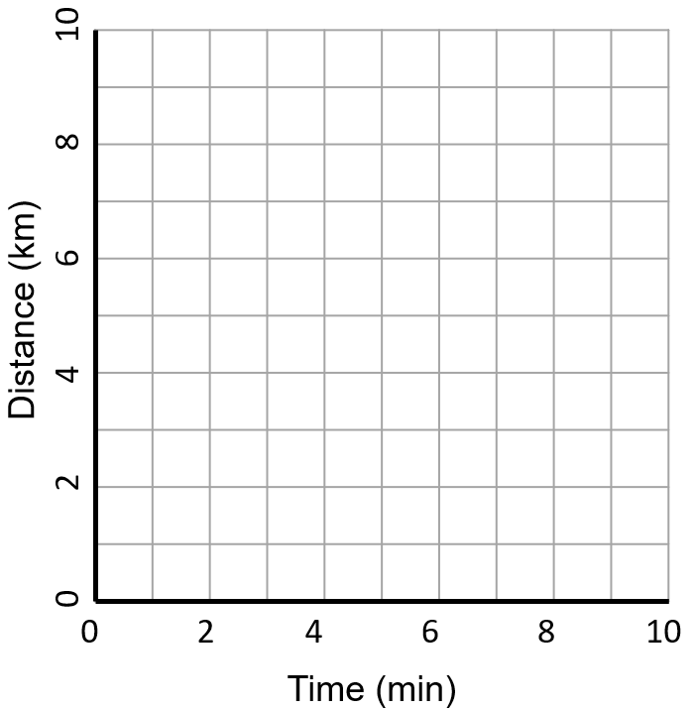
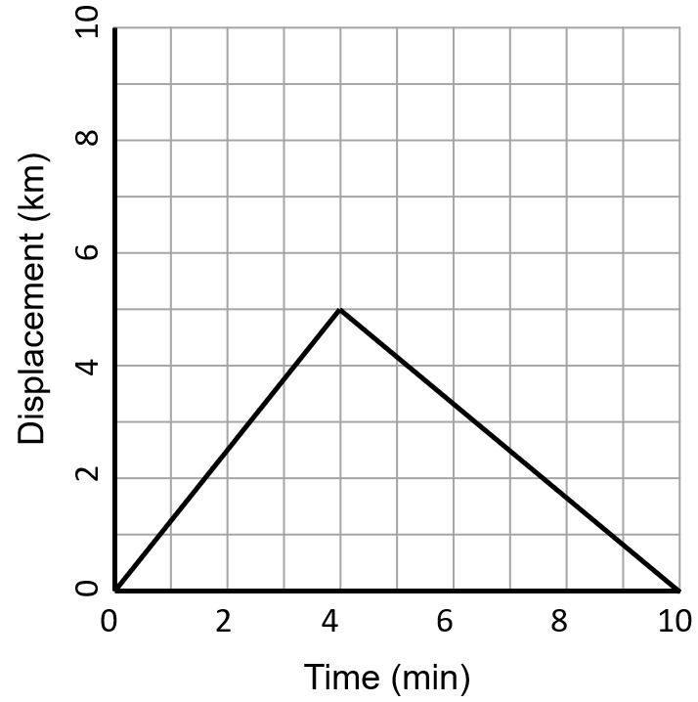
………………………………………………………………………………………………………………………………………………………………………………………………………..

EXAM QUESTIONS
Q1. A person has been for a walk. The figure below shows the distance–time graph for the walk.
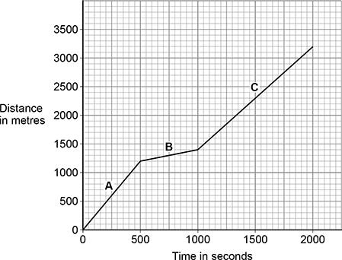
(a) Distance is a scalar quantity. How is a vector quantity different to a scalar quantity? (1)
___________________________________________________________________
___________________________________________________________________
(b) Name a vector quantity. (1)
___________________________________________________________________

(c) Calculate the average speed of the person during the 2000 seconds. (2)
___________________________________________________________________
___________________________________________________________________

Average speed = ____________________ m/s

(d) Which section of the figure above shows the person walking the slowest?
Give a reason for your answer. (2)
Tick (✓) one box.

A |  | B |  | C
Reason ____________________________________________________________
___________________________________________________________________
Q2. A train travels from town A to town B.
Figure 1 shows the route taken by the train.
Figure 1 has been drawn to scale.
Figure 1
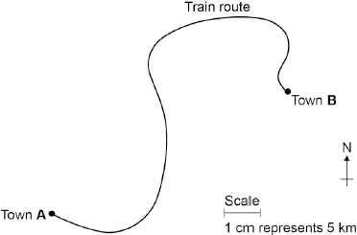
(a) The distance the train travels between A and B is not the same as the displacement of the train.
What is the difference between distance and displacement? (1)
___________________________________________________________________
___________________________________________________________________
___________________________________________________________________
(b) Use Figure 1 to determine the displacement of the train in travelling from A to B.
Show how you obtain your answer. (2)
___________________________________________________________________
___________________________________________________________________
Displacement = ___________________ km
Direction = _________________________
Stretch:
(c) There are places on the journey where the train accelerates without changing speed.
Explain how this can happen. (2)
___________________________________________________________________
___________________________________________________________________
___________________________________________________________________
___________________________________________________________________

