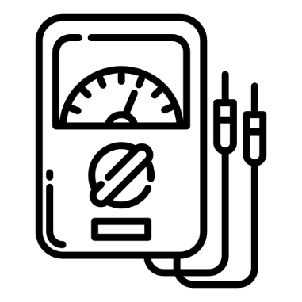
ESAT Physics Prep
Week 1 – Electricity

Week 1 – Electricity
Week 2 – Magnetism
Week 3 – Mechanics
Week 4 – Thermal physics
Week 5 – Matter
Week 6 – Waves
Week 7 – Radioactivity

There is one sample ESAT test – note that they use the same questions from NSAA 2020 specimen paper. Past NSAA & ENGAA questions are the most relevant.

There are no calculators in the ESAT.

Electricity Spec
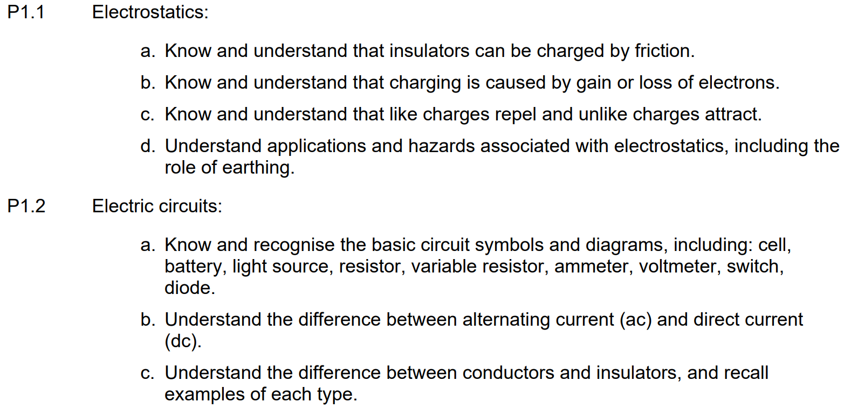
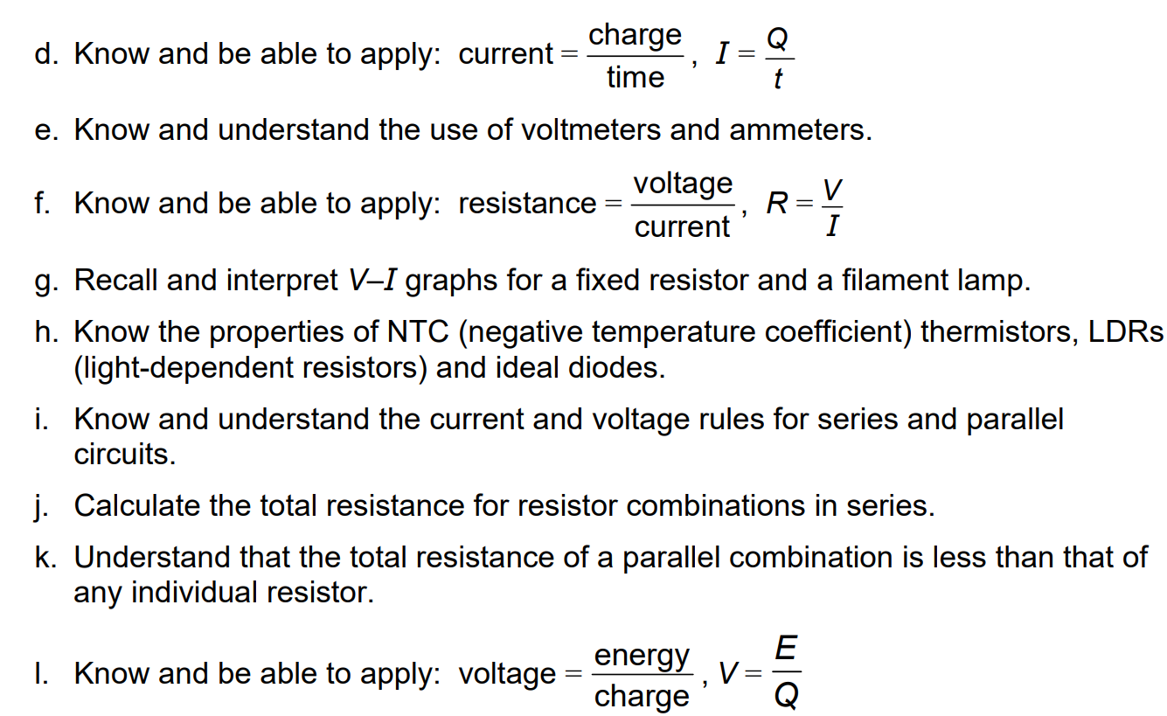

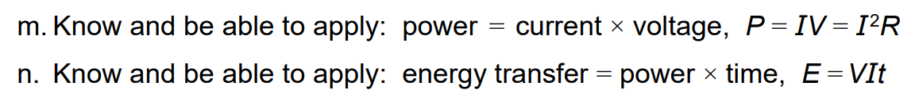

Q24 Section 1 NSAA 2020 Specimen
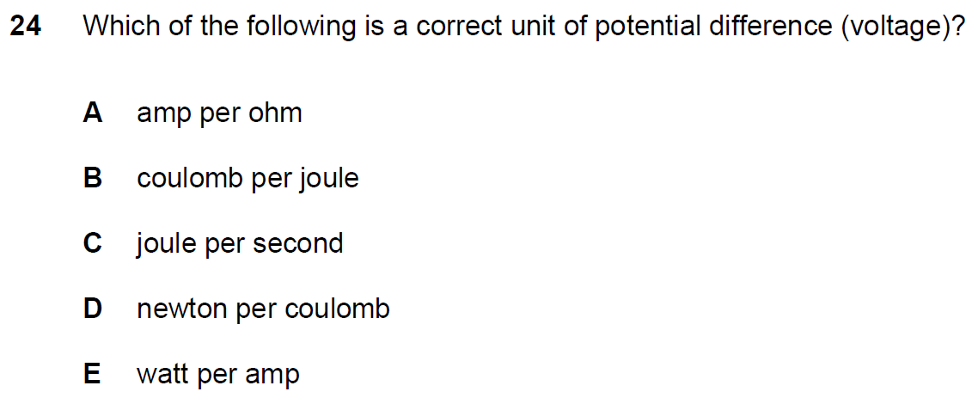
Q28 Section 1 NSAA 2020 Specimen
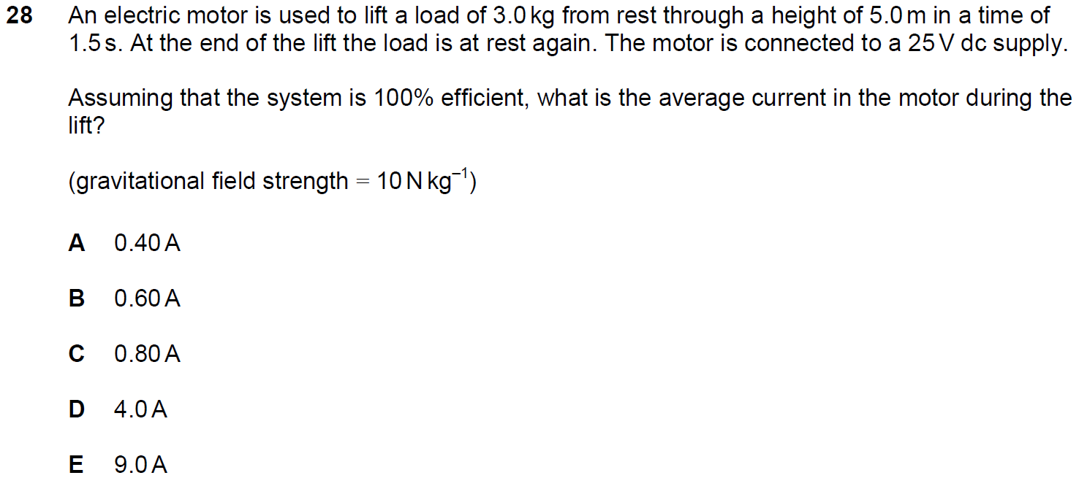

Q36 Section 1 NSAA 2020 Specimen
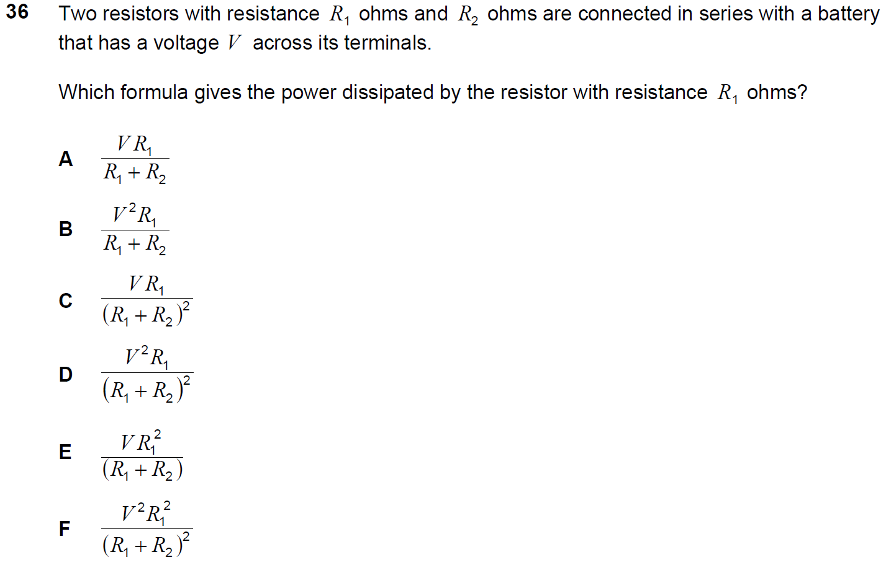
Q23 Section 1 NSAA 2018
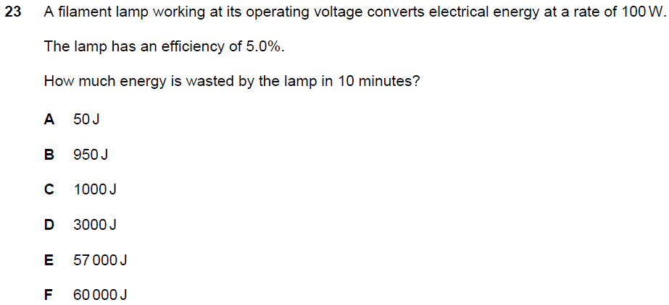

Q2 Section 1 ENGAA 2019
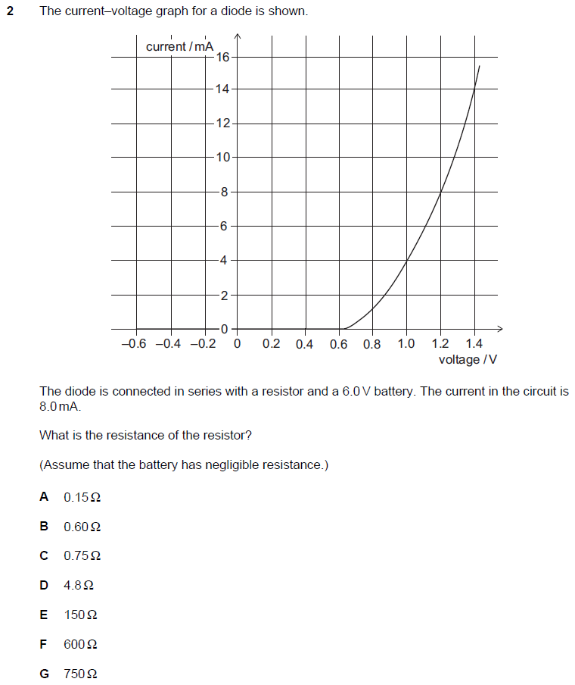

Q8 Section 1 ENGAA 2019
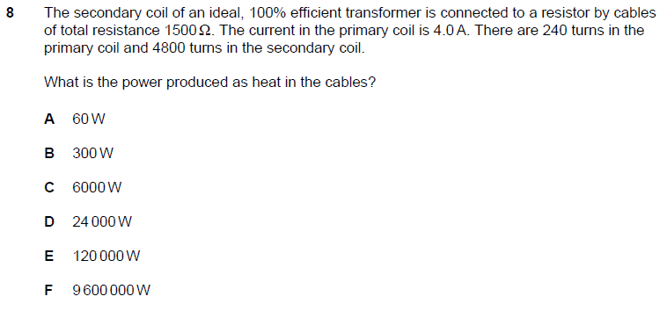
Q20 Section 1 NSAA 2018
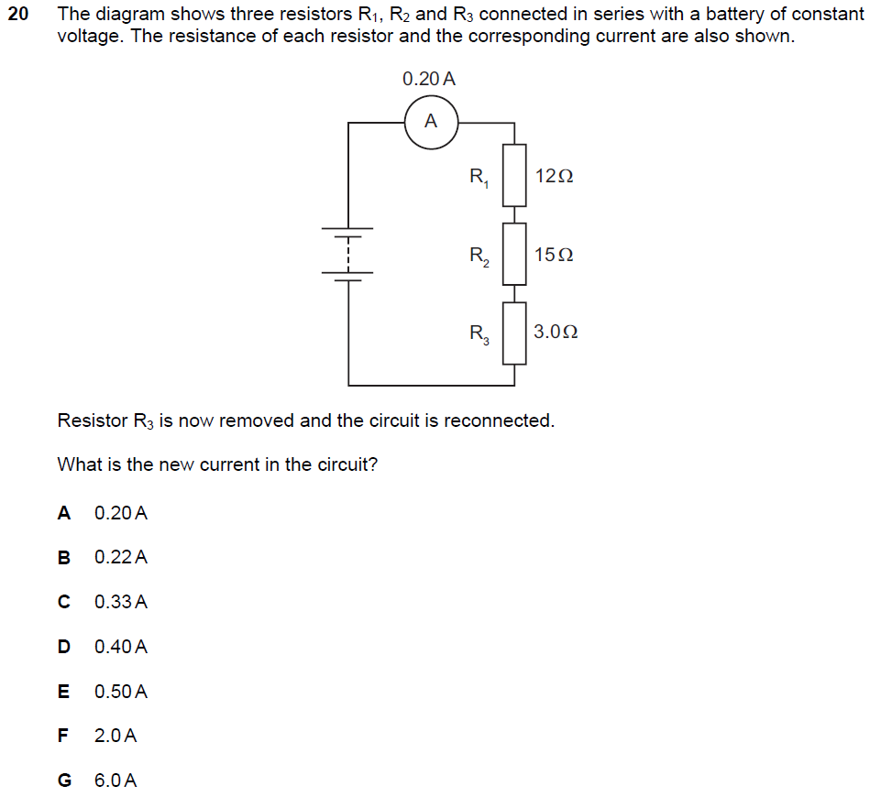
Q9 PAT 2017
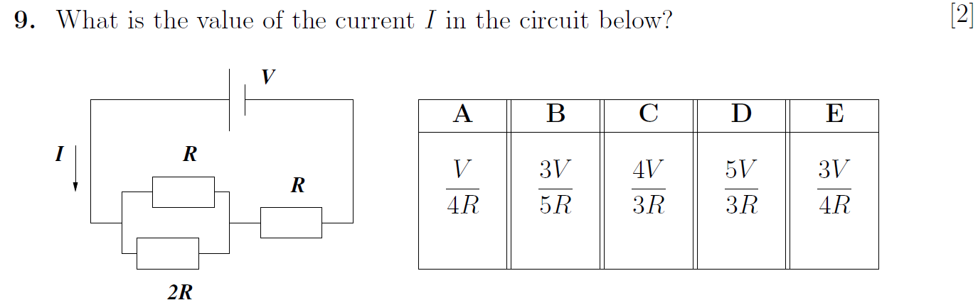

Q2 Section 2 ENGAA 2019
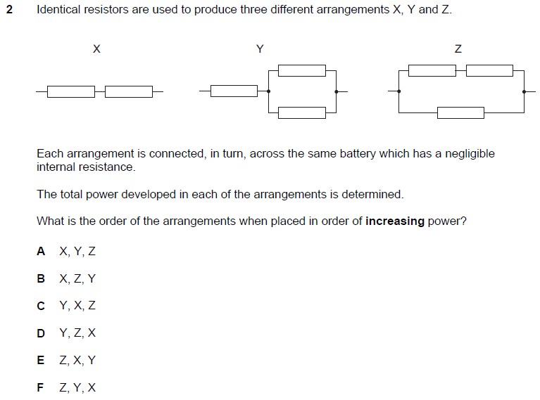

Q4 Section 2 ENGAA 2019
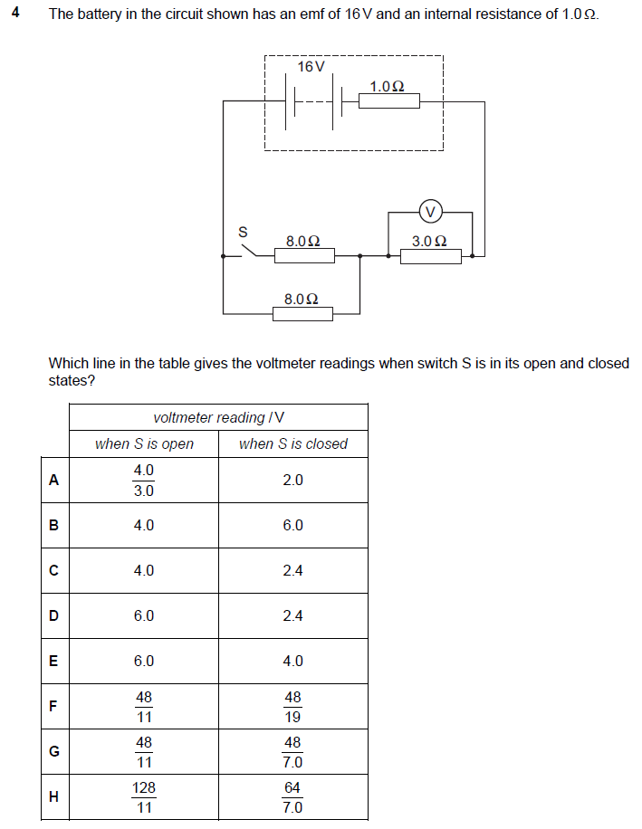

Q15 Section 2 ENGAA 2019
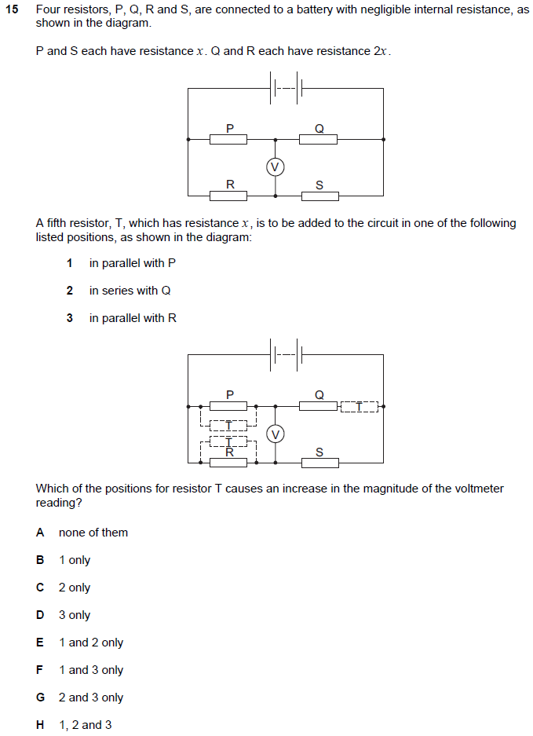

Q16 Section 2 ENGAA 2018 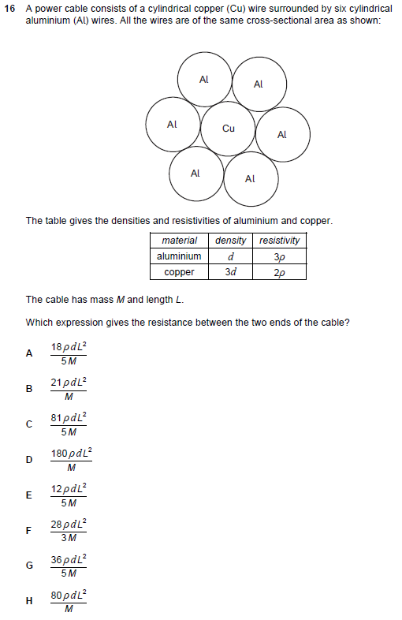
Q35 NSAA 2018
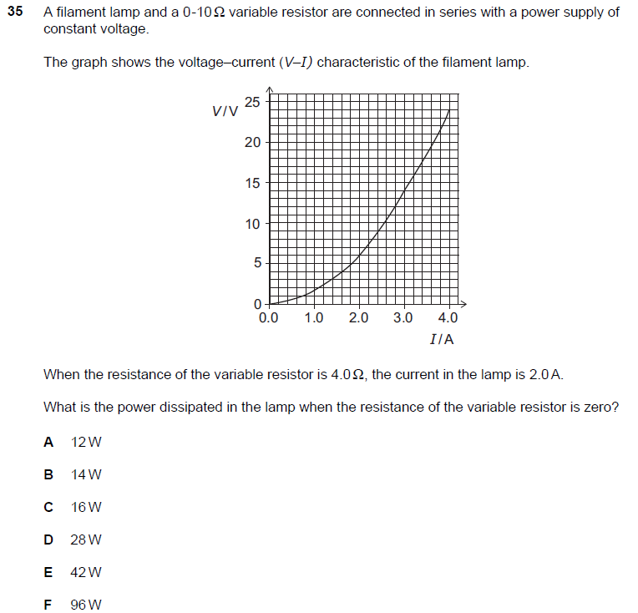

Q24 NSAA 2022
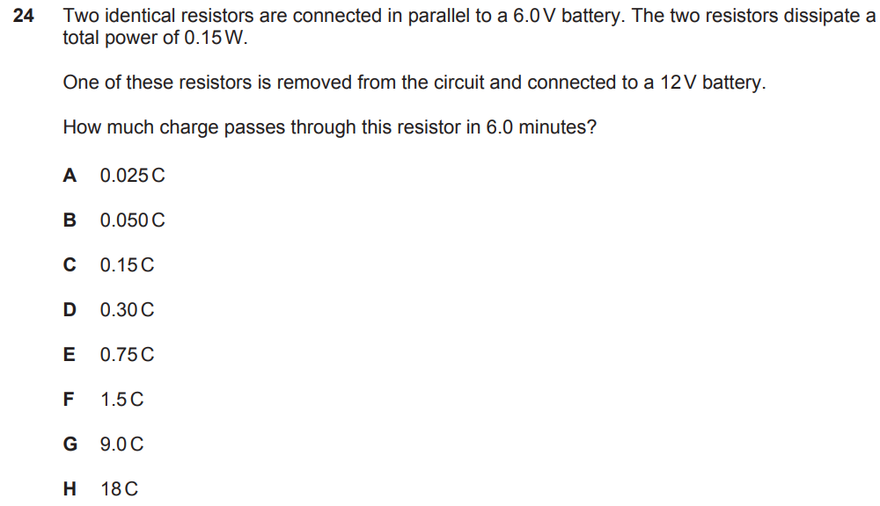
Q28 NSAA 2022
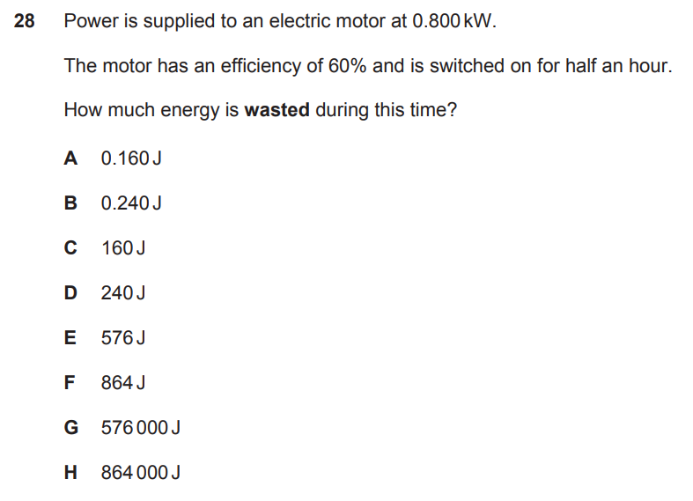

Q29 NSAA 2022
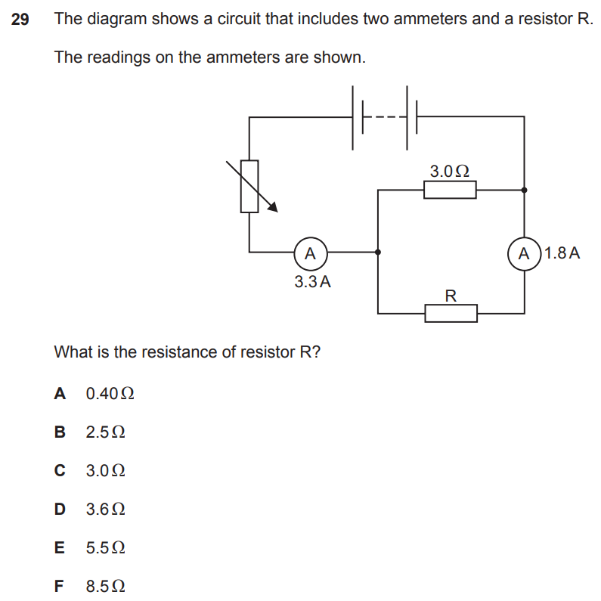

Q30 NSAA 2022
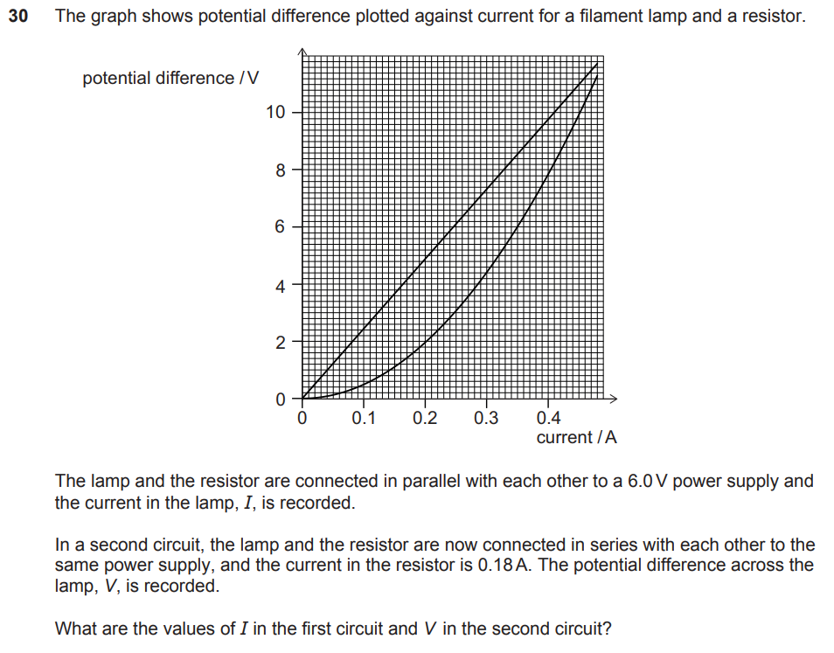
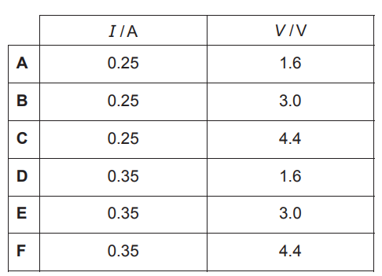

Q21 NSAA 2021
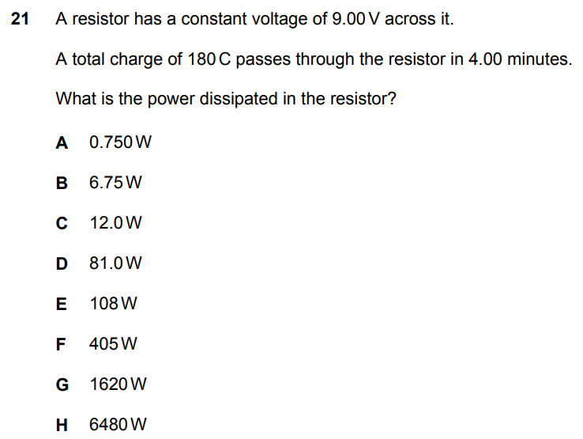
Q28 NSAA 2021
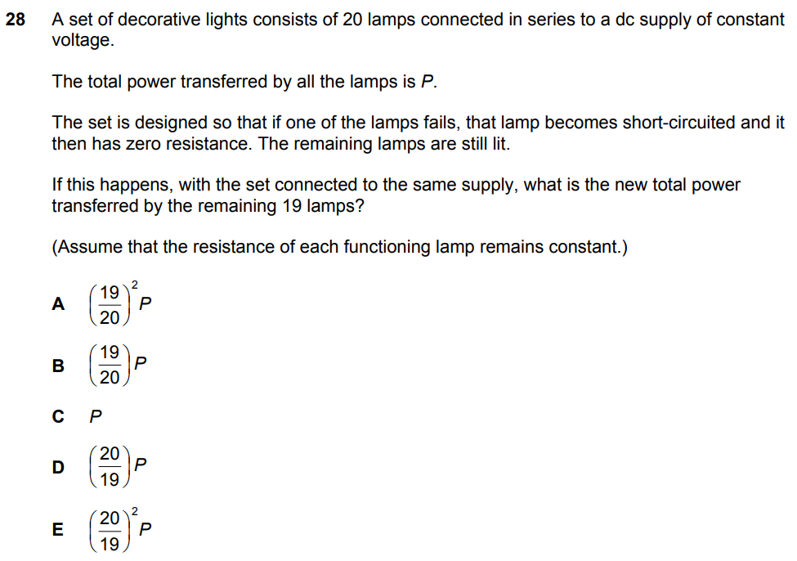
Q31 NSAA 2021
