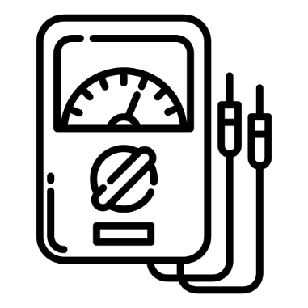
ESAT Physics Prep
Week 2 – Magnetism

Week 1 – Electricity
Week 2 – Magnetism
Week 3 – Mechanics
Week 4 – Thermal physics
Week 5 – Matter
Week 6 – Waves
Week 7 – Radioactivity

There is one sample ESAT test – note that they use the same questions from NSAA 2020 specimen paper. Past NSAA & ENGAA questions are the most relevant.

There are no calculators in the ESAT.

Magnetism Spec
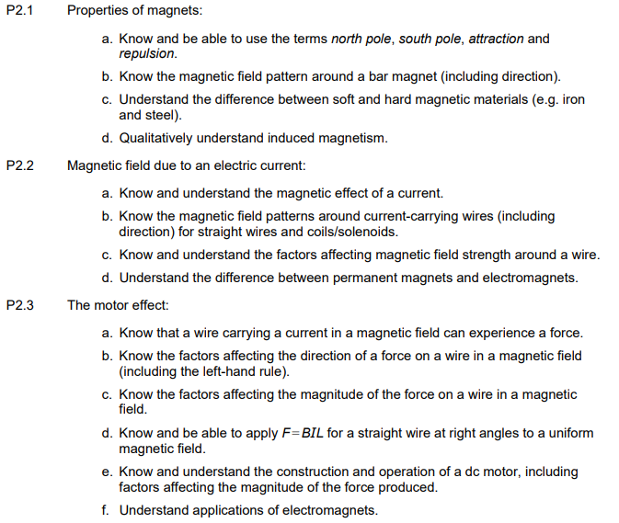
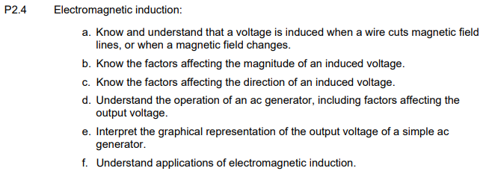
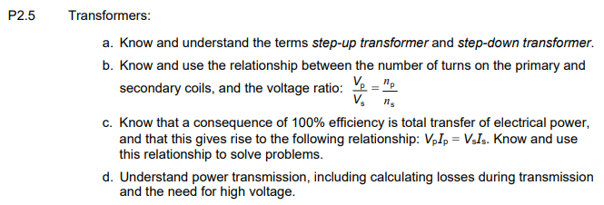
NSAA 2019 Q29
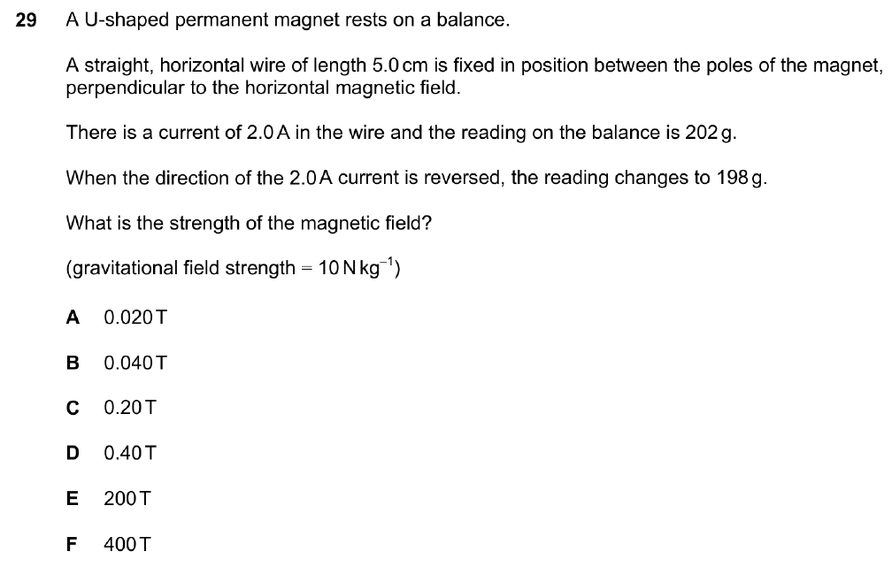

NSAA 2020 Q30
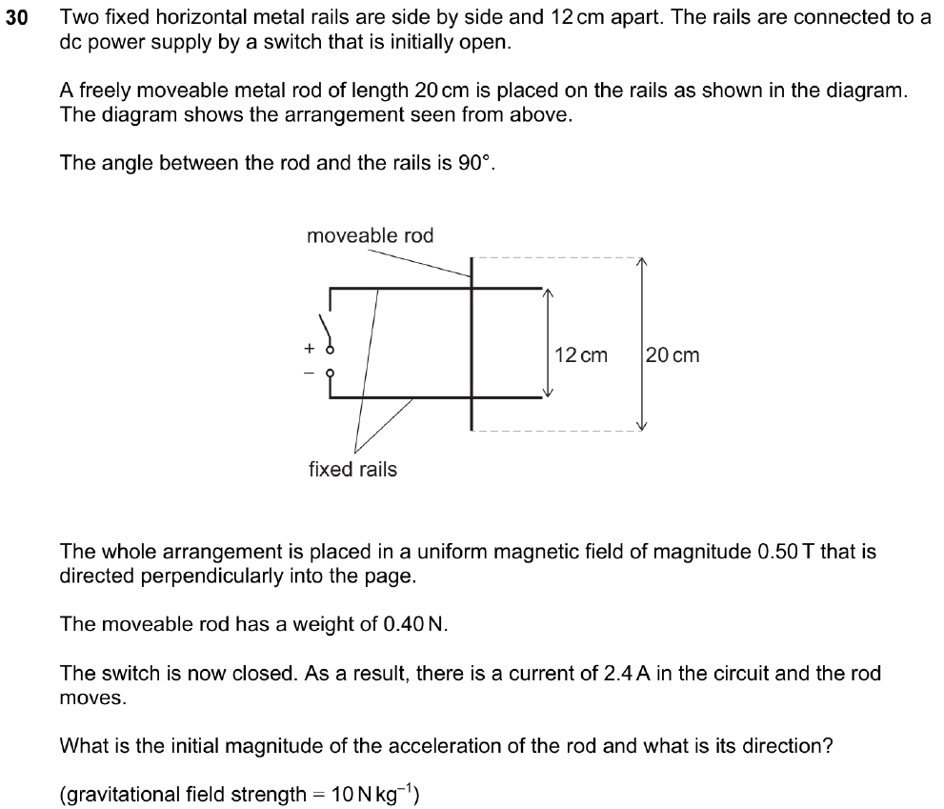
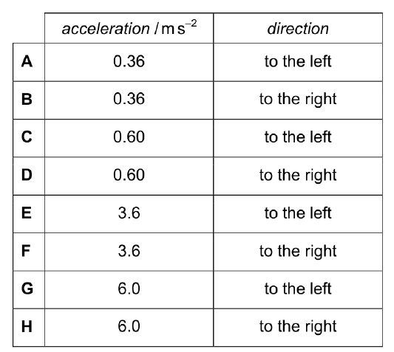
ENGAA 2020 Q28
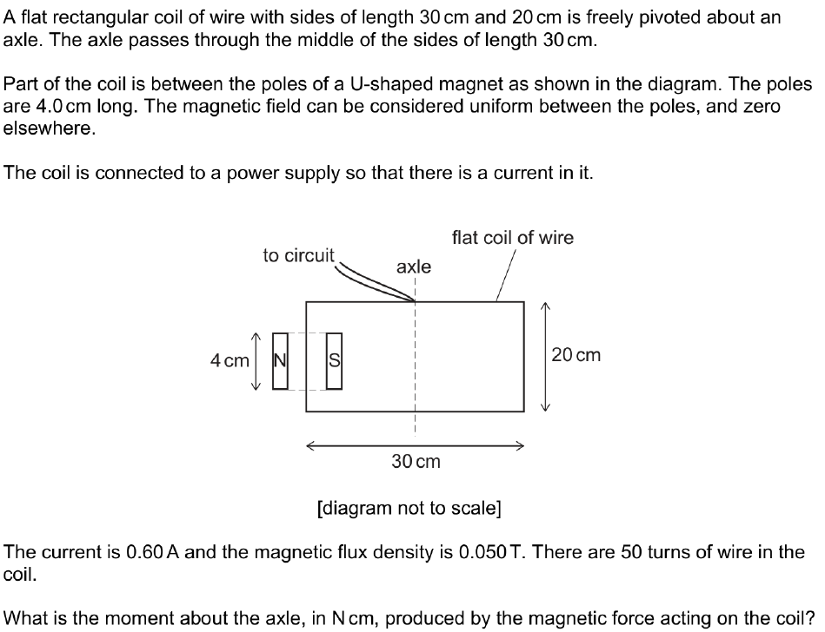
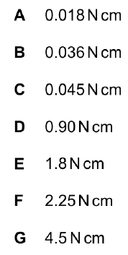

NSAA 2021 Q32
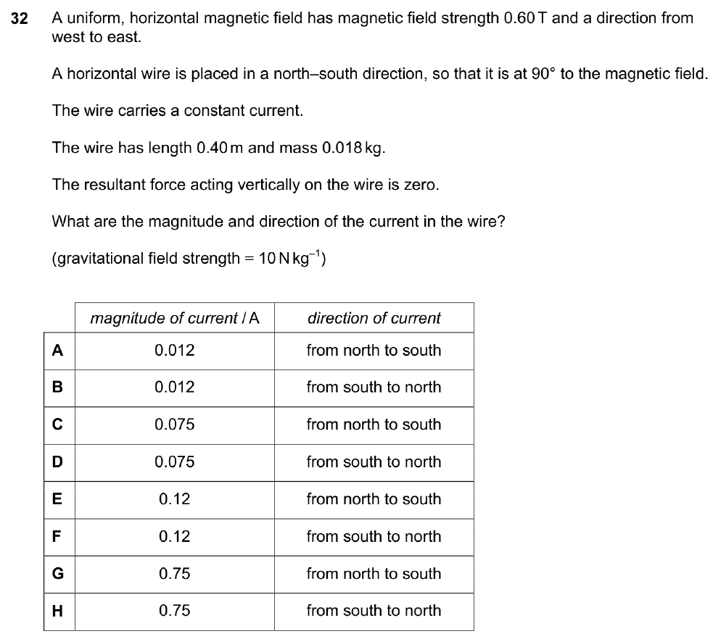

NSAA 2022 Q36
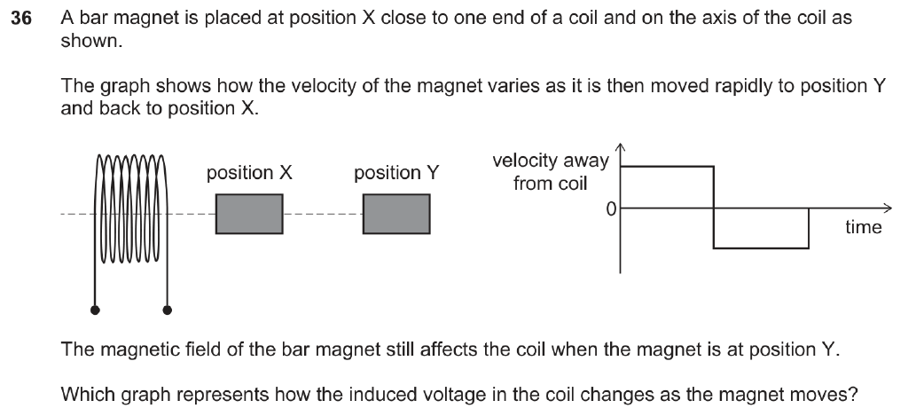
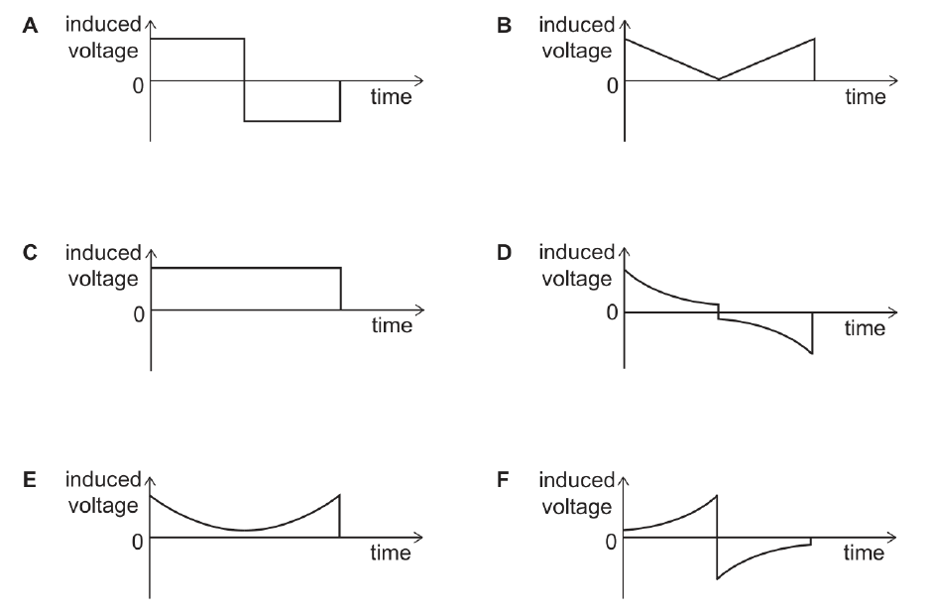

NSAA 2022 Q21
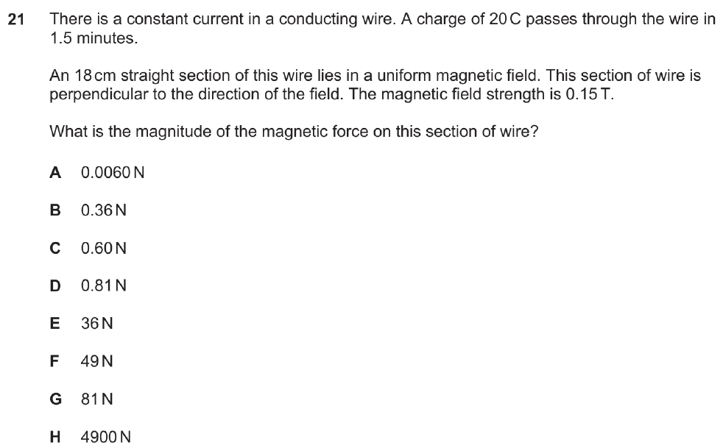
ENGAA 2022 Q2
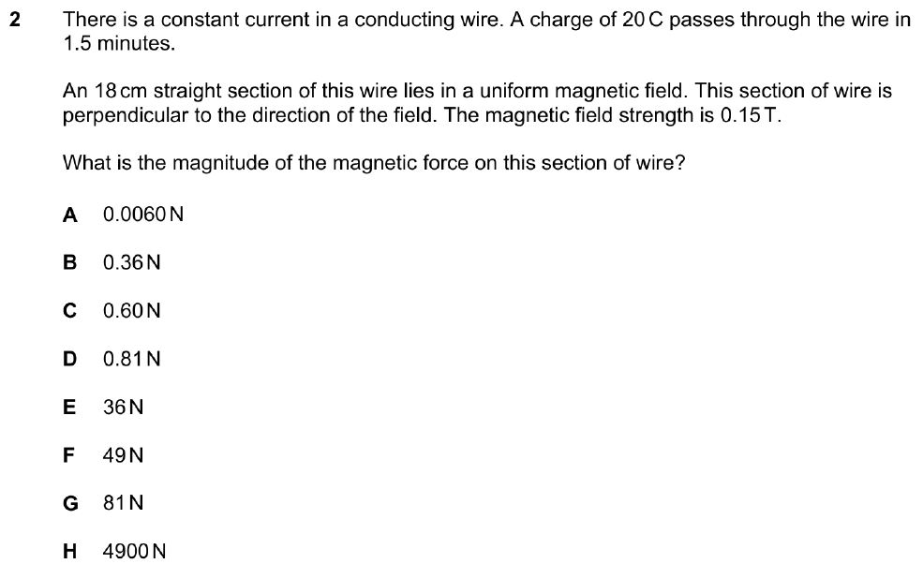

NSAA 2023 Q37
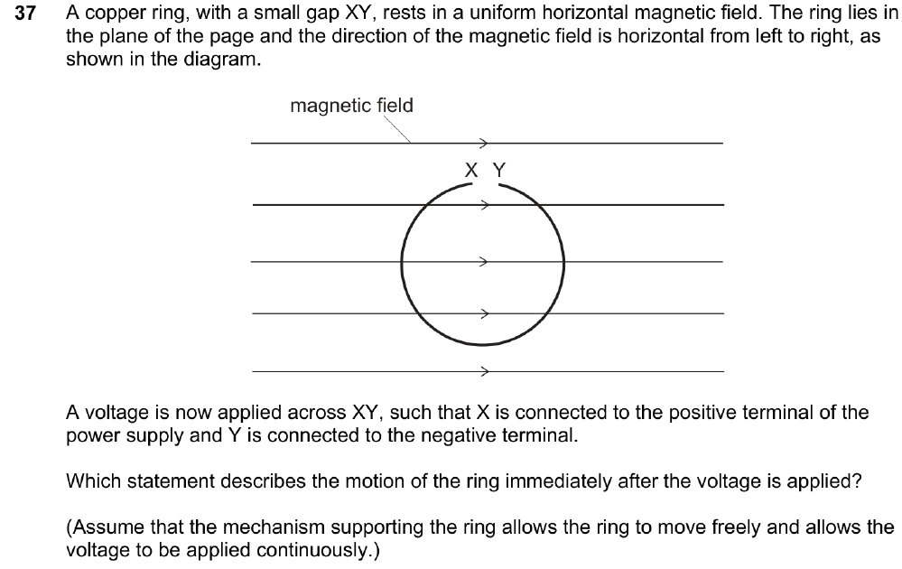
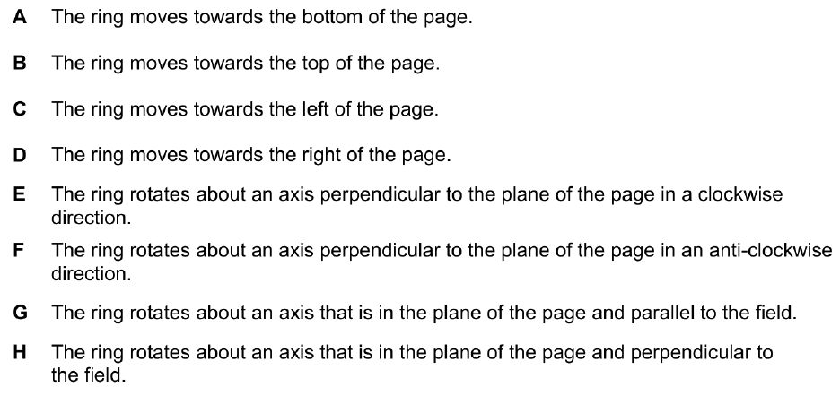

PAT 2019 Q9
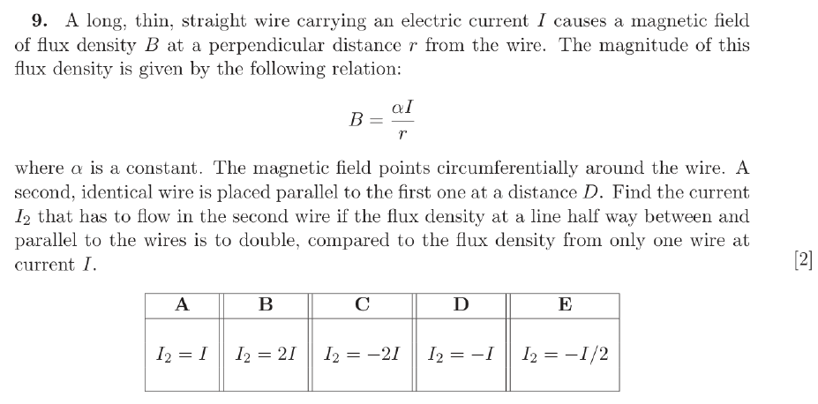
PAT 2023 Q12
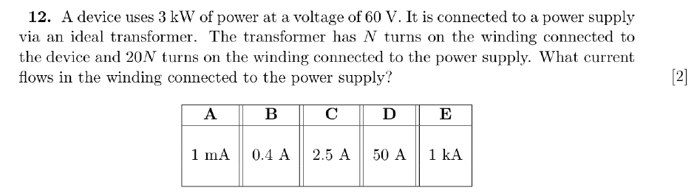

ENGAA 2023 Q14
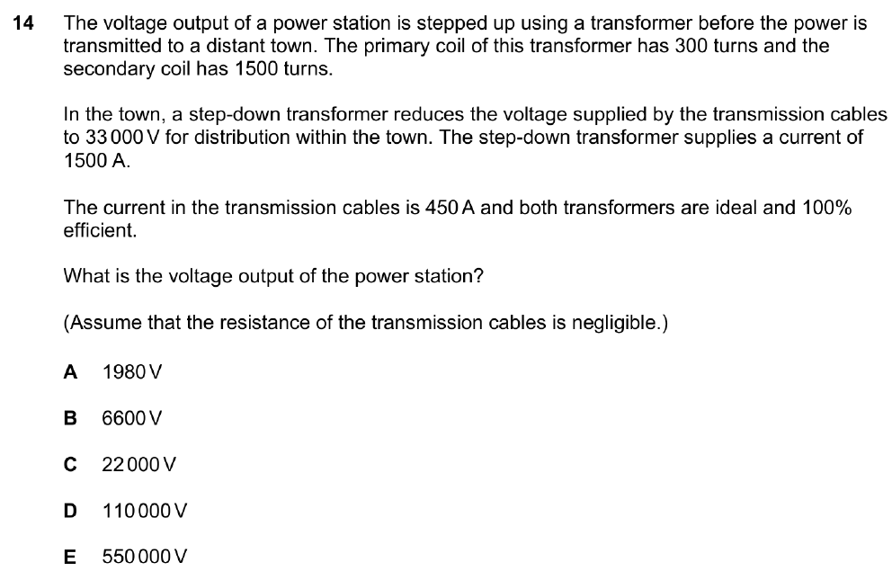

ENGAA 2021 Q4
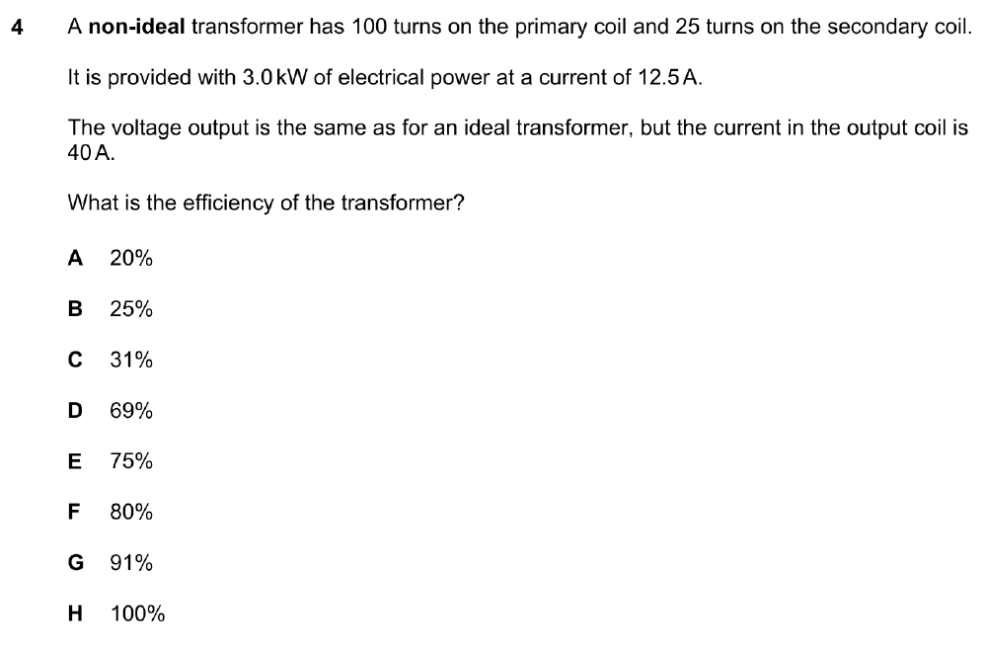
ENGAA 2019 Q8
