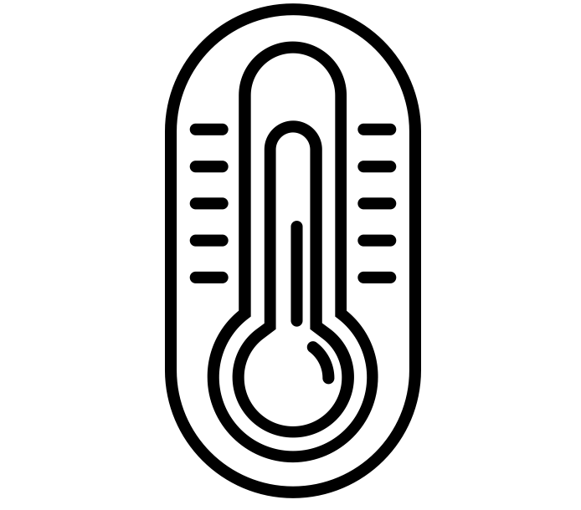
ESAT Physics Prep
Week 4 – Thermal physics

Week 1 – Electricity
Week 2 – Magnetism
Week 3 – Mechanics
Week 4 – Thermal physics
Week 5 – Matter
Week 6 – Waves
Week 7 – Radioactivity

There is one sample ESAT test – note that they use the same questions from NSAA 2020 specimen paper. Past NSAA & ENGAA questions are the most relevant.

There are no calculators in the ESAT.

Thermal physics spec
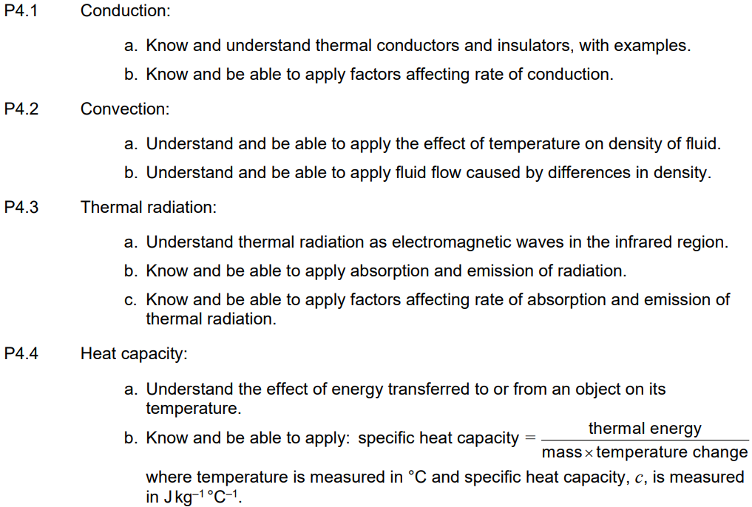

Q12 ENGAA 2023
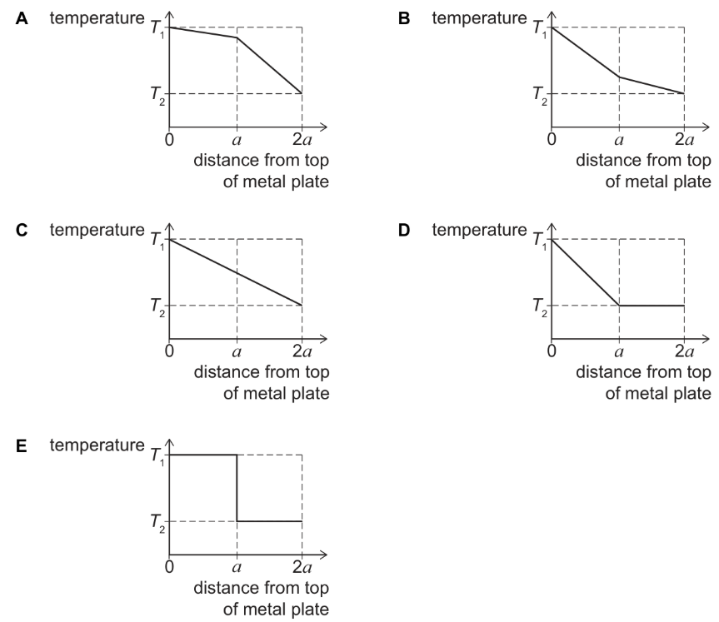
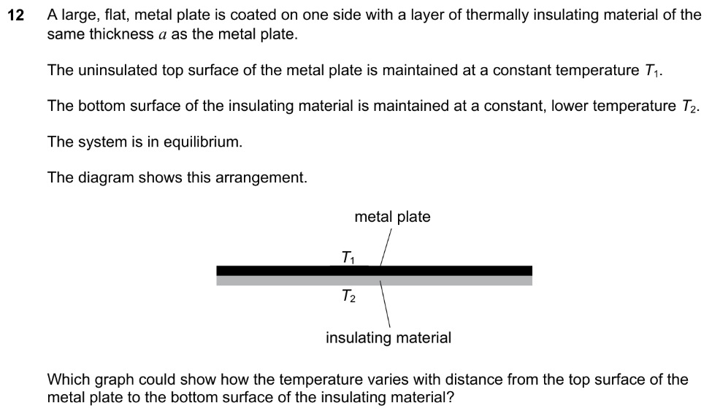

Q33 NSAA 2023
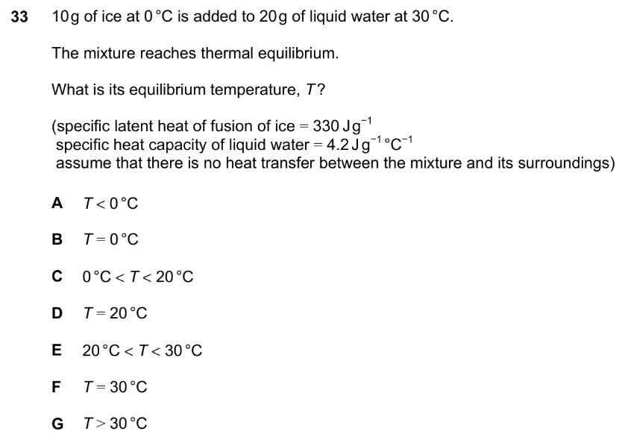

Q14 ENGAA 2022
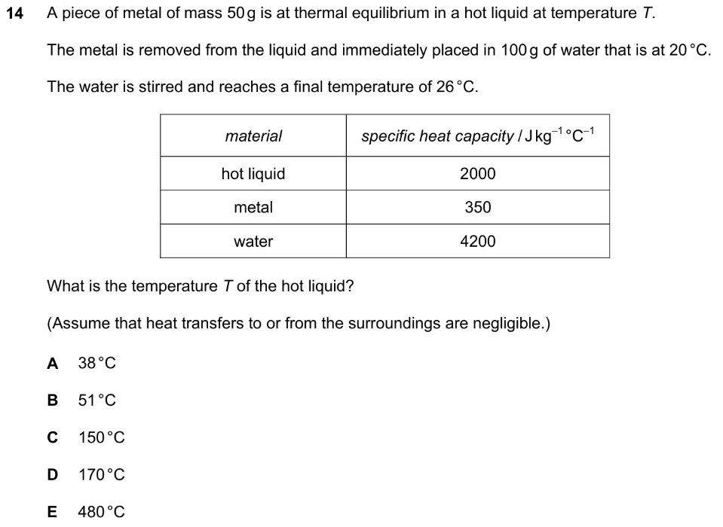

Q23 NSAA 2022
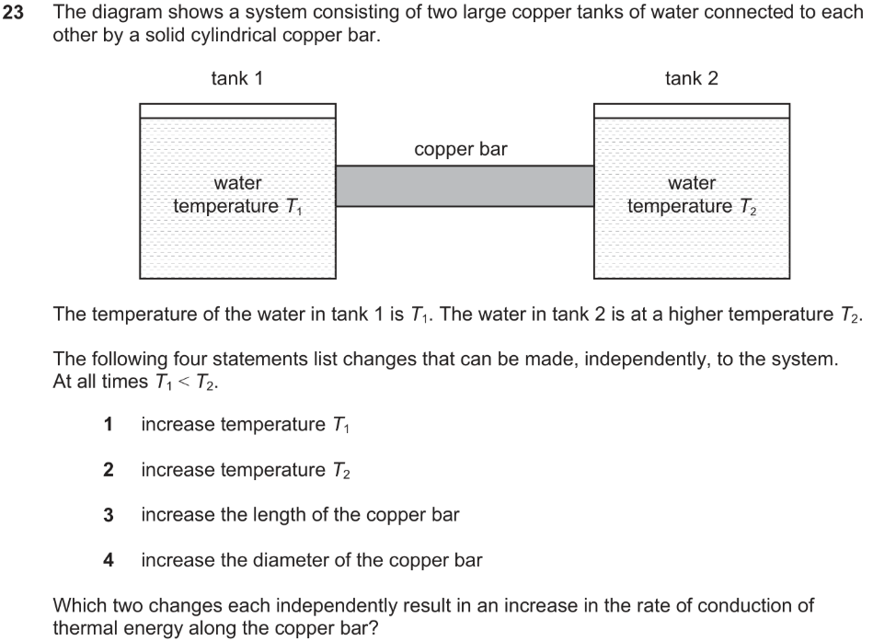
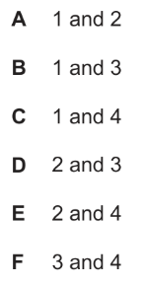

Q18 ENGAA 2021
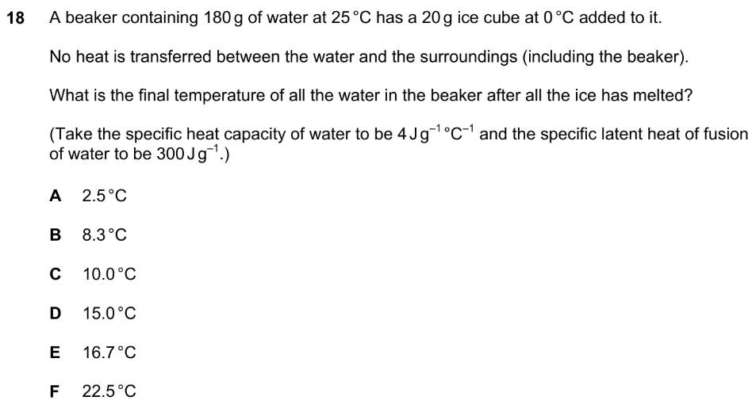
Q20 ENGAA 2020
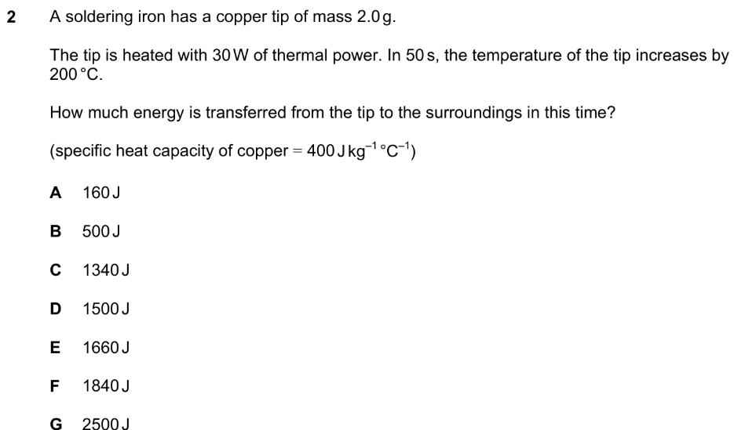

Q26 NSAA 2020
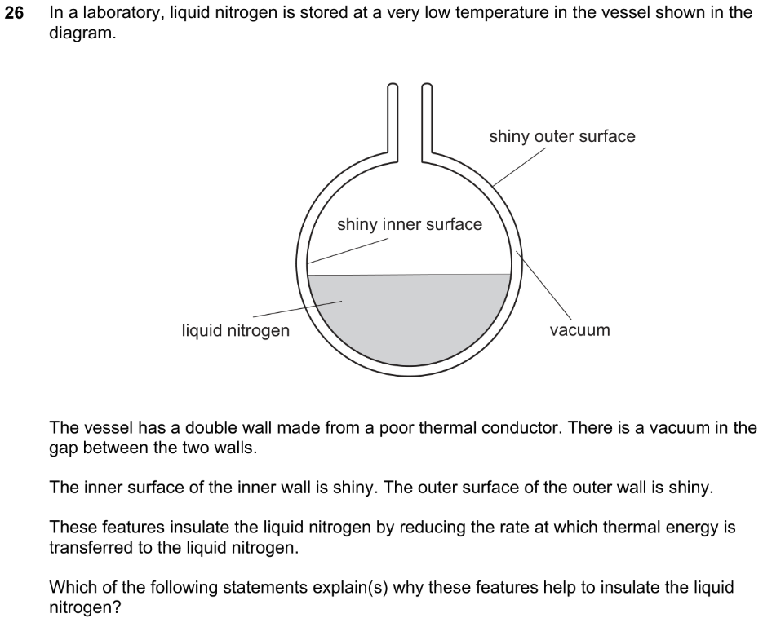
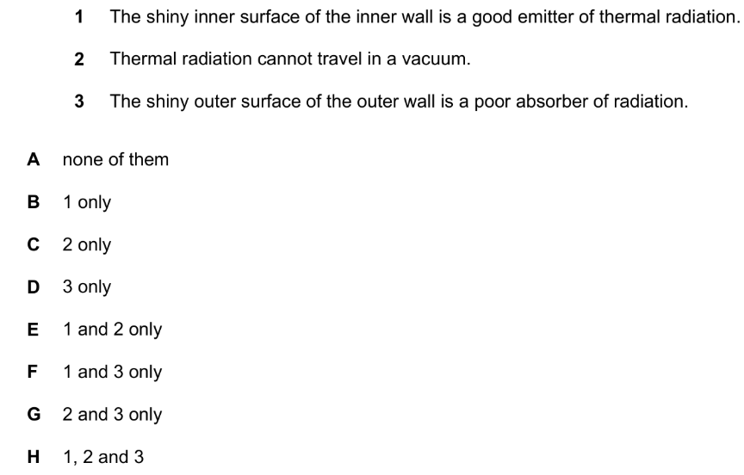
Q10 ENGAA 2019
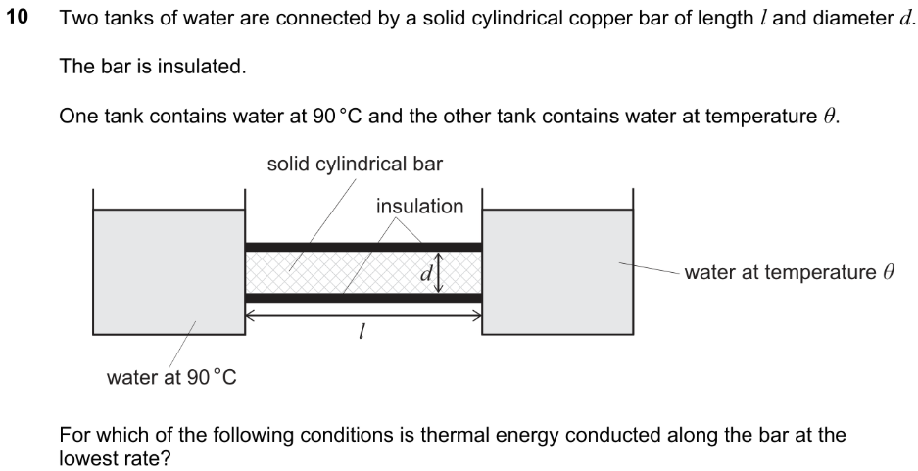
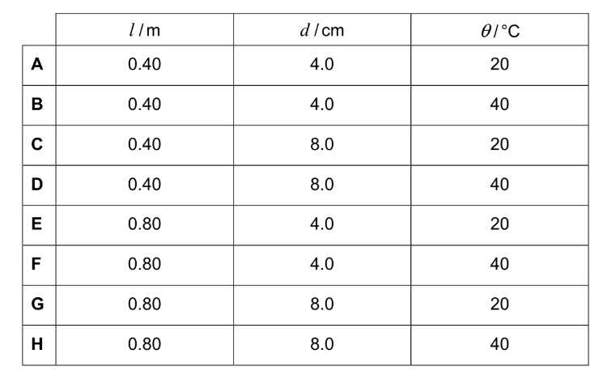

Q35 NSAA 2021
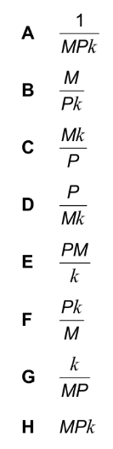
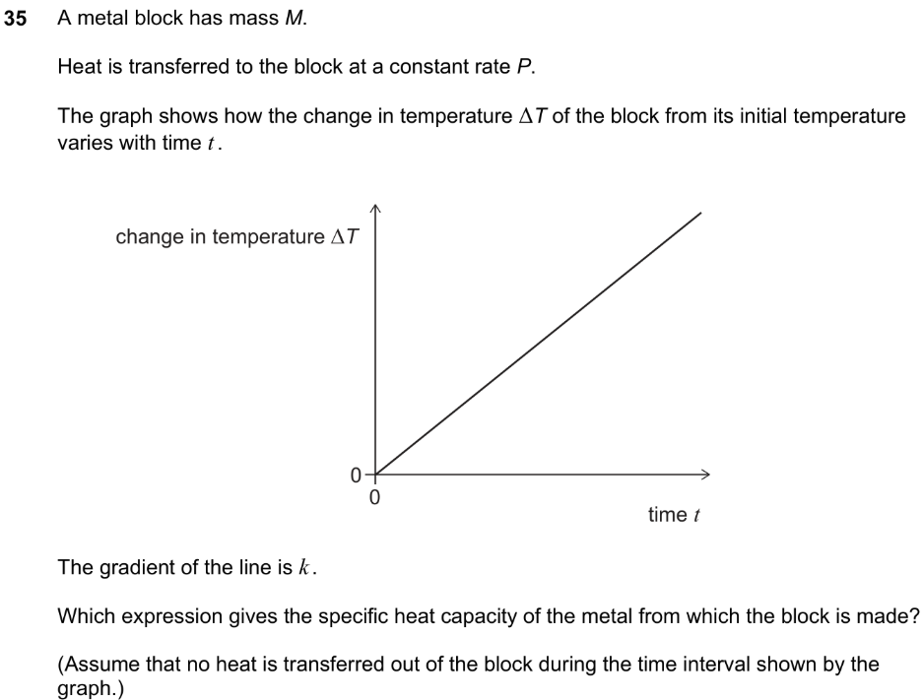

Q23 NSAA 2019
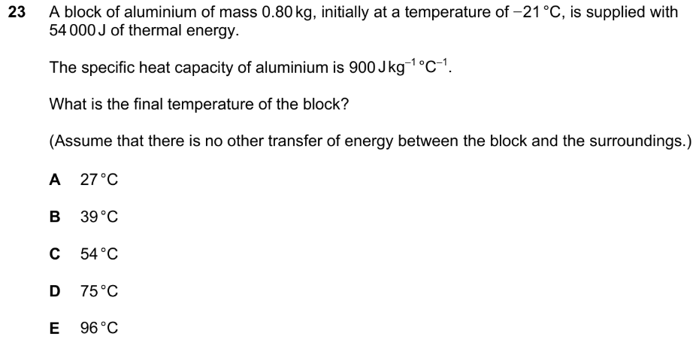

Q27 NSAA 2019
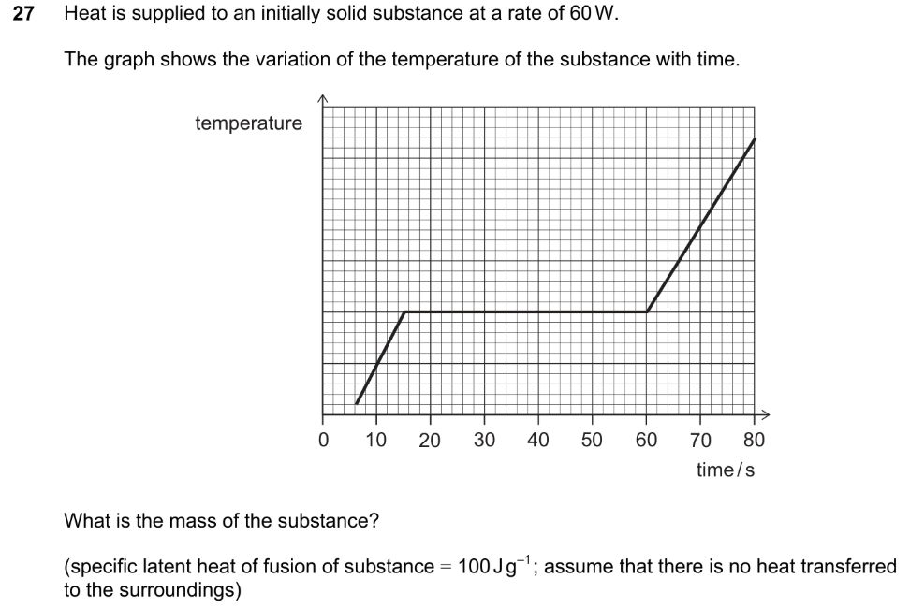
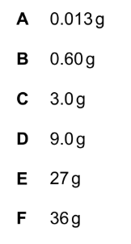

Q4 ENGAA 2017
