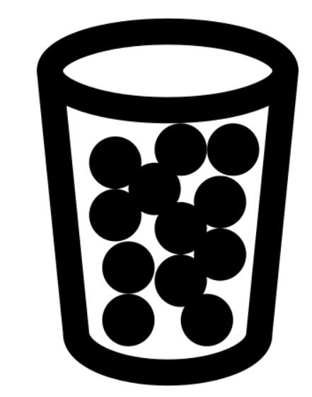
ESAT Physics Prep
Week 4 – Matter

Week 1 – Electricity
Week 2 – Magnetism
Week 3 – Mechanics
Week 4 – Thermal physics
Week 5 – Matter
Week 6 – Waves
Week 7 – Radioactivity

There is one sample ESAT test – note that they use the same questions from NSAA 2020 specimen paper. Past NSAA & ENGAA questions are the most relevant.

There are no calculators in the ESAT.

Matter spec
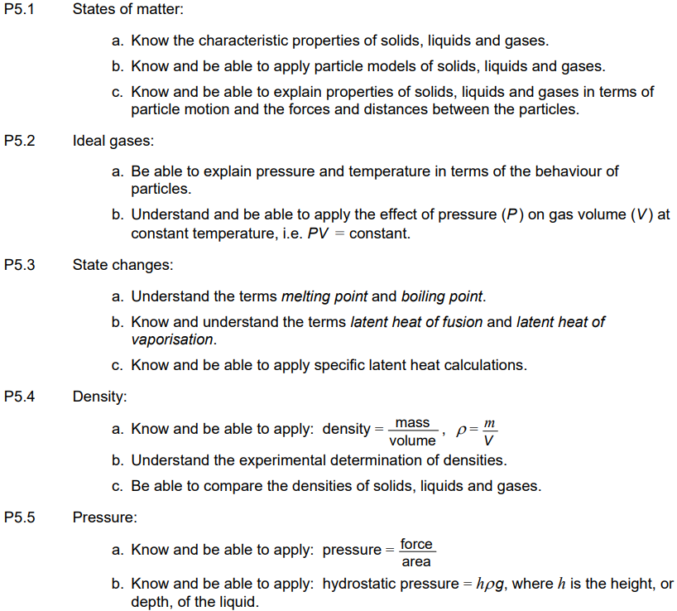

Q20 ENGAA 2023
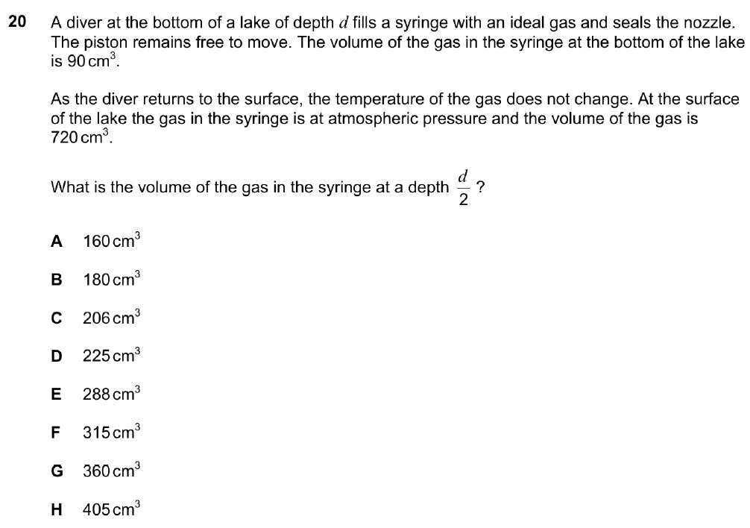

Q28 NSAA 2023
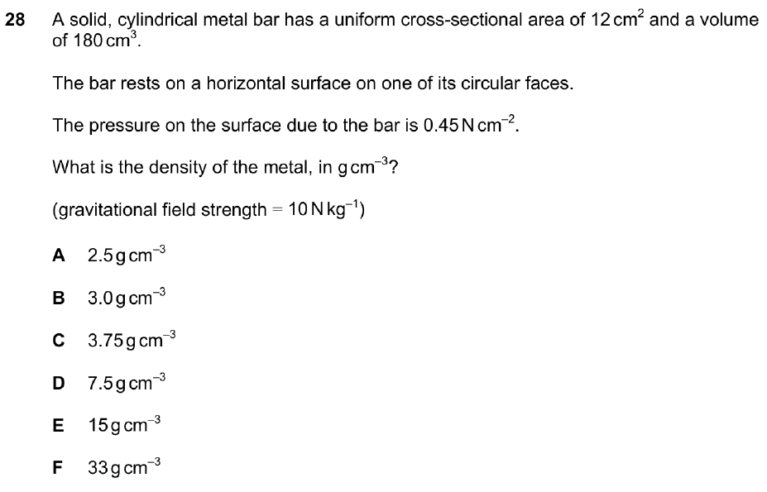
Q33 NSAA 2023
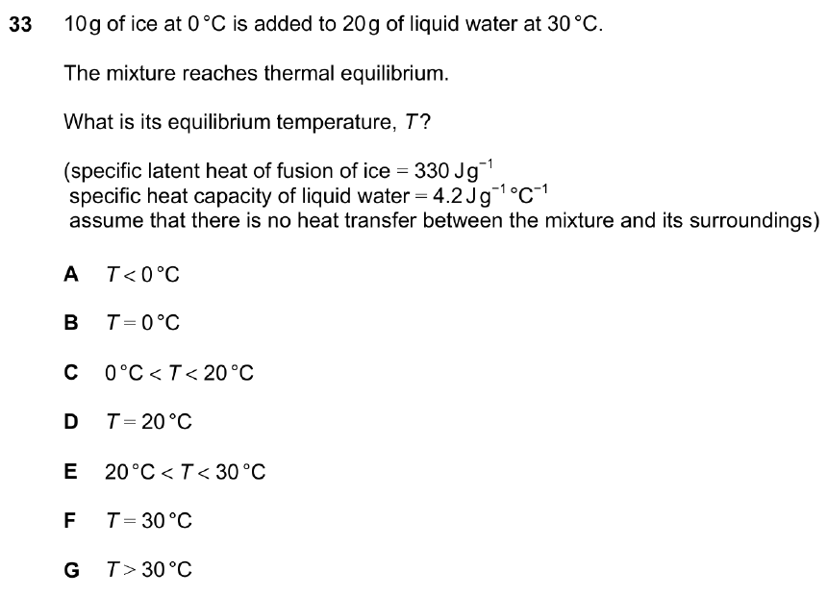

Q38 NSAA 2022
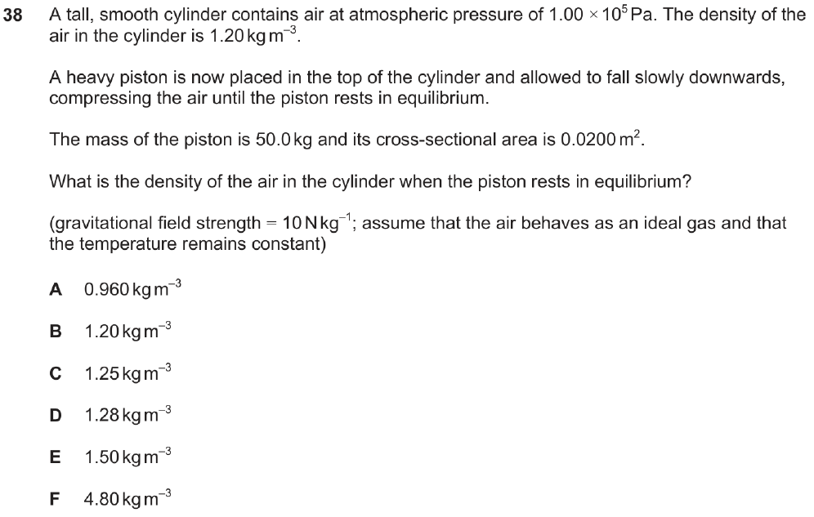
Q40 NSAA 2022
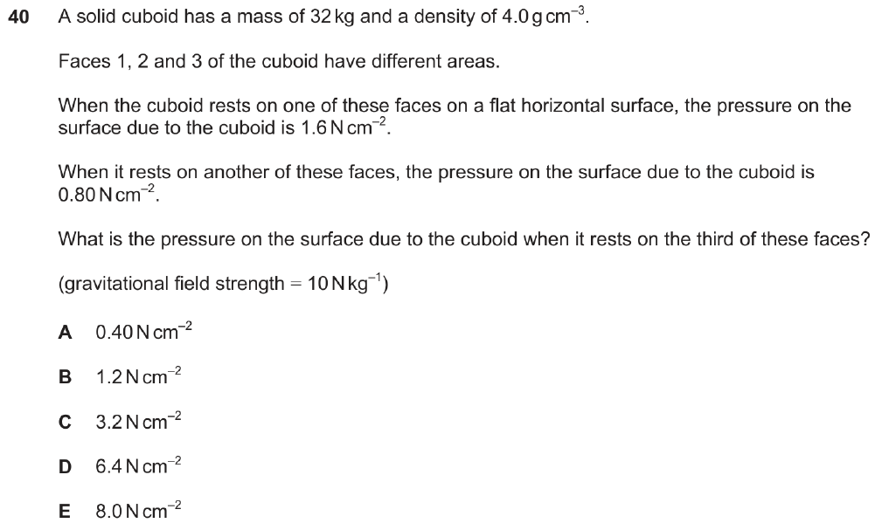

Q20 ENGAA 2022
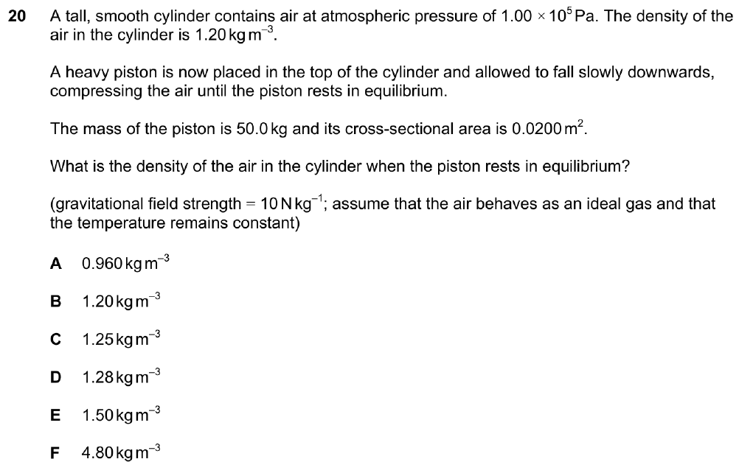
Q2 ENGAA 2021
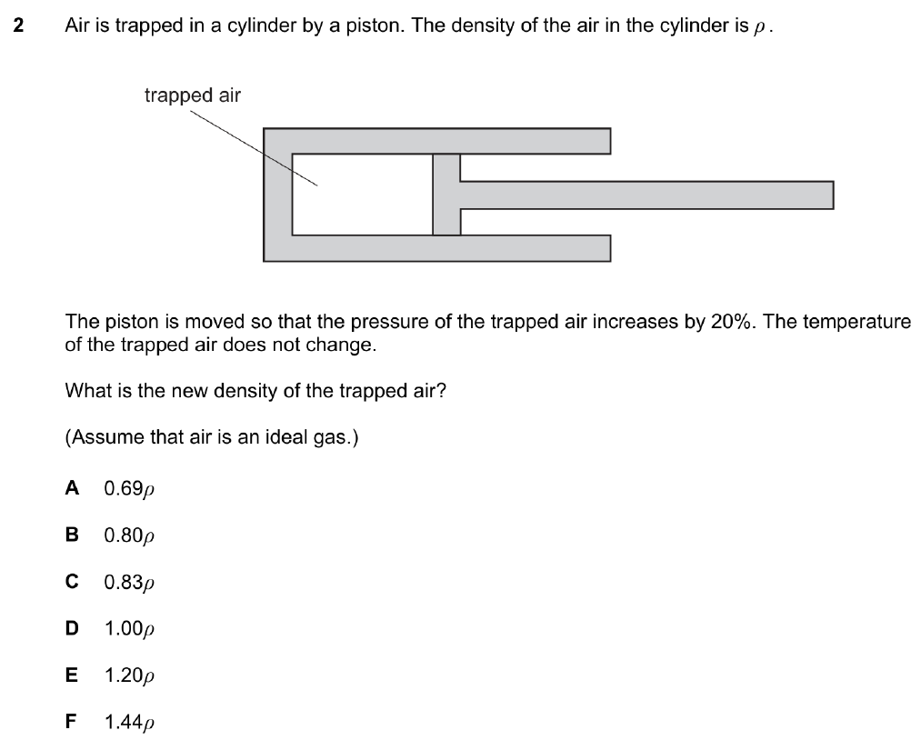
Q27 NSAA 2019
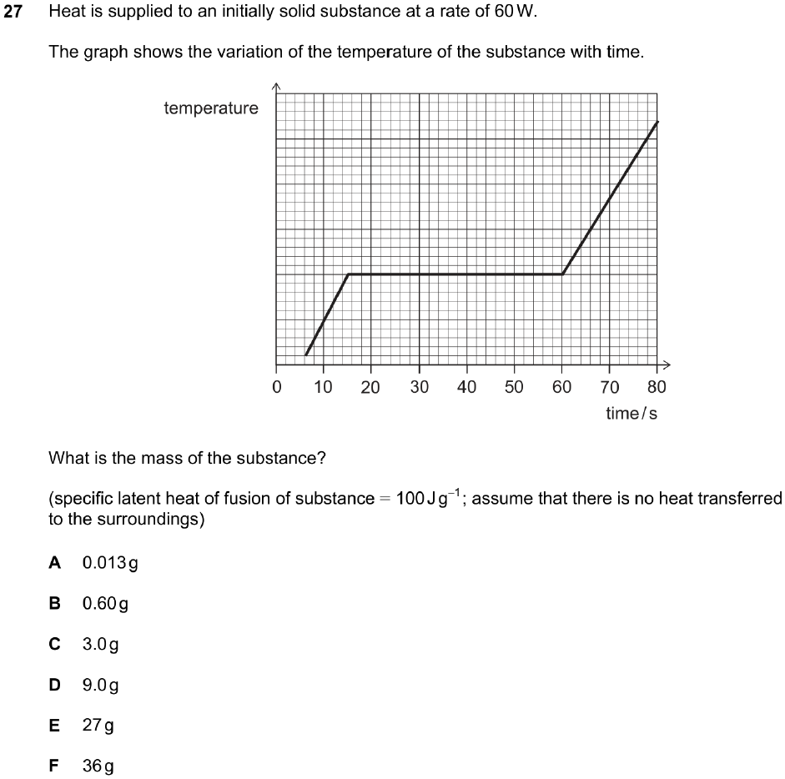

Q20 ENGAA 2018
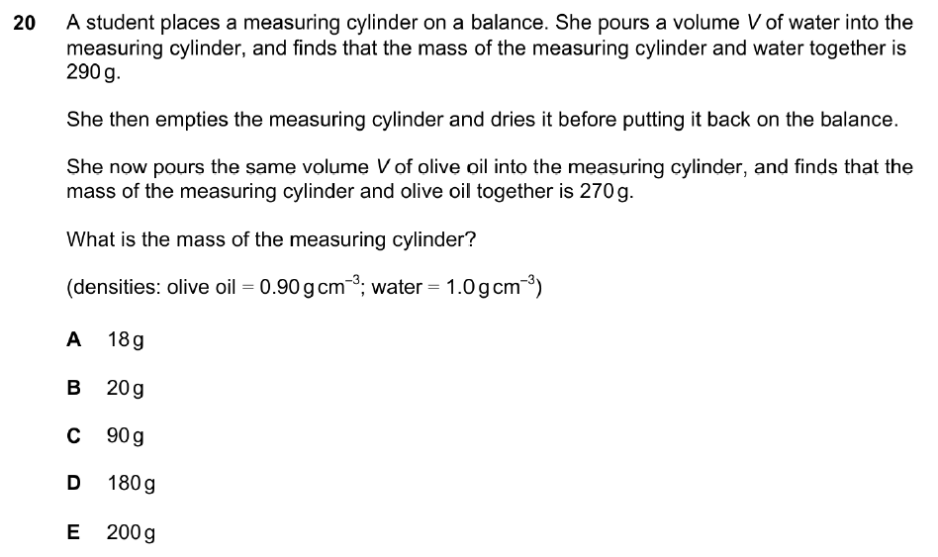
Q16 ENGAA 2017
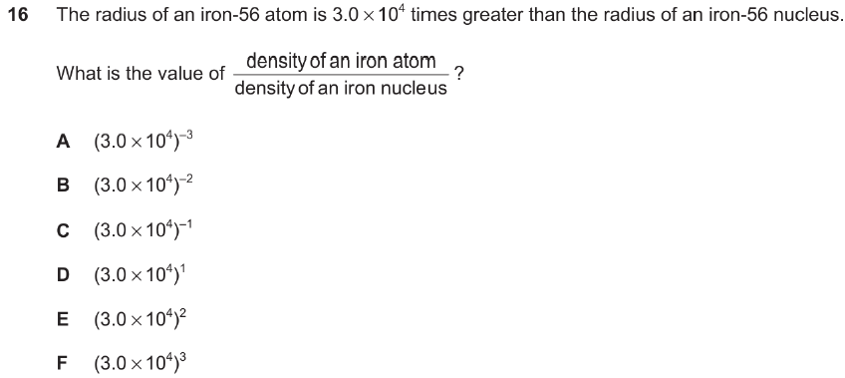

Q18 ENGAA 2018
