ESAT Physics Prep
Week 6 – Waves

Week 1 – Electricity
Week 2 – Magnetism
Week 3 – Mechanics
Week 4 – Thermal physics
Week 5 – Matter
Week 6 – Waves
Week 7 – Radioactivity

There is one sample ESAT test – note that they use the same questions from NSAA 2020 specimen paper. Past NSAA & ENGAA questions are the most relevant.

There are no calculators in the ESAT.

Waves spec
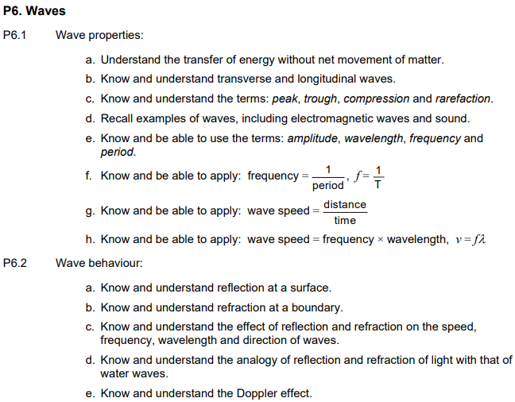
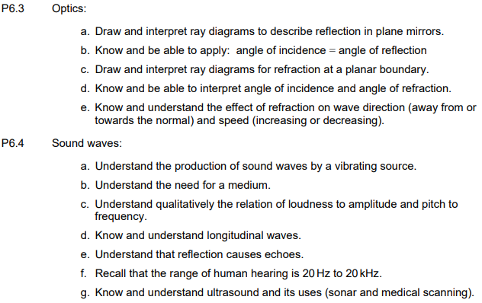

Q16 ENGAA 2023
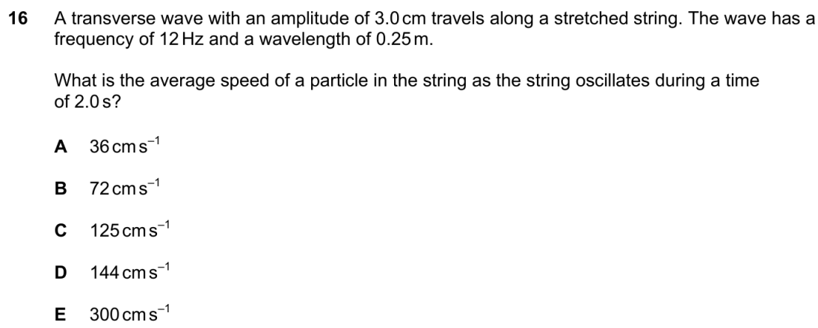

Q22 ENGAA 2023
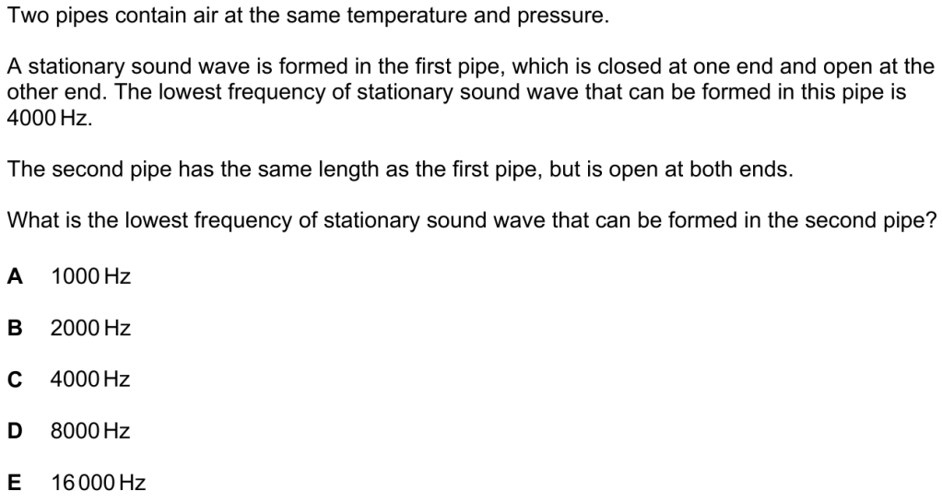

Q38 ENGAA 2023
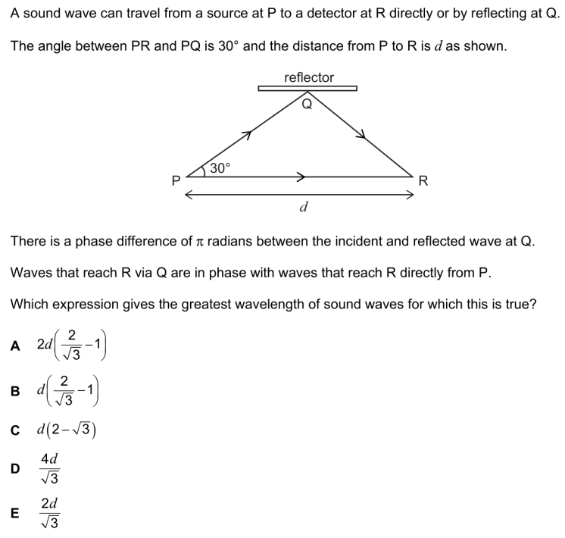

Q6 ENGAA 2022
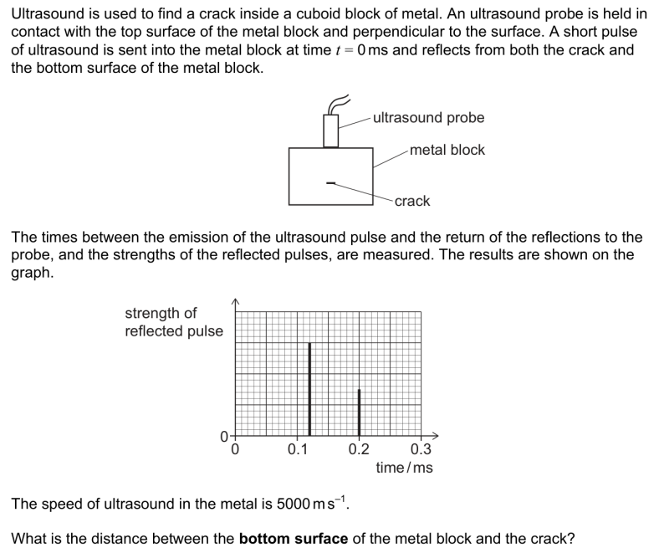
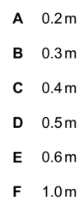

Q12 ENGAA 2022
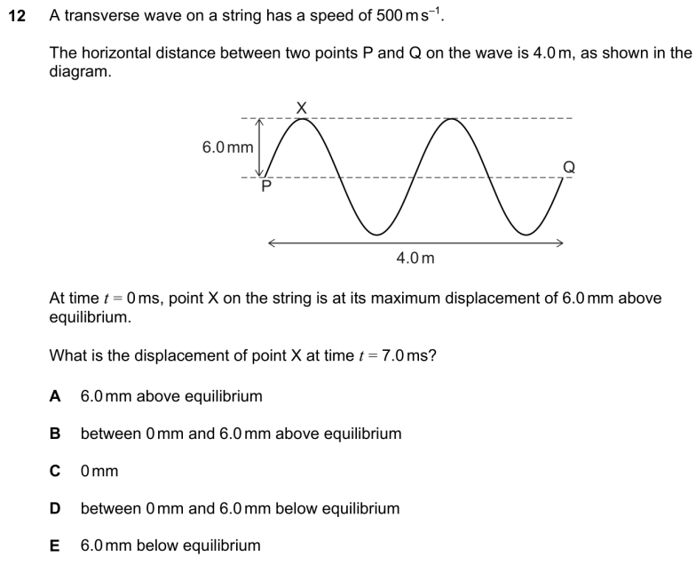
Q22 ENGAA 2022
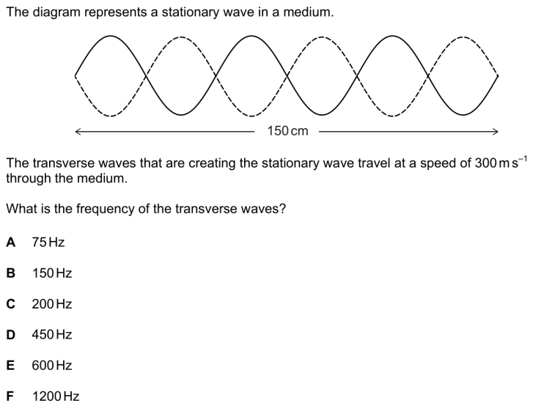
Q26 ENGAA 2022
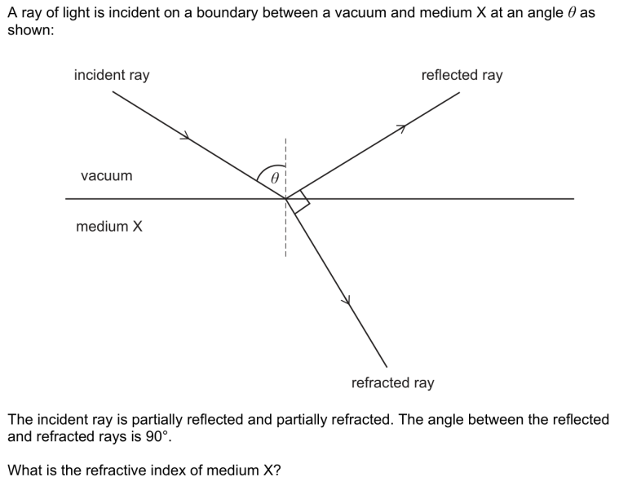
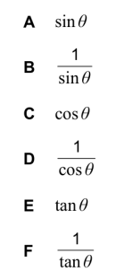

Q12 ENGAA 2021
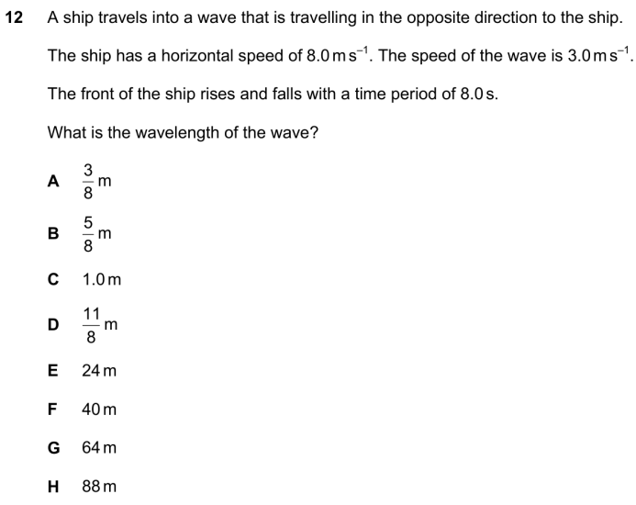

Q20 ENGAA 2021
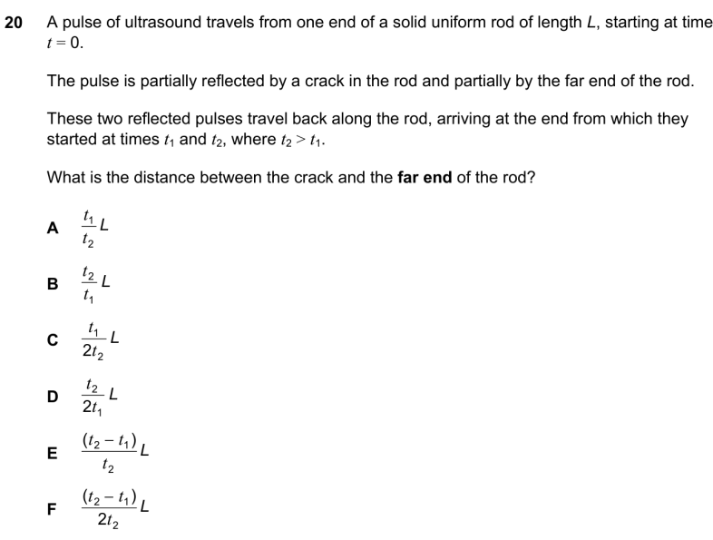

Q24 ENGAA 2021
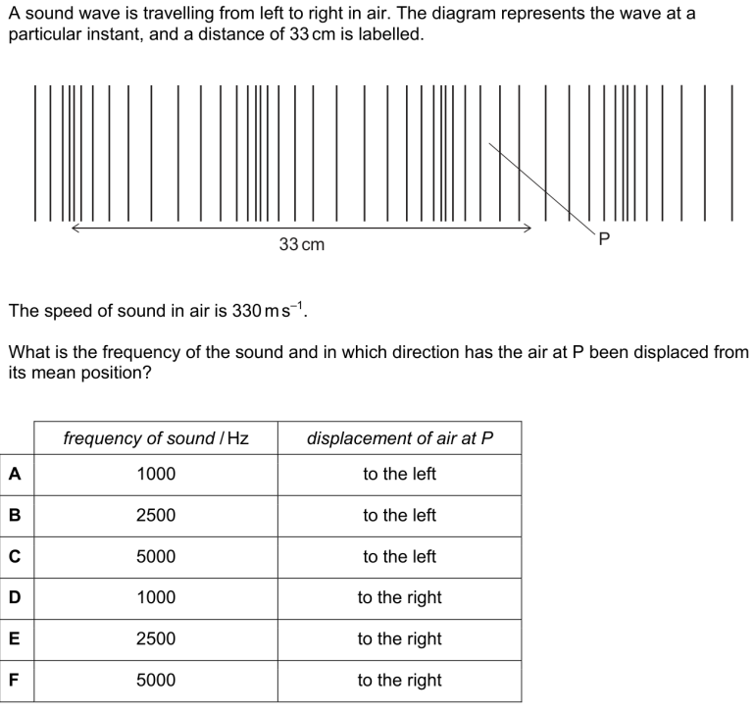

Q14 ENGAA 2020
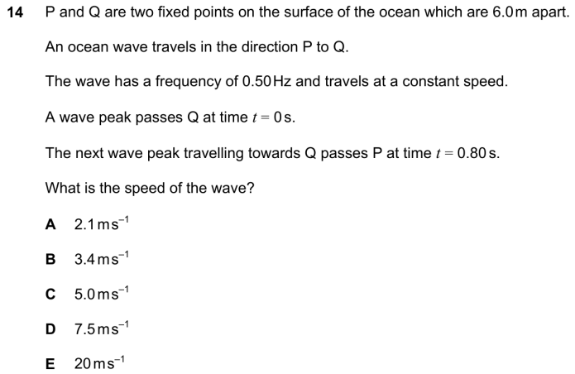

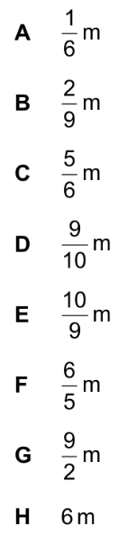
Q26 ENGAA 2020
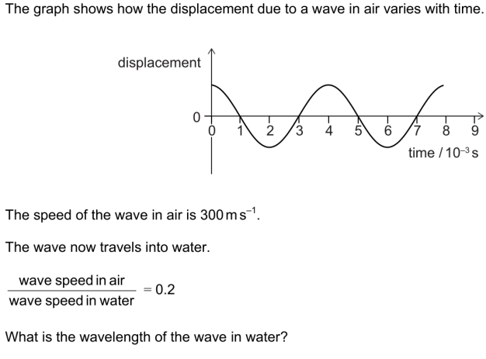

Q4 ENGAA 2019
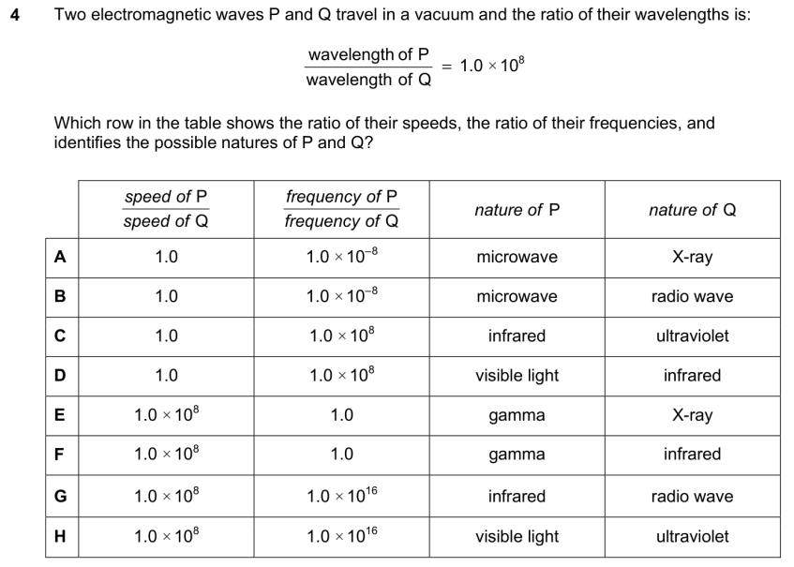

Q30 ENGAA 2019
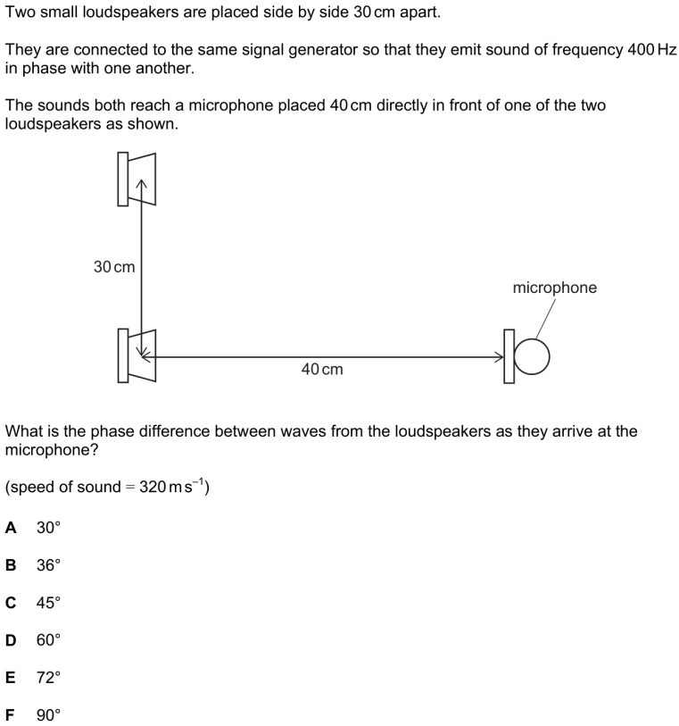

Q38 ENGAA 2019
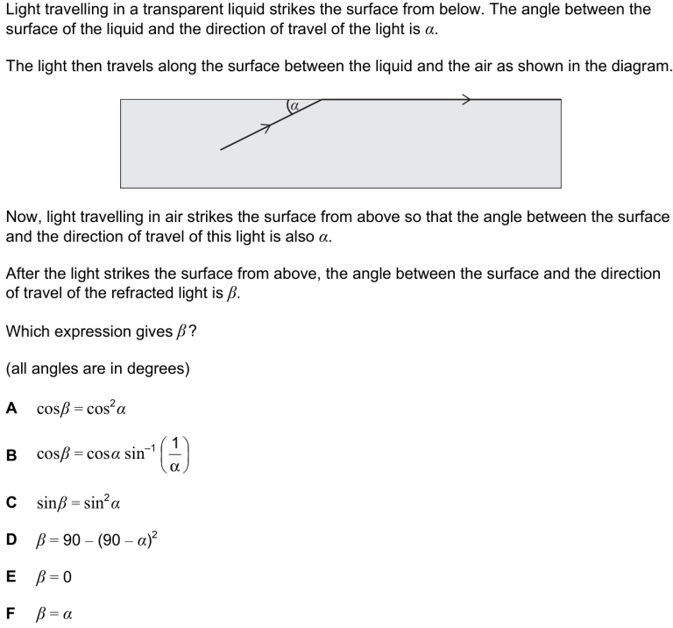

Q6 ENGAA 2018
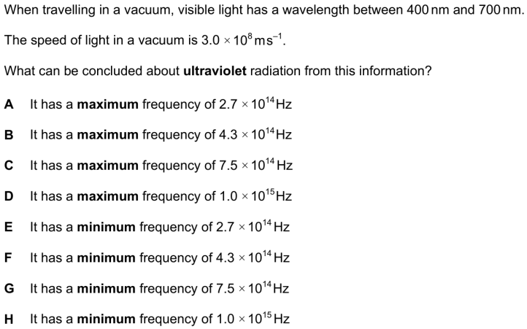
Q18 ENGAA 2018
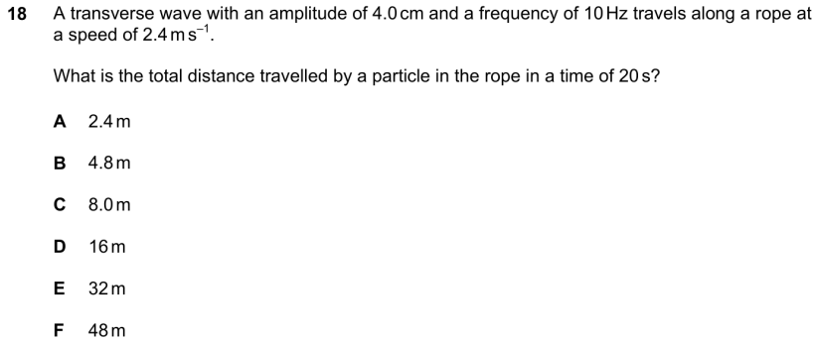

Q18 ENGAA 2017
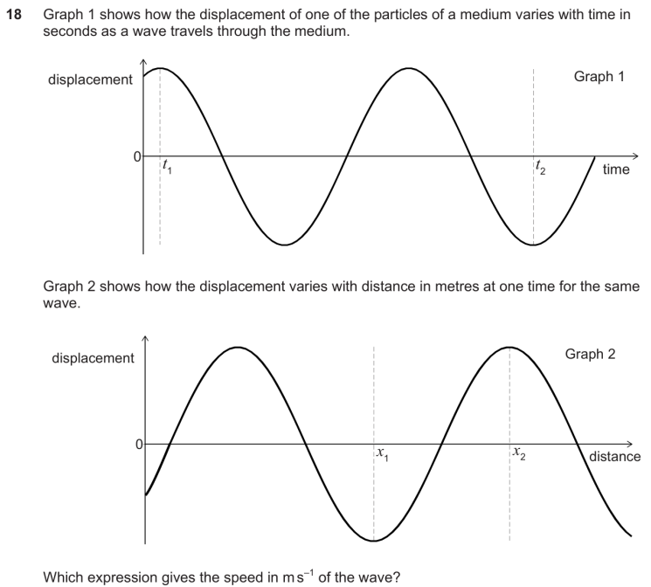
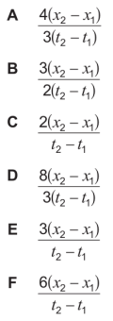

Q12 ENGAA 2016
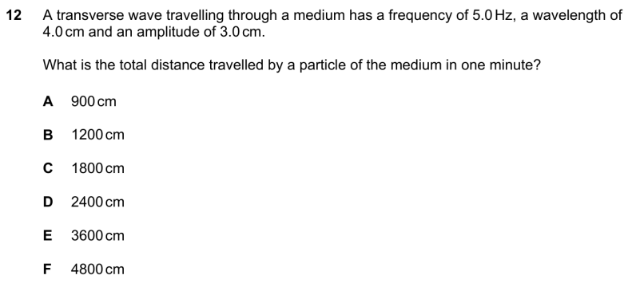
Q28 ENGAA 2016
