ESAT Physics Prep
Week 7 – Radioactivity

Week 1 – Electricity
Week 2 – Magnetism
Week 3 – Mechanics
Week 4 – Thermal physics
Week 5 – Matter
Week 6 – Waves
Week 7 – Radioactivity

There is one sample ESAT test – note that they use the same questions from NSAA 2020 specimen paper. Past NSAA & ENGAA questions are the most relevant.

There are no calculators in the ESAT.

Radioactivity spec
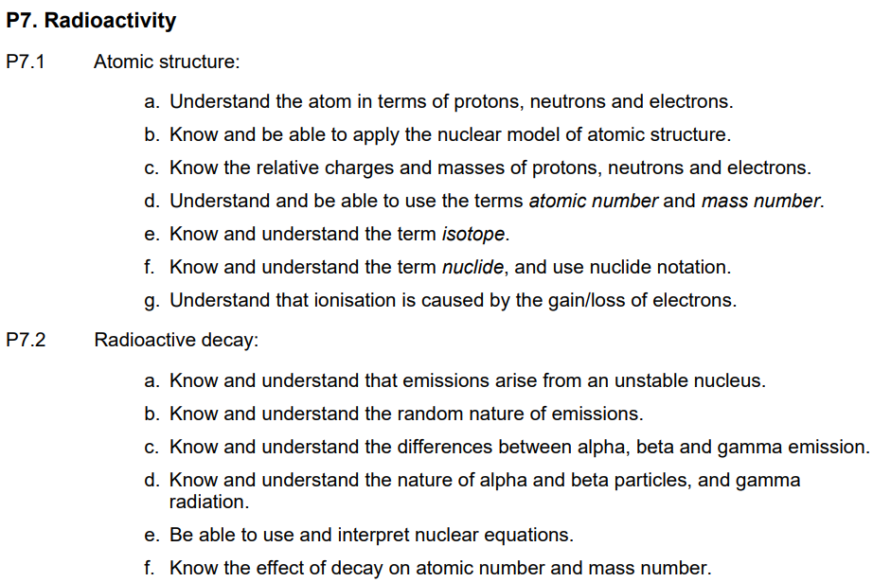
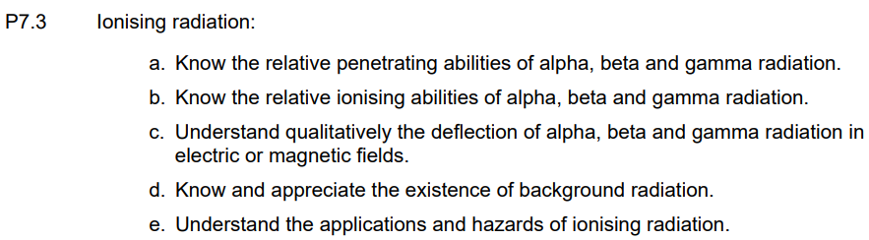
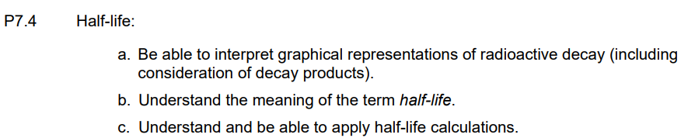

Q10 ENGAA 2023
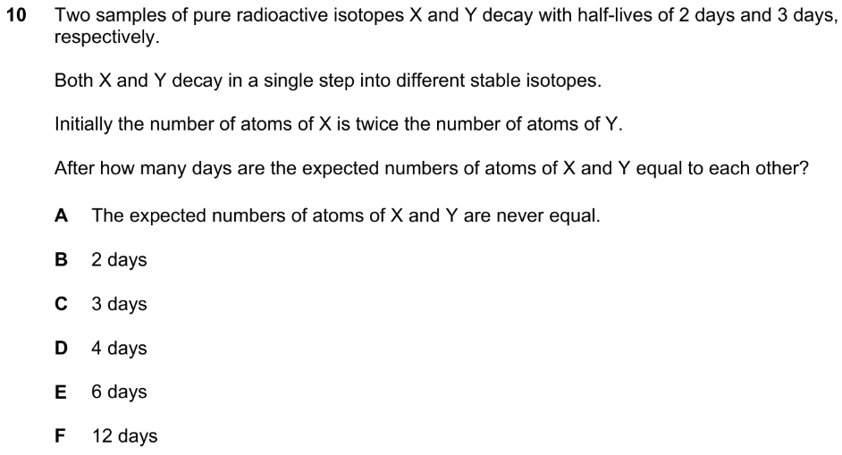
Q27 NSAA 2023
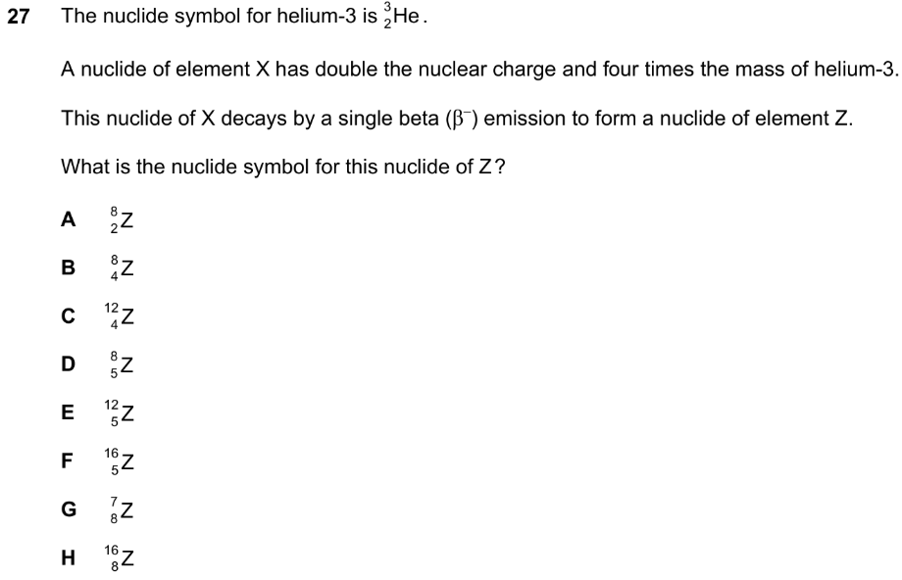

Q34 NSAA 2022
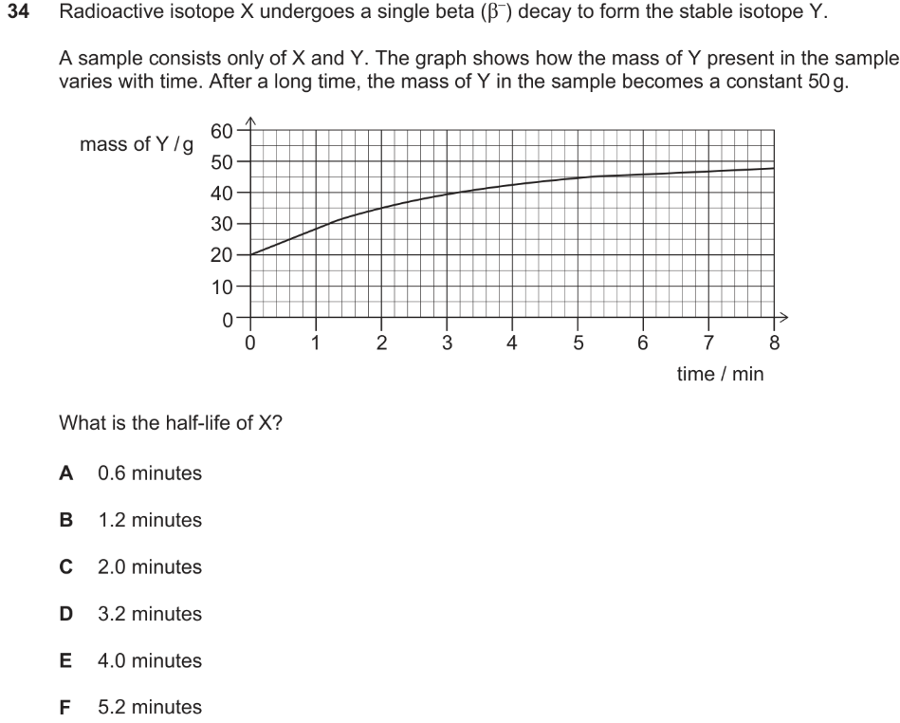

Q16 ENGAA 2021
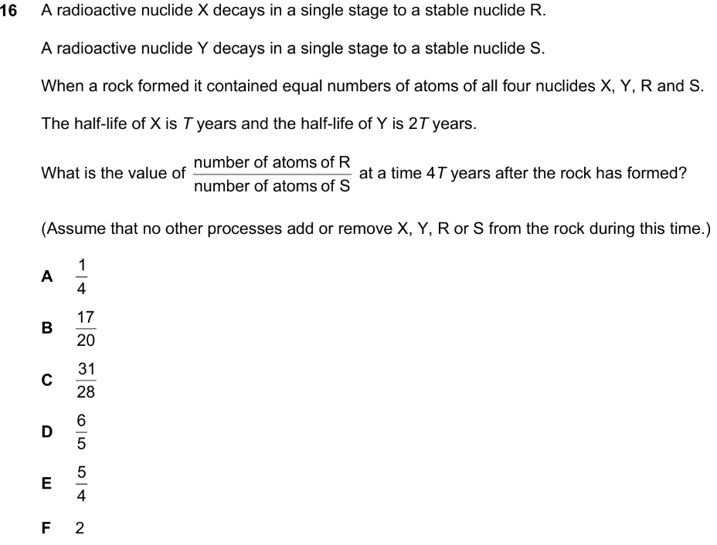
Q4 ENGAA 2020
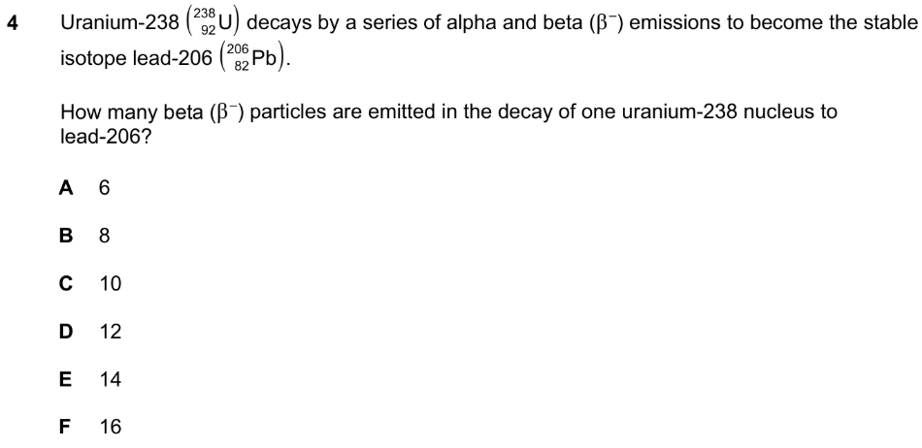

Q36 NSAA 2020
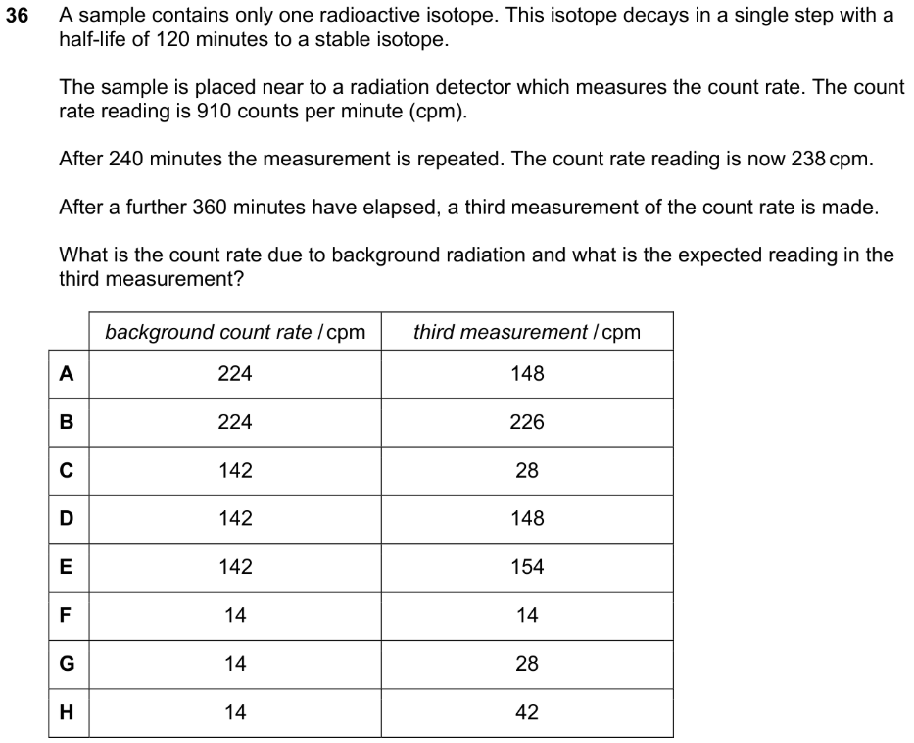

Q12 ENGAA 2019
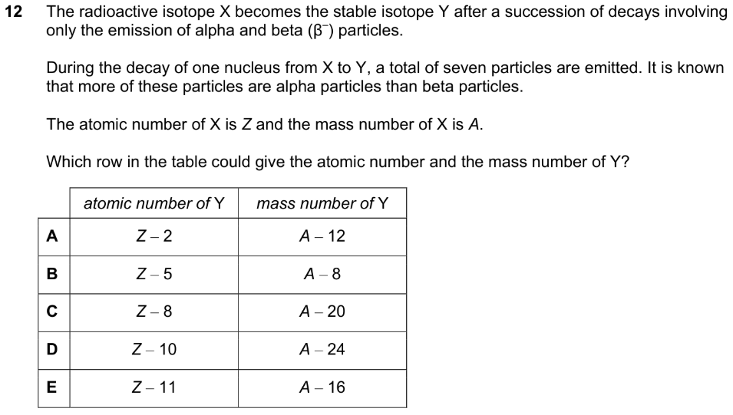
Q20 ENGAA 2019
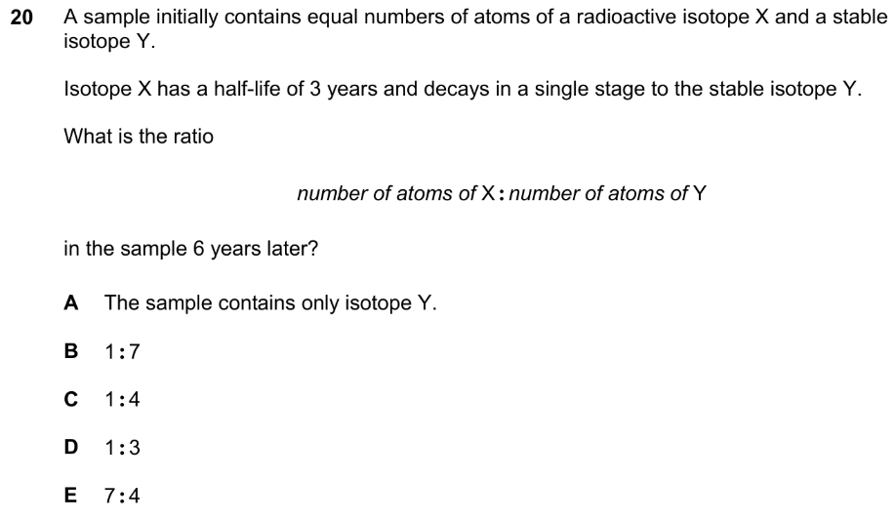

Q2 ENGAA 2018
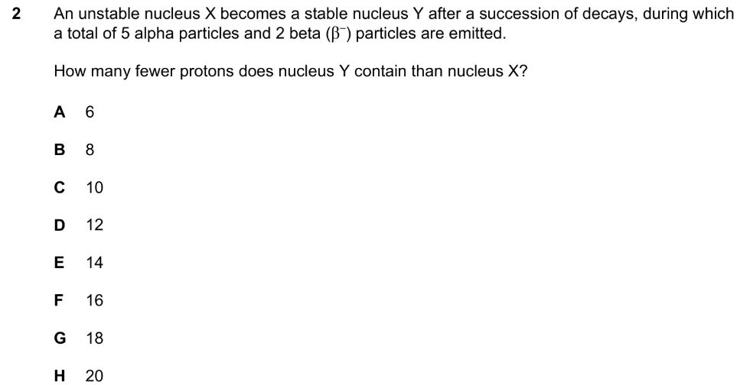

Q14 ENGAA 2018
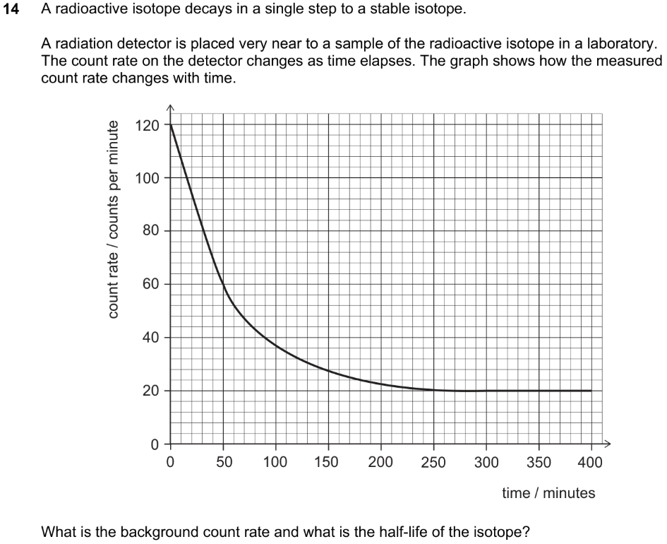
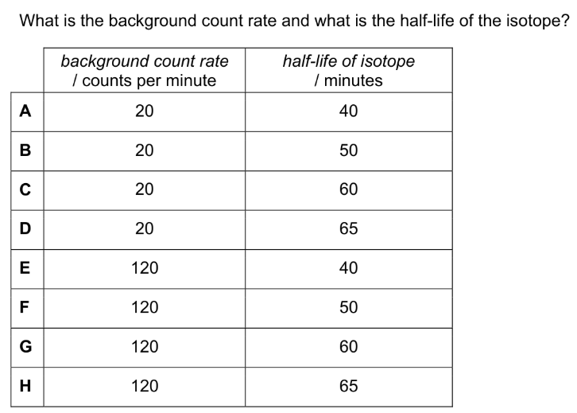

Q24 ENGAA 2018
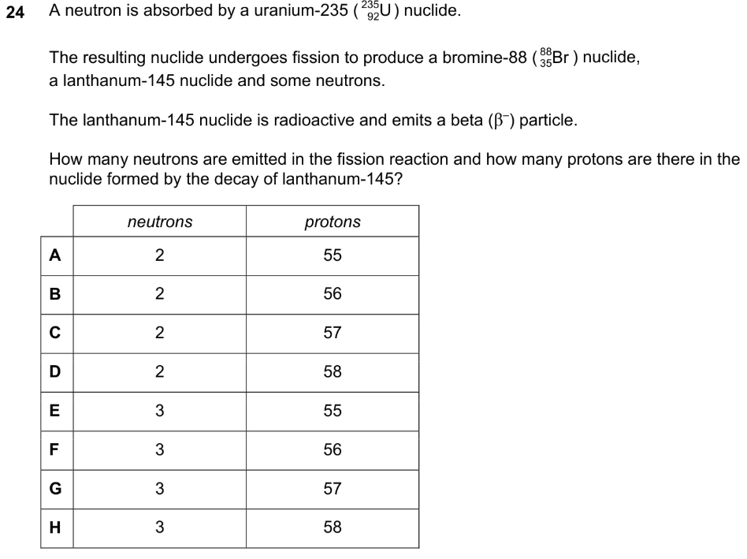
Q10 ENGAA 2017
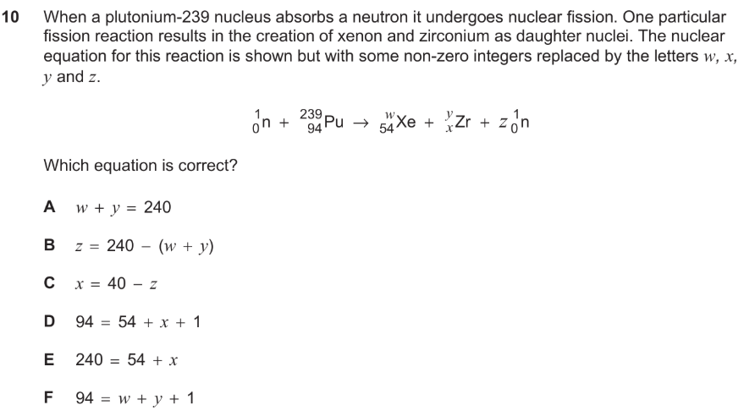
Q14 ENGAA 2017
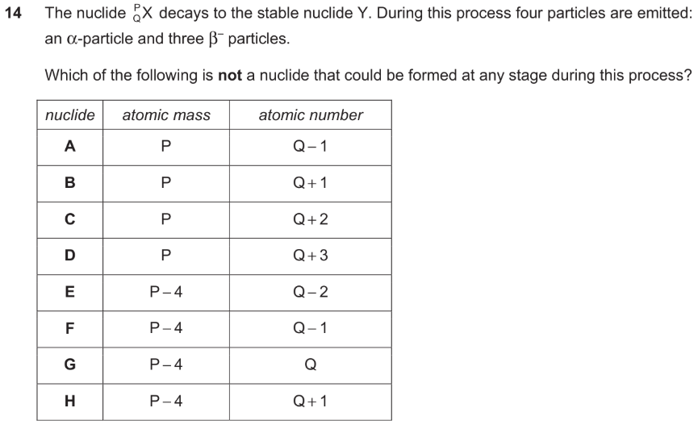
Q2 ENGAA 2016
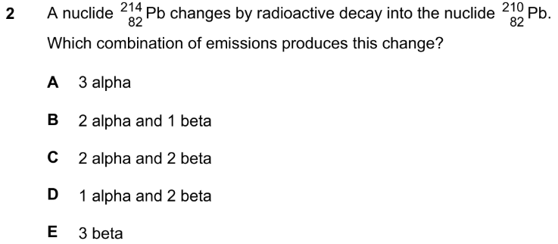

Q6 ENGAA 2016
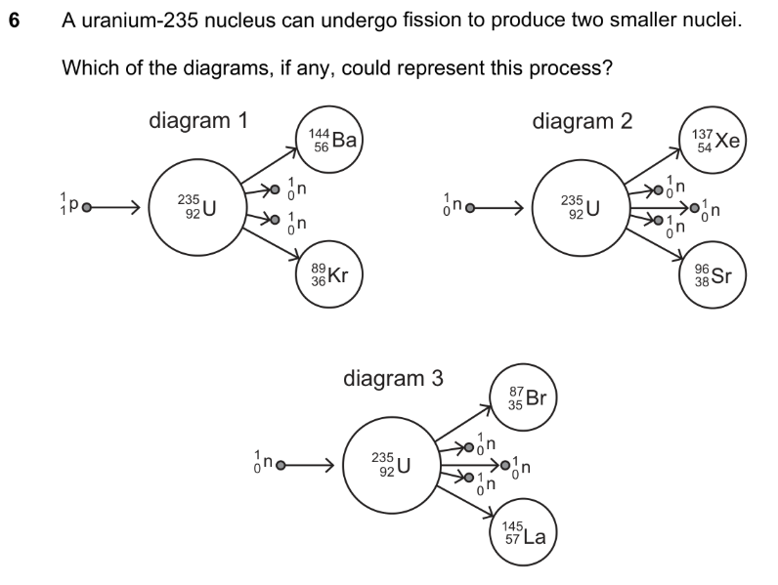
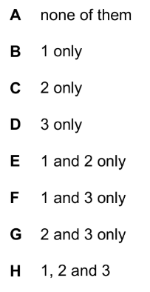

Q26 ENGAA 2016
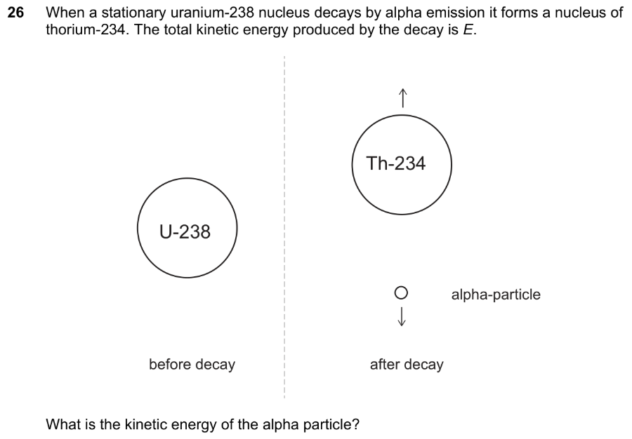
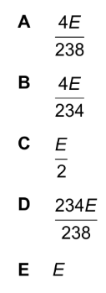

Q33 NSAA 2016
